
Assignment Cover Sheet

Student Name: | Blessing Amosun
Student Number: | 1447
Course: | Fashion design
Assignment NO: | 10

Marking Criteria:
We expect the learners to write minimum one well expressed point in three lines against each allocated mark. This means one needs to write 15 lines with 5 well expressed points to get high grades for a 5 marks question.
For high grades use examples and illustrations where appropriate.
Please insert your completed assignment ( in word format) here:

ASSIGNMENT 10

FASHION SKETCHING

1 A, Fashion figure is about 8 to 10 head tall.
1 B, Rule to follow in sketching face is to Omit as much detail as possible.
1 C, Fashion artist exaggerates the length of the figure and maximises the width of the hands.
2, Important thing to consider when sketching for dressing the figure;
The style of the sleeves short, long, tight.
Where is the neckline, high or low.
Does the costume have a collar which shape.
Does it have a belt, tight or loose.
Which type of skirt is it, circular, pleated straight.
How long is the skirt.
Which type of fabric is it.
Where is the waist line, above or below the normal.
3, How fashion design sketch help a fashion designer,
To be able to know what type of material to use for the dress.
To know how the style will be on human body
It will also help to illustrate the structure of the garment.
It's help save time
Seeing the dress on sketch we help the designer visualize how the design will look like.
Also to helps to paint the picture we have in mind.

4, how bottom of the skirt be sketch; The bottom of the skirt should be sketch to have the general feeling of rectangle and not straight across, rectangle should be curve at the sides to lend the appearance of going around the figure. Draw rectangle line using the measurement, the hip, waist to hip measurement, desired skirt length

B, why is important to harmonise the mood and action of the figure with the cloth in which artist draw her, because actually describe the nature of the cloth or dress if the figure looks like sport woman figure then she should be dress in sport wear, if the figure women is wearing make up and looks like party mood then she should be dress in party or evening dress, also if the figure looks as if is office women then the figure should show her wearing office cloths, this helps in boosting sales of the design, and do help people know what to wear at all most time. Is good to dramatize the figure particularly the feminine figure, the figure should never be more prominent than the apparel .also the figure must wear the clothes with an air of comfort to make the garment look as if it were actually worn by a human being. EG if the dress is a evening gown then the figure woman should look like a woman in happy mood dress with maybe little bit of some evening outing jewelries,

ACTIVITY
`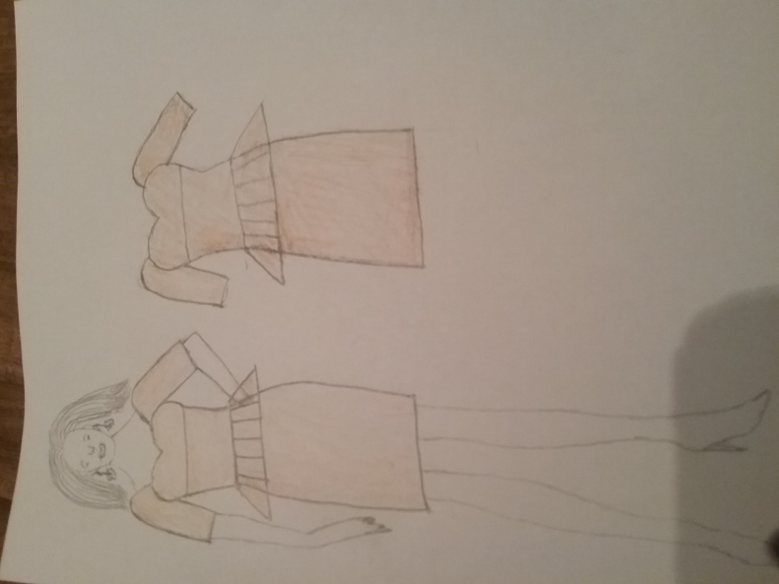

Student Statement:

By submitting this assignment, I confirm that this is my own work.

Student Signature | Blessing Amosun | Date | 23/07/16

For Tutor / Assessor Use Only
Total Marks
Marks Obtained
Percentage / Grade

