
Assignment Cover Sheet

Student Name: | Pastor Aderemi Afuye
Student Number: | 1924
Course: | Diploma in Forensic Accounting
Assignment NO: | 5

Marking Criteria:
We expect the learners to write minimum one well expressed point in three lines against each allocated mark. This means one needs to write 15 lines with 5 well expressed points to get high grades for a 5 marks question.
For high grades use examples and illustrations where appropriate.
1. i Difference between proactive and reactive investigation.
Usually, the difference between proactive and reactive investigation work is clear.
- When investigating - proactively, investigator initially has no indications of the type of fraud that may be present and follow investigative procedures designed to detect evidence to confirm or deny the speculation.
- Once indicia of fraud is detected, regardless of how slight, suspicious are enhanced, but investigator still is not certain of the existence of fraud. However, when validating evidence discovered, and investigator becomes convinced that the case pursued a bona – find fraud discovery, the investigation tends to change to reactive one.
- Further investigating procedures are designed to concentrate on those factors that will improve the prosecutive worth of the finding; such finding includes determining who the perpetrators are, whether other cases involving the perpetrators have occurred previously, proving their intent to commit fraud, and determining the total loss to the victim resulting from the fraud.

ii. Different between the weighted and unweighted solvability factors.
- Solvability
A system or characteristics (belief, reliable or credible source of information) in short the forensic accountant cannot assume that the initial information provided by complaint is completely accurate
- Efforts should make early on to determine if the information is believable, reliable and or credible.
There are two types of solvability factors, weighted and unweighted.
- Weighted solvability factors: the recognition that all factors are important in determining solvability. For example, the existence of a fingerprint at the scene might be more important in determining outcome than co-worker/mates witness evidence. Like this, the fingerprint factor weighted more heavily.
- Unweighted solvability factors on the other hand, conversely, do not assign any particular importance to individual factors. But, each factor is a relatively important as the next. The existence of one or more factors determines whether the case receives further attention.
When using a formal system of evaluation involving weighted factors, it is important to evaluate each case.

iii. Reasons for goal setting and planning in investigative process.
Goal setting and planning are important.
- Goal setting and planning effectively start by the skills and knowledge of team, of the experienced investigator
- The investigator's task is result orientated, therefore; it is important to define the goal of the investigation is the term “legal actions. It makes the investigator’s job easier
- “No one plans to fail but fail to plan.”
- Therefore, to proceed an investigation in a haphazard manner with slipshod techniques (without goal setting and planning) regardless of investigative team experience skills is unlikely to succeed than inexperienced and ignorant that proceeds with a careful designed investigative plan.
- Investigative plan must base on focus, control, and adaptability
- Determined ahead of time, what potential outside support required, reduce ad hoc decision and overall integrity increased
- If the investigative team develops; financial planning, personnel planning and Technical planning (an investigative planning) it helps to know for example, at which stage it is important to use outside expert (e.g. in undercover/surveillance operation or evidence gathering in computer forensics.)
- Though not always preventable, careful planning can make the inevitable arrival less catastrophic to the investigation.
IV. Major goals of investigative planning:
Fraud investigative plan has three major goals:
- To maintain focus
- Control growth and
- Promote Adaptability
Maintain focus:
Forensic Accountant must focus his/her investigative plan in line with the set objective of the investigation. Knowing that strong focus prevents duplication of investigative efforts or oversight to hamper the progress of the case.
Control:
Financial fraud investigations are living entities. (No wonder, says that “the more you digs, the more you finds”)
- Easily they grow and take on, the character of their own.
- Give birth to other cases or marry themselves to every investigators’ case files
- Hence time-consuming and costly.
Investigators with strong investigative plan recognise the above in fraud investigations and manage it.
Though not always preventable, careful management through planning can make the inevitable arrival less catastrophic to the investigation
Adaptability:
In keeping with the living nature of financial fraud, fraud investigations evolve.
Investigations may grow (most of the time) or may shrink (less of the time), but they change. Hence
- All good investigative plans must have some built in adaptability
- Without adaptability, slight changes in the circumstances surrounding the investigation will render the plan useless.
- If this happens, choices are to either operate ad – how or take time to evaluate and replan and none are unfavourable
But by ensuring that the investigative plan has built in adaptability, changes in the course of the investigation will not require wholesale changes in the investigative plan

V. Stages involved in planning an investigative plan.
Financial Planning:
Regardless of the size of the investigations, there is rarely enough money to do the job in the way the investigator would like. So like almost everything in the investigation, the cost is a matter of compromise, identification of potentially expensive issues early in the investigation allow to make key fiscal decisions at a time when alternative approaches can easily consider.
- Undercover/surveillance operation might be the perfect investigation tool to achieve the overall goal, failure to examine the net cost of that approach, is costly, both regarding financial resources and in term of wasted investigative man – hour.
- Undertaking financial analysis during the planning phase leads to alternative techniques’ to consider and instead of hope that money will eventually come through and when it doesn’t, the investigation bogs than with the hope of achieving the initial objective.
- Failure to identify alternatives to costly investigative procedures, results into compromised outcomes, either outcome stated objective or expenditure of more funds than reasonable or outcome procedures dissatisfaction and failure to achieve customer expectations.
Personnel Planning:
Early identification of personnel issues helps to ensure efficient investigation.
- Mapping out the overall scope and direction of the investigation makes it easier to predict the staffing needs and to assemble an investigative team designed to proceed with the investigation.
- It is essential to identify key personnel requirements early, even for long term complex case it is imperative. Use of outside of experts (enlist the help of financial professionals as either consultants or experts in the area of stocks and securities transactions, corporate governance and structure, international financial transactions plus another expert witness) consider at this stage, and the investigative team is well-prepared to handle any financial fraud.
- Knowing that the odds of encountering computer based information in today’s world of high - tech are very high. It is good to expect that even the most well-trained investigator will not be capable of handling every possible scenario, for this reason outside personnel to act as investigative resource, whether in the area of topography, computer security, cryptography or individual proprietary software is considered

Technology Planning:
Shoe leather often bests the investment that investigator can make in a case, as the technology advances and the advancement of digital revolution, investigators must employ more than muscle power of the image of the knocking on doors and following down leads but requires an investment in technology
The investment, either temporary or permanent requires a plan.
- Sometimes, the need for the high – tech equipment is short term, such as rental of expensive camera equipment to obtain surveillance photos of the target piloting the off shore time share properties he purchases with company proceeds. Other times, the investment is more long term. An example of such an investment is computer upgrades.
- Investments in new technology, evaluation must base on cost/benefit, and usually occur at predetermined intervals (temporary investments are not so predictable)
- Plan case, identify areas in which may need money and identifying particular technological concerns in advance reduces their logistical impact.

vi. The three main areas of intelligence gathering process

Intelligence gathering process
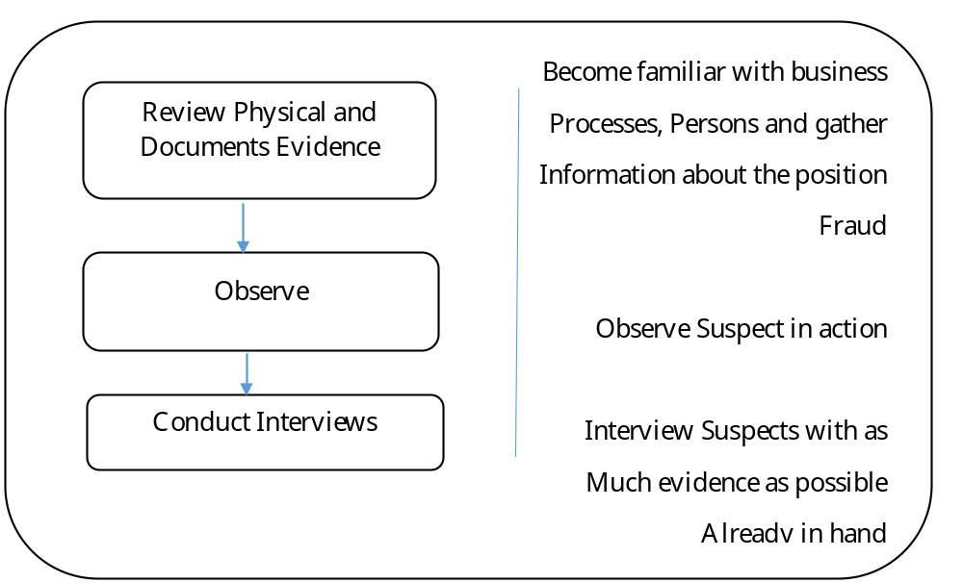

The intelligence gathering process begins with a review of the physical and document evidence. The process then proceeds to Observations and interviews.
Review, the physical and document evidence, may involve items such as accounting records, application forms, credit reports, bank statements, and tax returns.
The objective of the physical and document review phase is to become as familiar as possible with the relevant business processes and individual involved as well as the possible fraud scheme before conducting any interview. And this serves two main purposes.
- Helps the investigator to know whom to interview, the order in which to interview individuals, and the questions to ask.
- In many cases, it is possible to keep the investigation secret while reviewing physical and document evidence. Once interview begins, it can be difficult to keep everyone, including perpetrators, from knowing that investigation is underway. Once perpetrators know that an investigation is underway, they may destroy evidence, disappear or fabricate false stories (smoke screen)

Observation:
There is nothing better than catching a fraudster in the actions of the fraud. Moreover, in some types of frauds, especially those that involve identity theft, it is the only way to catch and convict a fraudster.
In cases of internal asset misappropriation, catching the fraudster in the acts may result in substantial savings in the cost of the fraud investigation
In considering the extent which to use observation, the investigator must weigh the benefits of catching the thief in the act versus the possibility of continuing losses.

Interviews:
Interview conducted after the investigator has carefully studies all other types of evidence and has a fairly strong theory of the fraud scheme under consideration.
The goal in interviewing is to obtain a confession if possible. If a confession is not possible, then the goal is to record the suspect as much relevant detail as possible.
Ideally, it is best to record the suspect before the suspect is aware that he/she is a suspect, or even aware that a fraud investigation is underway. The step increases the possibility of catching the suspect making inconsistent statements or telling outright lies.

2. Private and Public Databases.
Databases are representations of information about persons, places, or things. (Including records in electronic format) That usually provide circumstantial evidence. And circumstantial evidence may be the only evidence available to fraud investigators. Helpful to the investigator in building a profile of the suspect and establishing a case to support the allegation of crime.
Several of sources (including social networking sites) are easily accessed and provide helpful information that the suspect himself divulges. These databases may divide into two categories private and public.
A. Private Databases:
That (commercial) database to which access is restricted
- Powerful repositories of data
- Contain broad range of information that investigator may find helpful in establishing the suspect’s profile and history. For example, Lexus provide information including ages, birth dates, address history, phone numbers, household numbers, home values and income. Another example is IntegramScan, which advertises its capability to do a complete scan of official records that can disclose arrest records; warrants, civil records including taxes liens, lawsuits, Judgements, alias, 25 years address data and other information such as Real Estate Records, Uniform Commercial Code (UCC) filing.
- Offer a one stop shopping approach to intelligence information gathering.
- Access to some area restricted to Law enforcement personnel for law enforcement purposes
- Private individuals can download information for a fee.

B. Public Databases
Alternative to the fast and powerful of the private commercial databases is the public databases access.
Records Available to the Public (Subject Access Request- SAR policies and procedures)
Public databases include both commercial and government sources
Some are available to the general public, and others restricted to entities, local and state employees.
- An excellent place to begin a search for evidence is in the public records because of their availability, Civil, and Criminal histories are often available on court records, Uniform Commercial Code filing can be an immense help in locating owners of assets. And establishing connections between suspect or business entities.
- Real Estate Records: Documents such as title certificate and deeds ownership usually maintained in the Jurisdiction Land Registry office. Also, the Tax assessor’s office maintain records of the person who pay property taxes within the Jurisdiction.
- Other Examples Financial Crimes Enforcement Network
- Reports regarding currency transactions and suspicious activities must file with the government (The Financial Crimes Enforcement Network – Fin CEN.) is charged with assessing penalties for noncompliance.
- Currency Transaction Reports –
- Financial Institutions are required to file Currency Transaction Reports (Fin CERN Form104) when a customer deposit more than £10,000 in currency. The form identifies the customer by name, address, date of birth and the identity of the person who conducts the transaction on behalf of the owner of the currency. The definition of the financial institution includes not only the banks but also the brokers or dealers in securities, currency exchangers, and Cheques cashiers, issuers of money orders and Traveller’s cheques and dealers in real estate businesses.
- Report of International Transportation of Currency or Monetary Instruments.
Any person who physically transports, mail, or ships currency or monetary instruments of more than £10,000 into or out of UK. Or any person who receives payments from a source outside the UK must file a Report of International Transportation of Currency or Monetary Instruments (Fin CERN Form 105) this report and others use to link the movement of money to those who control the funds.
- Tax Returns
Tax return provided by the taxpayer might not have the same information on the tax return filed with Her Majesty's Revenue and Customs (HMRC) contained.
A forensic accountant can obtain copies of any Restricted Records through the discovery process by use of search warrant for financial fraud.

3. Financial crime investigations resulted in a higher volume of evidence and more complicated theories of evidence than on – financial crime.

The principle of reverse proof means Investigator must consider the evidence for both parties (Plaintiff and the Defendant) – The investigator must not only attempt to prove that a given fraud occurred but also attempt to prove that it did not. Therefore, the investigator must, to some extent possible, consider and rule out all evidence that would support the arguments of both the plaintiff and the defence.
Several standard defences include the following.
- Someone else’s did it.
- It done before or after the suspect worked for the entity.
- Something is wrong with the computer software
- Had the fraud examiner reviewed 100%of the transactions, the apparent shortage would account for
- The problems were simply errors, not fraudulent entries.
- That is what the owner told the suspect to do
- A hacker did it.
Let consider this example of what require for the second one of these standard defences. Assuming a business owner believe that the store keeper has been pocketing cash receipts rather than deposit them.
To unveiling such a fraud would seem an easy task at a glance for a fraud examiner.
- The only process needed is to reconcile the cash account with the bank account.
But in the real world, things are considerably more complex.
Further assumption:
- The store keeper batches together cash receipts (which include both cash and cheques) for several days or longer and makes occasional deposits. Also, the deposit slips contain lump –sum amounts, no details.
- Finally, the storekeeper makes batch – type entries in the cash receipts journal that do not coincide with actual batches of deposits.
The investigator is not able to identify any specific deposits that not made. Likewise, unable to simply compare adjusted monthly changes in the cash balance per the accounting records to the same month changes in the cash balance per bank account. Because the matched entries to the cash journal do not necessarily represent cash received in the month of recording and because funds deposited into the bank account do not necessarily represent funds received in the month in which they deposited.
- The investigator cannot even rely on the opening balance for any month in the cash ledger. There is this possibility that it includes cash collected in the previous month
The result is that the fraud investigator is left with little but arguments about account balances and timing to prove fraud.
- Not the best type of evidence on which to build a court case.
To develop strong evidence:
- The investigator must contact the bank and obtain image copies of the deposit slips for the entire period the store keeper was making deposits. It could span years.
- The investigator would need to obtain reliable records of cash receipts from a source other than the store keeper unreliable accounting records. Such records would include source documents such as sales invoices, cash receipts logs, register receipts. Given these documents and images of the deposit slips, the investigator could in effect reconstruct the account records and document specific deposit that not made.
Above process could take months of work, and would likely complicate by missing documents. Documents with errors and unexplainable cash transactions, like cash transfers to and from other bank accounts belonging to the same entity. With the consequence that the investigator would have to include the other account as part of the investigation to rule out that money is missing funds were deposited to, or transferred to, the wrong account. In this case, the same problems could begin all over again with the other accounts.
- Not only time consuming and expensive, financial crime investigations resulted in higher volume of evidence and more complicated theories of evidence than on – financial crime

Case Study:
i. The second leg of fraud triangle involved a perceived opportunity to commit fraud and get away with it. The owner of this business did establish an effective oversight presence in his device accounting system. Failure to diminish the perception of Mr Baron, which he will able to steal without getting caught.

ii. Other than theft by Baron, below are possible causes of shortfall
- Lack of visible owner presence at the cash entry point, including the cash registers. It is not to say that the owner must hover, Mr Baron or cashiers, too much oversight can produce a negative effect on the employee, causing him to feel distrusted or resentful. But the owner should routinely check on all cash entry points, not just to look for fraud but also to ensure proper customer service, monitor sales and so on.
- Instead of owner physical presence, Video camera can be installed at cash entry point to serve essentially the same purpose.
- The cash register should record the login and logout time of the user. It is a simple measure that makes easy to detect off – hour sales by comparing log in times to the pub hours of sales. Also, should a theft occur, the user log is helpful in identifying the potential culprit?
- In addition to monitoring, the pub owner should have taken other steps to reduce Baron perceived opportunity to steal. For example, it is advisable to maintain a secure area where cashiers are required to store coats, hats, purses and so on. The idea is to eliminate potential hiding places for stolen money.

Student Statement:

By submitting this assignment, I confirm that this is my own work.

Student Signature | Aderemi Afuye | Date | 31/08/2016

For Tutor / Assessor Use Only
Total Marks
Marks Obtained
Percentage / Grade

