
Assignment Cover Sheet

Student Name: | PLOUTARCHOS KONGOROZIS
Student Number: | 2415
Course: | Diploma in Human Resource Management
Assignment NO: | Assessment #4

Marking Criteria:
We expect the learners to write minimum one well expressed point in three lines against each allocated mark. This means one needs to write 15 lines with 5 well expressed points to get high grades for a 5 marks question.
For high grades use examples and illustrations where appropriate.
Please insert your completed assignment ( in word format) here:

1.

- The objectives of an effective training program should be the development of confidence and performance improvement of the employees, help the employees grow within the business, reduce the learning man hours for new-comers and or promoted employees ensuring they become competent quickly and cost effective.

- Training needs can be assessed individually or in a combination with one another with several methods to be taken into consideration such as: employee meetings, management meetings, create questionnaires and conduct surveys, create focus groups and review the goals and mission statement of the business.

- An Outline of training process steps:

- Training needs assessment
- Plan, design and curriculum development
- Selection of trainees and training method
- Accurate analysis of demand
- Training Delivery
- Procedures improvement
- Delivering the training
- Evaluation and follow-ups

- Job training methods may involve on the job training done while an employee is working, it may be an orientation training concerning new freshly hired employees. Furthermore training techniques may involve off the job training by attending lectures, lab training and conferences. More advanced techniques may include role playing and simulation (audio visual methods like documentaries and films), job rotation (on which employees are engaged in different job areas), programmed learning, internships and apprenticeships.

- Training programs can assist the organization in improving efficiency thus resulting in financial profits, increasing its productivity, reducing employee turnover and supervision. Moreover employees will gain greater self-worthiness resulting in productivity which eventually offer them more material gains (incentives and other benefits). By training personnel an organization actually utilizes a risk management tactic and states that the company has good management tactics.

- Training is usually a short term process whilst development is long term in nature. Development often includes education in philosophical and theoretical concepts whilst training concerns a specific task or job role which often does not comprise leadership activities. Development aims at developing relationships for the purpose of improving leadership skills and has a more general scope (nonspecific).

2. Activity

A meeting was conducted at the company’s HQ with six marketing & sales officers, their supervisor, the Head of the Department and a Senior Manager in order to identify areas of improvement regarding their performance and productivity. We have asked the employees to write down ten of their most important training needs in order to assess the areas that need most improvement. After these procedure we have placed the needs of each employee on the white board and requested them to vote the most immediate ones.
The votes showed that the most immediate attention to the matter was to expand the department’s knowledge in MS Office applications specifically MS Excel 2013, the software the company currently uses.
An e-mail with Questions was send to the employees regarding MS Excel 2013 applications. In this way we can have a clear view on the areas that need attention.

- Assess staff training needs

Please complete this form so that we can assess your training needs. Please note that your answers will be held in complete confidence and it is very important that you answer all questions as accurately as possible to help us selecting the course that will be most beneficial to you.

After filling your personal information please e-mail the complete questionnaire to hr@sscl.com.sa as soon as you can.

Excel Levels: Level 1=(Q:1-4), Level 2=(Q:5-8), Level 3=(Q:9-12))

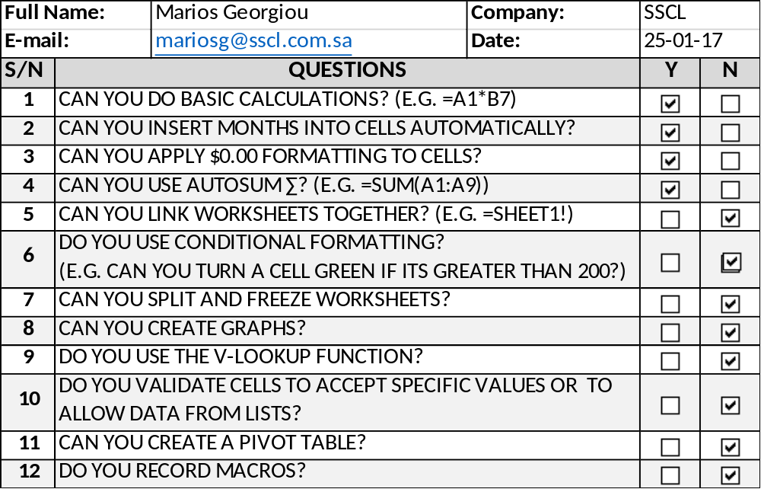

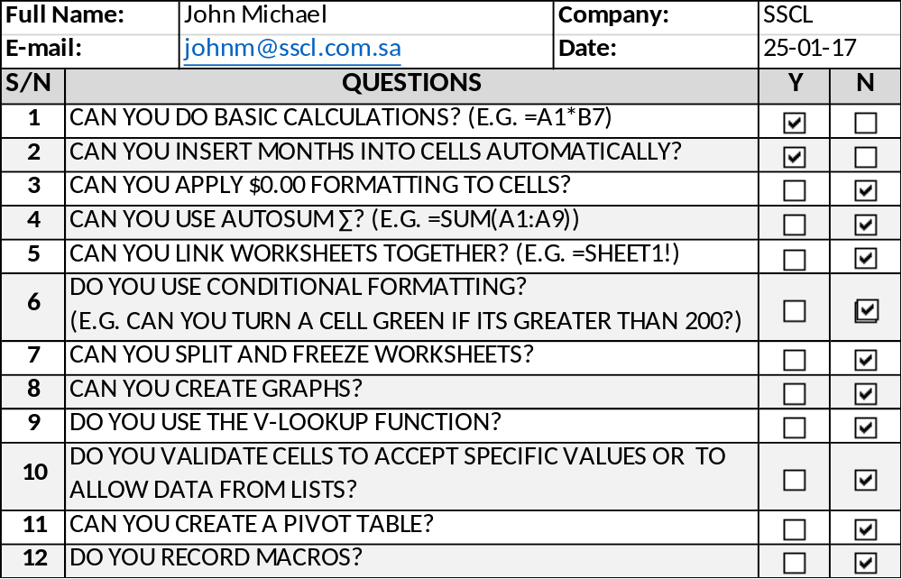

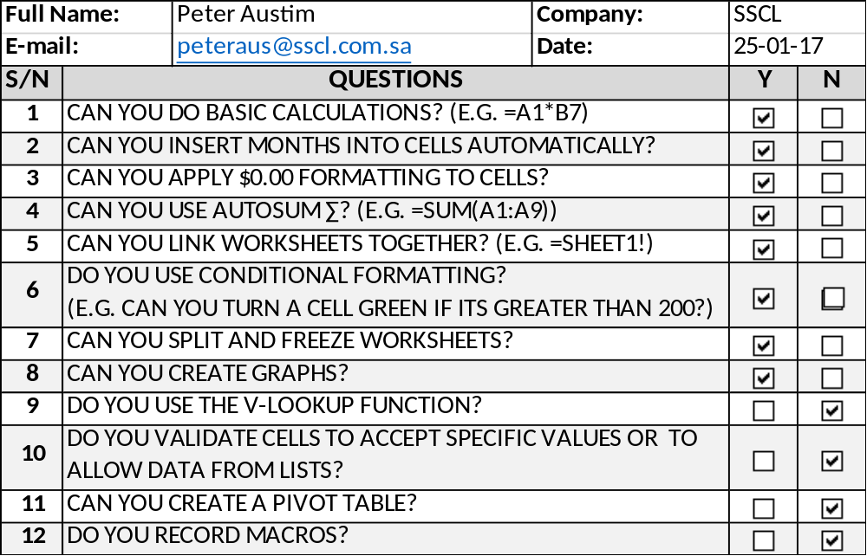

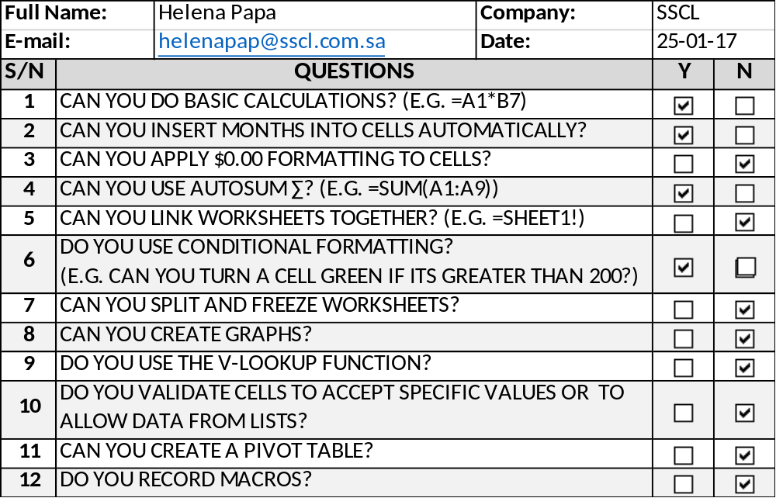

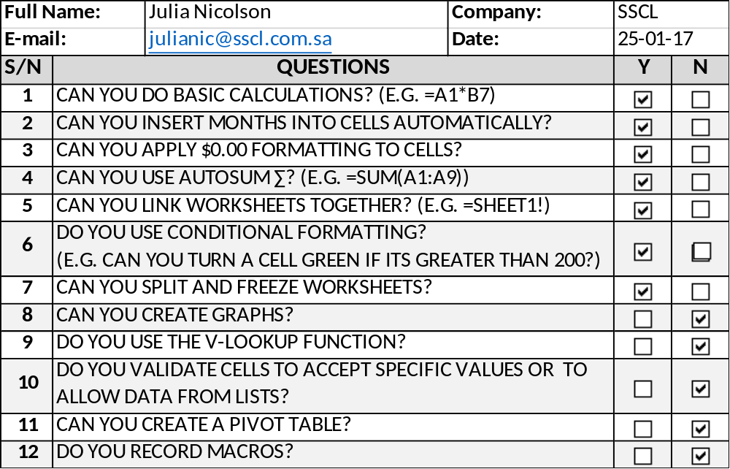

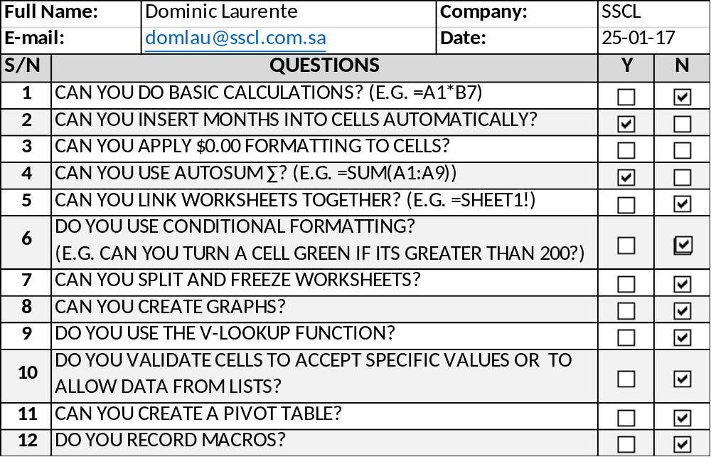

- Identify the areas need to focus on for training

After assessing staff training needs by conducting surveys the occupational program selected in order to increase productivity was their skills development in Microsoft Office applications and more specifically Microsoft Excel 2013 Levels 2 and 3.

- Explain the training procedure

Objectives (learning outcomes) of MS Office Excel 2013 Training

By the end of the training program the employees will be able to:

- Use MS Office Excel 2013 in an advance level
- Use MS Office Excel 2013 as a tool to improve
organizational performance and productivity.

Training will be conducted by an off-house training institute specialized in all MS Office applications and is an official partner of Microsoft. At the end of the training program an exam will take place, upon successful completion the employee will receive an official MOS certificate on MS Excel 2013.

Student Statement:

By submitting this assignment, I confirm that this is my own work.

Student Signature | Ploutarchos Kongorozis | Date | 26/01/2017

For Tutor / Assessor Use Only
Total Marks
Marks Obtained
Percentage / Grade

