
Assignment Cover Sheet

Student Name: | Terry Pittaway
Student Number: | 5463
Course: | Supply Chain Management
Assignment NO: | 1

Marking Criteria:
We expect the learners to write minimum one well expressed point in three lines against each allocated mark. This means one needs to write 15 lines with 5 well expressed points to get high grades for a 5 marks question.
For high grades use examples and illustrations where appropriate.
- Outline the main benefits of a supply chain

A supply chain is a network of organisations and activities that functions to procure materials and change these from raw materials to intermediate and finished goods. As well as the final distribution of these goods to the final customer.

These chains can take place within one company, for example a large multinational car producer which has vertically integrated much of their production would control each process within their own supply chain. The norm is different however and companies will work together with their suppliers and consumers as goods/materials move along the supply chain.

Among the varied benefits from a supply chain the main benefits are achieved through economies of scale. By having an intermediary acting as a wholesaler between a range of producers and consumers of a good the process can be made more efficient, for example a coffee beans are grown in Africa and South America but the major consumers are in Europe and North America. A large supply chain starting with the farmers and ending with the coffee seller exists to service the end consumer, including the raw materials going in such as fertilizers and the intermediary processes and transportation – drying, roasting grinding, packaging and transportation at various stages. A complex but elegant supply chain reduces the cost to an individual consumer on a huge scale. Without the above example of a supply chain a coffee drinker in Europe would have to complete each process themselves.

The below flow chart shows a very simplified version of the supply chain, taking out many of the processes but does highlight the complex nature of seemingly simple supply chain.

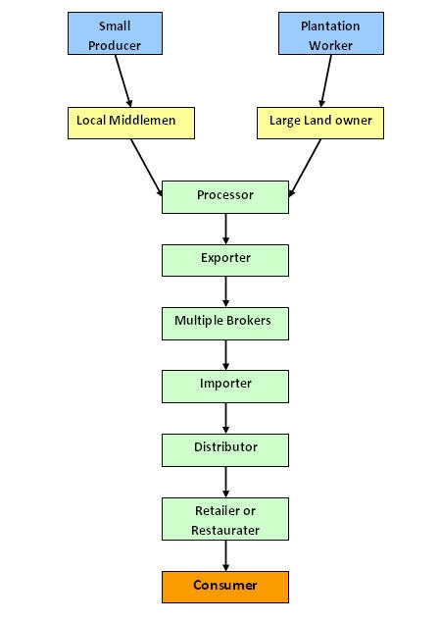

These benefits result in a simplified process on a large scale; producers place their operations in the best locations, regardless of the location of their customers. This in turn means economics of scale are achieved and can be passed on to wholesalers and then eventually the final consumer. A company can become expert in distinct stages of the product and supply chain again increasing the efficiency and improving the economies of scale, these benefits can then be passed on to the final consumer.

- Companies in any supply chain can make their decisions individually and collectively in five areas
What are these areas?

The five areas in which any supply chain can make their decisions individually and collectively include the following; production, inventory, location, transportation and information.

1. Production —How much of which products should be manufactured and by when? This activity comprises of the formation of master production schedules that consider plant capacities, quality control, workload balancing, and equipment preservation.
2. Inventory —The main reason of inventory is to protect against ambiguity in the supply chain.
3. Location —where should production facilities and inventory storage space be located? Should present facilities be used or new ones established?
4. Transportation — How should stock be transported from one supply chain site to another? Air freight and truck delivery are usually fast and consistent but they are costly. Shipping by sea or rail is much less costly but generally involves longer transit times and more doubt. In some supply chains, such as crude oil there are pipelines which can dramatically reduce the cost of transportation. However, the high set up costs must be considered, a specialist company in this area of the supply chain would generally be used.

The below table shows the cost differences of using a pipeline to transport crude oil compared with using trucks.

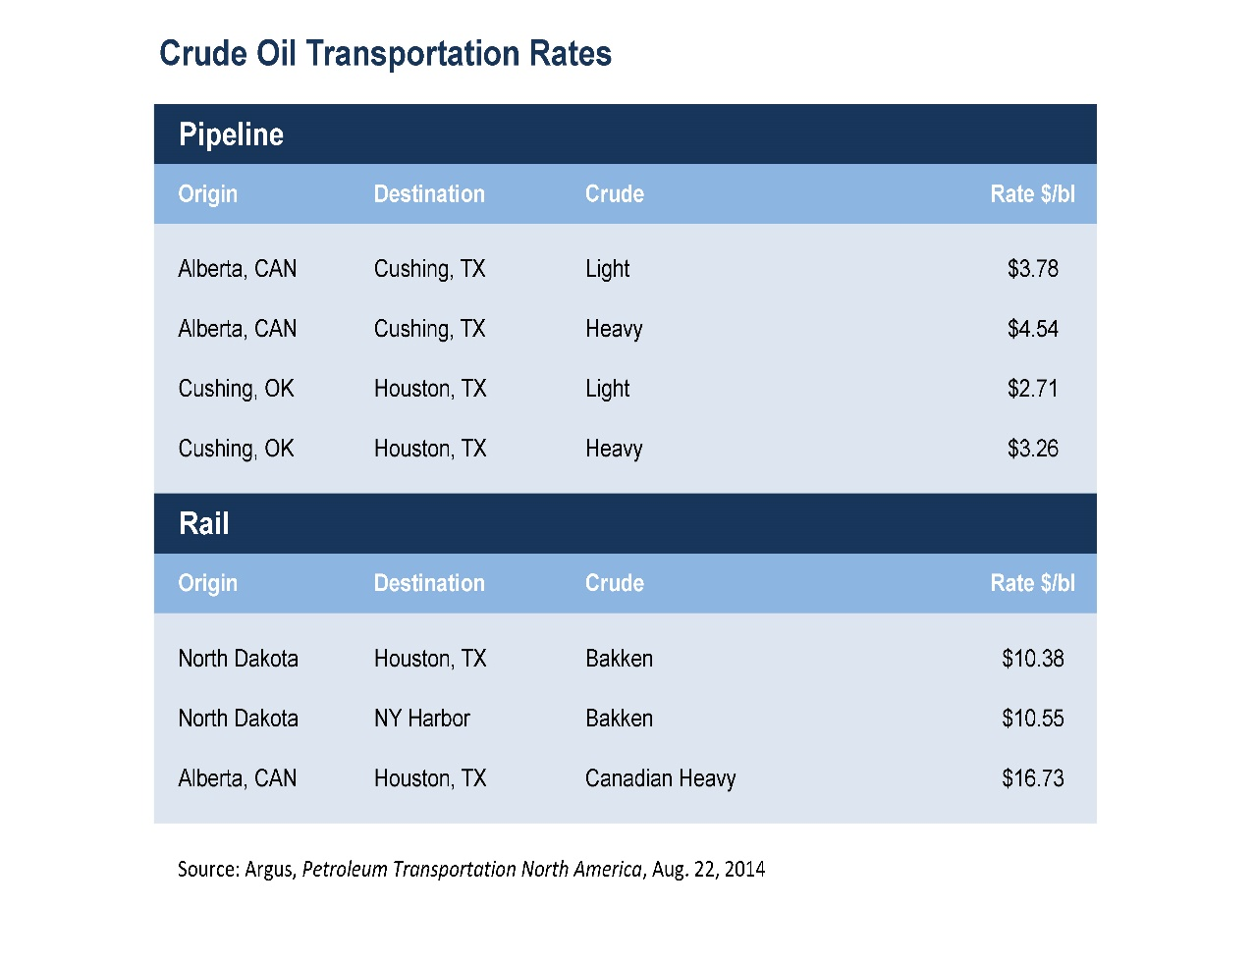

5. Information — Timely and accurate information holds the guarantee of better coordination and better decision making. With fine information, people can make effective decisions concerning what to make and how much, about where to place inventory and how best to transfer it.
3. What is inventory management?

Inventory management is applied to control and regulate the levels of inventory held at different stages of the supply chain. With the aim to decrease the cost of materials or stock as much as possible while still ensuring that all customer demands can be met. The inputs to inventory management are from the demand predictions and the prices paid for product. Inventory management is a delicate balancing act between serving demand for goods and ensuring the best economics of scale to control the prices of products.

An important point to consider with regard to inventory management is the type of inventory that is to be managed; cycle inventory, seasonal inventory or safety inventory. Cycle and seasonal are affected by economy of scale concerns and how the cost structure determines levels of stock to be held at particular times.
4. Write short notes on the following participants of supply chain:
a. Producers

As understood in the context of a supplier chain a producer would be an organisation who makes a product. These can be the producers of raw materials or the producers of finished goods. For example, coffee bean farmers are producers, as are the cafes or restaurants that deliver the final cup of coffee. Producers in the developed part of the world increasingly consist of companies offering non-tangible items and services.

b. Distributers

Distributors are the companies that transport inventory in large quantities from producers and supply to consumers. Generally, they are termed as wholesalers, selling to other businesses in large quantities. They cushion the producers from variations in product demand by keeping inventory and conduct sales to discover and service customers.
c. Retailers

Retailers stock inventory and sell in lesser quantities to the common public. They will closely track the demands and preferences of the consumers. The business will advertise to its consumers and often utilizes some blend of price, service, convenience and product selection, as the primary draw to attract consumers for the products it sells.

Flow chart: http://www.dolcera.com/wiki/index.php?title=Premium_Coffee_Market_Segmentation

Oil Table: http://www.aopl.org/pipeline-basics/about-pipelines/

Student Statement:

By submitting this assignment, I confirm that this is my own work.

Student Signature |  | Date | 19th January 2017

For Tutor / Assessor Use Only
Total Marks
Marks Obtained
Percentage / Grade

