

Assignment Cover Sheet

Student Name: | Abigail Garcia
Student Number: | 2461
Course: | Diploma in Accounting and Finance
Assignment NO: | 5

Marking Criteria:
We expect the learners to write minimum one well expressed point in three lines against each allocated mark. This means one needs to write 15 lines with 5 well expressed points to get high grades for a 5 marks question.
For high grades use examples and illustrations where appropriate.
- The Statement of Profit and Loss, or most commonly known as Income Statement, provides an overview of company sales and net income. It summarizes the result of the business operation for an accounting period. It consists of all the revenue earned and expenses incurred during that period to determine profit.

- Expanded Accounting Equation:
Assets = Liabilities + Owner’s Capital – Owner’s Drawings + Revenue – Expense
This means that the amount of assets of the company should be equal to the amount of the operation of the business. This allows us to identify that the Equity of the business is increased by revue and decreased by expenses, aside from the decrease due to drawings.

- The Realisation Concept focuses on the recognition of revenue. It means that the business recognizes an income for the goods sold or services rendered whether it has been paid in cash or on credit. For instance, revenue is recognized even if the payment for golds delivered will be received after 30 or 60 days. The Matching Concept suggests that revenues received for a financial period should be matched to the corresponding expenses incurred within the same period. The expenses linked to revenues are those which has a direct impact on the revenue generated (eg. Cost of Goods Sold).

Student Statement:

By submitting this assignment, I confirm that this is my own work.

Student Signature |  | Date | 26/09/2016

For Tutor / Assessor Use Only
Total Marks
Marks Obtained
Percentage / Grade

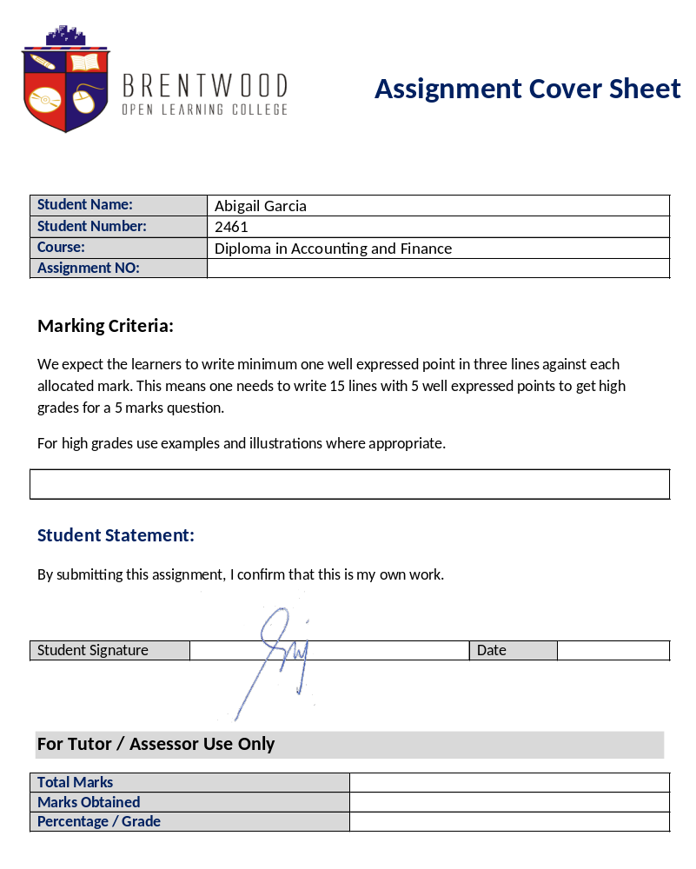

Understanding Profit or Loss Statement

ASSESSMENT # 5 Total Marks: 30

Answer the following questions:

1. | Explain the contents of the statement of Profit or Loss.  The Statement of Profit and Loss, or most commonly known as Income Statement, provides an overview of company sales and net income. It summarizes the result of the business operation for an accounting period. It consists of all the revenue earned and expenses incurred during that period to determine profit. | (10)
2. | Explain the following equation in detail: | (10)
Assets = Liabilities + Capital
Expanded Accounting Equation:
Assets = Liabilities + Owner’s Capital – Owner’s Drawings + Revenue – Expense
This means that the amount of assets of the company should be equal to the amount of the operation of the business. This allows us to identify that the Equity of the business is increased by revue and decreased by expenses, aside from the decrease due to drawings.
3. | Discuss the following concepts: | (10)
• Realization concept
• Matching concept
The Realisation Concept focuses on the recognition of revenue. It means that the business recognizes an income for the goods sold or services rendered whether it has been paid in cash or on credit. For instance, revenue is recognized even if the payment for golds delivered will be received after 30 or 60 days. The Matching Concept suggests that revenues received for a financial period should be matched to the corresponding expenses incurred within the same period. The expenses linked to revenues are those which has a direct impact on the revenue generated (eg. Cost of Goods Sold).

Accounting and Finance Level 4 Brentwood Open Learning College Page: 1

