
Assignment Cover Sheet

Student Name: | HIRA FAHIM
Student Number: | 5733
Course: | Diploma of Construction Management
Assignment NO: | 09

Marking Criteria:
We expect the learners to write minimum one well expressed point in three lines against each allocated mark. This means one needs to write 15 lines with 5 well expressed points to get high grades for a 5 marks question.
For high grades use examples and illustrations where appropriate.
- Answer the Following Questions:

- Outline the various elements of purchasing with the help of suitable case examples.
Elements of Purchasing
Buyers and their colleagues are naturally keenly aware of the importance of price. When considering the purchase of a product or service, the buyer will have a number of key factors in mind for determining the reasonableness (or otherwise) of the price being asked. For example:
- The price being paid by competitors
- What may be thought of as a fair price
- The period over which the price is agreed
- The quantities likely to be involved
- The level of risk attached to the purchase.
Once the buyer is happy to proceed he will enter into a price agreement with the supplier. This will be either on a firm price basis, which has obvious advantages for the buyer, or on a cost plus basis, whereby an agreed percentage is added to the basic cost of the product or service; this is the supplier’s margin. Price is usually the most visible part of purchase costs and non P&SM professionals often focus on it too much. Other costs associated with a purchase could include:
- Training costs
- Test and support equipment costs
- Inventory and distribution costs
- Customer service costs
- Transport and handling costs
- Technical data cost
- Disposal costs.

- What are the main objectives of purchasing?
Objectives of Purchasing
Fundamental Objectives of Purchasing
- Maintaining
- Minimizing
- Prevent duplication
- Maintaining proper quality standards
- Obtain valued for money in terms of obtaining lowest price items at the highest quality and functionality
- Helps to maintain organisation’s competitiveness by purchasing materials at reduced prices.

- What are the various prerequisites for becoming a good purchase manager?
As a purchasing manager, you'll need to:
- Forecast levels of demand for services and products;
- Keep a constant check on stock levels;
- Conduct research to ascertain the best products and suppliers in terms of best value, delivery schedules and quality;
- Liaise between suppliers, manufacturers, relevant internal departments and customers;
- Build and maintain good relationships with new and existing suppliers;
- Negotiate and agree contracts, monitoring the quality of service provided;
- Process payments and invoices;
- Keep contract files and use them as reference for the future;
- Forecast price trends and their impact on future activities;
- Give presentations about market analysis and possible growth;
- Develop a purchasing strategy;
- Produce reports and statistics using computer software;
- Evaluate bids and make recommendations, based on commercial and technical factors;
- Ensure suppliers are aware of business objectives;
- Attend meetings and trade conferences;
- Train and supervise the work of other members of staff.
- What are the objectives and functions of stores?
Function and Objectives of Stores
The general definition of as store is simply where materials are kept to be used later during the course of construction. A store can be defined as a place for:
- Receiving raw materials, components, tools, equipment and other items and account for them
- Providing adequate and proper storage and preservation to the various items
- Meeting the demands of the user departments by proper issues and account for the consumption
- Minimizing obsolescence, surplus and scrap through proper codification, preservation and handling
- Highlighting stock accumulation, discrepancies and abnormal consumption and evolve effective control measures
- Ensuring good housekeeping so that material handling, material preservation, stocking, receipt and issue can be done adequately
- Assisting in verification and provide supporting information for effective purchase action

- Describe the general criteria adopted for the layout of stores.
General Criteria for Layout of Stores
- The design should make for easy identification of items
- Stored items should be easy to retrieve from the facility
- Design of layout should allow free movement of people and equipment
- Layout should facilitate preservation of materials from dust, moisture, chemicals etc.
- Excellent lighting system
- Layout must make provision for effective fire-fighting
- Space should be available for toilet, maintenance and repair areas, safe wiring systems etc.
- The most economic layout should be arrived at after extensive analysis of alternative designs Height of store must provide sufficient space to aid vertical movement:
- All major functional areas should be properly marked out and labelled. Areas for bulk storage, inspection section, receiving bay should all be clearly identified.
- Racks, pigeon holes, bins are suitable for individual items
- It is best to fix the racks to the walls. Alternatively you may use revolving racks with castors
- Secure locking systems should be provided for expensive items
- Ideally, trucks and lorries should be packed against the wall of the receiving bay to allow for easy loading and unloading of items using suitable ramps
- Large doors and sufficiently-spaced columns are best
- High security measures should be in place
- Security personnel should be present to prevent theft and store facility should be close to a police station
- Excellent communication between departments concerned with storage issues should be encouraged for seamless operations
- Training should be provided to personnel on how to use fire-fighting equipment effectively

- Differentiate between stock valuation and verification.
There is a distinct difference between the two terms "valuation" and "verification". Valuation is the monetary equivalent of the stock or material in hand whereas verification is the determination or quantification of the material in stock and checking its deviation from the figures shown in the books.

- Discuss the different stages of "material procurement cycle".
Material Procurement Circle
When items pass quality checks, they are dispatched to the warehouses or stores for storage. The end-use department may request for the item following store system procedures. All stages in the material purchasing system can be classified as a “Material Procurement Cycle” as shown in figure 9.2.
Figure 9.2 shows this Material Procurement Cycle initiating from indenting materials to issues with the items.
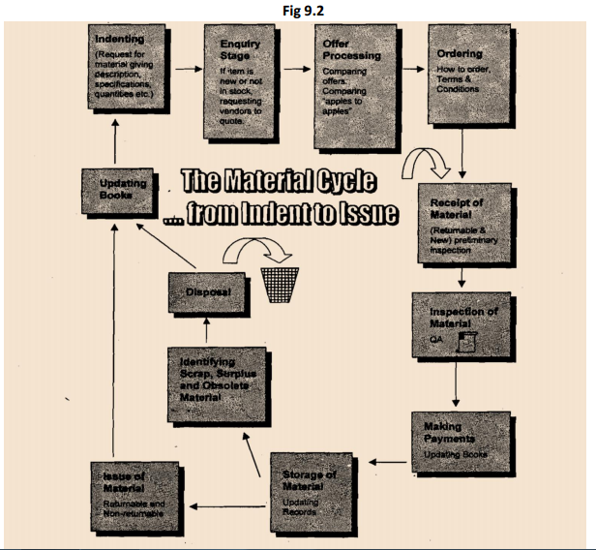

Warehouses or Stores
Stores and warehouses are critical components of the whole construction project. The use department interacts with the stores on daily basis to request for materials. Having a store or warehouse prevents undue interruption to the flow of work on the site. Since items stocked at the stores cost lots of money, they are often regarded as capital asset or money.

Function and Objectives of Stores
The general definition of as store is simply where materials are kept to be used later during the course of construction. A store can be defined as a place for:
- Receiving raw materials, components, tools, equipment and other items and account for them
- Providing adequate and proper storage and preservation to the various items
- Meeting the demands of the user departments by proper issues and account for the consumption
- Minimizing obsolescence, surplus and scrap through proper codification, preservation and handling
- Highlighting stock accumulation, discrepancies and abnormal consumption and evolve effective control measures
- Ensuring good housekeeping so that material handling, material preservation, stocking, receipt and issue can be done adequately
- Assisting in verification and provide supporting information for effective purchase action
- Explain the various tendering system used for ordering the material
Tender System
This method of procurement is prevalent in the private sector. The objective of this tender system is mainly to encourage fair and competitive pricing and to discourage favouritism or nepotism in procuring items. Nepotism usually occurs when the terms and conditions or the specifications seem to favour one particular vendor. Loading is done to eliminate nepotism by comparing all advantages and disadvantages of purchasing a specific item from vendors in terms of cost and productivity. For instance, a machine which is more expensive may be many times productive that a less costly one. Detailed specifications would ensure objectivity and eliminate suspicion of nepotism.
There are 3 methods of tendering to choose from:
- Open tender
- Limited tender
- Single tender
Open Tender
The process begins with the publishing of Notice Inviting Tenders (NITS) in major newspapers and Trade Journals. The tenderers are expected to purchases the tender documents which contain the terms and conditions, as well as the specifications of the project. There is also an option to submit a technical or commercial bid during the process. Tenderers are expected to provide quotes and meet all contractual obligations or a certain minimum technical specification with regards to the terms and conditions. If any deviations occur in the quantity of supply or with the terms and conditions, then this would have to be discussed to arrive at an agreeable solution. Costly items with high technological content which require global tenders are financed by international financial institutions like the IMF (International Monetary Fund). To ensure a smooth tender process, clear and simple language must be used for this type of tendering. Also, a comprehensive checklist should be prepared before embarking on this global order. The main problem present by the open tender method is that of the ‘rogue bidder’ who quotes very low prices to win the contract only for him to attempt to renegotiate terms for an increase in payment once the buyers have committed a lot of investment to the project.
Limited Tender
This type of tender is designed to solve the ‘rogue bidder’ problem. It requires having a limited number of bidders who meet certain pre-defined specifications. Precautions must be put in place so that genuine bidders are not disqualified or the criteria for qualification do not favour one particular bidder. Limited tender produces reduce lead times.
Simple Tender
This type of tender is ideal for proprietary items but should be avoided to prevent unfair pricing or blackmail. It may, however, be useful when frequent repeat orders are required in order to reduce lead time during contract negotiations.

Student Statement:

By submitting this assignment, I confirm that this is my own work.

Student Signature | HIRA FAHIM | Date | 21/02/2017

For Tutor / Assessor Use Only
Total Marks
Marks Obtained
Percentage / Grade

