
Assignment Cover Sheet

Student Name: | Kimberley Jones
Student Number: | 1591
Course: | Diploma in Event Management Level 4
Assignment NO: | Unit 9

Marking Criteria:
We expect the learners to write minimum one well expressed point in three lines against each allocated mark. This means one needs to write 15 lines with 5 well expressed points to get high grades for a 5 marks question.
For high grades use examples and illustrations where appropriate.
Please insert your completed assignment ( in word format) here:

Task 9
1.
a) Ludlow Catering Company
b) Ludlow catering company’s purpose is to provide excellent service of catering for all types of events. This is done to the best our ability to ensure the event runs smoothly to make sure the client is stress free and happy.
c) The service we offer is catering. This can come in many styles to suit the client. It can range from a sit down meal to a buffet or even drop off foods.
d) The primary analysis: I asked a range of different people in my local area about what they would think of the business. Most people were very positive and impressed that we were so flexible. Some of the other local business were impressed that we would be using them because they provide local produce.
The secondary analysis:
The government have put out a report about the catering industry. This is because caters are getting more diverse in what they cook/prepare. It suggests in the future the industry will grow and the public will be spending more money into the catering services.
e) There is a lot of competition within my area for caters. It is very trending to have marque weddings in the country side. More and more people are getting married as it is starting to become a trend again.
f) Our marketing plan will be to have local people, suppliers and business around to have canapes and drinks. This will get people talking and socialising about our business. We will also make our own posters/flyers to hand round and to pin on notice boards etc. If our budget will stretch we will try to get onto the local radio around 8am or 6pm. This will be when most of our clients are listening. We will also need to create a web page advertising our business.
g) We must register with the local authority. We need to register as a limited company. Do a risk assessment. Get the correct hygiene and first aid training. Get the right insurance. Get a gas and electrical certificate. Also get a due diligence system and hand washing facilities.
h) I hope to make 100% profit.

2.
a)
A. Event Rationale
The event is being held to raise money for a charity.
B. Event Summary
Name of event: Football Fundraiser/band night
Venue/location: Football ground
Date/s: 21st August
Time/s: 12pm
Contact Person*: Kim Jones
Position: Event Manager
Mobile: 078983457
Fax:752936
Email: kjonsd.87@yahoo.com

Event description
It will be a football sporting event. There will be 3 famous footballers who will have football sessions with the children to train them on skills. Then the event will change over and there will be bands in the evening for the adult’s entrainment.

Event vision/mission statement/positioning, e.g. local, regional, national
The event will hopefully be at a regional level to ensure we have enough interest to attended.
EVENT MANAGEMENT

Core activities of the event
1. Football skills sessions with football stars
2. Bands

Event strategic long term objectives
1. We hope to attract all local people
2. We hope to do this annually to raise money

Event operational short term objectives
1. Increase in visitors
2. Make more profit each year

C. Event Organisation
Name of the event’s sponsoring organisation/s
Craven Arms community centre

Event Committee:
Security
Food vendors
Drink vendors
Staffing
Litter pickers
First aiders
Bands
Footballers
EVENT MANAGEMENT
What strategy is being used to get local businesses involved?
Council – to get young people of the street during summer
Food vendors – to publicise their businesses
Local people – discount if they get a leaflet through the door
Local businesses could pay to advertise with banners.

Description of volunteers’ management approach
There will be a one day training session for all the staff that are volunteering.

D. Event Attendees
Target markets
1. Families
2. Local people
3. Visitors to the area

Marketing objectives for each target market listed above
1. A message on the radio
2. Flyers
3. Emails and social media

Marketing and promotional strategies to achieve each target market objective
1. Ticket pricing will be reasonable – locals will get a discount
2. A well know radio (not just a local one)
3. Emails can be sent out to groups of people faster and to more people
4. social media is cheap and will reach all age groups
EVENT MANAGEMENT
E. Event Funding (if applicable)
Funding strategy for current year
Mainly be sponsors and people volunteering

Funding strategy for future years (if the event takes place on yearly basis)
Mainly be sponsors and people volunteering

Sponsorship policy (attach sponsorship prospectus)
List Potential Sponsors
1. Community centre
2. Local businesses
3. General public
4. Famous footballers
5. Football stadium

G. Evaluation
Financial measures of success, e.g., profit
- How much did we raise

Methods for measuring performance indicators, e.g., data collection through surveys (businesses, attendees, and stall holders), sponsor feedback, and market research, etc.
1. Attendees will have survey to fill out
2. Businesses will have a survey to fill out
3. Feedback forms will be available

Expected outcomes
1. Good day
2. Lots of entertainment
3. Plenty of services
4. Helpful staff

b)
Key:
TI – tourist information
T – Toilet
FD – food and drink
FA – first aid
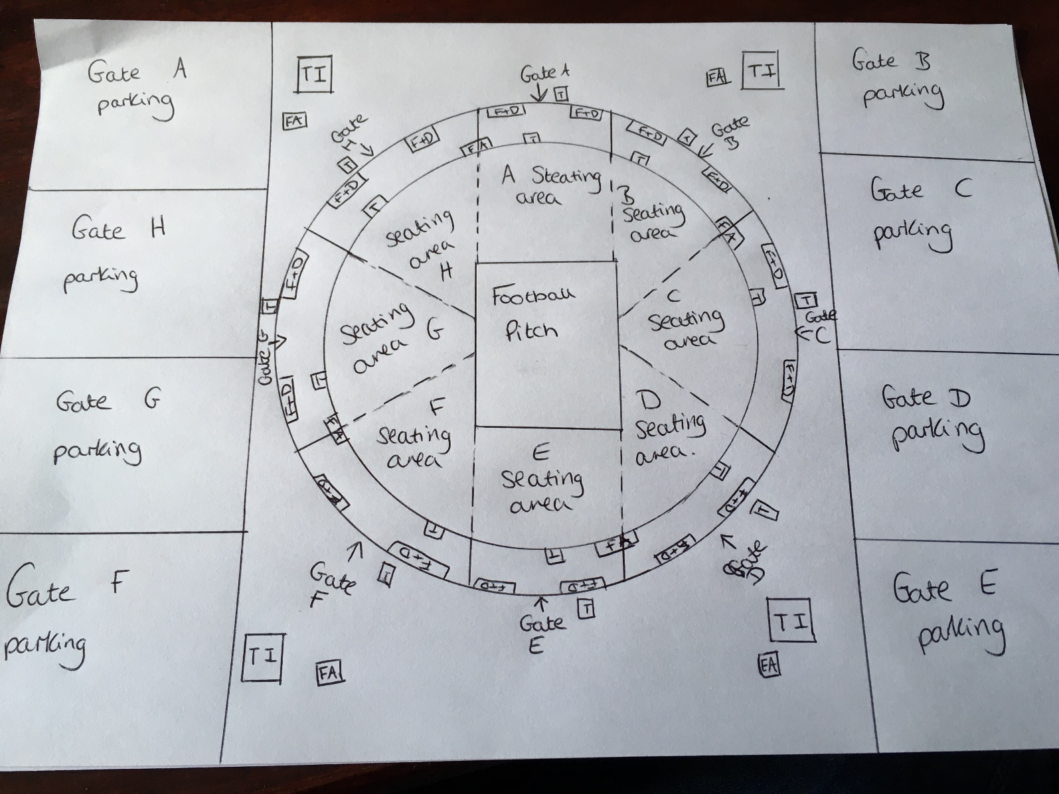

Student Statement:

By submitting this assignment, I confirm that this is my own work.

Student Signature | Kimberley Jones | Date | 03/10/2016

For Tutor / Assessor Use Only
Total Marks
Marks Obtained
Percentage / Grade

