
Assignment Cover Sheet

Student Name: | Raymond Wilson
Student Number: | 2362
Course: | Diploma in Logistics and Supply Chain Management
Assignment No: | 2

Marking Criteria:
We expect the learners to write minimum one well expressed point in three lines against each allocated mark. This means one needs to write 15 lines with 5 well expressed points to get high grades for a 5 marks question.
For high grades use examples and illustrations where appropriate.
Assessment #2 Total Marks: 30

1. Give short answers for the following questions: (14)

i. Outline the activities involved in logistics.
Logistics services the desired flow of products from a specific originating starting point to a point of consumption. In the sphere of influence of logistics the following activities are generally considered as part of the overall logistics process (not in any specific order);
- Customer Services
- Demand Forecasting / Planning
- Inventory Management/Stock Control
- Logistics Communications
- Materials Handling
- Order receiving and Processing
- Packing
- Parts and Services Support
- Plant and warehouse Site Selection
- Procurement
- Return Goods Handling
- Reverse Logistics
- Traffic and Transportation
- Warehousing and Storage
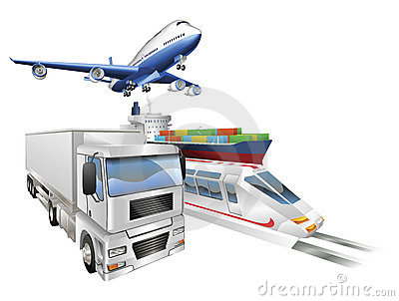Nowadays there is a significant amount of information processing that needs to be undertaken to ensure the movement of materials and goods from source to end user goes seamlessly.

ii. What is meant by the term ‘crossdocking’?

Cross docking is a logistics process upon which products from a supplier or manufacturing plant are distributed directly to a customer or retailer with marginal to no handling or storage time. Cross docking takes place in a distribution docking terminal; usually consisting of trucks and dock doors on two (inbound and outbound) sides with minimal storage space.
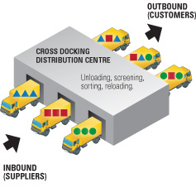

In simplistic terms, as illustrated above, inbound products arrive through transportation such as trucks/trailers, and are allocated to a receiving dock on one side of the ‘cross dock’ terminal. Once the inbound transportation has been docked its products can be moved either directly or indirectly to the outbound destinations; they can be unloaded, sorted and screened to identify their end destinations. After being sorted, products are moved to the other end of the ‘cross dock’ terminal via a forklift, conveyor belt, pallet truck or another means of transportation to their destined outbound dock. When the outbound transportation has been loaded, the products can then be transported to their end users.
iii. Briefly describe the main aims of logistics.

Normally logistics companies provide warehousing, distribution and transportation to assist organizations manage the flow of materials in the supply chain. Freight forwarders, customs brokers and also intermediaries, that handle the details of importing and exporting goods, are types of logistics companies within the industry.

Some of the main aims or objectives of all these entities is to consider and ensure the following;

Costs
Reducing costs is a long-term goal for any logistics company. Reducing the cost to transport and warehouse materials increases the profit the company earns from every client. Objectives such as consolidating shipments can help reduce the energy costs to the logistics company. Maximizing transportation routes can also result in a lower energy/fuel costing for the company. In addition to increasing the profit to the logistics firm, theoretically the cost savings can be passed on to the customer.

Customer Service
The objective of providing clients with outstanding customer service involves the ability to handle a business’s transportation and logistics needs in an efficient manner that increases the logistic firm’s reputation within the industry.
To that end, the logistics firm can increase distribution centers to respond to consumer’s needs in different geographical areas. The logistics supplier must also manage customer feedback, such as complaints of damaged goods or late deliveries, and correct deficiencies within the process that caused the problem in the first place.

Industry Awareness
Reputation must be earned and this is especially so in Logistics where a quality service to is a must to gain an edge in the competitive industry. Firms can of course specialize in the logistics for an area of the market such as, farm feedstock suppliers, to establish itself as an expert in the field. This type of logistics firm can become knowledgeable in the details of transporting and warehousing perishable feedstock types in and around the country.

Continuous Improvement
A system of continuous improvement such as Total Quality Management (TQM) can help a logistics company achieve its aims. The continuous improvement system can constantly seek ways to reduce costs, eliminate inefficiencies and improve customer service. All employees can participate in a continuous improvement system and of course ultimately the company can attain accreditation from a major Auditing establishment that certifies the company operates at the highest level of SCM.

iv. Which activities are included in Stock Control Procedures?

There are numerous activities to consider within the SCM process. Primary focus is on procurement, receiving handling and processing of the incoming goods. Following the procurement and inward transportation it is important the upon receipt of the goods the following activities are considered and undertaken in line with the Store Policy;
- Cleanliness and orderliness in receiving bay maintained.
- Goods unpacked and packing material disposed of using correct techniques and equipment.
- Incoming stock accurately checked and validated against purchase orders and delivery documentation and handled in a safe manner in accordance with HSE guidelines.
- Items received inspected for damage, quality, use-by dates, breakages or discrepancies and recorded.
- Stock levels accurately recorded on store stock systems.
- Stock dispatched to appropriate area/department.
- Stock price and code labels applied when required.
Next area of focus is Stock location, reordering and Rotation of Stock once again in accordance with Company policies;
- The monitoring of Stock, levels, refreshing, order sizes and reordering etc. all need regulating
- Stock rotation procedures for merchandise and wrapping and packing of materials needs to be carried out.
- Stock needs to be readily available to enable customer requirements and satisfaction
- Excess stock placed in storage or disposed of.
- Minimum stock levels identified.
- Stock requisition forms or electronic orders completed accurately.


Finally Dispatch Goods, Distribution Management, Waste disposal and Communication round off the standard types of activities associated with Stock Control.
- Goods to be returned to supplier identified and labelled with date, supplier and reason for return or referred to management if required.
- Credit request documentation completed according to store policy.
- Goods stored securely while awaiting dispatch.
- Delivery documentation completed according to store procedures.
- Special delivery instructions noted, communicated and implemented.
- Items packed safely and securely to avoid damage in transit.

v. What is the importance of communication in a supply chain?

Communication is crucial to a supply chains success and yet, even today, it is surprisingly one of the biggest areas in need of improvement. When it comes to cooperating with staff in other company departments, many procurement professionals will admit it is very difficult. And when it comes to communicating with those outside the organization, i.e. the suppliers, freight forwarders, communications can become even further strained and dysfunctional.
Clearly proper communication between stakeholders and external suppliers, is the key to success whereupon more creative ideas can be brought to the table, thus improving the process. If people from different locations within the process are able give ideas for improvements based on firsthand experience, it stands to reason that this will made for a much better managed process. If communication is limited, so is the ability of the procurement department to influence the end to end procurement process.
To therefore improve the communication process in supply chains, there are some steps that procurement professionals need to consider;
- Rank patrons/suppliers. Assess how supportive your stakeholders are and their importance to the organization and rate them accordingly. Suppliers; consider the impact it would have on your business if they stopped supplying and how strategic they are to your needs.
- Regularly meet with these stakeholders and suppliers. By getting together with them on a regular basis you can highlight and tackle their concerns and worries as they occur. Don’t be afraid to over-communicate, make sure they are regularly updated even if it’s just a quick summary email. With suppliers it’s also important to regularly asses how you can improve your relationship and this should be from both sides, and offer constructive feedback to the supplier as well as asking for it yourself.
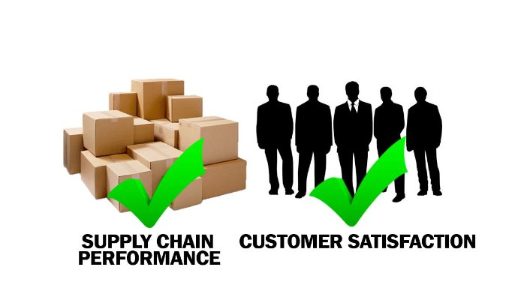
- Always offer options. After negotiations, produce a list of options and relevant cases that back up each. This way, you are giving the stakeholders some influence and aren’t taking the decision out of their hands, making them feel they have status.

vi. How are logistic activities organized in different sizes of organizations?

The scope and influence of logistics was developed in the late 1940s. In the 1950s, and 60s, the military was the only organization which used logistics extensively. The scope of logistics today has been extended well beyond the army, as it has been recognized as one of the most important tools for developing competitiveness. Competitive advantage means the company has the ability to set apart itself, in the customer’s eyes, and also is operating at a lower cost and greater profit margin.
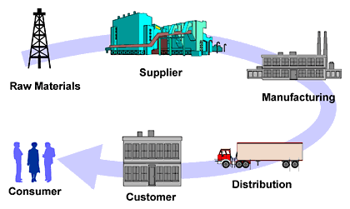
Clearly the scale of supplying an army to that of a small producer in a suburban industrial estate is of significant difference.
The army would have hundreds or even thousands of personnel working within the logistical umbrella were as the smaller organization might have just one person to look after the things. Therefore the procedure of activities would vary enormously as the scale of logistics activities also depends upon scale of organization. The small industrial estate operation may obviously lack bodily and monetary resources for an in house logistics department and mat therefore outsource this function to third parties specialists.
Also, the frequency of delivery is an important part of the “customer” service. A military operation needs huge quantities of particular items on a regular basis, whereas the small operation detailed above would prefer smaller quantities in smaller lots at less frequent intervals.

vii. How do logistics affect the price of products?

Logistical challenges faced nowadays by supply chains have one major topic that is somehow lurking in the background and that is Cost. Market volatility, economic contractions and modest recovery cycles affect the way companies manage distribution, manufacturing, invoicing and materials sourcing. Expansion into new markets, for instance, introduces complex taxation, invoicing and governmental related burdens and these discrete market segments demand different pricing models and services that all have cost implications on the product supplied. With so many critical functions in flux, enterprises need to optimize their supply chains simply to remain competitive
Unfortunately, many businesses are still trying to apply old-fashioned processes and technologies to local and global supply chain operations. Often, these existing systems are not capable of meeting modern demands therefore it is vitally important that as an organization’s logistics expand, so must its ability to quickly see the cost and service implications of every decision as this will ultimately affect product pricing.
That visibility is particularly important in this day and age when most products have become commoditized. Gone are the days when pricing, features, and brand recognition were enough to set a business apart from its competitors. Differentiation in the global marketplace has as much to do with what happens in the supply chain as it does with product innovation. Increasingly, logistics leaders are charged with delivering legacy products while also supporting the development, production, and transport of new offerings ensuring they;
- Reduced costs.
- Increase transparency.
- Lower risks.
- Support legacy and new products.
As companies look to increase growth and expand quickly into promising new markets, they will have to take a hard look at what their current supply chains are capable of, and whether those capabilities are enough to support global competition and failure to do so can be costly to them and the products they produce. Many will find that in order to support existing and future business objectives, they’ll have to reconsider their management processes in favor of more flexible practices so as not to overly price their products and therefore become uncompetitive. Get the sums wrong and this has an adverse effect on the products cost.

2. “Logistics are essential for every organization.” Discuss this. (4)

Business logistics is the forecasting process, as well as the application, of proficient and effective storage of raw materials, inventory, finished goods and services. In simplistic terms it is the flow and transportation of product from the warehouse to the consumer. Service organizations also value business logistics who make certain that materials and information is provided at the time of service delivery making the process essential regardless of company size.
Prosperous business logistics provide a competitive edge against other organizations. It provides a system or process by which customer needs can be fulfilled in a more efficient manner. A business should endeavor to provide shipments of commodities in a more accurate and speedy manner than competitors do. Nowadays the Internet has made it possible for many companies to do this due to accessibility for most.
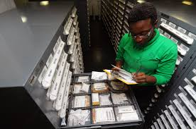 Providing items for consumption in an efficient manner, which logistics helps to do, also helps to build good consumer relations. This is not only vital for instant monetary gain, but also because good customer relations can mean more business in future. One of the best ways to advertise and grow your business is to provide good, quality service that customers will appreciate and tell other customers about.
A business needs to ensure there are enough raw materials available to make complete products. Without quality consumables, a business cannot make quality products. Having enough products stocked is also necessary for supply and demand purposes and to maximize customer satisfaction. Needless to say efficient logistics play a vital role here.
Each time an item for consumption is produced, business logistics can help to ensure the process goes efficiently. It is important that inventory be tracked, transported, stored and manufactured in a way that accommodates all of an organization’s departments. Controlling this flow so that each department knows what to do and what is expected will help to ensure that the company’s plans and goals stay on track against ever increasing competitor pressures.
3. What are some ways in which logistics can improve on issues related to environmental protection? (4)

The interface between logistics and the environment is embedded in the value adding functions a firm performs. As resources are used to create desired products, pollutants are implicitly produced as byproducts during each step of the integrated supply chain process and quite rightly there is global concern about the pollution to our planet from all corners of Industry and society. For example, packaging is used to protect the products from damage from source, during transportation but is then an undesired item once they are consumed.

Proper management and awareness of the environmental implications of logistics activities can significantly reduce the negative impact. Integrative environmental management means that every section in the corporate value chain is involved in minimization of the firm’s total environmental impact from start to finish of the supply chain and also from beginning to end of the product life cycle. Managers must reassess their logistics decisions in such a way that they can respond to impacts coming from other functions such as marketing and manufacturing and from external sources such as the government and the consumer.

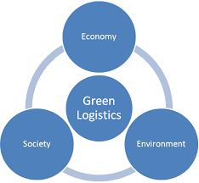

Logistics managers play a critical role in the company’s environmental management program because their decisions, though affected by other functional decisions in the supply chain, have a direct impact on the environment. Logistics decisions intimately interact with other business functions. Inventory management, for example, is an important part of logistics from purchasing all the way to service parts management. Decisions made in other functional areas may have an impact on logistics and, ultimately, the environment. For example;

- The decision to produce environmentally friendly T-shirts made of organic cotton (marketing decision) may limit the sources of raw materials and consequently limit the options available to logistics managers in the logistics network.
- Another example is product design. Environmentally responsible product designs such as highly concentrated detergent and rechargeable batteries (marketing and manufacturing) reduce the resources required to manufacture the product and thus reduce the pollutants generated. Highly concentrated detergent also creates logistics efficiency because it is compact to transport and takes little warehouse space.

Case Study (8)

Chris is the Managing Director of McDonald Timbers, which makes specialized wood products for the construction industry. He has recently been worried by late deliveries to some very important customers. Chris asked the production manager for an explanation. She told him that ‘Our own suppliers were late in delivering certain types of wood. This shortage of a key raw material disrupted our production plans’. Chris then went to the warehouse manager to see what was happening. ‘There can’t be anything wrong here’, he was told. ‘Stocks have been climbing for the past year, and last month they were at an all-time high. The purchasing manager continued by saying, ‘Let me remind you that eight months ago, you instructed me to reduce materials costs. I am doing this by taking advantage of the discounts given by suppliers for larger orders. Often I order more than requested under the assumption that we will need the material at some stage, so I get a discount and the material is already in stock when we need it. Sometimes keeping things in stock would take too much space or be too expensive, so then I might delay an order until I can combine it with others to get bigger discounts.’

Then, he talked to the transportation manager who was not so sure. ‘It is much more efficient for me to bring larger quantities in to the company’, he said. ‘If you reduce the average order size, the transport costs will rise. Our budget is already being squeezed, as we have to pay for expensive express deliveries of materials that production classify as urgent. If you lower the order size, there will be more shortages, more express deliveries and even higher costs.

Chris talked to some major suppliers to see if they could somehow improve the flow of materials into the company. Unhappily, while he was talking to one company, they raised the question of late payments. This was contrary to McDonald Timbers stated policy of immediate payment of invoices, so he asked the accounting section for an explanation. He was given the unwelcome news that ‘The company’s inventory and transport costs are so high that we are short of cash. We are delaying payments to improve our cash flow. As it is, we had to use a bank overdraft to pay suppliers for last month.’ Later that day Chris found that the late customer deliveries which had started his investigation, were actually caused by poor sales forecasts by the marketing department. They had seriously underestimated demand, and planned production was too low.

Questions
- Why do all the logistics costs seem to be rising at the same time when the quantity of the order is reduced?

Clearly the Purchasing Manager wants to reduce his departmental costs by getting discounts from suppliers for larger orders, as directed months ago by Chris (the MD of McDonalds Timber). This strategy however entails deferring some of the bulk orders so as not to take up storage space but in doing so this means the transportation costs will increase as the deferred orders are called up later as urgent call offs when certain types of consumables run low.
The greatest mistake that many manufacturers make today is equating transportation cost reductions with total available supply chain savings. In fact, transportation savings do not even correlate with overall supply chain savings. The largest economies come from inventory reductions that often result from buying more transportation.
 Inventory levels, not transportation costs, drive supply chain savings. For most manufactured products, transportation is only two to five percent of total cost. In contrast, raw materials, components, and subassemblies typically constitute 55 to 75 percent of total cost. This reality helps explain why large cost savings result from complete supply chain solutions that reduce raw material and finished goods inventories.
Mismanagement and mismeasurement are two factors encouraging this dysfunctional behavior within McDonald Timbers as described in the case study narrative (this will be expanded on in the next questions answer). This is not limited to this Company however as today, most transportation departments are cost centers that are not involved with inventory management. For them, success is defined as negotiating greater discounts from carriers.
Another reason why companies focus on reducing transportation costs is that changes are easily measured. In contrast, measuring amounts of inventory and calculating changes in inventory carrying costs are much more difficult tasks. Companies often fail to go after inventory savings simply because they cannot measure the amount of inventory in their supply chain.

- What do you think are the basic problems in McDonald Timbers?

Companies can lower their supply chain costs by using new management strategies to reduce and stock inventory safely. First, they must stop treating transportation as a management "silo" that is separate from inventory management which certainly seems to be the case with McDonald Timbers based on the narrative supplied. Clearly not only the transportation dept. seems to be in a silo, they all do and this could be the undermining problem here
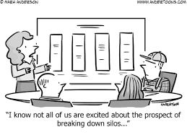
Second, if not already available Chris (MD) should consider installing technologies that provide detailed inventory visibility throughout their supply chain. These are the prerequisites for lowering inventory and achieving supply chain cost reductions.
The largest required management change however is a willingness to pay higher transportation costs in exchange for lower inventory levels and carrying costs. To succeed, managers must focus on the total cost of the supply chain rather than just transportation costs. To avoid false savings, Chris and all his departmental managers must measure and manage all costs together. Transportation decisions that do not account for changes in inventory will often result in overall cost increases while delivering apparent savings.

- What would you recommend Chris to do?

Chris needs a total overhaul of his organization and rethink where the company sits and how to improve reputation and cash flow before things get out of hand. Clearly the strategy to save cost on purchasing materials has had an adverse effect on the company’s reputation so much so that customers are complaining of late deliveries and suppliers are not getting paid on time.

This inadvertently has caused a cash flow problem that could ultimately see the company in crisis and heading towards breaking point. It is imperative that Chris and his company broaden their performance measures to include inventory investment and carrying costs so that total expenses are managed, bills are paid on time and customers remain satisfied.
Obviously there needs to be better communication between departments so that each one can understand how the other is operating and also appreciate their constraints either financially or physically (lack of space, insufficient transport etc.)
Options such as procuring their own transportation fleet should be considered so to better fit the company’s logistics profile so they can react to supply and demand more proficiently. Then, buying fast, reliable transportation will allow managers to operate supply chains with the lowest possible safety stocks.

Student Statement:

By submitting this assignment, I confirm that this is my own work.

Student Signature | Raymond Wilson | Date | 19th Aug 2016

For Tutor / Assessor Use Only
Total Marks
Marks Obtained
Percentage / Grade

