

Student Name: | Tatjana
Student Number: | 2449
Course: | Fashion Design Course (Short Course)
Assignment NO: | 1.

Marking Criteria:
We expect the learners to write minimum one well expressed point in three lines against each allocated mark. This means one needs to write 15 lines with 5 well expressed points to get high grades for a 5 marks question.
For high grades use examples and illustrations where appropriate.
- Principles of design
  - Balance.
Balance concept is based on symmetry. Object that is placed on one side has to be put on the other side as well. This helps to create stable look. Human body is symmetrical as well, therefore clothes shapes should be created symmetrically. This principal includes not just shape, but colour and texture as well. Balance can be symmetrical, asymmetrical and radial.
- Symmetrical(formal) balance is when same weight is placed on equal sides of a centrally placed fulcrum. Centre does not necessarily have to be a line in the middle of the garment, this can an imaginary line as well.
- Asymmetrical(Informal) balance is more complicated. Different weight objects are placed around central fulcrum to create balance. These objects equalize each other in disorganized manner.
- In radial balance objects are placed around central point and may be similar.
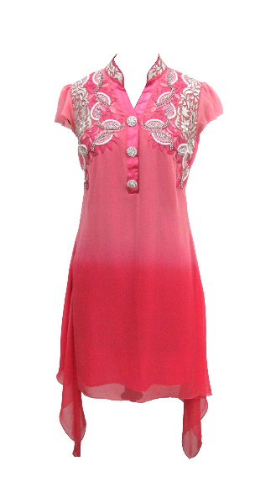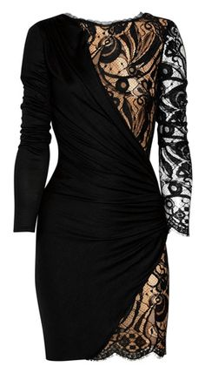
Fig.1.1. Symmetrical balance Fig.1.2. Asymmetrical balance.

  - Emphasis
Emphasis is used to create a point of focus to draw viewer’s attention. Generally, this is achieved by making one area to stand out by contrasting it from the others. However, there are few things to be aware of when considering using emphasis principle. To begin with, there should always be just one emphasis object, not more, as it will create viewer’s confusion. Moreover, designer should be careful when creating an area of interest, not to attract attention to wearers awkward parts. Emphasis can be created in different ways:
- It can be created by repetition, when shape, texture or colour are repeated many times.
- By Contrast: this helps to achieve emphasis by making it opposite or different to the rest of the design.
- Also this can be achieved by using different size or scale to help attract attention.
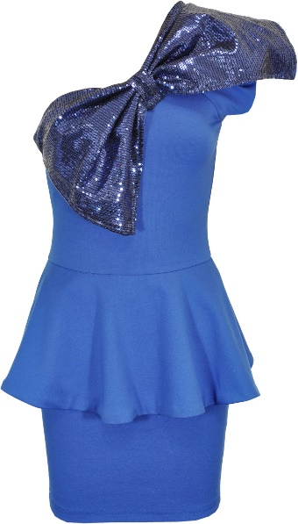
Fig.1.3. Emphasis

  - Harmony (Unity)
All successful designs must achieve harmony(unity)and it is very important in design. Harmony is created when all principles and elements of design are working together well. Every single detail should be connected to the hole design to create an attractive look. When designing clothes, harmony can only be achieved when not only garment is considered but the shape of the figure it will be covering as well.
  - Proportion
When we look at the garment our eyes automatically separate bigger parts from the smaller ones. This is why proportion must be considered in design. Proportion is a pleasing interrelationship of all sizes of the garments. Standards of the proportion change in time with fashion cycles. Choosing right proportion can create an illusion that person is taller or slimmer.
In fashion body types are divided into 3 types: small, medium and large. All these categories should be considered when creating proportion as different rules apply for each one of them.
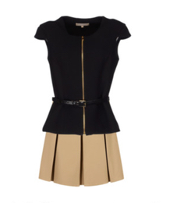
Fig.1.4. Proportion 1:2.

  - Rhythm
Rhythm is an organized movement in space. It is a connected path which creates a pleasing view and allows for the eye to move across the garment. The effect of rhythm can be achieved in number of ways.
- Linier rhythm. This principle is based by continuous lines. Linier rhythm can be achieved by regular placement of same element in linear path. Colour, shapes, pattern or any other elements can be used to create this.
- Repetition. This principle is achieved when one object or shape is constantly repeated. This is different from pattern. Pattern is a combination of different elements in regular arrangement, whereas repetition is more simple and is limited to one constantly repeated object.
- Progression. This is an increase or decrease of similar design elements. Progression can be expressed in many ways: changing shapes from small to large, changing colour from light to dark. But most importantly to achieve progression in rhythm, all this must be done gradually.
- Radiation. In this case rhythm is created by waves or rays, which create a feeling of movement in different directions.

- Formal dress design
Formal or symmetrical balance is created when equal weight is placed on each side of an imaginary central vertical line. For this to be achieved each half of the object has to be the same.
The easiest way to achieve formal balance when creating a dress is to draw a vertical line in the middle of the garment and try to create the mirror image on the both sides. Fig.1.5 and Fig.1.6. shows a perfect example of formal balance in the dress. If dress is folded in half in the middle and both sides match, then we can say formal balance has been achieved.
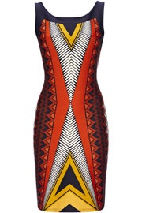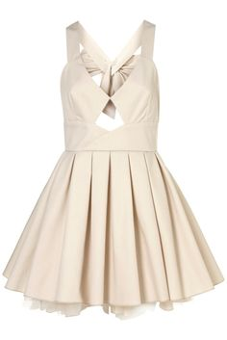
Fig.1.5 Formal balance Fig.1.6 Formal balance

- Relationship between elements of design and principles of design.
The principles of design help to organize elements of design in that way that they create a visually attractive look. This is usually called a composition. In any work of art, not just fashion design, an artist has to arrange the elements in a certain way to create something worth looking at. Any artist who base their work on principles of design are more likely to create something more organised and pleasing to an eye. As an example of relationship between elements and principles of design, we can say that balance (principle) can be created by placing two circles (element – shape) opposite each other in same distance from center line.

- Terms

  - Classic. Fashion constantly changes. But there are things that stay in cycle for a very long period of time and they are called classics. These items can be t-shirts, denims, skirts or even shirts. In time these will change, but only slightly.

  - Fads. Fad is something that catches people attention and become popular very quickly. Usually it is accepted by a certain group of people. And then they tend to disappear as quickly as they have come.

  - Interrupted cycles. When retailers and manufacturers see that some certain goods are about to lose its popularity, they can make a decision to remove this stock from market and it will no longer will be available to the public. Therefore, this stock would not have gone through full fashion cycle and is called interrupted cycle. Also interrupted cycles can be caused by economic factors.

  - Recurring cycles. When certain fashion has faded there is always a chance it is going to reoccur. Designers often look back at old designs, making them better or just different. Its shape can be the same, just different pattern or fabric introduced.

  - Traditional fashion adaption. This fashion adaption is based on high street fashion. New fashions are firstly introduced to upper level classes. When new line is accepted by upper classes, manufacturers tend to create same but more affordable fashions for lower class. When lower classes start to wear that fashion, upper classes tend to change theirs to new one.

  - Reverse adaption. Reverse adaption is complete opposite to traditional. Manufacturers and designer lookout for youth or street fashions and get inspired by this. Then designer brings new fashion and presents it to upper class societies.

Student Statement:

By submitting this assignment, I confirm that this is my own work.

Student Signature | Tatjana | Date | 30/10/2016

For Tutor / Assessor Use Only
Total Marks
Marks Obtained
Percentage / Grade

