
Assignment Cover Sheet

Student Name: | Pastor Aderemi Afuye
Student Number: | 1924
Course: | Diploma in Forensic Accounting
Assignment NO: | 7

Marking Criteria:
We expect the learners to write minimum one well expressed point in three lines against each allocated mark. This means one needs to write 15 lines with 5 well expressed points to get high grades for a 5 marks question.
For high grades use examples and illustrations where appropriate.
1: I Non - financial sources for evidence:
Notes: Non - financial sources include
- Interviews
- Document examination
- Handwriting analysis, and
- Physiological aspects of the fraudster –

There are many nonfinancial sources of potential evidence in a fraud investigation. One of those key areas is people; interviews, casual conversations, and physical cues of deception or guilt.
If a fraud perpetrated, the fraudster is certainly being as clandestine as possible including using deception in appearance and communications. Verbal and now – verbal techniques (SCAN, Deception Cues, Statement Analysis and other techniques used to determine the presence of deceptive behaviour)
Note that the physiological arena of nonfinancial information is limited in its ability to provide evidence that courts will allow.
Some of the methods are not even reliable enough for serious use in a fraud investigation, and should use with great caution (e.g., body language and lies cues). The only one that is ‘‘forensic’’ enough for evidence is an interview.

II. Importance of body language in the interviewing procedure:
Kinesics is the interpretation of body languages, such as facial expressions and gestures or more formally, nonverbal behaviours related to movement, either of any part of the body or the body as a whole
Given time to prepare, a guilty subject will sometimes enter an interview with the intention of withholding the truth (not necessary lying, but it still obstructs the opportunity to obtain an admission) and during the interview, the mindset of the interviewee in this state undergoes several stages before voluntarily providing an admission. Those stages include –
- Defiance
- Neutrality
- Acceptance
- Cooperation and
- Admission
During the defiance stage, the interviewee is inclined to deceive the interviewer and withhold information. Common tool to accomplish this is use of lies (simple denial, the lie of omission, the fabrication, minimisation and the exaggeration)
Body language of the guilty:
As these lines are employed, the interviewee will often provide indications of his/her intention to deceive and both his/her words and body language betray him.
- Such as, using language to mask the truth, such as “to tell the truth” or “honestly speaking.”
- A selective memory
- The inability to recall even no incriminating factor or circumstances
- Inconsistent, evasive responses
- Avoiding eye contact or appearing to be visually looking for an answer
- Body languages and mannerisms that are inconsistent with one who is telling the truth
The last two are not – verbal, and these are kinemes.
Attempting to withhold the truth, the interviewee appears overly anxious, unconcerned, defensive, even angry or arrogant. Communicating both verbally and on – verbally, the interviewee is sharing information with the interviewer. The correlation between these forms of communication include:
Overly anxious:
- Tapping feet
- Clicking teeth
- Bobbing knee
- Constantly looking at clock
Unconcerned:
- The lint – picker
- Whistling
- Rolling eyes
- Grooming self
- Inspecting nails
Evasive:
- Memory loss
- Vague
- Aloof
Angry or arrogant:
- In your face
- Argumentative
Complaining:
- Room too hot
- To cold
- Thirsty
- Body pain
Further messaging, the interviewee squirms, cross his legs or arms tightly, covers his mouth, or rug at his/her ears. While these images are of actors and the poses are somewhat exaggerated, it is easy to understand the emotions of the subject.
The skilled interviewer can detect not only the intent to deceive but also the mindset of the interviewee and the stage that he is.
In addition to the more obvious expressions using his body, the subject will sometimes offer lesser visual cues without even recognising them. Professional gamblers call these cues “tells” like the following:
- Looking away when asked an incriminating question
- Looking away when lying or withholding the truth
- Harshly starting at an object or nothingness
- Temping or assuming another dominant body language
- Putting fingers to his forehead as if in deep thought before uttering an untruth
Just as a good interviewer observes his subject, the exceptional interviewer knows the interviewee is observing him. And, as such, he is conscious of his every movement and mannerism. An interviewer who appears nervous is nervous, or an interviewer who is clueless will appear both clueless and pathetic. The best interviewer appears confident, relaxed, and professional, at ease with themselves and the interviewee. Arm with kinesics, good interviewer are not intimidated but come to the interview prepared and able to demonstrate it. For example, use something called mirroring – sometimes emulate the body language or mannerism of the interviewee. If the suspect is templing, also a temple and if he notices it, sometimes change to something more complaint to make the suspect unconsciously mirror too.
It is a method that if use professionally can alter not only his posture but his mindset as well.

III. SCAN Analysis as an investigative technique:
Scientific Content Analysis (SCAN) is a technique for analysing the words people use. It is similar to the investigative discourse analysis – Statement Analysis. Like statement analysis, SCAN does not try to look for the truthfulness of the facts but rather the reflection of deception in the way statements made.
SCAN is cross-cultural, which increases its applicability, it is used to detect concealed information, and whether the information that person has provided is true or false.
Deceitful people tend to lie indirectly, and not tell blatant lies. The indirect lies involve hedging, omitting critical facts, feigning forgetfulness, pretending ignorance, and distancing oneself from the adverse event in the choice of words. Deceitful people are reluctant to commit themselves to deceptions and instead use ‘‘verbal trick ration’’ to avoid making damaging statements.
SCAN, like statement analysis, looks for a shift in the use of pronouns. It also looks for gaps in the narrative, which portray deception. The ‘‘I don’t remember’’ phrase often is an attempt to conceal something. A change in tense also indicates a strong emotional response to the context. There are some other clues that experts in SCAN use. SCAN is as reliable as a polygraph examination. But both SCAN and polygraph are investigative tools and not legal evidence.
- Ideally, the technique guides the fact finder to ask to follow – up questions to uncover discrepancies and inconsistencies. These irregularities used as the basis for more targeted questions.
- For SCAN to be effective, the analyst needs a clean truthful statement from the suspect.

IV. Visual assessing cues and how eyes of the victim help the interviewer
Movement of the eyes can indicate the truthfulness of a suspect’s response. A subject who is sight dominated when asked a question usually
- Looks up and to the left
- Straight ahead or
- Uses both of these movements.
They allow the interviewee to more easily access visually stored memories. These eye characteristics, coupled with the language the subject uses, provide an indication that her dominant sense is a sight.
At times the interviewee must visually construct an image of a situation that has not occurred. It happens, for example, when a guilty suspect is asked, “What would top management think about you if it discovered that one of your subordinates was embezzling funds?” When asked a question such as this, a sight – dominated person would most likely look up and to the right.
- How to use this information as an interviewer:
If an interviewee believes is sight – dominated is asked a question that should elicit the recounting of a factual situation and looks up and to the right, he is likely speaking of things that did not occur and thus is speaking changing history. Before asking the question like this, the forensic accountant should ask a question to which she knows the answer and expects the suspect to respond truthfully. By doing this, she will have a higher level of assurance that the suspect is sight – dominated person. In interviewing, the key information often contained in changes in the suspect behaviours, not any particular habit.
A person who is primarily auditory will exhibit memory recall by either:
- Looking down and to the left or
- Horizontally and to the left
It sounds the suspect recalls hearing from external sources are associated with the eyes looking down and to the left. If the interviewee recalls internal sounds (sound he made), he is more likely to look horizontally and to the left. Similarly to the visual construction of the sight – dominated person, the interviewer would expect a different pattern if the interviewee asked how a particular scenario would sound. In this case, the auditory – dominated person would most likely look horizontally and turn right. Being alert to changes will reveal clues as to the truthfulness of interviewee response
For a touch – (or feelings) dominated person, the eye patterns are slightly difference. This type of person will either:
- Look downward and to the right
- Look downward
- Blink rapidly, or
- Close the eyes or
- Combination of these eye movements
Recall that one of the interviewer objectives is to move the unwilling interviewee to the willing position. For a feeling person, it can accomplish by establishing an emotional rapport with him. Because that person reacts more often by what he feels instead of what he thinks, creating an ambience that leads him to feel that he is doing what is best for him often encourage him to cooperate with the interviewer. Likewise, a person who usually experiences the world through feelings exhibits certain characteristics when he is receptive to questions posed by the interviewer. For example, deep breathing accompanied by a relaxation of the major muscle groups like those of the arms, legs, abdomen and chest is often a sign he is more willing cooperate. However, if he exhibits any tenseness, he may indicate that he is not in a willing position.
A change in behaviours, whether toward a more relaxed position or away from it, indicates to the interviewer the relative willingness, and thus receptiveness, of the interviewee to the interviewer’s attempt to gather evidence.
- The eye movement cues and interpretations, however, are true only for right-handed persons (so the interviewee must sign something before starting any use of VAC because the cues are opposite for left-handed people)

V. Other cues which help to identify lies:
DECEPTION CUES
In addition to body language cues, there are other cues that are used to identify lies. Other areas of cues and an example of each follow:
- Interpersonal interactions. Shakes head ‘‘yes’’ after the point is made, inconsistent gestures.
- Emotional states. Deceitful people tend to avoid touching the person questioning them.
- Verbal content. Reflects question back as the answer immediately after the question; ‘did you write a check to yourself?’’ ‘‘No, I didn’t write a check to myself.’’ How comments made. Disassociating people, events, and so on by replacing the pronoun—the equipment’’ versus ‘‘my equipment.’’
- Psychological frames. Deceitful statements almost always omit what went wrong in describing events, except concerning delays or cancellations.
As interesting as these signs are, again, there is enough inconsistency to create problems. It would be helpful if a fraud investigator at least were aware of these signs. For example, for SCAN to be effective, the analyst needs a clean truthful statement from the suspect.
SCAN, like statement analysis, looks for a shift in the use of pronouns. It also looks for gaps in the narrative, which portray deception. The ''I don't remember'' phrase often is an attempt to conceal something. A change in tense also indicates a strong emotional response to the context. There are some other clues that experts in SCAN use. According to one expert, SCAN is as reliable as a polygraph examination. But both SCAN and polygraph are investigative tools and not legal evidence.
Statement analysis also called investigative discourse analysis and scientific content analysis is a technique for analysing the words people use. It is a technique that is used to detect concealed information, missing information, and whether the information that person has provided is true or false.
Related to statement analysis is a different technique word people use called statement validity assessment, which uses something called criteria – based content analysis CBCA. CBCA accepted as evidence in court in Germany (according to Wikipedia)
Statement analysis involves the fact finder searching for linguistic cues and gaps in a subject’s testimony or preliminary statements.

2. Asking questions in an audit is different from asking questions in fraud investigation.
Auditors ask questions in the course of most audits, whether they are internal or external. But there is a big difference in asking questions in an audit and asking questions in a fraud investigation.
The goals are different:
- One has the goal of determining the material correctness of the financial statements (Audit)
- The other has the goal of uncovering fraudulent activity (fraud investigation)
The goal of a normal audit (how most people think of it) is to an independent accounting firm to express an opinion as to whether a company's financial statements fairly presented. Essentially, the company prepares the financial statements and asks the audit firm the question, "is this correct?"
Auditors use a variety of techniques come to their conclusions, including examining source documents, general ledger accounts, performing analytics and reasonableness tests, documenting paper flow, external account verifications (i.e. loans, banks, accounts payable, etc.), sampling, testing, just to name a few. And toward the end of the audit, the audit firm will submit a list of "adjusting journal entries," for senior financial management's (Chief Financial Officer/Controller) review, discussion, and possible booking. This list represents the account balances and transactions that the auditors are essentially saying "we do not agree with these particular accounts and transactions." The reasons for these discrepancies could include oversight, inadequate paper control, incompetence, improper review procedures, among others.
A fraud audit is a separate engagement from a financial statement audit. In a fraud audit, there typically is an allegation of fraud, or a fraud has already discovered; the accountant is called in to gather evidence or to act as an expert witness in connection with legal proceedings relating to the fraud. The auditor is not asked to give an opinion on the financial statements as a whole. For example in a cash register theft. To the accounting department, everything looks fine and no cash shortages to alert them to potential improprieties exist (i.e. everything balances out). It is not until many months later that the store discovers they have a "shrinkage" (theft) problem when the units of the "book" inventory do not agree with the "physical" inventory of televisions. By that time, many months have passed, and there are too many variables for any fingers to be pointing in my direction. The item could have been stolen by a customer, any number of the ten employees that have worked on the floor, collusion, etc.
A fraud auditor would ask to look at the sales register tapes, which provide an audit trail of each and every transaction that went on during those months. What is the name of the cashier? Does he keep avoiding sales? Why is that? Suspicion turns to the anomalous activity. Are questions asked? Plausible explanations expected.
To ask questions effectively in a fraud investigation, one must employ best practices for interviewing techniques. Questions used in interviews could be Introductory, informational, closing, assessment, or admission-seeking.

3. Interviewing procedure for a financially sophisticated victim
“A good investigator can connect the dots. A great investigator can find the dots to connect.” – Charles E Piper, CFE
To ask questions effectively in a fraud investigation, one must employ best practices for interviewing techniques. Questions used in interviews could be

- Introductory
- Informational,
- Closing
- Assessment, or
- Admission-seeking.

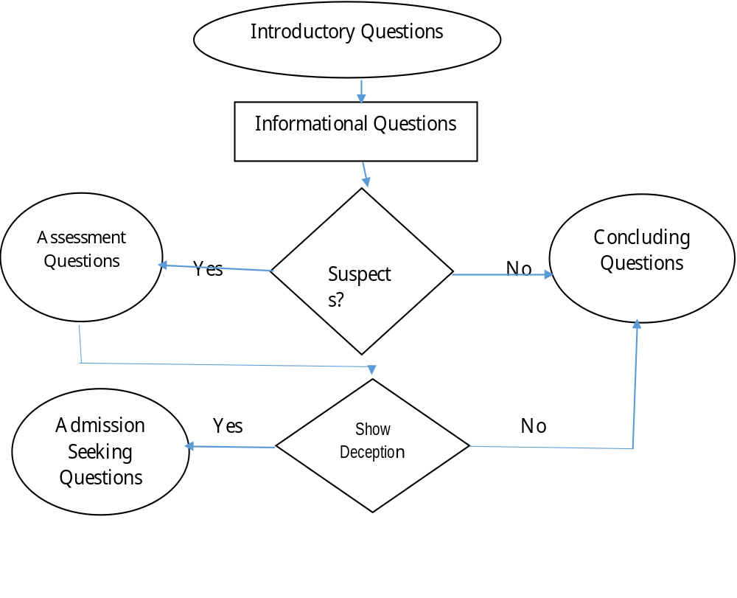
Open-ended questions are far superior to questions that can be answered with a simple ‘‘yes’’ or ‘‘no.’’
The list begins with an appropriate level of preparation and ends with getting a signed statement, especially when the interview is the suspect who confesses during the interview.
The second step is ‘‘think as you go.’’ Although it seems intuitive that the interviewer should write down questions for the interviewee, actually, the best thing to do is not write them down. Instead, the interviewer should have a list of key points and allow the conversation to take its natural course. Besides, you do not want the astute fraudster to get a peek at the questions and prepare an answer.
Next, the interviewer should watch for nonverbal behaviour. Usually, humans have a different body language when under stress. The trained fraud investigator knows how to watch for signs of stress in a process called calibration. This process is used to assess a witness’s truthfulness
The interviewer sets the tone. That includes dressing properly, using good social skills, introducing himself or herself appropriately, and especially developing a rapport with the interviewee.
The interviewer should pace the questions to keep the interviewee comfortable with the interviewee and the process—not too fast, not too slow, and not too long! The hard questions should follow a few easy questions and ease up to the harder ones. The interviewer should listen more than talk, allowing the interviewee to become stressed, if he or she is deceptive, and eventually provide the interviewer cues of his or her deception. Besides, the more the investigator talks, the more the interviewee learns, which could be a strategic mistake for an interviewer.
Next, the interviewer should be straightforward. Approach the process in an open way, and be as honest as possible without compromising the process. Trying to be too secretive or aggressive can cause the interviewer to become defensive, and that would likely lessen the effectiveness of the interview process.
Top Ten Steps in interviewing procedure for a financially sophisticated victim
“QUESTION: What do you call someone who is willing to pay £800 for a toilet seat? ANSWER: General” – 1980’s political joke.
Steps in a well-prepared interview:
- Prepare.
- Think as you go.
- Watch nonverbal behaviour.
- Set the tone.
- Pace your questions.
- Do more listening than talking.
- Be straightforward.
- Take your time.
- Double-check the facts.
- Get it in writing.
The interviewer needs to take his time. Honest people usually do not mind follow-up questions when the interviewer’s instincts say he did not get all of the facts. Guilty people, however, typically get impatient. Another obvious step is to double-check supposed facts gathered, and start that process during the interview. Nothing damages an investigation more than having testimony contradicted by the very person who gave it. Tape recording is an option, but the downside to that tactic is the probability of losing rapport with the interviewee. Guilty persons tend to clam up or be evasive when a tape recorder is on.
(“2 Good 2 Be 4 Gotten“- Graduation yearbook signature)The primary purpose of the interview process in a fraud investigation is to interview in the investigation process, and to obtain a signed confession in that interview: known as an admission-seeking interview. There is little evidence more reliable in court than a written confession signed by the perpetrator’s signature.
Statement
Statement analysis (The investigative discourse analysis) and scientific content analysis (SCAN) is a technique for analysing the words people use. It is a technique that is used to detect concealed information, missing information, and whether the information that person has provided is true or false.
Related to statement analysis is a different technique word people use called statement validity assessment, which uses something called criteria – based content analysis CBCA. CBCA accepted as evidence in court in Germany (according to Wikipedia)
Statement analysis involves the fact finder searching for linguistic cues and gaps in a subject’s testimony or preliminary statements.
Don Rabon’s deception indicators (dry mouth, excessive sweating) are obviously useful and are more calibration cues.
Legal Issues
Fraud investigators do not necessarily require legal authority to interview or inquire into fraudulent matters. (However, the investigator should consult legal counsel and agency policies and procedures before considering or implementing any investigative activity. Always follow all applicable international, state, and other laws and rules before considering or conducting any investigative activities)
Use deception to legally gain information from a suspect, as long as the interviewer does not use deception that will likely cause an innocent party to confess. Promises of leniency, confidentiality, monetary rewards, or other advantages should be approved by an attorney first.
The interviewer should also avoid any statement that could be taken as extortion (for example, ‘‘either tell us the truth or we will turn you over to the HMRC to investigate you for tax evasion.’’)

Student Statement:

By submitting this assignment, I confirm that this is my own work.

Student Signature | Aderemi Afuye | Date | 28/09/2016

For Tutor / Assessor Use Only
Total Marks
Marks Obtained
Percentage / Grade

