
Assignment Cover Sheet

Student Name: | Khamayel Al-Salehi
Student Number: | 5871
Course: | Certificate in Strategic Change Management Level 3
Assignment NO: | 3

Marking Criteria:
We expect the learners to write minimum one well expressed point in three lines against each allocated mark. This means one needs to write 15 lines with 5 well expressed points to get high grades for a 5 marks question.
For high grades use examples and illustrations where appropriate.
  - Change occurs all the time around us; in organisations we are always looking for better ways to do things, to improve our image or increase profits, etc. We are always in the run, competing with other organisations; hence, facing the need to change all the time. However, not all of our change projects succeed; in fact most of them fail - around 70% of transformation efforts fail based on a study by John P. Kotter, a Harvard professor. Why? If there was a technical approach to overcome resistance to change or to increase adoption rate, we will all follow it and no change project shall fail. But that is not the case; in fact people acceptance or resistance to it will depend on the change itself, for example: If change will bring personal perceived benefits to an employee, such as raise in salary, promotion, etc. then it will be accepted and welcomed. If change benefits can be perceived by the organisation and its employees then again it will be welcomed, however, the problem mostly arise when the benefits of the change cannot be seen, or the needs to change are vague. Based on Everett M. Rogers “Diffusion of Innovations” people in every change project belong to 5 different segmentations depending on how they perceive the change. He also added that the same person can belong to different segmentations in different change projects at the same time, which implies that change adoption is not technical, but depends on the attitude of the audience regarding that change.
William Bridges pointed that it is not the change but the transition that people goes through emotionally that affects adoption to change. Hence, adoption to change is controlled by our emotions and attitude towards the change itself. So how can we manage such attitude?
It always starts at the top; leaders need to identify the benefits change will bring, is it needed and why, once that is clear and decided, then they need to create a road map or detailed project plan of how we will reach from here to there, a special budget for change needs to be identified as people might require special training or professional assistant, etc. Once the picture is clear for them, then they need to communicate it clearly to their employees taking into consideration their current work load and expected changes to such. Also leadership attitude towards the change needs to be improved - According to a study by PriceWaterhouseCoopers, research shows that nearly 75% of all organizational change programs fail because leaders don’t create the necessary groundswell of support among employees. Rogers, explains that the perceived attributes of change will determine 49% to 87% of change speed acceptance. For example, based on various research people fear or resist change if they suspect job loss or if they cannot see the benefits of change, hence leadership, middle managers and supervisors need to know and understand fully the goals and benefits of the change, and they need to highlight and communicate clearly the change relative advantages. Another reason might be the fact that employees find themselves lack the needed competencies that change will require or they might believe change to be a complex matter, again leadership and management should listen to their employees concerns and identify the root cause for their resistance or attitude towards change and provide solutions to the actual cause, for example, they can provide necessary trainings, provide external / professional aid and support; they need to identify people that will be affected by such change and focus on them early on in the project; they can break a big project into smaller more manageable projects; they can make the change goals more realistic, etc. If a change can be experimented on first, then leadership should not hesitate to do so and encourage affected people to participate in such experiment, and provide feedback. The results of such experiment should be taken seriously to modify change or its implementation to something that is more suitable to the organisation, its structure and function. Leadership, project managers and supervisors should also work on maintaining the change via applying quick wins and reward people at different stages of the change. They need to communicate success stories, achievements, provide comparisons of increase in profits and / or productivity; decrease in cost and / or cycle time before and after change was implemented. All of this will help to accept change and maintain it. Finally, Leadership, project managers and change managers, need to identify and capture all of the lessons learned from this change to improve future possible changes introduction, plan, management and implementation. They also need to realise that there is a segment of the population based on Rogers, that will resist change altogether –Diehards, but these need to be identified and not to be involved at the early stages of the change as if the change is not perceived as beneficiary to them they will resist it no matter what.
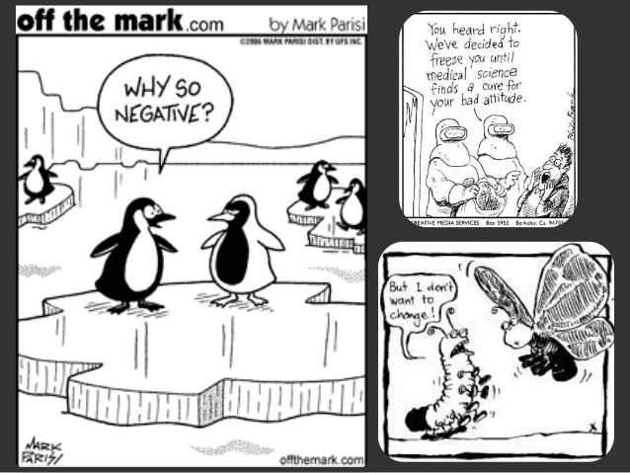
  - Resilience can be translated into the ability to cope or deal with change, or the abilities we need to adopt change fast. Resilience is the ability that today’s organisations are looking for in their employees as change is becoming the norm today. But why resilient people? Daryl R Conner states that resilient people will face the same issues and problems as the rest of the organisation, however, they will:
- Regain their balance faster
- Achieve more of their objectives
- Maintain a higher level of quality and productivity in their work
- Preserve their physical and emotional health
The question is why? Previously we have stated that peoples attitude towards change will determine its success or failure. We have also listed ways that organisations can follow to improve adoption of change, and how it always starts at the leadership level. However, what about personal characteristics of people affected by change, are there some characteristics whether mental, physical and / or emotional that an employee possesses or can learn to possess to adopt to change successfully and quickly? In other words, what are the characteristics of change resilient people? In his book Resilience: A Change for the Better, Daryl R Conner identified five personal characteristics or as he calls it “change muscles”, that aid people in accepting and adopting to change effectively and fast, these are:
- Positive: Having a positive attitude towards change is very crucial as it provides people with the push they need when facing difficulties brought by change, Daryl describes them as people that view life as complex but filled with opportunity. Change still brings hardships and challenges to them as with everyone else’s, but they give themselves the power to be above it, they believe they can pass through it and hence they use their energy to solve the arising problems rather than opposing the change. For example, if we describe change as a tunnel that we need to pass through to reach to our goal, positive people will see goals of the change as the light at the end of the tunnel, and that’s provides them with the energy they need to move through it. These people try to use their abilities to move through the dark tunnel, they try to identify new opportunities and ways of solving problems to pass the tunnel rather than retreating to start point or engaging in defensive activities that will lead them nowhere. In an organisation It is important to listen to our employees and help them shape their thoughts in a way to become positive, which means we admit to ourselves that we are about to face a challenge, but we repeat to ourselves that we can pass through it, it is possible to do so. We also encourage them to explore new ways to face the challenges ahead and / or identify what we need to do and how.
- Focused: Daryl found that resilient people have a clear vision of what they want to achieve. They can priorities their workload so that most important tasks to achieve change are completed first and less important ones can be delegated or deferred until a better time. Going back to our example of the dark tunnel, focused people will keep their eyes on the track that will lead to the light at the end of the tunnel. They will not waste their time or energy on unnecessary tasks or talks. In an organisation, we can aid our employees’ priorities their work, or take some of the load off through delegation. Furthermore, we need to get people together, share information and focus on short term goals – as we deal with people in confusion room. This will aid them become more focused.
- Flexible: Resilient people possess “pliability” when responding to change, based on Daryl. Resilient people try to find new ways to solve problems; they try and think out of the box. They are not afraid to ask for help to get the needed support, they do not resist learning new methodologies or skills. They are the people that will learn how to push the wagon in the tunnel to reach to the end of it. In an organisation, we can aid people become flexible through training, brainstorming sessions where we encourage team members to listen, accept and experiment other team members ideas to overcome a challenge and finally celebrate achieved project milestones.
- Organised: Daryl defines them as the ones that will develop structured approached to managing change. They create a plan to overcome challenges, they can priorities their tasks and manage their time. They are the people that will identify and follow the steps needed to push the wagon smoothly through the tunnel, who should do what and when. In an organisation we can aid people become organised by creating project plan, train our people on: project management skills, estimation skills, managing time, estimating and controlling cost and number of employees required per task.
- Proactive: Daryl explains that resilient people engage in change rather than defending against it. They try to solve problems as they arise, they are willing to take actions rather than wait until it’s too late. They are the people that will lead others through the tunnel; they will calculate the risks involved and will willingly take calculated risks to reach to the goals and find ways to light the tunnel and pass it. It is important to say that even though they are proactive and are willing to take risks; they do not perform uncalculated tasks as they learn from past lessons, run what if scenarios, anticipate possible challenges and even change. In an organisation we can aid people become proactive through training and rewarding proactive people that lead successful change.

Finally, having a balance among these different characteristics is what an organisation should be looking for. For example; if a team is positive but not flexible, then we end up with a team who feels strongly about their own opinion and ignores others, which leads to failing change project. So training people on these characteristics and putting people in teams that possess the right mix of characteristics is key to succeeding in change projects.
Student Statement:

By submitting this assignment, I confirm that this is my own work.

Student Signature | Khamayel Al-Salehi | Date | 27th February 2017

For Tutor / Assessor Use Only
Total Marks
Marks Obtained
Percentage / Grade

Source: how not to implement change, http://catherinescareercorner.com
Source: Everett M. Rogers “Diffusion of Innovations”, Fourth Edition.
Adapted from 12 reasons why employees resist change and how to guide against resistance, www.catherinescareercorner.com
Source: http://www.connerpartners.com/frameworks-and-processes/how-resilient-are-you
Source: http://www.connerpartners.com/frameworks-and-processes/five-aspects-of-resilience
Adapted: Daryl Conner, “resilience in teams and organizations”, 2010, http://www.connerpartners.com/frameworks-and-processes/resilience-in-teams-and-organizations

