
Assignment Cover Sheet

Student Name: | Sara Spiers
Student Number: | 1486
Course: | Diploma in Wedding Planning (Level 4)
Assignment NO: | 10

Marking Criteria:
We expect the learners to write minimum one well expressed point in three lines against each allocated mark. This means one needs to write 15 lines with 5 well expressed points to get high grades for a 5 marks question.
For high grades use examples and illustrations where appropriate.
Please insert your completed assignment ( in word format) here:
Q1
- What is the tradition of the bridal bouquet?

It was traditional that both the bride and groom wore a circular herb and spice garland to promote life and fertility and to keep away evil spirits, and the bride took a small amount of each garland to create a posy which she held going down the aisle. It’s thought that this tradition began in ancient Greece and herbs and spices such as garlic were used as the strong smells were the ‘most effective’ in warding off evil spirits (Perfect Wedding Day, n.d.) It wasn’t until the marriage of Queen Victoria and Prince Albert in the Victorian era when the herbs and spices were replaced by fresh flowers. Flowers are now universally known for conveying messages of love and compassion.

- Outline the most important factors that should be considered when selecting flowers for the wedding.

There are five main factors that should be considered when selecting flowers. Firstly, the season that the wedding will take place in will determine the availability of local fresh flowers. Some floral designers can source flowers from other countries with different climates but this may be more expensive. Similarly, flowers with a short season may also be highly expensive. It all depends on the couple’s budget and how much they are willing to spend.

Colour is also an important factor and most brides choose white as this is the most popular colour of dress and want to avoid clashing or taking attention away from the dress. Pale colours are also considered with white dresses, typically pastel colours, as they provide some colour without taking away too much attention. Most brides save any kind of bold colour to the bridesmaid’s bouquets.

Shape is also an important consideration. Bouquets can be hand-tied where a group of flowers are tied together with a ribbon, round where hundreds of small blossoms are grouped together and hand-tied into a ball, or cascade where the flowers are arranged into a teardrop or waterfall shape using longer stems.

There are also other considerations including whether the bride wants fresh or fake flowers, or even a mixture of both and what message they want to convey through the language of flowers.

- Which type of flowers will you choose for traditional weddings?

Traditional flowers such as roses and tulips are most popular for traditional weddings. Roses are thought to be the symbol of love and purity which is why they are often the choice of flower for brides. They also come in a variety of colours, which are each thought to have their own separate meanings, and therefore provide a variety of choice to match many colour schemes.

Tulips are readily available only in the spring season and they are thought to symbolise new life and perfect love (Proflowers, 2012). Like the rose, each colour is thought to have its own meaning. For example, red is thought to be the colour of true love and tulips with more than one colour are thought to represent beautiful eyes. They are also popular due to their small size and uniform shape.

- How can centerpieces be used creatively in a floral décor? Use examples and illustration.

There are a variety of ways to combine centerpieces and floral décor. Modern weddings often have glass vase centerpieces in a variety of shapes and sizes which contain fresh or fake flowers.
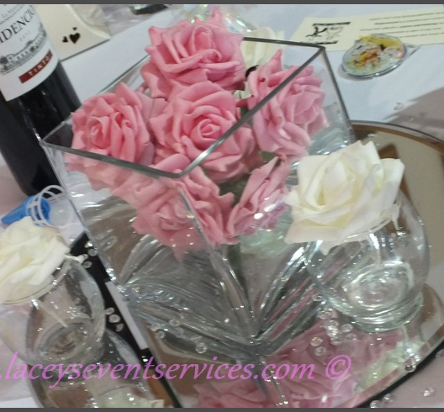 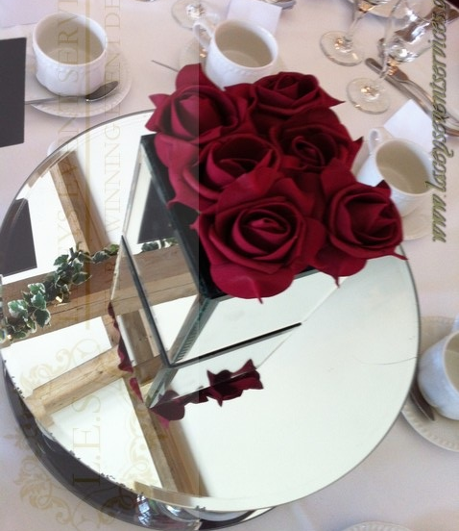
Photo Credit: Lacy’s Event Services

Taking this to the next level, flowers can be fully or partially submerged in water in a glass vase which would go well with a beach themed wedding, or just as an unusual and creative centerpiece idea.
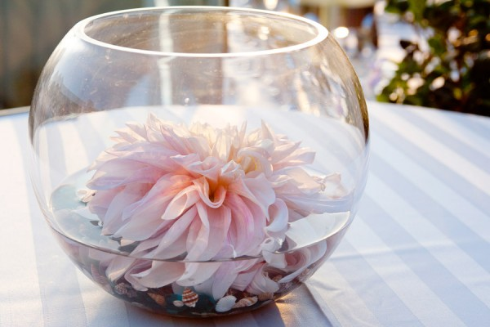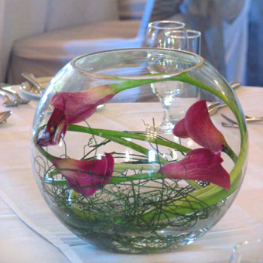
Photo Credit: Elizabeth Anne Photo Credit: Project Wedding

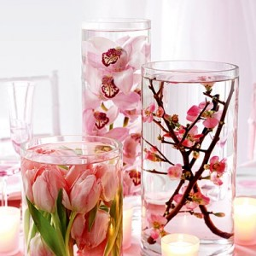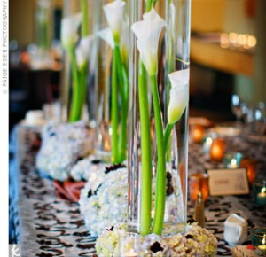
Photo Credit: DIY Weddings

Flowers being wrapped around the candelabra is becoming a common floral centerpiece which brides use to tie in with their cascading or round bouquet.

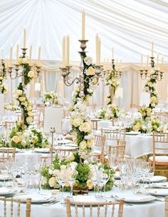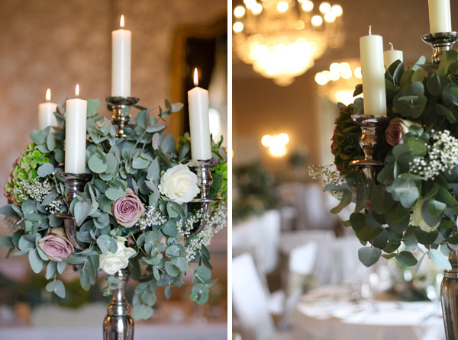
Photo Credit: Brides Magazine Photo Credit: Passion For Flowers

Many brides are now often choosing to opt for a more natural themed wedding, using wild flowers and natural materials instead of synthetic ribbons and linens. Again, following the theme of mimicking the bouquet, centerpieces can be hand-tied into a bouquet shape.

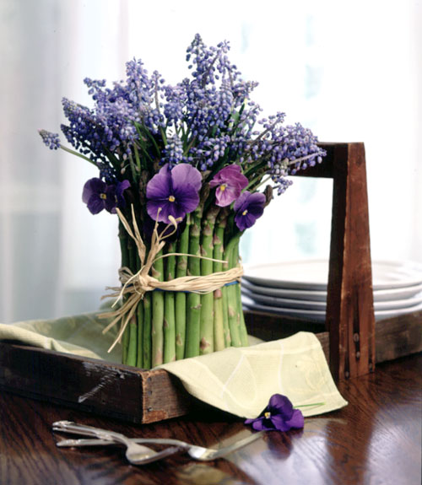 Photo Credit: Delia Blackler

Couples can often choose to go with more elaborate styles to tie in with other aspects of the day such as mimicking the cake with tiered styled centerpieces, or presents or the engagement ring box with boxed centerpieces.

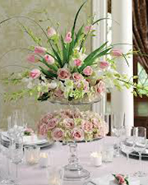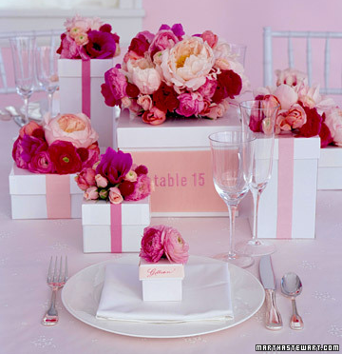
Photo Credit: PetalsnBuds Photo Credit: The Wedding Specialists

- What is the importance of colour for wedding flowers?

As previously mentioned, choosing the colour of the flowers is vital as they should tie in with the overall theme and also not take attention away from the wedding dress. The couple needs to have a delicate balance between a colour that matches the theme and style of flower that goes with the style and material of the dress and bridesmaid’s dresses.

Wedding planners often recommend bringing a swatch of fabric from the dresses when meeting with a florist and also an idea of flowers that the couple both like, along with any other contributing factors such as accessories, images of the room and any room décor that has already been chosen to ensure that the right flower(s) is/are chosen to compliment them.

2. How would you choose a floral designer for your client? Explain the step-by-step procedure in detail.

Like any other supplier, the floral designer must be reputable, within budget and come with recommendations and testimonials from previous clients.

- Source local floral designers, including ones that are able to source flowers from overseas
- Obtain their availability, portfolios (including types of flowers they use, styles of bouquet and types of centerpieces), price lists (including delivery, installation and removal) and testimonials from previous clients.
- Compare each designer against each other in terms of what they can and can’t offer. This can include certain types of flower, delivery at a certain cost and types of centerpieces they can design
- Compare each designer’s abilities against the couple’s ideas which they will have provided in initial meetings
- Provide a shortlist to the couple to review
- Arrange face-to-face meetings with floral designers and couple to discuss requirements, reminding the couple to bring the fabric swatches from the dresses, accessories, images or drawings of their own ideas, images of the room(s) and any other décor already chosen. The designer should prepare examples of their work for the couple to see up close.
This meeting should also be used to obtain other information about the florist including how many weddings they do per year, if they have worked in the venue before, how many staff members will be working on the order, their turnaround time to make each item, if they can produce a mock up of your chosen idea and when payments/deposits are due. Other information that should be discussed includes what types of flowers they will have available at the time of the wedding, whether the bouquet can be preserved afterwards, if fishbowls or candelabras can be hired from them (with our without candles) and whether a site visit is needed prior to creating the displays.
- The couple should also provide an alternative preference if for any reason their chosen flower(s) is unavailable at the time needed.
- Once this has all been discussed, full costs should be provided to the couple and planner to consider.
- Make the booking by requesting a contract and/or paying a deposit.
- Make regular contact with the designer on behalf of the couple with regards to updates on how the process is coming along and whether there are any issues in obtaining certain flowers (and if an alternative option is needing to be used instead)

References

Perfect Wedding Day. (n.d.) The History of Bridal Bouquets. Available: http://www.perfect-wedding-day.com/bridal-bouquets-history.html. Last accessed 2 April 2016.

Proflowers. (2012). History and Meaning of Tulips. Available: http://www.proflowers.com/blog/history-and-meaning-of-tulip. Last accessed 2 April 2016.

Photographs

Brides Magazine: http://www.bridesmagazine.co.uk/planning/general/flowers/2009/09/07/white-flowers---classic

Delia Blackler: http://www.goodhousekeeping.com/home/decorating-ideas/tips/g856/flower-produce-arrangements-0501/

DIY Weddings: http://diy.wed-central.com/?p=272

Elizabeth Anne: http://www.elizabethannedesigns.com/blog/2010/07/07/lauberge-del-mar-beach-wedding/submerged-flower-centerpiece-2/

Lacy’s Event Services: http://www.laceyseventservices.com/fresh-flower-centrepieces.html

Passion for Flowers: http://passionforflowers.net/blog/tag/candelabra-wedding/

Petals n Buds: http://www.petalsnbuds.ca/weddings/

Project Wedding: http://www.projectwedding.com/forums/submerged-flower-centerpieces-2

The Wedding Specialists: http://www.theweddingspecialists.net/beautiful-wedding-flower-centerpieces-2.html

Student Statement:

By submitting this assignment, I confirm that this is my own work.

Student Signature | Sara Spiers | Date | 02/04/2016

For Tutor / Assessor Use Only
Total Marks
Marks Obtained
Percentage / Grade

