
Assignment Cover Sheet

Student Name: | Roxanne Malone
Student Number: | 2767
Course: | Certificate in E-Commerce Management Level 3
Assignment NO: | Assignment 3

Marking Criteria:
We expect the learners to write minimum one well expressed point in three lines against each allocated mark. This means one needs to write 15 lines with 5 well expressed points to get high grades for a 5 marks question.
For high grades use examples and illustrations where appropriate.
Q1:
I. To design an engaging website for your user’s you need to research your field, analysis your competitor’s websites and how they interact with their users and most importantly find out what your potential users needs and expectations are. Finding out what your target market is, is fundamental, recognising what makes your users tick can help you tap into to what promotes those feelings in your users’ to fulfil their needs or wants from your website, you need to know what is important to them and what motivates them to shop and more importantly to buy. Researching other companies in a similar market to yours helps you to understand whether there is a particular trend in how they captivate their users, what offers and products they sell but it also lets you see how their posts and pages are laid out, what the common features are and what their processes are and overall what seems to work well and what doesn’t.

Most users are not willing to put the time in to learn how to interact with your website or wait too long for your pages to load, so it is essential you get the basics right. Reflect on your research and user preferences, think about what processes and layouts your users are accustomed to. Your websites layout needs to be familiar, consistent, quick and simple, include additional guidance from call to action buttons.

Using a combination of your own vision for your branding and your competitor research you can design how you want your site to look. Consider complimentary brand colours, but don’t over complicate your website with too many different colours, it still needs to be simple and easily read. Your home page should be an eye catching, exciting summary of what they may find, consider including photos, videos, graphics, audio, links to articles, competitions and the latest offers and products but, keep in mind that different audiences respond to different types of media. Use a user friendly, easy to read font and don’t be afraid of space, over filling your pages with unnecessary text on pages that don’t require it can be a mistake, include relevant images and videos and links to articles where appropriate to break up large amount of text.

To reduce the risk for your users becoming frustrated, quick loading times and a responsive website is important. By using Media queries, with flexible layouts, images and text which automatically adjust to the correct size and resolution depending on what devices your users are using, expands your accessibility and elevates your overall user experience.

Touchpoints such as an “about us” or “meet the team” pages that discuss how your company started out could give your user an interesting backstory, gives them an insight to what your company is about and what your goals are. You could include information and photos about the company’s owner, teams of employees, how the company is run and by who, disclosing what qualifies them for their position in the company or their personal experiences and endorsements of your products, this can humanise your company and give your site a personal touch to your brand.

Generating unique interactions with your users helps to build relationships with existing customers and can keep them interested, feeling valued and helps to ensure they remember your company. Having a good relationship with your customers can also advertise your company to potential new customers, through word of mouth, the reviews they leave and through the posts they share on their social media accounts.

Using dynamic pages to create a more personalised shopping experience is one way of showing appreciation for your existing customers, you can achieve this by adding simple features using their account information, like welcoming your customer by name, suggesting products or articles they might like or displaying items they have viewed.

Including widget buttons on your pages allows your customers to easily share your content, images and information on their chosen social media platform which can be great advertising and personal customer endorsement of your products and the credibility of your company.



Another way of retaining your users interested is writing blogs or articles, this keeps your users up to date with the latest products, helps customers stay on trend or find out interesting information or stories that shows that you are putting in the effort into staying current and a great way to connect with your company. When writing blogs or articles think about adding appropriate imagery, graphics, videos and interactive widgets to break up large amount of text into smaller chunks, this makes pages easier to read and more interesting. Blogs/articles again should offer the prospect for the users to interact with your company by leaving comments or having discussions or sharing the content on other social media platforms.

Emailing customers your latest offers, competitions and newsletters, is a way of reminding/prompting them to come back and have a look at what you have to offer, emailing your customers with an offer around their birthday is a great example of how to have a personalising interactions with your customers.

You could consider adding features to your product pages that allows your customers to rate and review products or even upload pictures of their purchases; if products are highly promoted/rated it instils confidence in the products and your company which can encourages new or nervous shoppers to buy.

You could consider creating a company account on social networking sites and actively posting is a great way of connecting with your customers on a regular and slightly more personal level, it also promotes brand recognition and customer loyalty. Customers may follow your social media pages for inspiration, to keep up to date with the latest offers and sales or the newest trends or products on the market. Posting videos, images, campaigns, links to articles/blogs or posting questions/statements, not only creates opportunities for you to advertise your most recent products or offers, but it allows your followers to interact with you by them liking your posts, or opening up the floor for discussions or sharing your posts, resulting in free advertising from your followers and a kind of personal endorsement promoting your products and your company to their followers to check out your website.

Some companies also post competitions on social media, asking their users to like their company page on social media or encourage their existing followers to and share a post with a premise of a prize, discount or feature, which can entice more users to follow your company’s social media accounts, and stretches your reach further, for advertising to promote your products.

II. If a site works correctly, is laid out well and easily read from any device, it is less frustrating and more visually pleasing, which elevates the users overall experience and broadens its accessibility. To create a responsive Web design, you will need to use, Media queries and Flexible grid based layouts and Flexible Images and media, so that you’re your website responds and adapts to multiple devices such a Computer, Tablet or smartphone.

Media queries looks at the capability of each device and corrects your website layout by following a set of rules based upon the devices resolution and the viewport dimensions, which will indicate which layout is best suited for each device.

Flexible/Fluid grid based layout follow the rules laid out by the Media queries which automatically changes the grid layout depending on what device or browser the users is using, such as header and footer, categories and content to change size and into easily read laid out columns. Flexible/Fluid Images and Media also follow the rules set out by the Media queries to adjusts images and other media content to the correct scale and resolution to fit comfortably within the appropriate grid layout.

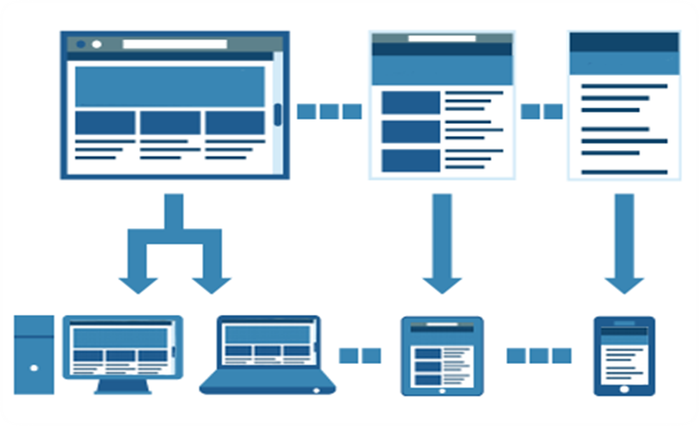

III. Dynamic Pages have the ability to change what they display throughout the day or for different users. Using your web hosting suite to load different content such as the latest articles, features, images, videos, posts or product pages etc. Dynamic pages can also be customised for your individual user to create a more personalised shopping experience, for example, using their account information to welcome your user by name, using their search or purchase history to suggest products that may interest them, or displaying products they have previously viewed, using their actions and interests to suggest articles or content they might like, this encourages the user to engage more with your website, which then allows customised content to be generated for your individual user to ensure the users next experience is better targeted.

Q2. Leverage user generated content is content provided by users, such as detailed product reviews on the company website or social media accounts, which can be vital when it comes to legitimising businesses, boosting sales and search engine optimization. Positive reviews, feedback and advertisements from real customers can drive sales, prompting a feeling of confidence, trust and appreciation, which are key emotional drivers to stimulate to be able to sell.

Widgets on web pages allows the content to be easily shared by users on their various social media platforms; which broadens the reach to potential new customers and advertisement of products and company.

Rate and Review sections on product pages enables users with a type of forum for them to express their opinion of products, interact with each other by exchanging experiences or discussing features, as well as the benefits or any problems they may have faced;

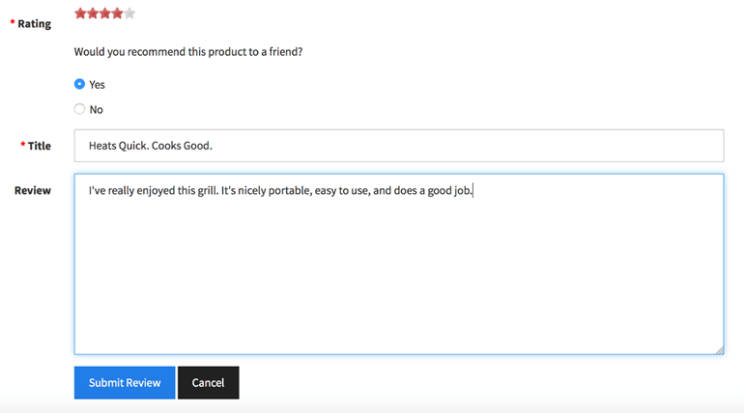

Creating company accounts on various social media sites, is another chance to interact with customers. Actively posting on social media accounts about the latest products, competitions or articles gives users the opportunity to like and comment on posts and share content with their friends and followers, which again widens the reach to potential new customers.

One way of encouraging users to engage and to create a buzz is to advertise competitions to submit reviews, share and like content or upload photos of their purchases of specific products and giving the winner a chance to receive a prize or feature on the company website.

Getting users to become a more active presence on your website by inviting some of the most positive influential users/followers to become guest bloggers, to write articles about their personal experiences with specific products and why they love them.

Student Statement:

By submitting this assignment, I confirm that this is my own work.

Student Signature | Roxanne Malone | Date | 28/02/17

For Tutor / Assessor Use Only
Total Marks
Marks Obtained
Percentage / Grade

