
Assignment Cover Sheet

Student Name: | Carly Timpson
Student Number: | 4987
Course: | Diploma in wedding planning
Assignment NO: | 6

Marking Criteria:
We expect the learners to write minimum one well expressed point in three lines against each allocated mark. This means one needs to write 15 lines with 5 well expressed points to get high grades for a 5 marks question.
For high grades use examples and illustrations where appropriate.
Question 1

The questions a venue manager should ask when selecting a wedding venue are:
- How many guests will the venue accommodate?
- What style of reception does the venue cater for?
- Will you have exclusive use of the venue, or will you be sharing it with others?
- Does the venue provide food and beverages, or do you require a caterer?
- Does the venue provide wait staff?
- Are all furnishings, cutlery and crockery etc. provided by the venue?
- What exactly is included in the venue’s wedding packages?
- Are there any special offers available with the venue’s wedding packages?
- Are you able to alter the packages to suit your needs?
- If alcohol is included in the packages, is it based on the number or guests or by the amount consumed? Are spirits included?
- Will the venue cut your cake and serve to your guests? Is this included in the package? Do you need to provide a cake stand, knife or cake bags?
- Does the venue allow for special dietary requirements for you or your guests?
- Will the venue provide a reduced-cost meal for your photographer, band members, children etc?
- Are there any additional expenses that you should be aware of?
- Are there any optional extras available?
- Is a Master of Ceremonies included?
- Does the venue provide any decorations? If not, will they set them up if you are to provide them?
- Is there a dance floor?
- Is entertainment included in the package?
- Are there any restrictions or requirements if you are to arrange the entertainment?
- How long will the reception run for and are there any fees for running over time?
- What time does the venue close?
- Is there a bridal room that will be available to you and your bridal party throughout the reception?
- Is the venue heated and air-conditioned?
- Are there any cleaning costs/requirements associated with your reception?
- When are deposits, instalments and final payments due? How much will they be?
- Are there any cancellation fees?
- Is the venue within your budget?
- Is it in keeping with the style and theme of the wedding?
- Is it available on the wedding date?
- Are there areas at the venue that will provide for photo opportunities?
- Is the venue close to your ceremony venue and photography locations?
- Is it accessible for the guests?
- Are the staff professional and experienced, and do you warm to them?
- Is the layout appropriate for your band/entertainment or other aspects of the reception?
- Is the reception venue appropriate for all types of weather?
- Are the facilities appropriate for the couple, the guests and others?

ii. The important measures that should be put in place when having an outdoor wedding are a shelter nearby/alternative setting or marquee (in case of bad weather), the time of day so the sun can be positioned on the backs of people, enough bathroom facilities & insect repellent/prevention/protection.

iii. Keeping a copy of the floor plan is important for a wedding planner because it offers a concise overview of placement and spacing & during the set-up phase it is needed to ensure all is correctly set up.

iv. When selecting equipment for the ceremony the most important things to consider are how many people are attending the reception, the size of the reception and the type of reception the couple are planning to have.

v. List of site layout essentials:

- Tents
- Tables
- Chairs
- Linens
- Tableware
- Lighting
- Other outdoor considerations
- Bringing it together with the site layout

vi. Tents are one of the most important rental items because they are not a straight forward item to order and set up. You must take many things into account when getting a tent for the reception, for example –
- Weather – If the tent selected is not good in any weather other than sun this can lead to issues.
- Insects – If the tent is too open insects will bother the guests.
- Tent style – Has to be in keeping with the wedding vision.
- Tent accessories – Have to be in keeping with the wedding vision.
- Size – A correct size must be selected for the number of guests.
- Setup – Is it a time consuming easy/difficult task.
- Cost – Is it within budget.

vii. The guidelines for selecting the correct tent are:

Number of guests | Tent size if seated at tables | Tent size if standing or buffett
50 | 20x40 | 20x30
100 | 30x50 | 30x30
150 | 40x60 | 40x40
200 | 40x80 | 40x60
250 | 60x70 | 40x80
300 | 60x80 | 60x60

Question 2

a. Tables – Common guest tables are 5ft rounds which seat 8-10 people or 6ft rounds which seat 10-12 people, 8ft oblong tables can seat 8-10. Sweetheart tables are becoming more common (where the bride and Groom sit at a table on their own.) Square tables seating to people per side are becoming more common. Other tables required for a wedding venue are a cake table, gift table & favours table.

b. Chairs – There are many styles of chair. Folding are budget friendly, they come in a variety of colours, materials & offer padding too. For upmarket weddings Chiavari chairs are a popular selection. A padded wooden folding chair costs roughly £3 to rent whereas a Chiavari chair is roughly £9.

c. Linens – There are so many options with linens, colour, style, material etc. the easiest way to choose the linens is to use the theme of the wedding for inspiration/guidance.

d. Tableware – Tableware has so many options, colour, style, material etc. the easiest way to choose the tableware is to use the theme of the wedding for inspiration/guidance.

Activity

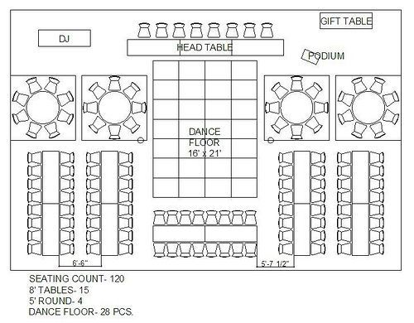

Student Statement:

By submitting this assignment, I confirm that this is my own work.

Student Signature | Carly Timpson | Date | 05-02-2017

For Tutor / Assessor Use Only
Total Marks
Marks Obtained
Percentage / Grade

