
Assignment Cover Sheet

Student Name: | Reema Ahmed
Student Number: | 1794
Course: | Diploma in Forensic Accounting
Assignment NO: | Assessment #1

1. Short Questions
- Fraud in the simplest form is deception; essentially, the intention to deceive. There are negative repercussions on the society as a whole, the organization, an individual and lastly, the economy. However, the repercussions depend varyingly on the fraud that is committed – there are three main types of frauds: Financial Statement Fraud, Asset Misappropriation and Corruption, with the latter being the most common form. When any of these frauds are committed, it highlights the lack of internal controls within an organization, gaps within the financial system, and overall, the trust an individual has been bestowed. As summarized by the fraud triangle in Fig 1.1, we learn that in order for an individual to commit fraud, there are a number of influential factors. In today’s world, employees feel they are overworked and underpaid. This feeling alone is strong enough for someone to be influenced in finding his or her own means to satisfy their cash inflows. Another example is financial difficulty, be it debt, unpaid bills or unfortunately, greed. Lastly, fraud can also be committed to hide someone’s personal addiction such as gambling or drugs. Whatever the incentive, enough opportunity is available for frauds to be committed and at the very core of it all; fraud is purely deception for one’s own financial and/or personal gain.
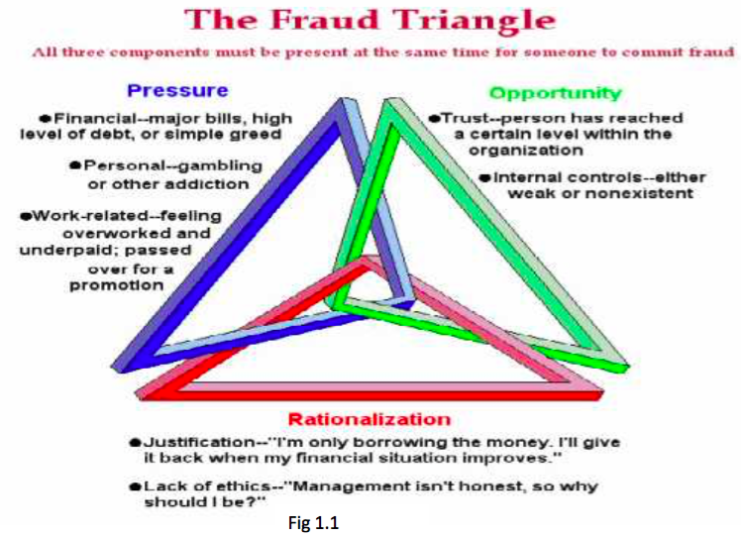
- There are few skills are that are essential for any forensic accountant to have. Of most importance is the need to be analytical. In holding analytical skills, any forensic accountant is in a better position to provide value added services in scenarios that go beyond the scope of just auditing and problem solving abilities. However, equally important for any forensic accountant is the ability to synthesize disparate information. Often, forensic accountants will have to work with very minimal initial information to identify the fraud and its elements. Therefore, a probabilistic approach should be followed. In essence, this is where the investigative ability and intuitiveness of the accountant would be tested. The way the fraudster and those involved are interviewed should conclude in obtaining a confession that will be admissible in court. Interviewing skills as well as the accountant’s evidence gathering techniques should ensure that any information gathered is of completeness. Understanding the concept of best vs. primary evidence becomes essential. It is also imperative for the forensic accountant to think like the wrongdoer. To do this, it is equally imperative for the accountant to be skeptical in every sense – questioning the originality/legitimacy of all transactions, testimony and other important documentation. In addition, being an effective oral communicator and holding the ability to simplify the information on hand are core skills of any forensic accountant. This would facilitate the accountant in telling the overall story – the fraud, the motive behind it, the opportunity existing for the crime to be committed, the benefit derived from it in the fraudster’s perspective and an estimate of losses.
- There are five qualities of mind that any forensic accountant should hold. The most important is the understanding of financial auditing and its purpose. Forensic accountants should be aware that financial auditing focuses primarily on the adherence to regulatory standards in financial reporting, and not on detecting fraud. This brings us to the second mindset factor – Fraud can be easily recognized by accident or by a whistle-blower, which is essentially a tip provided to forensic accountants on detecting the fraud. Thirdly, the detection of fraud relies on creative thinking and innovation. It is essential for any forensic accountant to hold investigative intuition and be skeptical of any information in nature of the fraud. This would lead the forensic account to act on impulse, which is ultimately, one of the proven abilities to detect fraud successfully. Fourthly, a successful fraud investigation is derived from a combination of intelligence, persistence, determination and self-confidence. The last mindset factor is that both forensic accountants and fraud auditors should hold three core skills: logicality, problem solving tactics and detective skills.

- There are five steps that are involved in a fraud investigation:

- Accepting the investigation: The investigation team should have the required experience and skills to undertake the job and no ethical dilemmas should exist prior to investigating.
- Planning the Investigation: The objectives should be identified – the committed fraud, the timeline, the concealment, the people involved, the financial loss to the organization, evidence of fraud and suggested measures to prevent reoccurrence.
- Gathering Evidence: Proper chain of custody should be observed to ensure evidence is conclusive and sufficient. Lack thereof, evidence may be deemed inadmissible.
- Reporting: Report structured for client outlining the evidence obtained, extent of losses incurred, weak or lack of control mechanisms, the manner the fraud was conducted and all relevant information pertaining to the fraud.
- Court proceedings: Investigators must be able to present their findings in a language that is understood by a general, non-accounting background audience.

- First and foremost, it is essential to understand that both fraud and investigative auditing are a branch within forensic accounting. Forensic accounting, as we know, is the combination of accounting, auditing and investigative skills that help in detecting and preventing fraud. It requires investigative accounting to determine the nature of the fraud and related elements, as forensic accounting generally leads to legal outcomes. Fraud auditing, however, differs because its focus is on the criminal activities restricted to fraud. There are four items of analysis that distinguish forensic accounting, fraud auditing and investigative auditing from financial auditing, which are: why, when, and where the services take place, scope of the job, details of tasks performed and lastly, reporting. These items and the distinguishing factors are outlined in the table below.

Items of Analysis | Forensic Accounting/ Fraud Auditing/ Investigative Auditing | Financial Auditing
Why, when, and where the services take place | Back up to prove fraud in a risk-prone environment. | Continuous, certifies nature of business and compliance with efficient market theory
Scope of job | Presents analytical accounting and financial information | Observe accounting statements vs. criteria used in preparation
Details of tasks performed | Documenting deterministic and calculative analysis | Sampled and/or probabilistic procedures
Reporting | Investigative or expert reports | Financial statements, management letters or auditors’ report.
Case Study
- First and foremost, we should determine if there is sufficient belief that a fraud has occurred by following the principles of the fraud triangle. In light of the situation, the administrator in question, exhibited feelings of frustration and embitterment, which is in essence, work related pressure. There was both a level of trust and weak internal controls that facilitated him to commit fraud. The trust that he obtained within the organization can be concluded from the fact that he was given ultimate singing authority and access to the board’s credit card. In addition, there was no segregation of duties between the submission of bills by one person and approval by another, which again, outlines the weak internal controls or lack thereof. Since there is enough reason to believe that a fraud has been committed, the next step upon accepting the investigation would be to identify the objectives – the fraud committed, timeline, people involved, etc.
- The type of fraud that seems to have been committed is an act of asset misappropriation, particularly fraudulent disbursements. Some documents that could help distinguish the administrator’s fraud activities would be to retrieve the bills of the expenses outlined: the credit card, restaurant, entertainment and car repairs. In addition, another form of document that could highlight the fraud activities would be the copy of check stubs that he personally approved. Check tampering depends highly on access to the company’s checkbook, therefore, an auditing trail exist. This trial can be the most prominent document in intercepting the fraud.
- The forensic accountant hired should be chosen based on the skills and experience he or she holds. They should be able to identify the fraud and its elements with initial minimal information, have exposure to proper evidence gathering techniques, be able to perform an interview and obtain a confession that would be admissible in court, be able to think like the fraudster, think outside the box, and most of all, be skeptical about all the transactions processed and its legitimate factor.

- Interviewing suspects for any alleged fraud is a key occurrence in order to obtain an admissible confession. Investigators need to refrain from confronting the suspect until there is enough reason and evidence to support the alleged fraudster. In light of this situation, the most promising stage to interview the administrator would be once the secretary blew the whistle. This is because, at this stage, there is sufficient evidence to prove the perpetrated fraud. It is also at this point where because a tip aided the detection of fraud, the investigator can then carry out his or her job effectively.

Student Statement:

By submitting this assignment, I confirm that this is my own work.

Student Signature | Reema Ahmed | Date | May 13, 2016

For Tutor / Assessor Use Only
Total Marks
Marks Obtained
Percentage / Grade

