
Assignment Cover Sheet

Student Name: | James Keown
Student Number: | 2569
Course: | Diploma in Logistics & Supply Chain Management
Assignment NO: | 7

Marking Criteria:
We expect the learners to write minimum one well expressed point in three lines against each allocated mark. This means one needs to write 15 lines with 5 well expressed points to get high grades for a 5 marks question.
For high grades use examples and illustrations where appropriate.
1. i. Distribution is the method by which you intend to get your product to the end user. This can be achieved by a multi-level distribution channel or by going direct to market. Considerations also need to be given to how the product will be marketed and how the marketing costs will be split. Your product and business model will determine your channel of distribution. You may choose to go directly to the market via the internet or through your own retail company. This will give you better margin and full control over the quality of service the end user receives when they purchase your product. A distribution partner with a wider geographical spread could offer a larger volume of product sales, and a larger sales and marketing function to promote your product. If you are a small start-up business with limited capital and human resource, a larger distribution partner could offer a quick route to market and the sales and marketing function to promote your product. Consideration would need to be given to the percentage of profit they would expect in return for their services. Distribution agreements can be negotiated with minimum annual order quantities to ensure you can meet the required volume to remain profitable. This is extremely important if looking to enter an exclusive distribution partnership.

ii. Channel participants are the main companies involved in a supply chain and consist of the following:

- Manufacturers – Are involved in the process of combining components and raw materials into products. E.g. baker, plastic pipe manufacturer, Nissan Motor Company. The involvement of other channel partners in the supply chain will only happen after a product is manufactured. They are the primary partner in the supply chain.
- Wholesalers – The wholesaler’s primary business function is to purchase from manufacturers and sell to retailers, industries and other business users. They are considered the middle man in the supply chain. See model below:

Supplier – Manufacturer – Wholesaler – Retailer – End User

- Retailers – Are in the business of selling products or services to end users who acquire them for their own use. They range from small specialist retailers like a family owned watch maker or lawn mowing business, to massive multinational retail businesses like Maces / K- Mart etc.

iii. Market coverage decisions are very important as they will determine your path to market and your geographical footprint. The three market coverage options are shown below. Pros and cons for each need to be explored before deciding on the best market coverage option for your business and product.

- Intensive Distribution - Involves placing a product in as many outlets and regions as possible. This achieves excellent coverage, but can dilute the service level and any technical support required for a product. Great for FMCG (Fast Moving Consumer Goods). Not good for technical and mechanical products that need service or product support. For example, dishwashers, computers, air-conditioning units.

- Selective Distribution - A limited distribution strategy for products that require technical support and service. In order to maintain the company / brand image, distributors will be qualified and selected to ensure they can offer and maintain the services required for optimum customer service.

- Exclusive Distribution – An exclusive distribution model where very few businesses are given the right to sell a product in a certain geographical region. Is often used for exclusive high end products like, Amani, Gucci where the customer experience is as important as the product.

iv. Single transaction channels involve transactions that are normally a one-off transaction. There will not be an ongoing trading relationship. Examples include: Funeral services, private heart surgery, and property purchase.

Conventional channels relate to products sold on an as required basis with no motivation for repeat business. The main motivation for the transaction is price. There is no partnership relationship between buyer and seller, it is purely transactional. A good example is supermarkets. They are selling very generic products to many consumers, in a very competitive market. As such they will mass market advertise via multimedia (TV, radio, newspaper, mail drop, social media) with aggressive pricing and other discount related deals. For example, 2 for 1, coupon deals, petrol vouchers etc. Consumers will often move from business to business depending on who has the best price for a specific item.

v. Product pricing and logistics have a direct relationship with each other and impact every member in the supply chain. When establishing terms of trade with suppliers and customers, consideration needs to be given to who will be absorbing the costs for the transport of the product. If a distributor is already having a network of trucks operating in the same area as his supplier, it may be more economically viable for them to collect the product from the supplier themselves. This could allow them to negotiate a reduction in the purchase price from the supplier, if they had included the transport component in their original product price.

International purchase can be even more complex as there are several different options to consider. Depending on what option is selected, it may or may not cover the following: product insurance, port storage and transport. It is imperative each supply chain member understands who is responsible for absorbing the freight component of the transaction. If not, it can quickly absorb any margin that was in a product if not accounted for.

2. Understanding the fundamentals of pricing strategy and how it relates to the supply chain is imperative. A clear understanding of which supply chain partner is responsible for specific logistics related costs is essential for the long-term profitability of the company. As there are many different logistics options to evaluate, careful consideration needs to be given to which option is the best fit for the business and products being transported. Some of the most common options are shown below.

FOB (Free On Board) – The seller will make goods available at his warehouse or factory and will load the product onto the mode of transport. This is a very common method of quoting for the seller as it liability for them is very limited, and there are no freights cost calculations involved.

Delivered Price - The price from the seller to the buyer includes the delivered price to the requested location. Seller will be responsible for the insurance of the shipment unless otherwise specified.

Single Zone Pricing - The same price will be charged for the delivery of the shipment regardless of the delivery location. In this case more costly deliveries to more distant locations will be subsidised by the closer less costly destination deliveries. Often used for small consignments where the transportation cost is a small component of the price of the product.

Multi Zone Pricing - The geographical area for delivery will be divided into zones. Each zone will have a different delivery price depending on its location in relation to supply source. Closer costs less, further away costs more. Courier companies often use this zone pricing practice.

Base Point Pricing - The transport price is determined by establishing the exact price from the base point (starting point) to the destination. This is often used for heavy, large volume and complex shipments. For example, house movers, heavy machinery movers.

There are a significant number of different logistics options (see Fig 1). As such, there needs to be a robust pricing strategy in place to ensure all anomalies are accounted for when pricing the logistics component of a product for both buying and selling.

Fig 1.
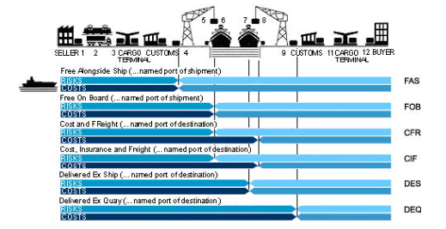

3 When determining the structure and function of the channel design and distribution strategy, two tools can be used to define it (see below). Important consideration needs to be given to the end user requirements and what will best accommodate their requirements. What is good for your business may not necessary meet the needs of your customers.

Channel Mapping – Feedback from internal stockholders needs to be taken to establish the individual needs of each, and identify what is working in the current structure and what isn’t. Once a clear understanding of the existing channel map exists, an evaluation of its current form needs to be completed. Changes can then be made to specific areas to improve structure and function.
When creating a new channel map, evaluating a competitor’s business can provide a good template to start from. It can then be adjusted to cater for the individual needs of your business and its customers. Channel mapping allows you to have an overview of the entire logistics process and to also pinpoint specific links in the map that can reduce, cost, time and unnecessary product movement. A broad version of a channel map is shown below (see Fig 2.)

Fig 2.

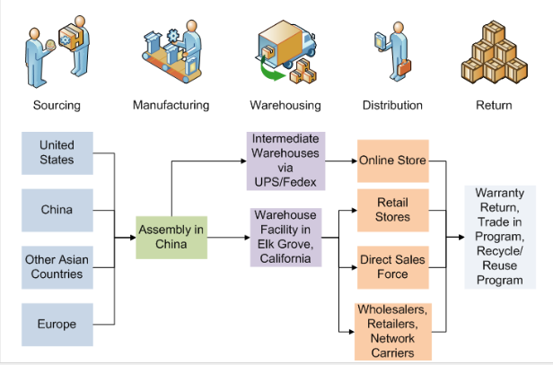

Matrix Approach - This explores the interaction of channel participants and how using the capabilities of each of them can be utilized to achieve the most efficient and effective path to market. Different channel partners serve different markets and customers. A certain mix of channel partners will or will not be included in your matrix, based on the product you are selling and the market(s) you are trying to penetrate.

References

Author Unknown, Unit 7 – Market Distribution in Supply Chain
Author: Unknown, http://www.zx-china.org/help/freight.html
Author: Unknown http://www.supplychainopz.com/2013/01/is-apple-supply-chain-really-no-1-case.html

Student Statement:

By submitting this assignment, I confirm that this is my own work.

Student Signature | James Keown | Date | 28th Jan 2017

For Tutor / Assessor Use Only
Total Marks
Marks Obtained
Percentage / Grade

