
Assignment Cover Sheet

Student Name: | Justyna Singh
Student Number: | 1690
Course: | Fashion Design level 4
Assignment NO: | #7

Marking Criteria:
We expect the learners to write minimum one well expressed point in three lines against each allocated mark. This means one needs to write 15 lines with 5 well expressed points to get high grades for a 5 marks question.
For high grades use examples and illustrations where appropriate.
Q: 1: Multiple Choice Questions:
a) A fashion figure is about;
• Seven and one half heads tall
• Eight to ten heads tall
• Fifteen heads tall
b) The best rule to follow in sketching the face is to;
• Give as much details as possible
• Define as much detail as possible
• Omit as much detail as possible
c) The fashion artist exaggerates the;
• Length of the figures and maximises the width of the hand
• Exaggerates the length of the arms and minimises the hands
• Exaggerates the length of forearm and minimises elbow
2. What is most important thing to consider when sketching for dressing the figure?
For designer while sketching for dressing the figure is very important to not make it look flat but look more like on actual body. Especially women like to visualise the garment on them. For the designer it is important to place the centre of the garment in the correct position as well as making sure that all lines and trimmings are in proportion and with correct location.
To give a 3D look it is good to add some wrinkles on the garment in right places as well as slightly outline the shape of the body. This will give more natural and real look and will be more interesting to the buyers.
While drawing a dress on a figure designer should ask themselves some questions about neckline position, collar and its shape, where is the waistline, what type of skirt it will be and so on…
3. How does fashion design sketch help a fashion designer?
Fashion design sketch helps to designer to focus on details and if the garment looks interesting enough. It is the simplest way to present the idea of the designer. They are the very first to be seen by manufacturers before making decisions which garments manufacturer is interested in. that way designer , especially the one who just starts his job can save the mone without producing uninteresting garments. Also he/she can work further on the ideas which were put on the paper and not chosen to manufacture.
By drawing the sketch of the product first designer can get the rough idea about types of fabric to use or what type of manufacturer should be hired to convert the sketch into a product.
4. How should bottom of the skirt be sketched? Why is it important to harmonise the mood and action of the figure with the clothes in which artist draws her. Explain giving at least one example.
Skirt is not only a female part of clothing. In Scotland traditional part of men clothes is kilt – which is very similar to a skirt. By drawing different bottom types of the skirts designer has to keep in mind what type of skirt it is: pencil skirt, miniskirt, tailored, maxi…
While drawing the skirt designer first should draw trapeze shape with the bottom as wide as he wants the skirt, the amount of flare will depend on the fullness of the skirt, to be and length followed by the idea of the designer. Than designer has to sketch the details/designs he/she wants to have on the skirt. Next line the drawing with the black ink and erase all the lines which are unnecessary.
It is better to use general feeling of a rectangle rather than straight across is better idea as it looks more like the actual body rather than flat. The hemline should be as well a bit longer over the foreleg or the foot which is closer to the designer. It is done this way to express the rhythm in the lines of the folds in the skirt.
It is very important to harmonise the mood and action of the clothes with the figure. For example while drawing figure in sport clothes designer should engage the figure in the sport activity. Also drawing should show that the clothes are comfortable and the figure feels comfy in them.
Activity
Sketch a fashion dress for a female showing all the details required in that garment. Then sketch a fashion figure dressed in same outfit.
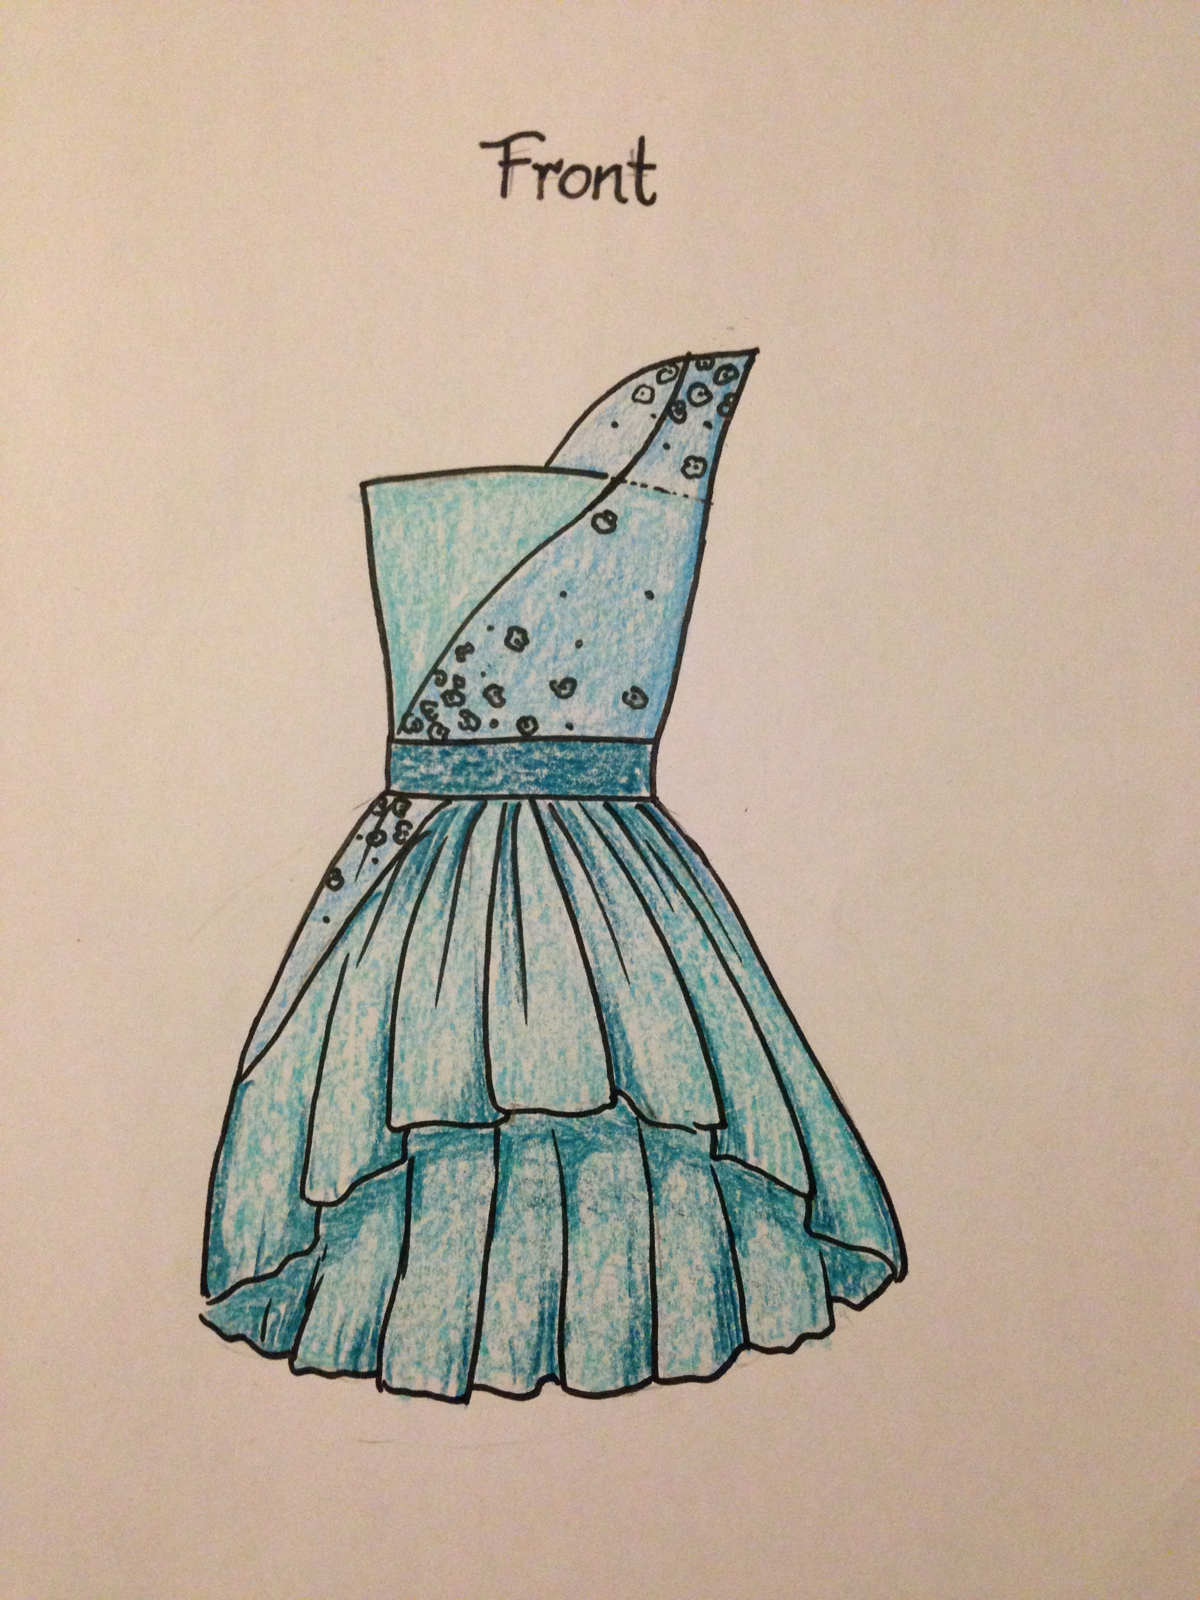
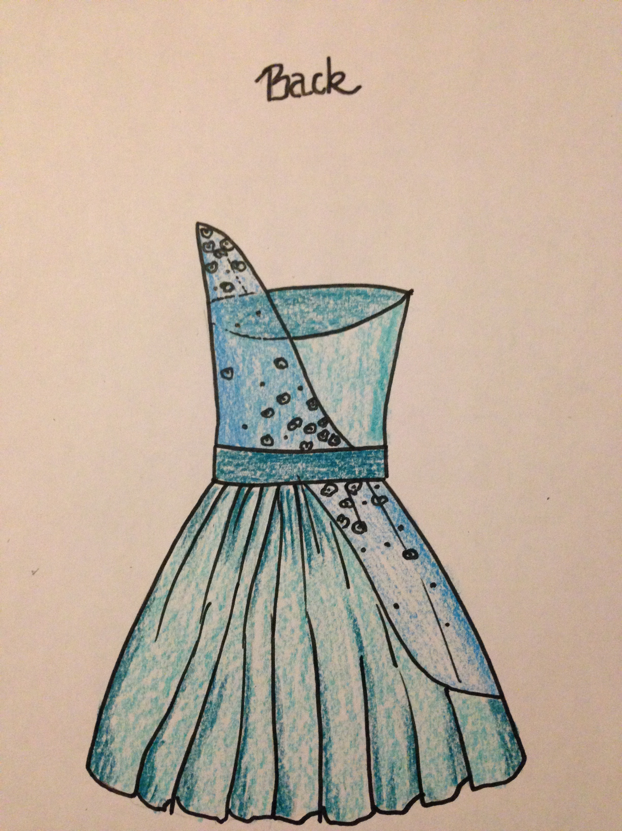
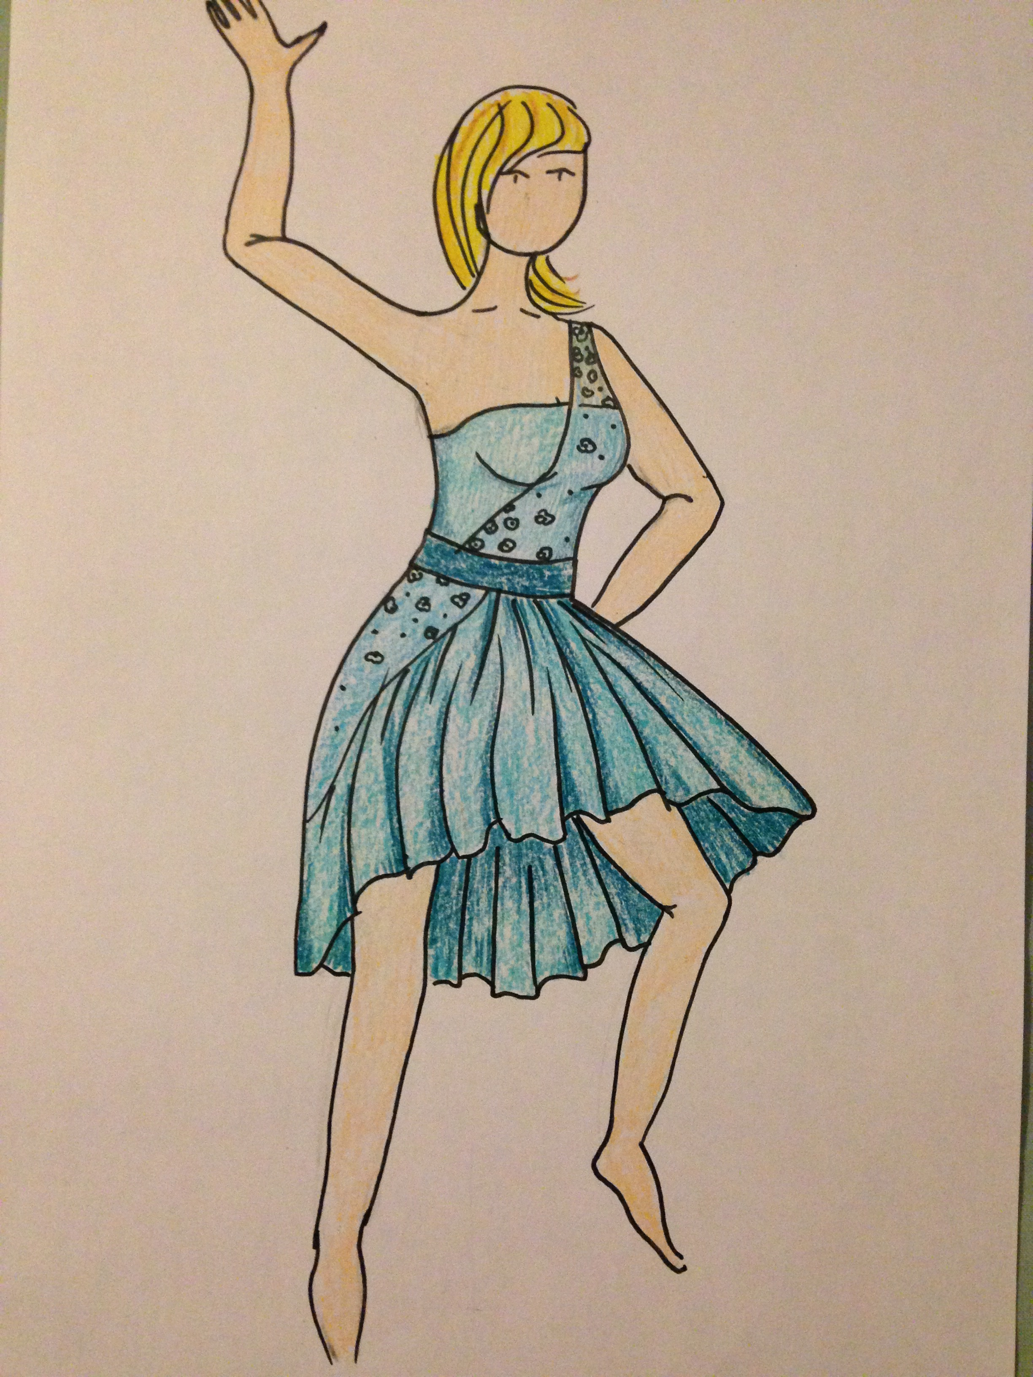

Student Statement:

By submitting this assignment, I confirm that this is my own work.

Student Signature |  | Date

For Tutor / Assessor Use Only
Total Marks
Marks Obtained
Percentage / Grade

