
Assignment Cover Sheet

Student Name: | Raymond Wilson
Student Number: | 5297
Course: | Diploma in Risk Management
Assignment No: | 4
Marking Criteria:
We expect the learners to write minimum one well expressed point in three lines against each allocated mark. This means one needs to write 15 lines with 5 well expressed points to get high grades for a 5 marks question.
For high grades use examples and illustrations where appropriate.
Assessment 4 Risk Analysis Total Marks: 30

1. Give Short answers for the following questions: (14)

I. What type of information does a business risk analysis give?

A business Risk Analysis, as illustrated, provides information on the Risks identified, Causes, effects the Risks may have on the company and the actions needed to remove (ideally) or limit their influence on the business as a whole.

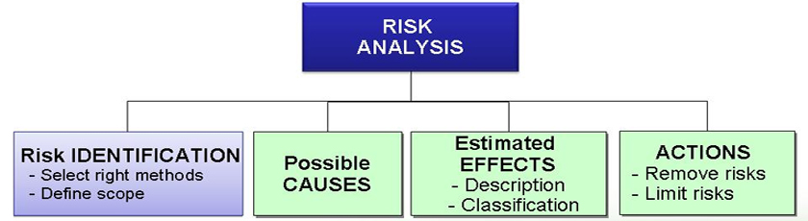
The Risk Analysis process is a proven way of identifying and assessing factors that could negatively affect the success of a business or project. It allows analysers to examine the risks that an organization faces, and helps them decide whether or not to move forward with a decision and estimating the likelihood of those threats being realized.
Once the company involved has worked out the value of the risks faced, they can start looking at ways to manage them effectively. This may include choosing to avoid the risk, sharing it, or accepting it while reducing its impact.
It's essential that the information that has been provided from the RA is thoroughly checked that everyone involved is aware of all of the possible impacts of the risks revealed. This includes being mindful of costs, ethics, and people's safety.

II. What are the outputs for a business risk analysis?

The major outcomes associated with the risk assessment include;

- Understanding of potential business risks, including their likelihood and impact on the business
- Identification of existing controls, and potential control enhancements or new strategies to mitigate business risk by protecting resources (as to decrease the likelihood or severity associated with a disruptive incident)

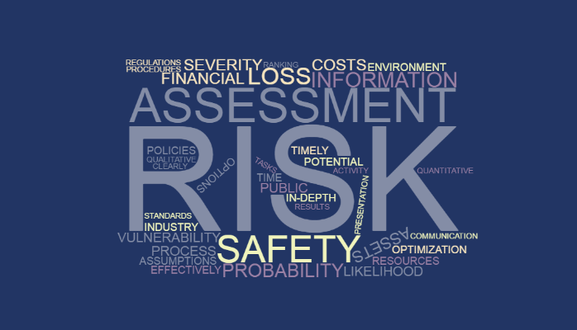

Following the risk assessment, the organization should then be able to list all business risks (prioritized by those that would have high impact and have a high probability of occurring), and a list of mitigating control options to address the business risks identified.
Based on the analysis findings, the risk register is updated with the probability, impact, score, and related comments. Based on the scores and urgency of the companies assessment, the risks are prioritized. Some risks will require further analysis, and those go into the quantitative risk analysis process. Some risks don’t need further analysis, and the company team can work to develop responses.

In reality however, most risks go on a “watch list,” and constant checks on the probability, impact, and urgency are made on these throughout the project. If any of those factors change, a decision needs to be made as whether to escalate the risk and develop a risk response or if the event passes without occurring, the probability drops to 0, and the risk is closed. This watch list isn’t a separate list; it just means time is not wasted to develop a risk response at this stage, other than to “watch” the risk on a constant basis.
III. Outline the constraints which could be involved in a business risk analysis.

Constraints are restrictions imposed on a project, such as the limitation of cost, schedule, or resource limitations/skills and managers have to work within the boundaries restricted by these constraints. It’s a fact that all projects have constraints which are well-defined at the beginning of the project and the most common industry constraints include are those identified above.

A constraint can be of two types;
- Business Constraints or 2. Technical Constraints

Business constraints will normally limit the answers based upon the current organizational state For example, a project’s business case may contain assumptions about realizing the business benefits of the project. Any assumptions about a specific business benefit should be well documented and linked to all the requirements that will ensure deliver those benefits. This may introduce additional risks into some places contained in the business case, since it is possible that the assumptions that are supposed to be true may not be true in the end.
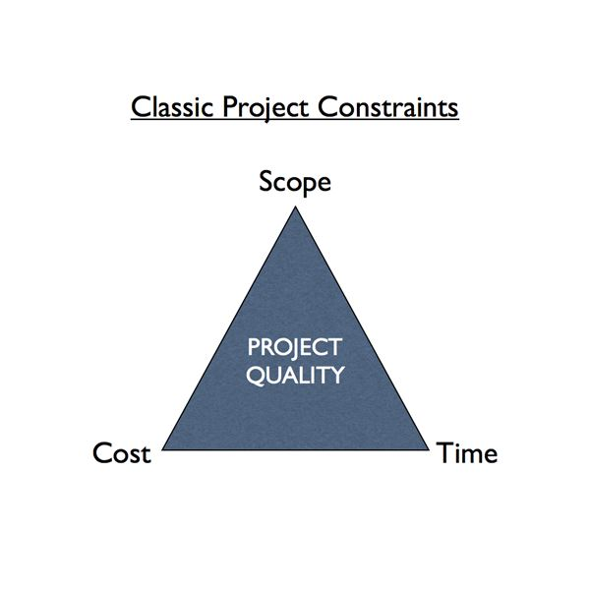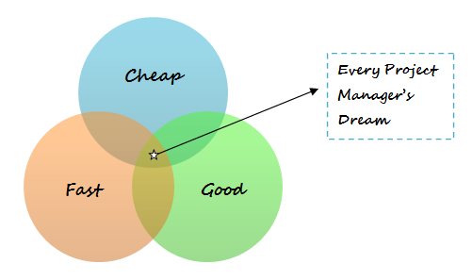
Technical constraints limit your design choice. For example, let’s say you’re constructing a pipeline, and according to the design your pipeline should be able to withstand a certain amount of pressure. Quite simply this pressure limit is your technical constraint.
Project Managers, and there teams, must identify all the project constraints (such as any milestone, scope, budget, schedule, availability of resources, etc.), and develop a plan accordingly. Constraints are outside of outside of a company’s control and they are imposed upon you by your client, organization, or by any government regulations.
There is an interesting fact about the constraints: If the constraints become false or are no longer valid, it is more likely that your project will benefit from it. The following are a few examples of constraints;
- You must complete 25% of the work within the first 30 days.
- You have to work with the given resources.
- You will be given only two site engineers.
The Project Manager must now analyze the information provided and assess how identified constraints affect the project and what will happen if any assumption fails or any constraint gets resolved or turns out to be false. If these project constraints are handled appropriately, it will assist in getting the project delivered on time while meeting stakeholders’ expectations.
IV. ‘Ratio analysis’ is one of the tools of risk analysis’. How is it performed?

Financial ratios are calculated comparisons of financial statement accounts or categories thereof. These interactions between the financial statement accounts help, internal company management, investors and creditors understand how well a business is performing and of the areas that need to be improved.
These financial ratios are easy to understand, simple to compute and are the most common and widespread tools used to analyze a business' financial standing. Since a ratio is basically a mathematically comparison based on proportions, big and small companies can be use ratios to compare their financial information. In this sense, financial ratios don't take into consideration the size of a company or the industry. Ratios are just a raw computation of financial position and performance and they can also be used to compare different companies in different industries.
Ratio analysis forms an essential part of the financial analysis which is a vital part of business planning. The key benefits of ratio analysis include;

- Determines profitability - Ratio analysis assists managers to work out the production of the company by figuring the profitability ratios. Also, the management can evaluate their revenues to check if their productivity is giving them the correct output.
- Helpful in evaluating solvency - By computing the solvency ratio, the companies are able to keep an eye on the correlation between the assets and the liabilities. If the liabilities exceed the assets, the company is able to know its financial position.
- Better financial analysis - Ratio analysis is also helpful to all levels of stakeholders such as, shareholders, debenture holders, recluses and creditors.
- Performance analysis - Ratio analysis is also helpful in analyzing the performance of a company over many years which gives a levelling effect to determine true gains/losses.
- Forecasting - At present, many companies use ratio analysis to reveal the trends in production. This provides them an opportunity for estimation of future trends and thus the foundation for budget planning so as to determine the course of action for the growth and development of the business.
V. How is the SWOT analysis performed for a business?

SWOT analysis is a matrix which looks at Strengths, Weaknesses, Opportunities, and Threats of a particular project or business in general. It is an appropriate tool for strategic planning and based on this analysis, objectives and goals can be set for a business which will provide a clearer and more objective picture to base decisions on as follows;

Strengths
This is an internal analysis of a company's/product's/service's strengths. Here is the place to sell the company and record the business's profile, resource's strength, major reasons why clients choose you over the competition, etc. Every business element that adds to the strengths of your products, services, and business standing can be added to this matrix.

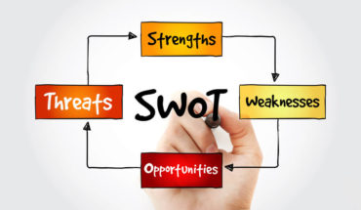

Weaknesses
We all have weaknesses and companies are no different. Here a listing of all the known issues that are preventing the business from reaching its full potential can be recorded. Sometimes it’s advisable to get a third-party opinion or even customer feedback to really understand the weaknesses of a business.

Opportunities
External analysis of the market a business is operating in is essential here, and gauging the opportunities that lie ahead for the business. Tracking down opportunities will immensely help in setting the company’s growth plans and understand current competition, business environment, and economic & political issues.

Threats
This involves external and internal analysis of the likely and probable threats that a business may have in the face of competition, Government policies, economic conditions, markets, trade unions, resource issues, etc.

Of course as with most analysis tools there are benefits of its use and some of these are listed below;
- It provides a clear view of the company’s strengths, and allows them to be enhanced to meet the business objectives
- It showcases weaknesses and provides a chance to build on them
- It gives an opportunity to look into the future and the opportunities that lie ahead. Using this a draft strategic growth plan can be developed based on your strengths and weaknesses
- It helps analyze possible threats to the business, and make required changes to the business policies and growth plans. Additionally, it facilitates making supplementary or alternative plans, contingency plans, and so on
The overall SWOT business plan could also be limited, misleading or impractical because of the following factors;
- If flawed data is used to analyze SWOT, incorrect decisions can be made
- External analysis may not be precise, as external factors are not within a company’s control
- This process normally involves lot of resources and associated cost
- The analysis could be biased if internal teams wish to showcase only their team's strengths and not weaknesses, as is sometimes the case

VI. “PEST analysis is a useful tool for analysing a business and in particular understanding market growth or decline." Discuss

PEST analysis, is a model in marketing principles. Additionally, this concept is used as a tool by companies to track the environment they’re operating in or are planning to launch a new project/product/service etc.

Also known as PEST(LE) this acronym, in its expanded form, denotes P for Political, E for Economic, S for Social, T for Technological, (L for Legal and E for Environmental). It gives a bird’s eye view of the whole environment from many different angles that one wants to check and keep a track of while contemplating on a certain idea/plan.



While conducting this analysis, there are certain questions that need to be asked which will give a company ideas of what things to keep in mind. They are;
- What are the current prevailing economic factors?
- What is the political situation of the country/counties involved with and how can it affect the business?
- Are there any current legislations that regulate the industry or can there be any change in the legislations for the industry in the future?
- How much importance does culture have on the market and what are its determining factors?
- What technological advances are likely occur and affect the market arrangement?
- What are the environmental concerns for the industry?

All the aspects of this technique are crucial for any industry a business might be in. More than just understanding the market, this framework represents one of the vertebras of the backbone of strategic management that not only defines what a company should do, but also accounts for an organization’s goals and the strategies stringed to them. This will enable companies to evaluate whether there is still growth within the market or if there is a possibility of decline the opportunity to looks at other areas of growth is considered.
It is imperative that any company who is considering to develop conducts the PEST(LE) analysis as it forms a much more comprehensive version of the SWOT analysis. It is very important therefore for those involved to understand the complete complexity of each of the letters of the PEST(LE) as outlined below;

- Political: These factors determine the extent to which a country’s government may influence the economy or a certain type of industry. Political influences include tax policies, monetary policy, trade tariffs etc. that a government may levy around the fiscal year and it may affect the business/economic environment to a great extent.
- Economic: These factors are basics of an economy’s performance that directly impacts a company and could have large long term effects. Economic factors include inflation and interest rates, foreign exchange rates, economic growth patterns etc.
- Social: These features scrutinize the social environment of the market, and gauge components like cultural trends, demographics, population analytics etc.
- Technological: These influences pertain to improvements in technology that may affect the operations of the industry and the market favorably or unfavorably. This refers to automation, research and development and the amount of technological awareness that a market possesses.
- Legal: These factors have both internal and external sides and there are certain country laws that affect the business environment, while there are certain policies that companies maintain for themselves. Legal analysis takes into account both of these angles and then charts out the required strategies needed.
- Environmental: These issues include all those that influence or are determined by the surrounding environment. Factors of a business environmental analysis include but are not limited to climate/weather, geographical location, global changes in climate, environmental balances etc.

VII. What is the importance of a marketing plan in the risk analysis of a business?

Marketing is essential because without it , potential clients may not be aware of the product or service your business is selling and without customers, most businesses will cease to exist. Marketing plays a vital role in business because planning how to reach potential customers helps to ensure that people are aware of your product or service and that you have an opportunity to convert that awareness into paying customers.
Marketing planning serves as a written guide for a business to follow in promoting its products and services and by scheduling the marketing strategies ahead of time allows companies to be proactively involved in the success of its sales.
Because the marketing plan is a portion of the overall business plan, a company can align marketing strategies during the planning stages with its overall business goals and assess/analyze any associated risks .
Planning marketing is hard work and involves more than just the marketing manager as it needs to integrate all aspects of a business, ranging from how products and services are priced to the financial state of the company and as a result, this brings upper management and the heads of departments such as finance together. This planning strategy still plays the role of integrating a business and requiring it to analyze itself from all of the different vantage points: finance, operations, legal and marketing.
This planning process also plays a forecasting role because it requires companies to estimate sales resulting from each marketing effort. A company’s operations department uses sales forecasts to create a production schedule. The finance department also uses these forecasts to create budgets, while the HR department looks to sales forecasts to plan for the correct skill set and number of employees.
An effective marketing plan must take a close look at a company’s products and services and compares them to their competitors in the market sector. A review of the company’s products in terms of quality, customer interest and customer response, among other qualities must also be carried out so that these elements can be adjusted to help a company develop new products and improve existing products as the company pursues its goals and targets.
The marketing plan must always keep in mind the company’s pricing position for its own products and services against those of its competitors. This will allow marketing professionals to run pricing comparisons of other company products and services within the marketing sector and then compare these prices to their own company’s prices. The results will help the company develop a pricing plan that serves two primary purposes: a) enable the company to price itself strategically within the market and b) assist the company in reaching its own financial goals.
2. Discuss the outputs of a business risk analysis. (6)

Numerically analyzing the effect of identified risks on overall project objectives is classified as Quantitative Business Risk Analysis.
As the name implies, the techniques in this process are quantifiable: In other words, you have to do the math’s and decide the likelihood and impacts as well.
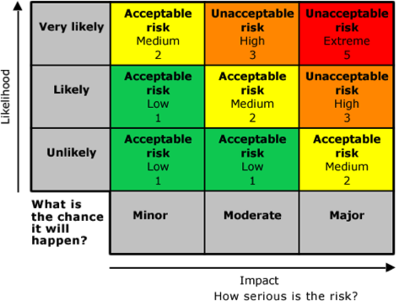
The purposes of performing quantitative analysis are to;
- Execute a deeper analysis on those risks that will likely/possibly and substantially impact a project or business objective (as illustrated in the above chart).
- Define the likelihood of meeting cost and schedule objectives and provide a range of conclusions or scenarios.
- Determine realistic schedule and budget targets given the project risks.
- Make available a method to calculate some of the uncertainty in the project to make better decisions.

So what does all this analysing work provide? For starters, it delivers quantified information on those risks that pose the greatest risk to a project (numerous analytic tools such as EMV, decision trees, and PEST analysis can also help assist with that).
The outputs from the risk analysis (as detailed above) and risk assessment processes will generally be used twice. Initially it will be when decisions are made: for the risk analysis, that means deciding whether or not to proceed on a new project; for the risk assessment, that means identifying the types of controls or safeguards that need to be implemented. For risk assessment, the output will identify what countermeasures should be implemented or document that management has determined that the best decision is to accept the risk.
A simulation can then be carried out using the outputs and this will indicate the likelihood of meeting cost and schedule objectives. This mock-up can also be used to note project performance trends. If the simulation is run once per quarter, for example, and the findings show that the probability of hitting your budget target is progressively going down, you’ll want to put some corrective action measures in place.
The other time the results will be used is when the "muck hits the fan." That is, when a problem arises and the organization must show the process it used to reach the decisions that it did, the inputs, tools used and outputs as illustrated below. The documentation created in the risk management processes will allow the organization to show who was involved, what was discussed, what was considered, and what decisions were made.
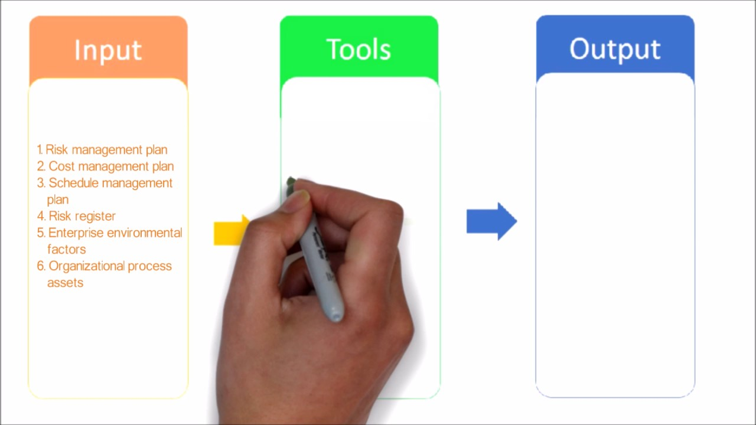

Case Study
A global energy company was considering a significant investment opportunity in Central Asia, a region where it had no previous experience. The country in question had a reputation as an unpleasant business environment, rife with rumours of bribes, licensing irregularities, and unwarranted government intervention. The company's senior management asked CRO to examine and assess the local business practices, with a particular focus on the business behaviour of competitors. CRO presented his report after a complete market risk analysis. According to this report the prevailing corrupt practices included off-the-record payments to facilitate licensing and contract agreements, improper influence in the tender process, regular extortion, and organized crime.

Question (10)

1. How do you think that CRO has gathered this information?

The CRO will have used one (or more if required) of the most appropriate analysis models such as PEST(LE) to gather his base information, and as indicated earlier, this model will cover areas such as;

- Political
- Economic
- Social
- Technological
- Legal
- Environmental

This approach for conducting background research on potential business partners in risky countries will depend on the potential partner’s risk ranking. To assess the risk level, companies can use the information collected an initial questionnaire. Factors to consider include the type of relationship, corruption risk associated with the jurisdiction, interaction with government officials, compliance regime, and known adverse information about the potential business partner.
Clearly, as the country being considered has a “history” with regards to non-ethical practices, the CRO will have focused in depth on the local business practices and behaviour of competitors who also operate in the region.


Business partners typically are divided into three categories: high-risk, medium-risk, and low-risk. High-risk business partners, as is the case in this study, include those located in a country with a considerable risk of corruption, those having significant interaction with government officials, or those for which red flags have been identified in the due diligence process.
Medium-risk business partners may have a lesser degree of contact with government officials, such as lawyers or accountants, yet are located in a high-risk jurisdiction. Low-risk business partners might include vendors of goods and services that are not acting in an official capacity for the company.
In this case the CRO would have hired an outside firm to conduct background research to benefit from access to sources otherwise not readily available and to demonstrate independence in the vetting process. When vetting a representative who has a high degree of contact with government officials, or one located in a high-risk jurisdiction, for example, single-database resources will likely prove insufficient. Local resources may be required for record retrieval and for human-source inquiries regarding the potential business partner’s reputation and background.

2. What should be the company’s approach based on this report?

Unless suitable safeguards are put in place it would be unwise for the company to invest in this country/region as doing business in countries that are rife with corruption can be arduous, frustrating, even dangerous. But companies that survive the experience, and learn from it, can develop an unusual competitive advantage that will serve them well when entering similar challenging markets around the world.

What is essential is to adopt a growth strategy and forge a relationship with the local government in a way that is aligned with the political situation in the energy market. Gaining experience in this market and location will potentially encourage the company to enter other difficult county markets, where competitors without similar experience are reluctant to follow.
According to various studies there are four main approaches for those wishing to operate in a corrupt market and these are fixed to increasing levels of corruption;
1. When firms can gain political influence in a country, they can attempt to use that influence to alter the regulatory structure. This can mean lobbying governments to reduce overall corruption or networking with other firms to argue for preferential regulatory rules.

2. In countries with limited regulation, firms can largely avoid the local political structure. Instead, they can create self-regulating industry associations, which effectively shift the decision-making power from the government to the industry and its stakeholders.

3. Companies with fewer political options in countries with strong centralized governments that enact overbearing regulatory laws, such as China and Russia, usually ally themselves with the government, networking with powerful officials and launching joint ventures with local firms. Companies using this strategy should also promote corporate social responsibility as a way to garner positive publicity and get influential stakeholders on their side, with the ultimate goal of influencing political decision makers and lessening the risk of regulatory interference.



4. Finally, the choice to accede is the strategy used by companies that don’t possess many political resources in countries where regulation has little impact on their industry — for example, in recently war-torn nations and emerging economies. To gain a foothold, companies might be tempted to use outright bribery. A safer choice would be to accept bureaucratic delays and slowly gain political influence.

Bottom Line;
In this case study the company can cope with government corruption by understanding the political situation in each market and operating accordingly. In this setting however they must proceed very carefully for fear of breaking anticorruption laws back home and risking damage to their reputation. The ultimate decision must be made by the Senior Management.

3. If the company goes for investing in this region, should they follow the prevailing business system or should they continue working in their own way?

As indicated in answer 2) above, if the company wishes to operate in a known corrupt environment they must approach the country concerned as a “one off situation” and understand what needs to be done to deal with the envisaged corrupt situations they may face.

 Of course, as with most major companies who operate around the world and invest in overseas opportunities, they will most likely have a robust business system in place that can be followed to ensure no malpractices take place within their operational activities.

It is normal for companies to follow their own business systems, regardless of operating country, as they are regulated and governed by country and international laws with regards to ethics and bribery and deviating from this path could cause irreparable damage to the business and reputation accordingly.

Student Statement:

By submitting this assignment, I confirm that this is my own work.

Student Signature | Raymond Wilson | Date | 6th March 2017

For Tutor / Assessor Use Only
Total Marks
Marks Obtained
Percentage / Grade

