ASSESSMENT # 1 Total Marks: 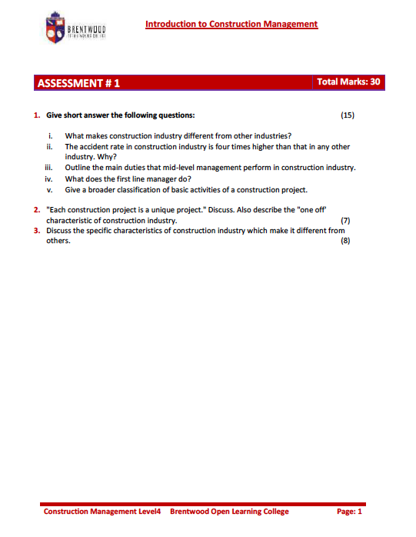

Answers

1.i One way in which construction differs from other industries is that no two projects are ever the same. One major difference between the construction and mainstream manufactories industries is that products from construction are stationary while from other manufactories industries tend to be mobile during value addition.

1.ii Construction projects are inherently dangerous because of the high propensity of an accident accruing. The wide range of the varying working conditions involving supported structure, moving equipment and labor make the site highly unpredictable environment.

1.iii They are involved in procurement of materials, labour and equipment management they also may be responsible for highly specialized duties.

1.iV A first line manager duties are:

- Instructing workers on what to do
- Encourages teamwork spirit
- Motivates workers to accomplish all objectives
- Ensure workers are well behaved
- Deal with all conflicts arising at the work site
- Promote a good relationship with general public
- Ensure plans and schedules are adhered to buy regular inspection and quality control
- Trains and develops the work force to meet new challenges

- V The main categories of activities of a construction project are:

- Design and planning
- Executing construction work
- Supervision and inspection

- “ Each construction projects in a unique projects “. Because each construction project is defined by the nature of the site of construction and is also influenced by the weather as well as the ground conditions due to various site locations.
“One off characteristic of the industry” Construction industry is one of the most important industries in earth is one of the biggest source of the employment and it’s a powerful tool for development and economic progress. Construction industry requires moving recourses from one place to other to create products under dynamic and hazardous working conditions.

The characteristic of construction is:

- Complexity
- Uniqueness
- Mobility of facilities

