

Assignment Cover Sheet
Student Name | Hiyam Daou
Student Number | 2320
Course | Diploma in Diet & Nutrition
Assignment No | Test 6 Balancing Diet

Q.1. Multiple Choice Question:

- A sedentary man who has calorie requirement of 2400 a day. takes 500 calories from proteins in his diet what is the percentage of protein in his diet?

- 20%
- 30%
- 50%

- a person has consumed 45 grams of food. The table shows that 100 grams of this food contains 80 calories. How many calories the person has consumed?

- 20
- 25
- 36

- fat content of a daily intake in a balanced diet should be

- 1%
- 2%
- 5%

iv. based on their nutrient content foods are categorized into

- five man groups
- six main groups
- seven main groups

v. how many portion of fruits and vegetables person should eat in a day?

- 3 portions
- 4 portions
- 5 portions

vi. one serve of cereal equals to?

- 1 cups of cooked rice pasta or noodle
- 2 cups of cooked rice pasta or noodles
- table spoons of cooked rice pasta or noodle

viii. fiber helps in the process of digestion and can

- lower blood cholesterol
- increase blood cholesterol
- cannot effect cholesterol level

vii. the glycemic index Gi is a way of ranking carbohydrate foods based on

- how quickly they decrease blood sugar levels
- how quickly they decrease energy levels
- how quickly they increase blood sugar levels

ix. fat transports

- vitamins C and B1 around the body
- vitamins A, D, E and K around the body
- vitamins C and D around the body

x. anti-oxidants are present in

- caffeine
- soft drinks
- green tea
Q.2. short Question:
All questions carry equal marks

- what are trace minerals?

Minerals are essentials found in a large variety of animals which and plant foods they help the body perform regulatory and structural functions. The word trace refers to the low amount of these minerals that the body needs less 100 milligrams per day. it also refers to the fact the body typically only has 5 grams or less of the mineral in the body.
Example are iron, zinc, fluoride, and iodine, other trace minerals include copper, selenium, molybdenum, chromium and manganese. All trace minerals are necessary for the body, especially the ones listed above.

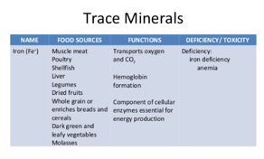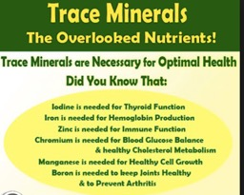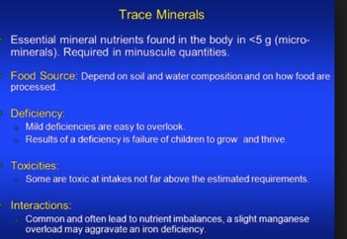

- Why should we prefer whole grain foods over refined foods?

Whole grains retain a lot of their nutrients including fiber and protein, which are good for digestion and for keeping you feeling full. Whole grains also contain tons of vitamins and minerals. Like antioxidants and other vitamins in their bran, and B vitamins and healthy fats in their germ. While refined grains like white flour are enriched with nutrients to make up for the ones lost in the processing, many of the nutrients aren’t replaced.
Loss more belly fat. Belly fat is a risk factor for heart disease and stroke. People who are eating whole grains instead of refined grains lost more weight and belly fat the reason why because the fiber in whole grains helps regulate blood sugar.
Reduce high blood pressure. Compared brown rice to white rice found that brown rice and half-milled rice contain an ingredient that helps block angiotensin II, a protein that may lead to high blood pressure and clogged arteries. White rice doesn’t contain that ingredient its taken away when rice is refined.
Whole grains help you feel less bloated while refined grains can contribute to a bloated feeling. Whole grains aid in digestion.

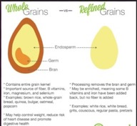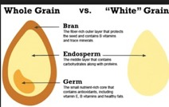

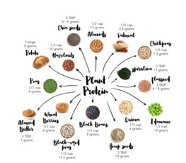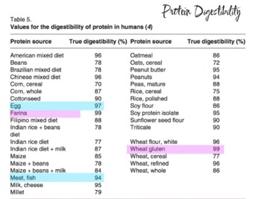
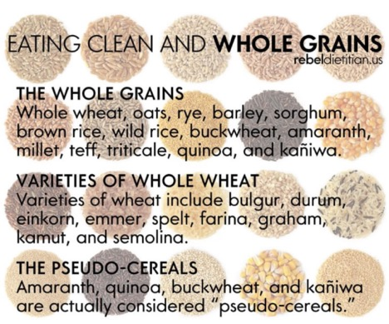

- What are the two main types of sugar?

Monosaccharides and disaccharides and the relationship between these and certain large carbohydrate.
Sugar is a carbohydrate that is soluble in water sugar are usually crystalline and have a sweet taste.
Chemicals that are sugars often have names ending in ose
For example, note the suffic, ose,in fructose, glucose, galactose, sucrose, lactose, and maltose.
The word-ending saccharides does not necessarily indicate that the chemical or group or category of chemicals is a sugar.
Monosaccharides are simple 9UNIT0 sugar.
Disaccharides consist of molecules whose form is that of two monosaccharides molecules joined together.
The main categories of sugars are Monosaccharides and disaccharides. They are often describing together with polysaccharides and sometimes also oligosaccharides due to the chemical relationship between these types of carbohydrates.

Monosaccharides
Monosaccharides are also called simple sugar.
Monosaccharides are the common base unit of all carbohydrates molecules.
Mono= one
Characteristics:

soluble in water, sweetness varies with induvial monosaccharides
example: fructose also known as fruit sugar main sources are fruits and honey.
Glucose used for body energy.
All other carbohydrates including all other sugars are converted into glucose within the digestive system(digestive processes)
Present in various forms of vegetation including many ripe fruits as well as onions and beetroot.
Galactose present in mammals’ milk (see also the disaccharide lactose which is composed of glucose and galactose)

Disaccharides
Chemical structure consists of exactly two monosaccharides joined together.
DI= TWO (2)
Characteristics: soluble in water. Must be broken-down into monosaccharides before they can be absorbed into the body.
Source present in fruits sugar cane or sugar beet also present in some vegetables.
Lactose chemically = glucose+ fructose also presents in mammal’s infants with source of energy also in milk associated with dairy products.
Maltose chemically one maltose consists of two glucose molecules attached together.
Present in cereal barley also known as malt sugar.

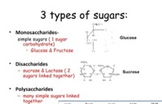

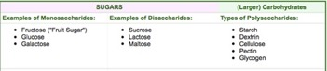

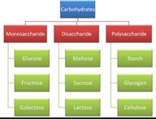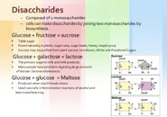

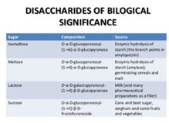

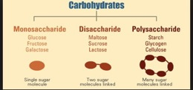

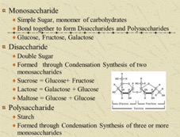

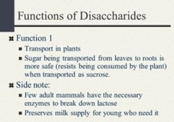

- Describe methods for healthy preparation for fruits and vegetables?

Buy the best fruits and vegetables you can find. Purchase fresh locally grown produce if you can check out organic fruits and vegetables which more expensive but provide the guarantee that they were grown without chemicals or hormones.

Preparation wash your hands with warm soapy water for at least 20 seconds before you handle food. Dry them with paper towel or clean cloth.
Rinse your fruits and vegetables in clean water. Run the food under cold water to remove any bacteria dirt insects or pesticides. You should do this for produce with skin as well such as bananas and avocados.
Use a clean vegetables brush to scrub items with a firm surface such as melons and cucumbers.
Dry the fruit and vegetables with a paper towel. Use the towel to lightly pat the produce to absorb any remaining water.
Prepare food for eating storing or cooking by cutting off any unnecessary stems or roots. Trim te leaves off celery shuck the husks off corn and remove grapes from their stems.
Store fresh produce in the refrigerator. Items that you plan to eat fresh such as apples carrots oranges and cucumbers can have kept at room temperature but will stay fresh longer if you keep them cool.
Cut fruits and vegetables into large pieces. If you plan to cook, your produce keeps the pieces as large as you can and minimize the time they spend cooking or stewing in any liquid. This will retain more nutrients.
Cook fruits and vegetables. You can do this steaming grilling roasting baking microwaving or frying them. They can be mixed with other ingredients including meat pasta rice and incorporated into breads and desserts.
Keep frozen fruits and vegetables in the freezer until you are ready to use them allowing them to defrost you cook and eat them may affect their taste.
Avoid soaking your fruits or vegetables in water. The water will work on the food and eliminate important nutrients such as vitamin.
Cut away any damaged or bruised areas of your produce. Bruises and cuts can allow pathogens to enter the fruit or vegetables.
Clean your counter top cutting boards and utensils after you prepare each food item, wash kitchen surface and utensils with hot soapy water.
Keep your workspace clean is especially important if you have peeled your produce without washing it. Bacteria from the outside of raw produce can be transferred to the inside when it is cut or peeled.
Inspect your produce make sure there are no specs of dirt or any tiny bugs remaining on your fruit and vegetables if you find some re-wash the produce.
Dry produce after washing dry every everything you have rinsed with clean paper towel. This will remove any lingering bacteria.
Scrub any produce with a thick skin like carrots potatoes which are grown in soil or cucumbers and melons. Brushing them helps to wash away hard-to- remove microbes just make sure the brush isn’t too rough it could damage the produce.
Be gentle with fragile produce some fruits and vegetables like raspberries which crush easily and become mushy when they take in too much water wash. put delicate produce in a colander and gently spay with water.
Mushrooms needs to be cleaned differently than other vegetables, if you rise them too much or soak them water they will become soggy. You must rise them lightly with just a sprinkle of water. Dry immediately and gently with paper towels.
Do not overcook to reduce nutrient loss.
Use stir-fry grill microwave bake or steam methods with non-stick cookware and mono-unsaturated oils.
Some nutrients such as carotenoids may actually be increased if food is cooked. For example, tomato has more carotenoids especially lycopene when it is cooked.

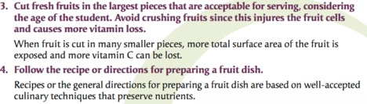
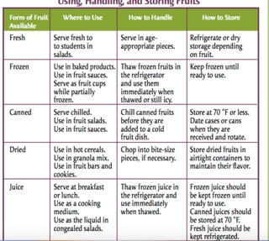

- What is the importance of adequate fluid intake?
Water or overall fluid consumption should be consistent with your lifestyle. Adequate fluid intake may improve metabolic functions, liver function endocrine gland function, and overall fluid status. Fluids may also help manage your appetite.
The adult body is 50-70 percent water. The leaner you are the greater your percent water since muscle contains than 80 percent water while fat has less than 30 percent.
Water is by far the most important nutrient for the human body. Next to oxygen the body needs water to survive it’s important to take in as much water as we can. our body replace 2 and half quarts of water each day to keep running; and in order to stay healthy our bodies need lots of water. Water is essential for many functions of the food. Its helping with digestion the absorption of food the regulation of body temperature and blood circulation, the carrying of nutrients and oxygen to the cells in the body and for the removal of toxins. Water also helps with the movement of joints, and helps protect tissues and organs in the body. It is also good to drink water for metabolic and weight loss purposes. Drinking water metabolizes stored fats, and helps maintain proper muscle tone. Water prevent dehydration.
Water consumption helps with the protection of movement of joint and other organs and tissues in the body. In between joints in the body there is a lining of cartilage that exists. The lining of cartilage between the joint uses water as a cushion between the bones so that the joints can move easily. If there not enough water consumed dehydration can occur in these joint, which may cause arthritis.
Water consumption can aid in protecting the gastrointestinal lining in your body as various organs and tissues. And protecting the spinal cord from shock and damage.
Water help to create most enzymatic and chemical reactions that occur in the body. Because it moves so may elements nutrients hormones oxygen and antibodies via the lymphatic system as the bloodstream, its important to have a proper intake. Proteins and enzymes found in the body will function more efficiently in lower viscosity fluids, which is important to balance with proper intake of water. Water regulate all functions of the body including everything that helps to circulate and dissolve.
Water intake helps metabolize fat. It is the liver’s job to metabolize fat and in order to do so it needs water. If not enough water consumed the liver takes over the job of kidneys. When the liver takes over the job of the kidneys however it is no longer able to metabolize fat in the body.
Therefore, the more water consumed the more the body will metabolize fat.
When the body is dehydration it has no reserve system it has to operate a distribution system for the amount of water that been made available.

Dehydration causes many side effects on the body as well you can produce joint pain, stomach pain and ulcers back pain dizziness feeling of disorientation and confusion. If you are not drinking water your body start to retain.
If you don’t maintain your body’s regulate fluid intake balance you can damage every part of your bod’s physiological functions. It is always important to drink more than limiting it to when you are thirsty.
When you exercise you perspire twice as much as you drink, therefor very important to keep hydrate. It’s better to be taken warm. warm water is known to absorb more quickly into your system than cold water.
In order to determine how much water, you should drink daily you must take weight and divide by 2. If you weigh 200 pounds than you should be drinking 100 ounces of water on average day.

Your weight divides by 2= how much water you need daily
Water consumption is crucial to a healthy lifestyle. Without water our bodies could easily begin to shut down. Water is needed for so many functions in the body.

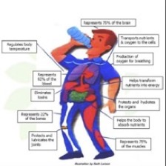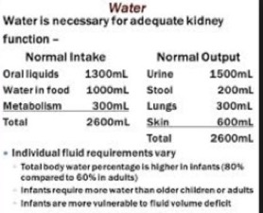

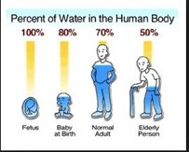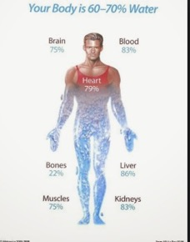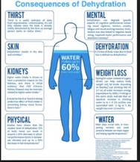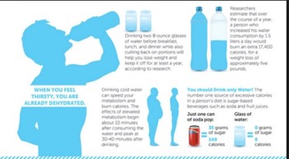
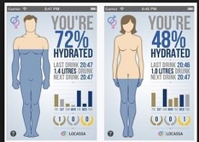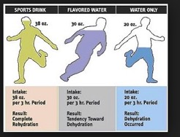

- What is energy density?

Energy density is the amount of energy or calories per gram of food. Lower energy density foods provide less energy per gram of food so yo can eat more of them without consuming too many calories. So this is a good way to help control how much we eat, without going hungry and may also be a great new way to help you lose weight.
Low energy density foods include foods with a high water content such as soups and stews foods like pasta and rice that absorb water during cooking, and foods that are naturally high in water such as fruit and vegetables food that are high in fiber such as wholegrain breads and cereals and lower fat foods also tend to have a lower energy density. High energy density foods tend to include foods that are high in fat and have a low water content for example biscuits and confectionery crisps peanuts butter and cheese.
How is energy density calculated?
You need to know the weight of a serving of the food in grams and the amount of calories that serving contains. The energy density of foods is the number of calories divided by the weight.
Energy density = no of calories/weight gram

Very low energy density foods= less than 0.6 calories/gram
Low energy density foods = 0.6 to 1.5 calories/gram
Medium energy density foods = 1.5 to 4 calories/gram
High energy density foods = more than 4 calories/gram
Its better to eat mostly foods that are very low, l medium in energy density and consume higher energy density foods in small amounts.

Example
Foods with lower energy density less than 1.5 calories/gram include fruit and vegetables and foods with lots of added water such as soups and stews. Lower fat foods including pasta noodles breakfast cereals and yogurt also tend to have a lower energy density . these foods should make up most of what we eat.

Here are some more examples:
Most types of fruit and vegetables
Most types of soup
Porridge made with water
Bran flakes with skimmed milk
Low fat yogurt
Baked beans
Potatoes
Boiled rice
Foods with high energy density more than 4 calories/gram tend to be high in fat and have a low water content e.g. biscuits and confectionery crisps peanuts crackers cheese butter oil and mayonnaise. When consuming a low energy density diet you can still eat foods from this category but in small portions and not too often.

Energy density is the amount of energy or calories per gram or calories per gram food
lower energy density foods provide less per gram of food so you can eat more of them
without consuming too many calories. 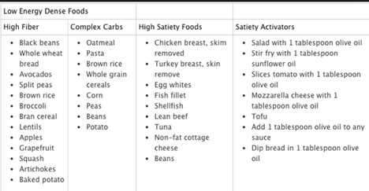 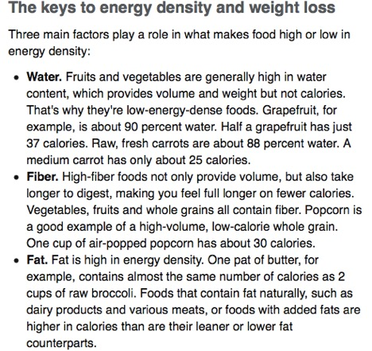
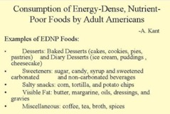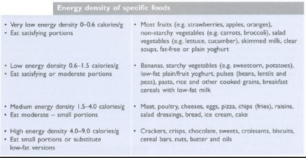

- Describe the best sources of dietary fiber. How does it benefit our health?
Nuts almonds pecans and walnuts have more fiber than other nuts
Baked potato with skin. It’s the skin that’s important here berries all those seeds plus the skin give great fiber to any berry.
Oatmeal whether its microwaved or stove cooked oatmeal is good fiber. Vegetables the crunchier the better. Beans think three bean salad bean burritos chill soup.
Whole grains that means whole bread pasta.
Brown rice white rice doesn’t offer much fiber
Popcorn it’s a great source of fiber.

High fiber diet may also help reduce the risk of obesity heart disease and diabetes.
Women eats at least 21 to 25 grams of fiber a day while men should aim for 30 to 38 grams a day.

Fiber choices
Whole grain products
Vegetables
Beans peas and other legumes
Nuts and seeds

The benefits of fiber:
Blood sugar control: Soluble fiber may help to slow your body’s breakdown of carbohydrates and the absorption of sugar, helping with blood sugar control.
Heart health: An inverse association has found between fiber intake and heart attack and research shows that those eating a high fiber diet have a 40 percent lower risk of heart disease.
Stoke: Researchers have found that for every seven-gram more fiber you consume on a daily basis your stroke risks decreased by 7 percent.
Weight loss and management: Fiber supplements have been shown to enhance weight loss among obese people, likely because fiber increase feelings of fullness and slow carbohydrate metabolism.
Skin health: Fiber particularly psyllium husk may help move yeast and fungus out of your body preventing them from being excreted through your skin where they could trigger acne or rashes.
Diverticulitis: Dietary fiber especially insoluble may reduce your risk of diverticulitis an inflammation of your intestine by 40 percent.
Hemorrhoids: A high fiber diet may lower your risk of hemorrhoids by preventing the need for straining.
Irritable bowel syndrome: Fiber may provide some relief from IBS.
Gallstone and kidney stones: A high fiber diet may reduce the risk of gallstones and kidney stones, likely because of its ability to help regulate blood sugar.
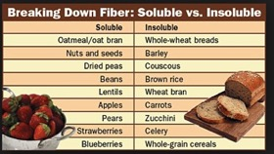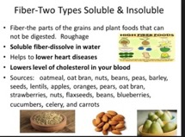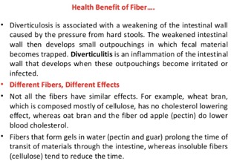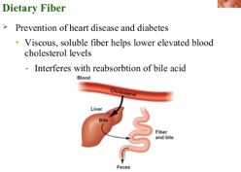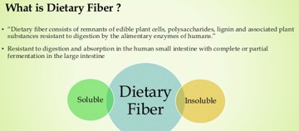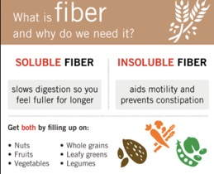
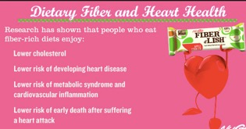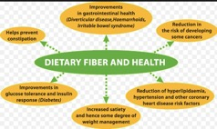

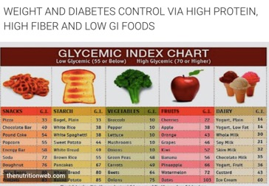
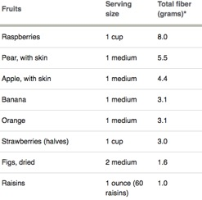
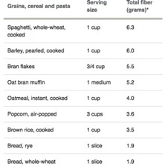
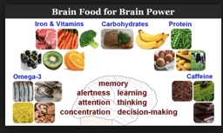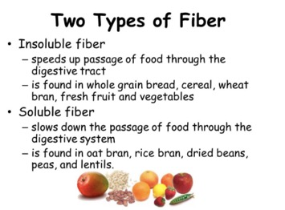

- What is Glycaemic index (GI)?

Glycaemic is a system that ranks foods on a scale from 1 to 100 based on their effect on blood-sugar level.

Glymeamic GI is a measurement carried out on carbohydrate-containing foods and their impact on our blood sugar. GI is a relatively new way of analyzing foods. Previously most meal plan designed to improve blood sugar analyzed the total amount of carbohydrates including sugars and starches in the foods themselves. GI goes beyond this approach looking at the impact of foods on our actual blood sugars. GI counting the total amount of carbohydrate in foods in their unconsumed state.

Why its important low GI diets have been associated with decreased risk of cardiovascular disease, type2 diabetes metabolic syndrome stroke depression chronic kidney disease formation of gall stones, neural tube defects, formation of uterine fibroids and cancers of the breast colon prostate and pancreas.

The glycemic index GI is a measure of how quickly blood glucose level rise after eating a particular type of food.
Glycemic index of 100 which is taken as a standard value. GI estimates how much each gram of available carbohydrate in a food raises a person’s blood glucose level following consumption of food relative to consumption of pure glucose. So the lower the GI of a food the healthier it is for you.

How is GI measured?
After 50gram of available carbohydrate have been consumed blood sugar level ae measured over a period of 2 hours. The results are plotted on a graph and summarized in what is called glucose AUV or area under the curve Glucose AUC shows the immediate impact of the food on our blood sugar.
Measuring GI requires a second step. In this second step 50 grams of available carbohydrate are consumed but this time the food involved is one of two reference foods: either white bread or pure sugar glucose once again blood sugar level are measured over a period of 2 two hours. And the glucose AUC is calculated. At this point it is possible to compare the two results. The impact of the first food on our blood sugar is compared to the impact of either white bread or glucose itself. When those two results are compared to the impact of the white bread or glucose is arbitrarily given a value of 100 to make the comparison easier.

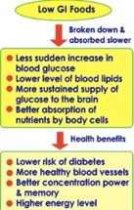
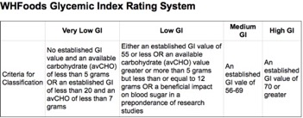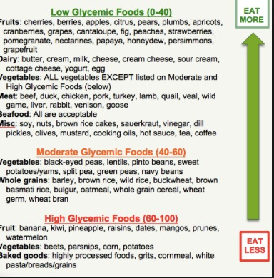

3. why is calcium important especially for children? And what are calcium alternatives for those who exclude milk and dairy products

calcium is an important part of the daily diet especially for children it is essential for the growth of strong bones and teeth. Dietitians and dentists recommend that children should meet their calcium needs by eating dairy foods and having a well-balanced diet.
Severe calcium deficiency can result in diseases like rickets in children and osteoporosis later in life.
Bones need calcium
Calcium is the most common mineral in the body. Around 99 per cent of the calcium in the body is found in the bones or skeleton the rest is in teeth soft tissues and blood. The skeleton is a living tissue and acts as a calcium reservoir which needs to be topped up daily. A high intake of dietary calcium is essential for growth of strong bones and teeth.
Calcium phosphorus and vitamin D work together in the body to achieve the right calcium levels that your body needs. Dietitians and dentists recommend that children should get calcium from eating dairy foods and having a well-balanced diet.
A low calcium diet in childhood may be linked with osteoporosis later in life. Osteoporosis can lead to fragile bones and an increased risk of fractures.

Milk promotes calcium absorption dairy foods are the richest source of calcium.
Calcium absorption is helped by the milk sugar lactose which seems to assist in uptake of calcium by the body. Vitamin D and phosphorus also help the body absorb calcium.

Milk is a major energy source during the rapid growth experienced by young children.
Children one to two years’ low fat milk is not suitable they should have full milk and dairy products
Children over two years can consume reduced fat milk and dairy products.
Recommended dietary intake of calcium for children
Babies children and teenagers require the following amounts of calcium:
Babies= 0 to 6 moths breastfed recommended datary intake 300mg
Babies 0 to 6 months’ formula fed 500mg
Babies 7 to 12 months 550mg
Children 1to 3 years 800mg
Children 8 to 11 years’ girls 900mg
Boys 800mg
Children and teenagers 12 to 15 years’ girls 1000mg boys 1200mg
Teenagers 16 to 18 years’ girls 800mg boys 1000mg

Other alternative of calcium
Cheese yogurt or milk-based custards.
Sardines and other fish that contain fine bones that can be eaten.
Nuts such as almonds have moderate amount of calcium and protein hoverer nuts are not suitable for very young children.
Leafy green vegetables such as broccoli spinach and bock choy.
Some breakfast cereal is fortified with calcium read the label carefully.
Some soy drinks are fortified with calcium read the label carefully.

