
Assignment Cover Sheet

Student Name: | Marie Markey
Student Number: | 1387
Course: | Fashion & Design
Assignment NO: | Fashion Forecasting

Assessment 3 Total Marks: 30

1. Give short answers for the following questions: (12)

- How the income groups influence fashion?
High, medium & low income earners all influence fashion in some way. High-income earners are more easily able to buy & wear the newest fashion trends straight from the catwalk at a high price as they can afford to do so. Their high profile being seen in the new trends then trickles down to the High Street stores for the medium income buyer to purchase – which could keep that trend stable for a while. The low-income buyer may be limited with their wardrobe and may mix & match, shop in charity shops & try different styles together in an effort to create a new look. This new look may catch on and make its way back up to the designers.

- Why is awareness of fashion forecasting important for the designer and the buyer?
For the designer it is crucial to get the very best quality & detailed forecast information as this dictates their success. For the buyer, especially the high profile individual always in the public eye, they want the cutting edge fashion – sometimes wanting to be ahead as this is a very big part of their persona/package.

- What is meant by fashion trend?
A fashion trend is a common theme amongst clothing that is very popular with consumers and is now classed as fashionable.

- What are the different factors that affect fashion trend?
A number of factors such as seasons, popularity of a trend may make it a short-lived trend as the consumer tires of it, clothes from a certain era can come and go at any given time.

Activity

2. Define the following terms;

Classics – simplicity of design, ease of wear
Fads – A very popular short-lived trend
Interrupted cycles – Consumer buying in halted due to external factors
Recurring cycles – Designers bring into their collections a fashion trend from a previous era
Fashion adaptation – Is the process fashion goes through on its way to the consumer/High Street manufacturer
Traditional fashion adoption – The reproduction of the newest & sometimes outrageous fashions from the catwalk to the High Street – modified to suit taste & price
Reverse adoption – When fashion begins with the consumer and works back up to the designer
Dissemination – This is fashion that is made for a specific area and comes under one umbrella eg: childrens’ wear would be this

Activity

Look into some old and new fashion magazines, read fashion columns in the daily newspaper. Compare contents with fashion looks six months ago. From the information you find, try to analyse the fashion directions for the future. Organise your ideas for few basic trend forecasts for colour, fabric, silhouette and line.

From current fashion magazines, collect five examples of each of the following types of fashion: (a) high fashion; (b) mass fashion; (c) classic; (d) fad. (10)

High Fashion
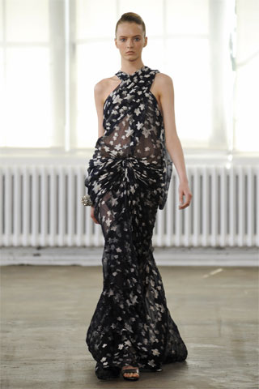

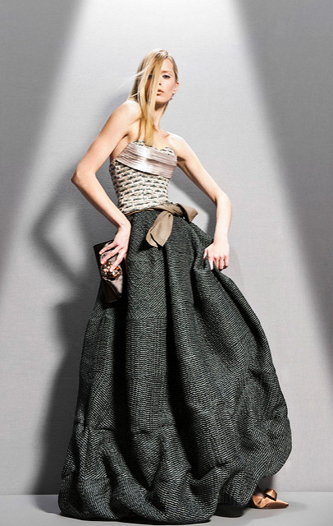

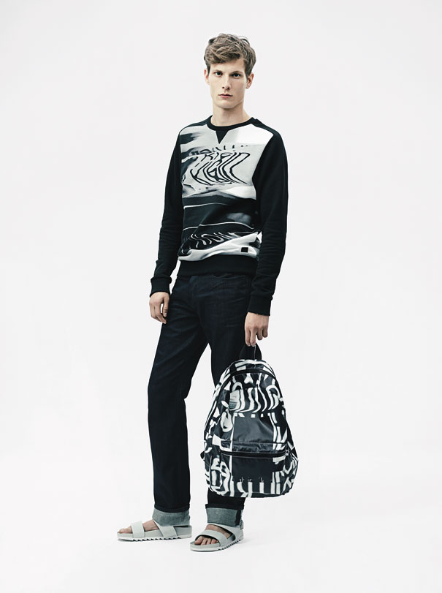

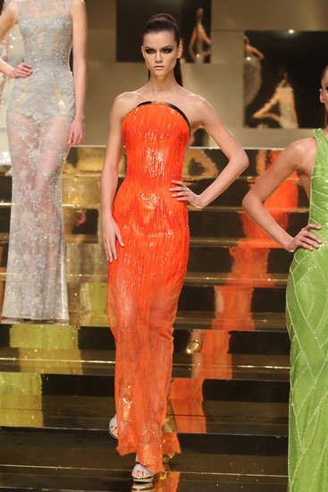

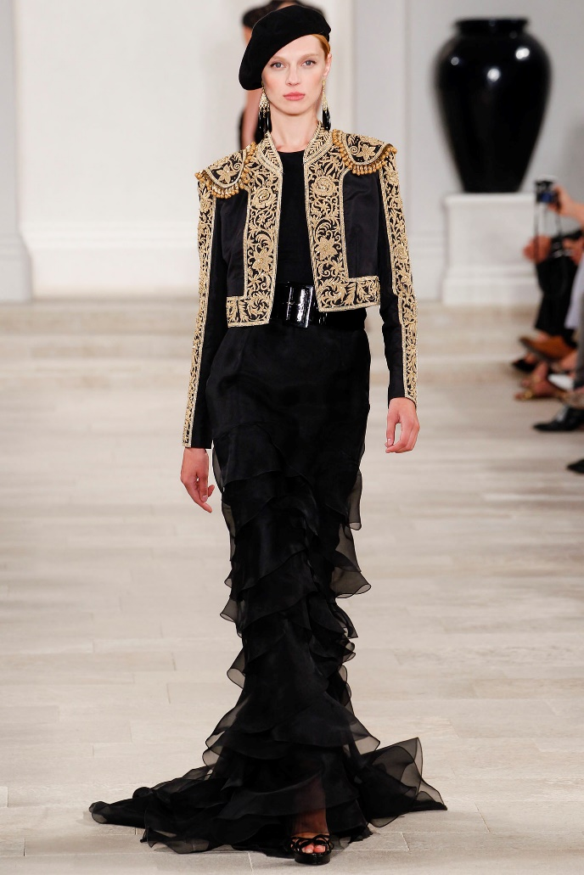

Mass Fashion

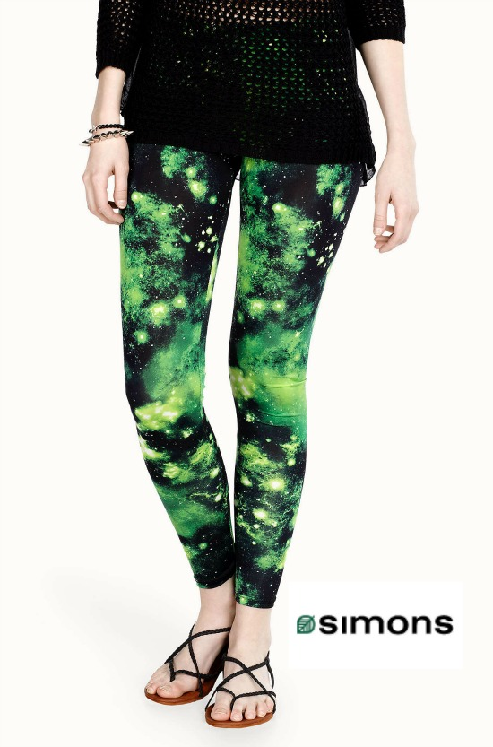



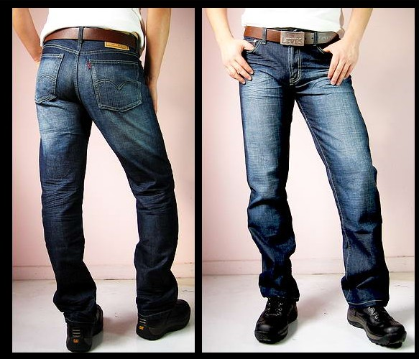

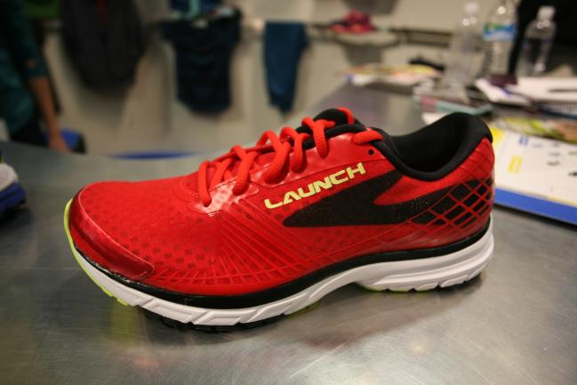

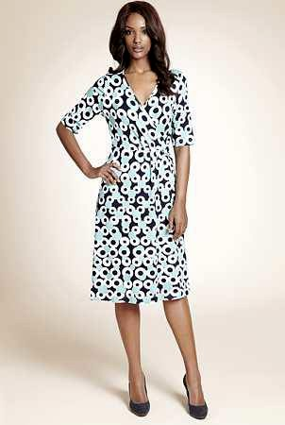

Classic

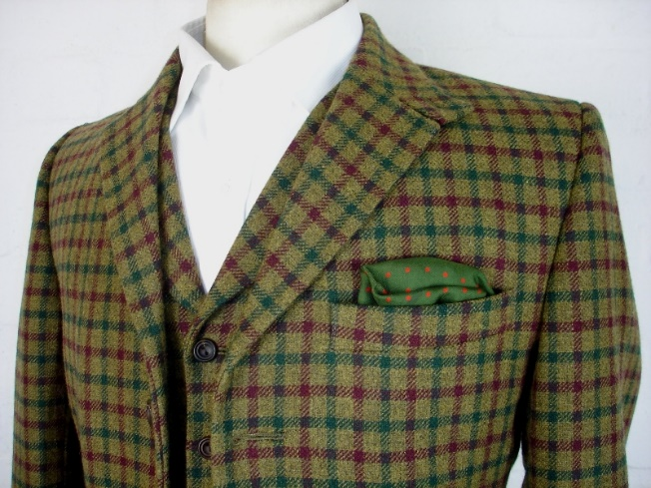

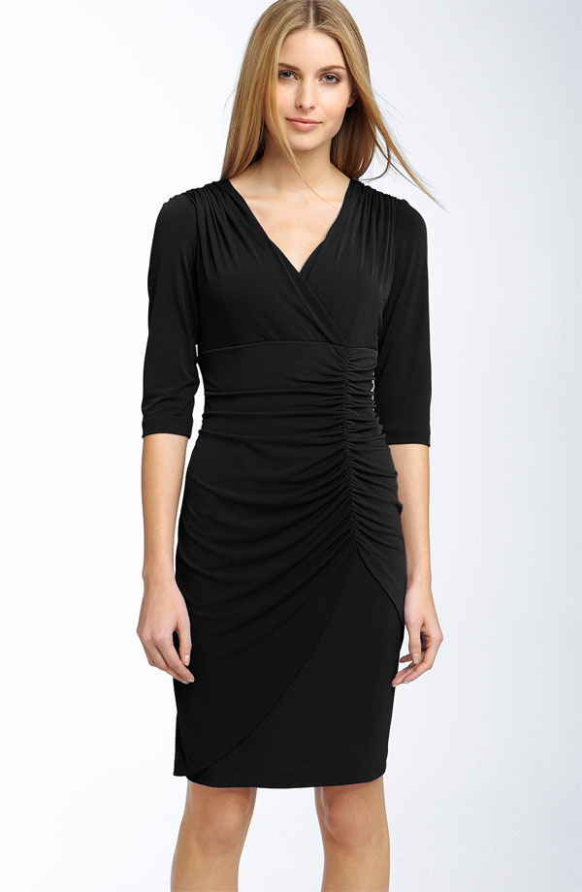

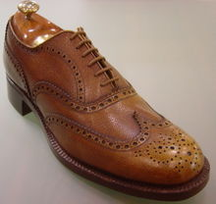

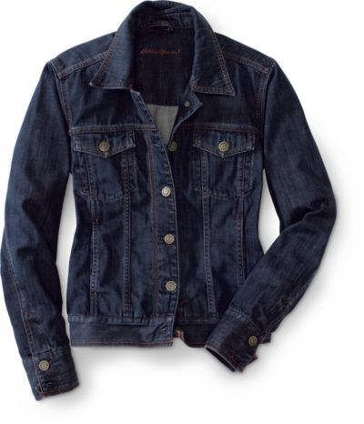
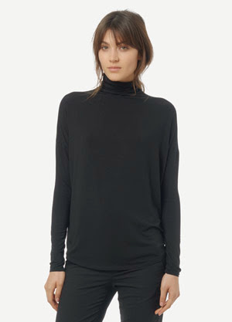

Fad
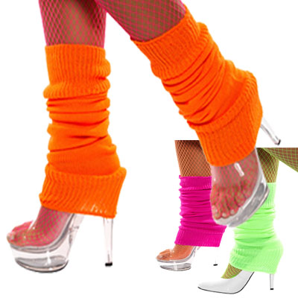
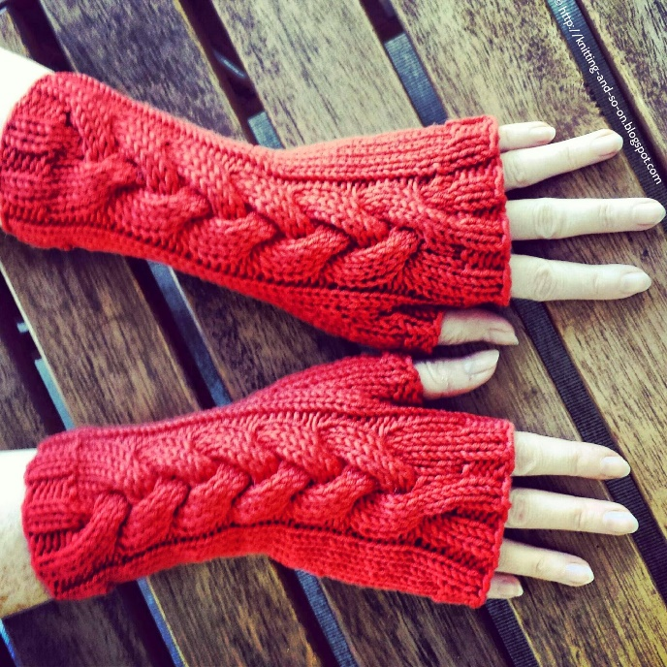

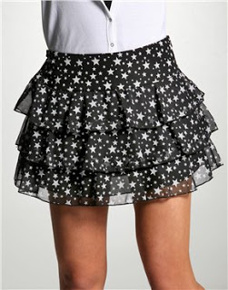

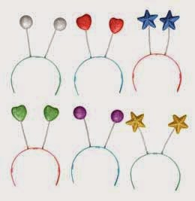

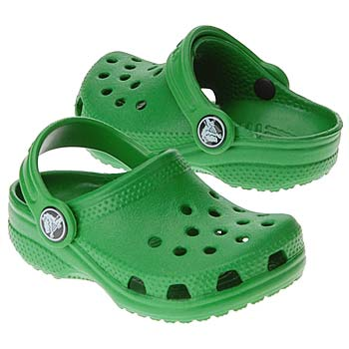

Student Statement:

By submitting this assignment, I confirm that this is my own work.

Student Signature | Marie Markey | Date | 18.12.16

For Tutor / Assessor Use Only
Total Marks
Marks Obtained
Percentage / Grade

