
Assignment Cover Sheet

Student Name: | Rachael Boon
Student Number: | 1501
Course: | Diploma in Fashion Design
Assignment NO: | 5

Marking Criteria:
We expect the learners to write minimum one well expressed point in three lines against each allocated mark. This means one needs to write 15 lines with 5 well expressed points to get high grades for a 5 marks question.
For high grades use examples and illustrations where appropriate.
1.
- What is meant by ‘weight and hand’ in textile industry?
Weight of the fabric is determined by how much mineral salt or starch is put into the fabric. This was usually used on the yardage, when the fabric was sold by the pound, e.g. silk. The hand of the fabric refers to how it feels on the skin, such as soft or rough.

- Name the warm colours. How best these can be used in dress designing?
The warm colours are red, yellow and orange.
Red is one of the few colours that can be used at its highest intensity in all season and still be flattering and pleasing on eye because of its attractive connotations such as love, lust and danger. Yellow can be difficult to wear as it counteracts many skin tones. However it looks very nice against many darker skin tones and is bright and sunny, best for the spring/summer season. Orange can be garish as it is very vibrant at its highest intensity, but mellowed down to a peach contrasts well with most skin tones. It is also popular in sportswear coupled with black or navy.

- Why it is important for a designer to consider the scale of a pattern, when using patterned fabric in dress designing?
It is important to ensure the designer considers the scale of pattern when designing a dress because the texture can get lost if not used in correctly in proportion e.g. a small figure would be effected by a large design as the pattern would be lost, likewise a larger figure would be emphasized by a large pattern. If the prints are too bold they will take emphasis away from the structural texture of the garment.
- What is the difference between conventional design and geometric design?
Conventional design is when an object from nature is used to suit the purpose of the object and becomes decorative, the motif no longer appears to be naturalistic. Whereas geometric design is not derived from nature, it is taken from shapes such as, circles, rectangles, triangles and parallel lines.

2. Define the term colour dimension. Explain the following terms; hue, value and intensity.
There are three different dimensions of colour, hue, value and intensity.
Hue enables us to tell one colour from another, e.g. red, blue or green. Value refers to how dark or light a colour is on a scale from white to black. Intensity if the level of brightness or paleness of a colour e.g. blue - marine blue is the highest intensity and pastel blue is the lowest intensity. Vivid colours are usually paired with colours of the same intensity, however a balance can also be achieved when pale or dark colours are combined with a small amount of bright colour e.g. embroidery.

3. Write short note on the following; basic Shapes in dress designing.
There are 7 basic shapes in dress designing;
- Rectangle, e.g. long, straight, graceful folds such as Grecian or Roman
- Triangle, e.g. Spanish styles, fitted bodice with a widened skirt
- Inverted triangle, e.g. wide shoulders, narrow skirt
- Oval, e.g. draped, very feminine and flattering on ‘ideal shape’
- Square, e.g. Straight neckline, capes flattering on thin figure
- Round, e.g. wide, crinoline skirt, puffed sleeve, afternoon wear.
- Hourglass, e.g. wide shoulders, natural waist. Flattering on tall, thin figure.
Project
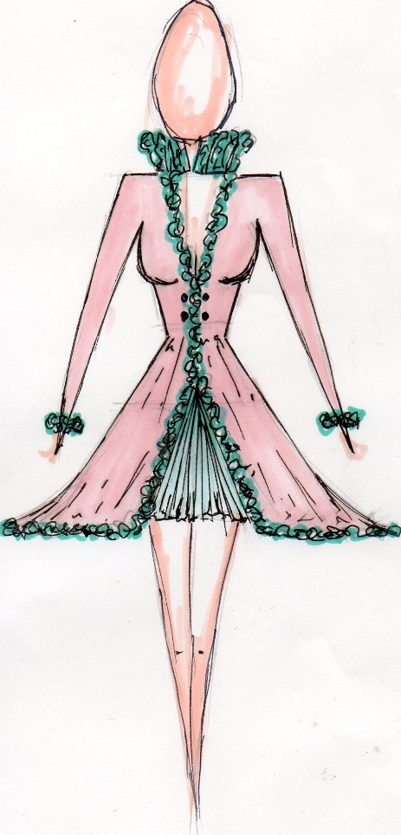
1. Look through costume books for pictures of an historic dress. Using these inspirations, design a garment using the line, shapes, colours and details from the historic garment in a new combination for our lifestyle.

Student Statement:

By submitting this assignment, I confirm that this is my own work.

Student Signature | RACHAEL BOON | Date | 12/01/2016

For Tutor / Assessor Use Only
Total Marks
Marks Obtained
Percentage / Grade

