
Assignment Cover Sheet

Student Name: | Tracy Kam
Student Number: | 3200
Course: | Diploma in Fashion
Assignment NO: | 7

Marking Criteria:
We expect the learners to write minimum one well expressed point in three lines against each allocated mark. This means one needs to write 15 lines with 5 well expressed points to get high grades for a 5 marks question.
For hi Assessment 7 Total Marks: 30
Q: 1: Give short answers to the following questions: (20)

- Which type of materials should be chosen for the dress of a thin person? And when choosing a stripy print which type of stripes would you recommend for the dress of a thin person?
For a thin person , I would suggest a shiny material can makes the thin person looks better . Also horizontal lines are suitable for thin person .Choose a light color to make the person loks stouter. Choose a lustrous material that could stands out that person . Try to wear loose clothing , broken or curve lines , short collars ,& wear cap .

- How would you design a dress for a person with large waist and hips? Which designing techniques would you apply?
If the person with large waist and hips I would suggest that person should wear a built out shoulder apparel , Long skirts in order to increase the height , large hat .

c) 'A person with stout figure must never try wearing a dress which is too tight for him/her'.
Discuss
Its true . The person with stout figure shouldn’t wear too tight for him / her as its can emphasis the person’s figure. It can show the weakness of his/her body like fattening part , plump figure . Its also can makes the stout person looks shorter and weird with tighter garment. If the dress color is too light it could even makes that person looks fatter .Stout figure is more suitable with soft fabrics , one color dress , vertical movement of lines .

- How would you design a dress for a person with round shoulders so this problem is least noticeable?
If a person with round shoulders , I would design a set in sleeves dress . The shoulder of te dress must placed about one-half back of normal shoulder line . Collars also must appear to straighten curve of the back . Either the collar is long enough to hang loose from the neck to below the highest point of the curve or have it short enough to fill in the space between the neck and the beginning of the curve ,The waist either in full and loose in order to create the prominent curve , This maybe done by use of a panel that hangs from the neck to waist , turning back under a loose belt , or by the use of a bolero jacket .

Q: 2: Activity

Make a collage of the pictures from a magazine, people wearing dresses unsuitable for their figures. For
each picture explain how this could have been designed correctly for that person’s figure. (10)

As for from the collage from the left photo , the lady in white is plump .her shoulder is round and bug she should wear some dress with V neck that can cover partly of the big shoulder . Also black is a suitable color instead of white color .

From the second photo ( middle ) is is not suitable for that person because of height issue .This kind of dress suitable for a very tall and slim person . Tall person wearing this dress can show overall eleganity of the dress & can carry well .

For the right photo ,the lady is very tall but she has big figure ( big bones ) . She should be wearing the top which can cover up her tummy as now it looks overall the body structure very big .

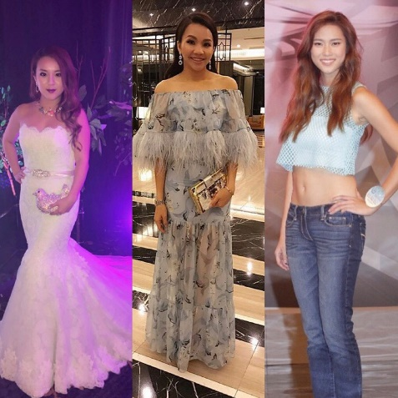

Student Statement:

By submitting this assignment, I confirm that this is my own work.

Student Signature | Tracy Kam | Date | 19112016

For Tutor / Assessor Use Only
Total Marks
Marks Obtained
Percentage / Grade

