
Assignment Cover Sheet

Student Name: | Eniko Surjanne Schuller
Student Number: | 2459
Course: | Diploma in Business Administration
Assignment NO: | 943543284

Marking Criteria:
We expect the learners to write minimum one well expressed point in three lines against each allocated mark. This means one needs to write 15 lines with 5 well expressed points to get high grades for a 5 marks question.
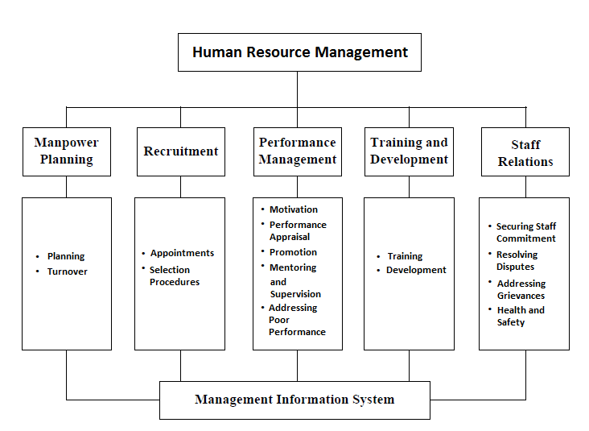
For high grades use examples and illustrations where appropriate.
1.

HR department is the only department in an organisation that deals directly with people with the ‘human capital’ as mentioned by Karen Legge (1995). They are dealing with broad issues relating to managing people as ‘strategic resources’ including manpower planning, recruitment, performance management, training and development and staff relations.

The objectives of HR management are: profit maximization without focusing on profit, keep the employees happy and satisfied by recognizing their needs and fulfilling them, maximization of employees capabilities, ensuring employees personal goals achieving, recruiting adequate organization members, developing the quality of work and maintaining the proper work-life balance, ensure ethically and proper treatment between people, training employees and improving their knowledge, increasing the morale of the workers.

The ethical business contributes their goals while employees feeling motivated and they are working efficiently and effectively. The ethics of HRM relating to the organisation and to employees are: providing high standards and policies, respecting human rights, safety in the workplace, privacy, providing equity and equal opportunity to everyone, respect, fairness and honesty based process in the workplace.

Benefits of the clear recruitment process are equality and adequate selection of the employees. It is very necessary to make sure about skills, qualifications, abilities, backgrounds ( former employers and police checks ), drug testing because any of these elements are not giving perfect fitting into the company, there will be issues which will affect the organisation negatively.

There are lots of ways to provide staff developments. It can be personal or professional developments also. For example leadership or team building activities, stress and time management, dealing with conflicts, marketing or sales coaching, work and free time related health tips, how to solve workplace bullying, communication or computational trainings and there are so many opportunities to provide employee development ideas. Continuous development is necessary to extend the range of skills possessed by staff members through these multi-skilled programmes. For instance, managers can gain confidence and respect of their teams, and the training will improve the quality of management and increasing commitment. Trainings can also be focused on increasing the competence of employees in specific areas.

2.
Of course, there is a need for human resource management specialist to reveal what and when needed to be done at the organisation and to provide constant development to improve the quality and performance. HR specialist is expected to be business partners, innovators, transformation and changing agents and implementers also. According to Ulrich: ‘impel and guide serious discussion of how the company should be organised to carry out its strategy’. They must take stock of their own work and set clear priorities. At any given moment, the HR staff have to be able to overview whole situations and acting instantly for example creating and placing job posts, orienting new employees, oversee current employee
satisfaction and productivity, deciding about trainings and development procedures, ensuring that the workplace is running efficiently and properly. They are preparing and updating employment records, explaining policies, procedures, laws and standards to new and existing staff. HR specialists are informing employees of their duties, responsibilities, benefits, promotion opportunities and working conditions. They are addressing any employment relations issues. I think their work will be more complex and changing quickly involving computerised tests, assessments and analysing.

Case study
- This example didn’t include the fact is the HR know about Tony’s disappointment, or not. In both scenarios, he could aware of the fact if there is no appraisal of his work there won’t be any changes. I think there are lots of people in these shoes like Tony, unfortunately. The morality of his work will decrease until he will be dismissed in the worst case. I believe that if HR staff didn’t know about this fact, Tony have to do the first step, in spite of this is not the right choice, but eventually, will lead changes. Both the employee and employer will be happy. The lack of communication could cause such cases like this.

- One of the possible ways could be if the HR staff will analyse and calculate is this the right position to Tony. If yes, they could motivate him through increasing his salary or/and changing work schedules if it is possible. If this is not the proper position to Tony, HR staff should assess his abilities, skills and then offer him another position in the hotel. Transferring employees from one job to another, or just rotating the duties, or one transferring them from one location to another can help in this case. Perhaps, job rotating is the easiest way to avoid tedious or stressful working throughout every working hour. For example, if Tony is working as a receptionist, and he is the person, who answer to every phone calls, he will be able to do some online booking administration when HR staff will choose the job rotation and he has the proper skills to do that. It is essential that HR specialists regularly assess employees opinions and abilities in order to provide constant quality and performance, and avoid massive resigns or disappointed workers who will take their feelings and telling these negative facts to other people.

Student Statement:
By submitting this assignment, I confirm that this is my own work.
Student Signature |  | Date | 13-Sept-2016

For Tutor / Assessor Use Only
Total Marks
Marks Obtained
Percentage / Grade

