
Assignment Cover Sheet

Student Name: | Sim Wooi Ping
Student Number: | 3648
Course: | Diploma in Business Administration
Assignment No: | 10

The completed assignment are as follows:
Q.1. Short Questions:
- Explain various techniques of assessing customer response.
Businesses rely on customer information to improve the services and better meet the customers' needs, as well as to make vital improvements to the customer service methods. The following are two (2) techniques to assess customer response or satisfaction:

Customer survey technique: Customer survey include email surveys, mailed surveys, phone surveys or take-home surveys attached to the customer's receipts. These surveys request information about customer's latest interaction with the business, such as how the customer feels about the service they received, their interaction with the company's staff and their opinion of the product they purchased.
Customer service questionnaire: Customer service questionnaires can be short physical surveys, a verbal questionnaire from a customer service employee or a general assessment by the employee about a customer's problem. These surveys give companies an important assessment tool to understand a customer's perception of the company's methods of handling problems.
- Discuss the role and function of policies and procedures in meeting customer requirements.

Policy:
The role of a ‘Policy’ is a predetermined course of action, which is established to provide a guide toward accepted business strategies and objectives. It is a direct link between an organization’s ‘Vision’ and their day-to-day operations. On the other hand, the function is to identify the key activities and provide a general strategy to decision-makers on how to handle issues.
Proceedures:
The role of every ‘Procedure’ is to provide the reader with a clear and easily understood plan of action required to carry out or implement a policy. A well-written procedure will also help eliminate common misunderstandings by identifying job responsibilities and establishing boundaries for the job holders. Procedures function by allowing managers to control events in advance and prevent the organization from making costly mistakes.

- What is the role of quality management in meeting customer needs?
Quality management plays a vital role in ensuring that customer-focused organisations better identify and address core customer needs. Companies are reliant on their customers for their existence and well-being and should therefore recognise all existing and potential customer needs, meet customer requirements and strive to surpass customer expectations by adhering total quality management processes across the organisation. The following are some example of roles of quality management in meeting the customer needs:
- Facilitate understanding of customers’ needs and expectations by providing the organization with timely information on quality needs of customers.
- Communicating customer needs and expectations throughout the organization and highlight deficiencies, if any.
- Monitoring customer satisfaction and acting on results continuously.

- “A happy customer is a reliable customer’, and a reliable customer means profit” keeping in view the statement, point out the ways which help to achieve customers’ trust.

- Be transparent about the products or services provided: When selling products or services online, customers know what they want and know how to search for it. As a quality seller, you should never misrepresent the benefits of a product or service you offer. Always give the whole truth about a product and let the customer decide if it solves their particular challenge.
- Understand the customer needs and know how to communicate with them: Take time to listen to what they want and need. Create open routes of communication through social media (Facebook, Instagram, and Twitter) to get some insight on their lifestyle, what products they already use and what features are missing from their daily life.
- Provide good customer service: This includes timeliness, responsiveness, and the ability to exceed the customer’s expectations. Showing genuine concern and a willingness to help your customers are also important.

- What is meant by CRM? Which type of information does it include?
- Customer Relationship Management (CRM) is a strategy for managing all your company’s relationships and interactions with customers and potential customers. Data such as sales and customer information can potentially provide key insights such as customer buying behaviour, customer needs and also customer feedback.

- Design and complete a customer satisfaction survey.
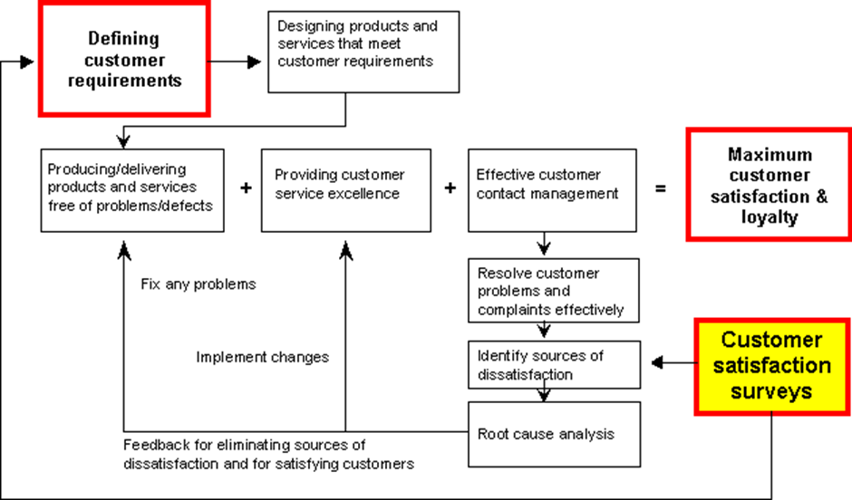

vii. Review the success of a completed survey.
The success of the completed survey can generate significant bottom-line benefits, such as:
- Learn what it takes to achieve breakthrough increases in satisfaction, loyalty, and retention.
- Gain insight for attracting new clients.
- Identify cross-sales opportunities.
- Discover ideas for new products and services.
- Manage moments of truth more effectively.
- Gain insight for prioritizing performance improvement initiatives and projects.
- Make significant improvements in service and sales attribute performance including timeliness, professionalism, courtesy, knowledge, communications with customers, problem resolution effectiveness, etc.
- Improve communications with clients.
- Increase service quality and productivity.
- Make better, more objective decisions based on client feedback.
- Identify problems and opportunities by location, communication channel, and other criteria.
- Identify and fix recurring problems.
- Send an important message that management cares about customers and their opinions.
- Become more competitive.

The survey maximizing satisfaction and loyalty. This survey play a key role in identifying sources of dissatisfaction and also conducts customer service surveys, assessing face-to-face and call centre service. It’s service that meets or exceeds requirements keeps customers satisfied and loyal. Conducting annually or more often is the most cost-effective way to ensure and identify ever changing requirements and learning directly from customers about how satisfied they are with the products and service.

Activity
Managers at Clifton leisure centre want to attract more customers. They have improved the Gym facilities with updated equipment. They have also hired a new trained fitness instructor. One of the managers argues that before starting on their marketing campaign they should collect some information about their target customer which includes; the age range and occupation.

1. How important it is for them to classify the centre’s users?
It is important for a business to identify and select a target market so it can direct its marketing efforts to that group of customers and better satisfy their needs and wants. Some examples are shown on the following page.

Gender:
Segmentation by gender is an obvious way of identifying possible markets. Women and men sometimes look for different results after the work out. The types of equipment chosen are not similar to male.

Occupation:
Good occupation increases the income. Therefore income is the most important and commonly used base for segmenting a survey market. The purchasing power of a typical consumer varies based on the level of income earned. Based on this demographic variable, consumers are grouped into three categories; high, middle and low income, with the market also classified on the same basis. This is due to the fact that high-income group are more health concise so a healthy body is important. The middle incomes will opt for medium-priced and durable goods, while consumers with low income purchase and often prefer lower-priced products to satisfy their physical needs. This is because they have less disposable income and hence are sensitive to price changes.

Age group:
Teenagers: Composed of young people ages 10 to 19. Typical teenagers have special tastes, attitudes and outlooks. They are interested in the new technology equipment and good audio sound while on gym workout. The teenagers disposable income is growing and brand loyalties are lasting.
Young adult: Market consists of young adults ages 20 to 34. People in this age group get their first major career positions, get married, establish homes, and start families. They are the vital market segment gym centre to target due to the fact that this group has major needs and wants and is willing to spend.
Middle aged: Market is made up of ages 35 to 64. This group has the most buying power and buys the largest number of consumer goods and services. Many middle-aged people, particularly the older ones, are at the peak of their earning power. Thus, this market segment receives much attention from the makers of high priced membership, top quality facility and services.

2. Explain how this sort of data could be helpful?
This enables the business to use its marketing resources more efficiently, resulting in more cost and time efficient marketing efforts. It allows for better understanding of customers and therefore enables the creation of promotional materials that are more relevant to customer needs. Also, targeting makes it possible to collect more precise data about customer needs and behaviours and then analyse that information over time to refine market strategies effectively.

Student Statement:
By submitting this assignment, I confirm that this is my own work.
Student Signature | Sim Wooi Ping | Date | 05/01/2017

For Tutor / Assessor Use Only
Total Marks
Marks Obtained
Percentage / Grade

As per quantisoft.com “Process for Maximizing Satisfaction and Loyalty”

