
Assignment Cover Sheet

Student Name: | Rachael Boon
Student Number: | 1501
Course: | Diploma in Fashion Design Level 4
Assignment NO: | 8

Marking Criteria:
We expect the learners to write minimum one well expressed point in three lines against each allocated mark. This means one needs to write 15 lines with 5 well expressed points to get high grades for a 5 marks question.
For high grades use examples and illustrations where appropriate.
Assessment 8
I.
The term binary colours, or secondary colours, refers to mixing two primary colours together to create a new colour. For example, green is a binary colour created by mixing primary colours, blue and yellow together.
II.
Grey is a cool colour. When creating an attractive colour scheme, grey can be applied to tone down any garish colours that may clash, e.g. red and yellow usually clash when paired together, however by adding grey, they become rose and tan, complimenting each others warm tones. Grey can also be used on its own in an ensemble to compliment a vivid colour, for example, many people find yellow a difficult colour to wear but when coupled with grey it can become much more versatile. E.g. Grey blazer/dress with yellow piping
III.
Generally I would advise a stout person to wear darker colours as there are slimming and create shadows to hide larger areas. However lighter colours, coupled with strategically placed darker banding or patterns can be very flattering in creating the illusion of an elongated figure.
IV.
To create height and slimness in a dress I would use different colours to create vertical panels to draw the eye downwards, elongating the body. I would use a darker colour on the outer panels of the dress, e.g. black, navy, dark grey. I would pair this with a contrasting lighter panel in the middle, drawing the eye to the center of the body and away from the wider/larger areas e.g. white, cream, light grey.
V.
When a grey haired woman is wearing black, they must have a lighter colour, preferably white, the prevent the black being directly next to the face. As a person gets older, and develops grey hair, their skin also lightens and loses pigment slightly. So if the black was directly next to the skin, you run the risk of it washing you out. To wear black in the most flattering way I would have a lighter colour next to the skin, e.g. white collar or cuffs.
VI.
If a person has a sallow complexion, (yellow undertones), I would recommend them wear a colour from the opposite end of the spectrum to yellow such as, blues and purples as they are complimentary to yellow tones and harmonise well together. I would advise people with a sallow complexion to avoid yellows and oranges and some bright greens as they can clash and result in the skin looking dull and washed out. Colours which mimic the tone of the cheeks e.g. rose, red, pink, are also very suitable for people with sallow complexion.
VII.
Colours with grey undertones, such as blue, greens and violets are suitable for blondes as they reflect the tones in the eyes. Lighter, pastel colours are also complimentary to blondes. When choosing jewelry, jade, amethyst, turquoise and topaz are popular colour choices for blondes.

Activity
Fabric swatches I collected from the internet and created colour harmonies with;
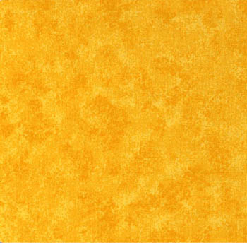
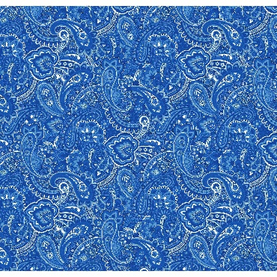
Blue and orange

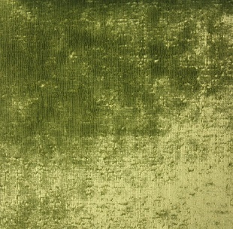
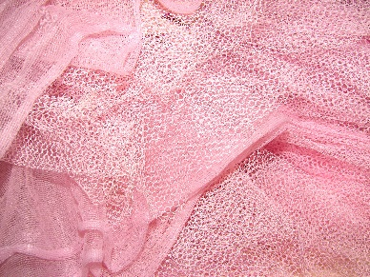
Pink and Lime green

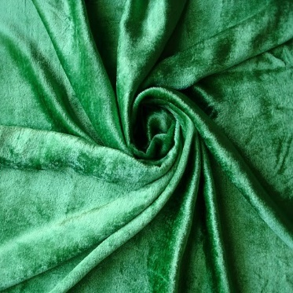
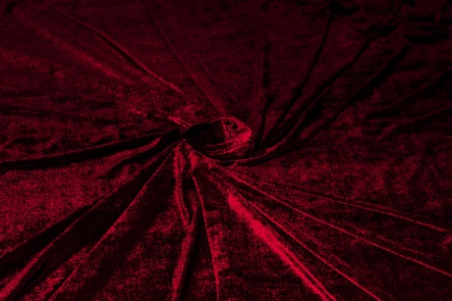
Ruby and Emerald green

The colour harmony I created consisted of pastel colours e.g. pink, rose, blue, and green on a grey background. As a naturally fair woman with blue eyes, I designed this fabric with myself in mind.
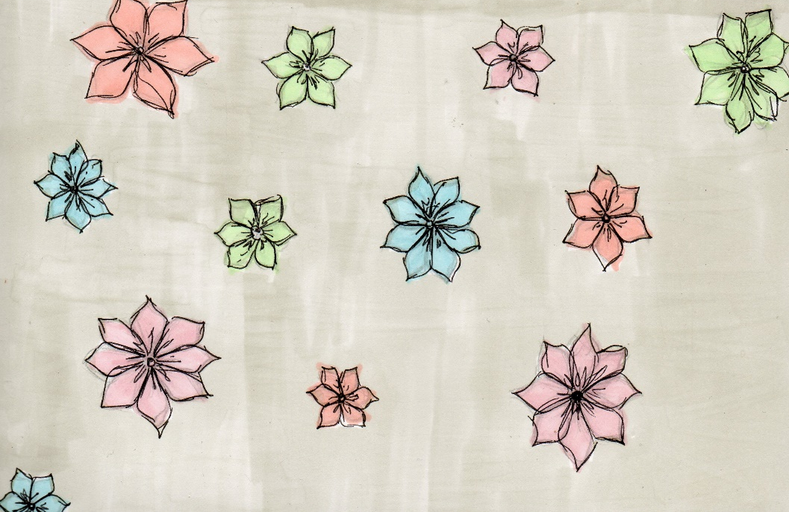

Student Statement:

By submitting this assignment, I confirm that this is my own work.

Student Signature | RACHAEL BOON | Date | 08/06/2016

For Tutor / Assessor Use Only
Total Marks
Marks Obtained
Percentage / Grade

