
Assignment Cover Sheet

Student Name: | Randolf M. Delmendo
Student Number:
Course: | Accounting and Finance Level 4
Assignment NO: | 1

Marking Criteria:
We expect the learners to write minimum one well expressed point in three lines against each allocated mark. This means one needs to write 15 lines with 5 well expressed points to get high grades for a 5 marks question.
For high grades use examples and illustrations where appropriate.
ASSESSMENT # 1 Total Marks: 30
Accounting and Finance Level 4 Brentwood Open Learning College Page: 1
Introduction to Accounting and Finance

1. Give short answers for the following questions: (18)

i. Define ‘Accounting’.

Answer: The art of recording, classifying, and summarizing financial transactions.

ii. Explain the primary objectives of accounting.

Answer: Through proper accounting, the business owners determine the health of their enterprise.

iii. Discuss the limitations of accounting.

Answer: Any actions, dealings or events that have a non-financial nature do not fall in accounting i.e. Management skills, variation in consumer preferences, or any other changes in the Human Resources which play very important factors in running a business.

iv. Explain the term “recordative”.

Answer: Accounting Activity; work extends to routine recording and classified posting of financial
Transactions and events.

v. What types of activities are included in data evaluation?

Answer: controls the business activities through budgets and standard costs, evaluating the
Performance of the business, analyzing financial statements, analyzing cash flows, and choosing alternative courses of action for decision-making process.

vi. Outline the main functions of accounting considering the following groups;

Please suggest information that each one is likely to need from accounting
Statements and reports.

- Lenders – ASSETS AND LIABILITIES, to identify financial health of a company. Creditors are concerned with information about the company’s ability to pay its loans back

- Employees – REVENUE, Employees are considered as stakeholders who should know if the company is performing well. A satisfied and highly motivated workforce is the most efficient and productive.

- Customers – REVENUE, can analyze and keep a check on the performance and
efficiency of businesses. The information also gives an insight into social responsibility of businesses.

2. Discuss the role of accountants in modern business organisations. (4)

Performs financial functions related to the collection, accuracy, recording, analysis and presentation of a business, organization or company's financial operations.

3. What is accounting cycle? Outline the basic steps included in accounting cycle. (4)

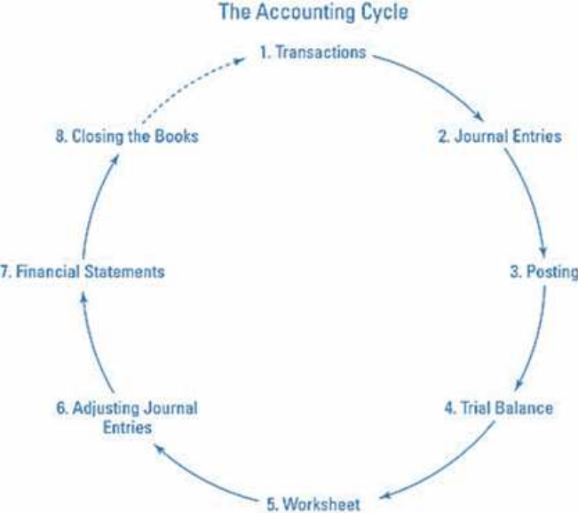

Activity (4)

List the various accounting activities that an organisation under takes and give reasons for each
as to why that particular activity is performed in the organisations.

Activity | Purpose
PERIODIC EXPENSE RECORDING | Gives information on company’s expense incurred periodically.
PREPARING REPORTS | Helps management make decisions, to provide information for banks and investors, and the measure the profitability of a business.
GATHERING FINANCIAL INFORMATION ABOUT THE ACTIVITIES OF A BUSINESS. | To be able to generate data/reports that will be a useful reference.
ESTABLISHING ACCOUNTING CONTROLS | to promote accuracy
MANAGEMENT ACCOUNTING | Helps you keep your business running while financial accounting tells you how well you’re running it.
COST VS. SALES COMPARISON | To know if the business earning enough profit to cover all type of expenses
PREPARATION OF FINANCIAL STATEMENT | Help them assess the firm’s financial performance. These financial reports—including the income statement, the balance sheet, and the statement of cash flows—summarize a company’s past performance and evaluate its financial health.

Student Statement:

By submitting this assignment, I confirm that this is my own work.

Student Signature | RANDOLF DELMENDO | Date | 14-Oct-16

For Tutor / Assessor Use Only
Total Marks
Marks Obtained
Percentage / Grade

