
Assignment Cover Sheet

Student Name: | Hissourou Aboubakar
Student Number:
Course: | Write a Business plan Level 2
Assignment NO: | Unit - 5

Marking Criteria:
We expect the learners to write minimum one well expressed point in three lines against each allocated mark. This means one needs to write 15 lines with 5 well expressed points to get high grades for a 5 marks question.
For high grades use examples and illustrations where appropriate.
Answer the following questions?

1. What is Finance, explain how to record Financial Transection (05)

2. How to develop financial projection? Discuss with detail? (10)

3. What is GAAP? Discuss. (05)

4. How to make strong presentation? Explain. (10)

1. What is Finance, explain how to record Financial Transection

What is Finance?
The Encarta Dictionary defines finance as, “the business or art of managing the monetary resources of an
Organization, country, or person.” Bookkeeping, banking, and accounting are all separate processes with
Their own definitions.
Seth Godin describes finance as a three-cycle process that continues endlessly:

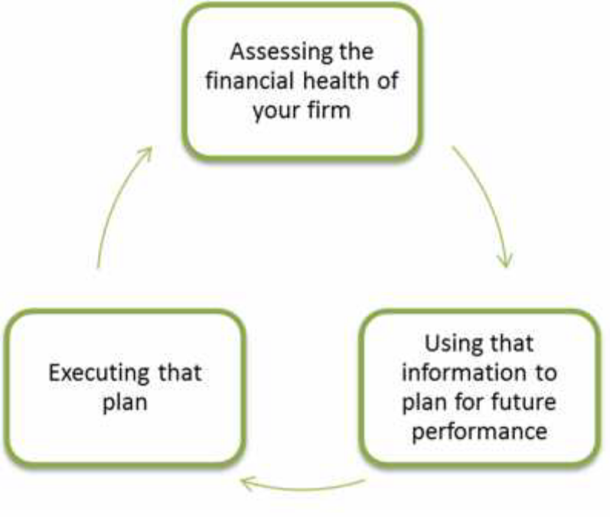
Recording Financial Transactions
Bookkeeping is the exercise of identifying, categorizing, and recording all the transactions that take
Place in a business. In general, everything a company does results in a bookkeeping transaction,
including things that take place between the business and:
• Customers, who buy products and services sold by the business
• Employees, who are paid wages and provided benefits
• Vendors, who sell services, equipment, and supplies to the business
• Government agencies, who collect taxes from the business
• Sources of equity capital (investors or owners who put money in and take it out of the
business)
• Sources of debt capital (banks and lending institutions)
Accounting, on the other hand, is the methodology used to record the transactions and prepare financial
Statements and reports. Accounting guidelines govern how businesses record transactions. They also
dictate the design of the recordkeeping system that a business uses and how reports are prepared,
Based on the information gathered and put into the system.

2. How to develop financial projection? Discuss with detail?

Financial Projections
What Do Projections Include?
Investors need to see your projections, even though they can be very difficult to figure out. You might be
Tempted to skip this part of the business plan if you are not looking for investment help. However, this is
Good information for you if you are funding your own business. This can help you see where you need to
Make adjustments, and whether your plan as it currently exists is even realistic.
The income statement is the standard measurement tool used to report your projected revenues and
Expenses. Your financial projection has to include how much money you plan to borrow, the interest
Charges and money you will invest from your savings. While you create this plan, you need to use the
Financial terms covered previously. Since financial projections and reporting are new undertakings for
Most of us make sure you work with an accountant on these projections.
At a minimum, your projection needs to include:
• Short-term projection, by month, for the first year
• Mid-term projection, typically two to three years, broken down by year
• Long-term projection, typically five years, broken down by year
This is not an easy task, so remember:
• Compare your numbers with similar companies in your industry to keep things realistic.
• If your projections are too optimistic, you can lose credibility with investors and banks.
• Startup costs, like licenses, permits, and equipment costs, go into your short-term projection.
• Allow for variation in things, including the price you are planning to sell your products or
services at, future funding requirements, changes in raw material or staffing costs, and
Anything else you can reasonably think of.
• Investors need to see a best-case scenario and a worst-case scenario. Avoid the temptation to
create all kinds of in-between cases, which will take up space in the business plan without
Adding a lot of value to your reader.
Use the Writing Rules
Remember that writing rules are important, so you need to use them in this section just as you do in
Other areas of your business plan. Make any assumptions in your plan clear. You can articulate how you
will collect on delinquent accounts and what your billing cycle looks like, but if your industry is softening
And you are projecting huge growth in revenues, your credibility falters in the eyes of your reader.
Financial statements are prepared and written in tables and spreadsheets, often in a program like
Microsoft Excel. Learn how to read this information, to work with it, and to use spreadsheets as
Effectively as you use programs such as your word processor and your e-mail.

3. What is GAAP? Discuss.

Answer,

General Accepted Accounting Principles (GAAP)
Accounting is simply a measurement. Measurements allow for consistency. Just like everyone knows
what one foot (or 30 centimeters) of distance is, the business owner (or CEO) and all stakeholders should
Be confident that they know what a company’s assets are. The accounting concepts and standards that
Govern consistency are called generally accepted accounting principles (GAAP).
There can be slight differences between regions, but GAAP typically includes the following principles:
• Comparability among different companies.
• Reliability of information.
• The business entity concept: A business is a separate distinct entity from its owner/owners.
• The matching principle: Earnings and expenses must be recorded in the same accounting
Period that they relate to each other.
• The cost principle: Assets and service, and the resulting liability, are taken into the accounting
Records at cost.
• The consistency principle: A company’s accounting procedures need to remain consistent
Over time. If they are changed, the reasons for the change and the financial impact of the
Change must be documented in detail.
• The time period principle: The operating period of the business is divided into equal periods
Of time, such as a month or a quarter.
• The going-concern principle: The business will continue to operate, using its assets to carry
on its operations and, with the exception of merchandise, not offering the assets for sale that
Are necessary to run the business.
• The objectivity principle: Whenever possible, the amounts used in recording transactions are
Based upon objective evidence rather than on subjective judgments.
• The stable currency assumption: The idea that the purchasing power of the unit of measure
Used in accounting (such as the dollar or the euro) does not change. (In other words, a dollar
Bill will not become worthless overnight.)
• The realization principle: This principle defines revenue as an inflow of assets (not necessarily
Cash) in exchange for goods or services. It requires the revenue to be recognized at the time,
But not before it is earned.

4. How to make strong presentation? Explain.

Answer,

Making a Strong Presentation

Ask yourself that question again: who is your audience? Your answer is going to help you determine how
Best to present your information and solicit support for your business plan.
If your business is of a technical nature, should your business plan be written as a document? If you are
in the computer or design business, should it be created as a subdomain on your website with restricted
Views? If you are an author, will you bind it as if it were a book? If you are a trainer, would you set it up
As a PowerPoint presentation? How can you take your plan and fit it into the electronic forms that some
Banks, governments, or grant application systems want?

The Finishing Touches
You’ve put a lot of effort into your business plan, and now is not the time to abandon details. The final
Stretch is about making sure your plan has the impact and gets the results that you have designed.
The essential closing skills of a fine piece of work bring us to fact-checking, reviewing, and editing. You’ve
Put considerable resources into developing your business plan. Whether the goal of your plan is to
secure support from stakeholders, fully flesh out your ideas and test their viability, or acquire grant and
Operational funding, the plan itself is a huge undertaking with serious consequences. As a result, you
Want to make sure that it is the absolute best product you can create.
When you check your business plan thoroughly, you must also look at the viability of your plan. If the
numbers don’t make sense, the product cannot be distributed as you originally planned, or there are
Legal issues around patents, these are signs that your plan needs some continued work.
A lot of business owners want to protect their ideas so they are not stolen, or they want to launch their
Product or service before the competition does, so they will complete the business plan on their own.
You have to weigh this out, because we do support you wanting to protect your information. However, if
you have your spouse proofread the plan and they aren’t good at spelling, your plan is not going to have
The impact you are looking for.
We recommend that you consider your options carefully and then complete the following steps in order.
• Read through your plan completely. Highlight every fact that you report and any website or
External reference you make. Then, validate that they continue to be accurate, valid, and
Correct.
• Depending on your audience (such as a board of directors, a bank, or grant panel), you could
hire an editor to conduct a line edit for spelling and grammar and to complete a content edit
To make sure things flow smoothly and make sense to someone outside the business.
• Complete changes highlighted by your editor.
• Have the document edited one final time to make it as complete as possible.

Student Statement:

By submitting this assignment, I confirm that this is my own work.

Student Signature | Hissourou Aboubakar | Date | 10/01/2017

For Tutor / Assessor Use Only
Total Marks
Marks Obtained
Percentage / Grade

