
Assignment Cover Sheet

Student Name: | Raymond Wilson
Student Number: | 5297
Course: | Diploma in Risk Management
Assignment No: | 3
Marking Criteria:
We expect the learners to write minimum one well expressed point in three lines against each allocated mark. This means one needs to write 15 lines with 5 well expressed points to get high grades for a 5 marks question.
For high grades use examples and illustrations where appropriate.
Assessment 3 Enterprise Risk Management Total Marks: 30

- Give brief answers for the following questions: (14)

- What is Enterprise Risk Management?
Enterprise Risk Management (“ERM”) is a tactical business discipline that supports the success of an organization’s objectives by addressing the full spectrum of its risks and managing the combined impact of those hazards as an interconnected risk portfolio.

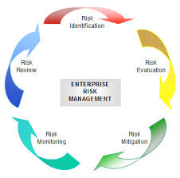ERM can also be described as a risk-based approach to managing an enterprise, integrating concepts of internal control, strategic planning, and the Sarbanes–Oxley Act (SOX) which is continuously evolving to address the needs of various stakeholders, who want to understand the broad spectrum of risks facing complex organizations to ensure they are appropriately managed.
ERM represents a significant development beyond previous approaches to risk management in that it;
- Encompasses all areas (as illustrated on page 1) of organizational exposure to risk (financial, operational, reporting, compliance, governance, strategic, reputational, etc.)
- Arranges and manages those exposures as an unified risk portfolio rather than an individual “silo” process
- Evaluates the risk portfolio in the framework of all significant internal and external environments, systems, circumstances, and stakeholders
- Identifies that individual risks across the organization are interrelated and can create a combined exposure that fluctuates from the sum of the individual risks
- Provides a planned process for the management of all risks (whether those risks are primarily quantitative or qualitative in nature)
- Views the effective management of risk as a competitive advantage
- Seeks to embed risk management as a component in all critical decisions throughout the organization.
II. Outline the main responsibilities of a CRO in an organisation.

Following the world financial crisis of 2008, there was a transformation on the view that risk management is mainly a compliance tool. This resulted in the CRO’s raising his/her importance within an organization and they have now developed clearer lines of communication and reporting with the CEO and a committee of the board of directors engaging in business and strategy setting. However there is still room for improvement given 25% of institutions still claim that the views of their risk functions are often overruled within their organization which is attributed largely due to poor communication between departments as a result of continued “silo” approach.

While company executives must foster team work within an organization, the CRO must often be the devil’s advocate
and offer alternative views to enhance discussions. Five main success factors, detailed below, are for CROs to consider to effectively increase the value of risk management through his job profile;

- Viewed as a Peer with Business Line Leaders – In order to achieve the forward-looking risk perspective and its serious deliberation, the CRO must be able to deliver those expectations through a shared relationship with business line leaders, therefore, the CRO must be viewed as a peer.
- Board Reporting and Interactions – While the CRO is not an owner of specific risks, he/she has the task of executing a tactical overview of the entire risk management process that commands free access to the board for delivery and reporting.
- Managing Risks is Everyone’s Job – The CEO, board of directors, senior management and all the other line managers must remove the misconception that the CRO is the only person responsible for risk. Risk has to be an enterprise-wide concern.
- Risk is Equal to Opportunity – Risk management functions are designed to preserve value as well as generate value. The best interests of the organization needs to be maintained whilst pursuing strategies to improve the business. The CRO must attempt to strike a balance through decision making and risk appetite formulation.
- Broaden Focus Beyond Compliance – The focus of the CRO should be on the enterprise risks, risk profile and aligning the strategy based on risks identified. This goes beyond compliance risks and raises the bar for the CRO who has to be in compliance with the laws and regulations. Expanding his/her focus will however will make it easier for the CRO to have the desired impact in managing risks.

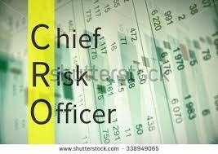 The importance of the depth and degree of the relationship the CRO has with senior executives (and the board) will enable the CRO to be in a stronger position to manage the overall risks instrumentally protecting the value that organizations have taken years to build.

III. What is ‘risk control’?

Risk control is the method by which companies can evaluate potential losses and take appropriate action to eliminate or reduce such threats. This technique utilizes findings from risk assessments which involve identifying potential risk factors in a firm's operations, such as technical and non-technical aspects of the business, financial policies, and other policies that may impact the well-being of the firm. Risk control also implements changes to reduce risk in these areas.
Risks should be reduced to the lowest reasonably practicable level by taking preventative measures, in order of priority as defined in the ERM plan. The list below sets out a sample and ideal order to follow when planning to reduce risk. Consider the headings in the order shown, do not simply jump to the easiest control measure to implement.
The hierarchy of controls to be considered is;
- Elimination or control of the hazard or risk at source - Redesign the job or product
- Substitution - Replace the material or process with a less hazardous one
- Engineering controls - Separate the hazard from operators by methods such as enclosing or guarding dangerous items of machinery/equipment. Give priority to measures which protect collectively
- Administrative controls - Identifying and implementing the procedures you need to work safely or control costs
- Insurance control or PPE – If all the above cannot control or manage the risks faced by the company, consider transferring some or all of the risk to a third party. In the case of physical activities PPE is the last line of defence to protect workers.
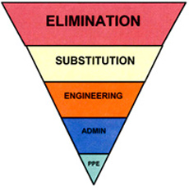Control at source is a more reliable option than insurance. Nevertheless, where adequate control cannot be provided by other means, provide suitable insurance measures in combination with other control measures which is the ultimate goal of the ERM plan.

IV. Outline the main components of a business plan.

Every business, whether “a new kid on the block” or a full-fledged, profitable organization, needs a business plan.
Below are a number of key elements that will ensure a successful business plan;
- Executive summary. This document is a one- or two-page summary of your entire business plan. Normally this executive summary is produced after finalization of all the details within the plan itself.
- Business description. A company’s business description, needs to include and define various aspects of the services offered, the history and profile of the company’s field of operation, any current projects and its goals, objectives, and other elements that add to the overall company profile. This section is the backbone of any business plan and will set the stage for the information included in the rest of the plan.
- Products and services. All companies have a product or service that they are offering to prospective clients. It is important to be able to describe what it is that is being sold as well as identify what makes the company’s product or service unique.
- Sales and marketing. This section important as it allows outsiders a window into the industry involved in , the state of the market, general costs, how business is acquired and also affords an opportunity to distinguish the company from competitors. In previous years most businesses had shop fronts, however in today’s modern environment, rather than just thinking of the company website as a dormant place to tack your name on, kick it up a notch so the website can be used as an online storefront -- the place where business gets done.
- Operations. This purpose of this section is to help outline the more administrative side of the business, including how it operates, where the office is located, staff or assistant profiles, equipment, expenses, legal relationships, network of suppliers and credit policies etc.
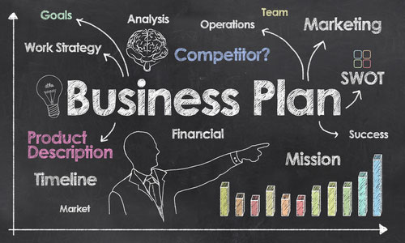
- Management team. This is where you identify and acknowledge their involvement and the capacity by which they contribute to the company’s success. Also, if there is a hierarchy of positions within the company, this is the place to detail that hierarchy and the relevancy of each relationship.
- Development. Not everything in this section is based upon pure fact like the information that has been provided in the other sections previously. Project into the future, think big and plan accordingly as development is a necessary part of business to remain competitive.
- Financial summary. Here a record of the company’s financial dealings, investments and how it came to the position it is in today. It needs to be demonstrated how the company has been operating and assessment made of financial status, including how things balance out at the end of each month as well as the overall financial health of the business and its cash flow status.

V. What is the importance of communication in crisis management?

Every organization is vulnerable to crises. Companies can try to ignore issues , but stakeholders will not be so understanding or forgiving because they’ve seen what happened with Volkswagen, Chipotle, FIFA, and Lance Armstrong in recent years.

If companies don’t prepare, inevitably more damage will occur.

Experience demonstrates that organizational leadership often does not understand that in the absence of adequate internal and external communications;
- Operational response will break down.
- Stakeholders will not know what is happening and quickly become confused, angry, and negatively reactive.
- The organization will be perceived as inept, at best, and criminally negligent, at worst.
- The length of time required to bring full resolution to the issue will be extended, often dramatically.
- The impact to the financial and reputational bottom line will be more severe.
The basic steps of effective crisis communications are not difficult, but they require advance work in order to minimize damage. By preparing and having a process in place, crisis management communication will play a vital role in mitigating risks during a disaster or emergency situation. A summary of these steps are as follows;
PRE-CRISIS
- Anticipate Crises
- Identify Your Crisis Communications Team
- Identify and Train Spokespersons
- Spokesperson Training
- Establish Notification and Monitoring Systems
- Identify and Know Your Stakeholders
- Develop Holding Statements

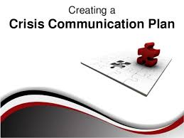
POST-CRISIS
- Assess the Crisis Situation
- Finalize and Adapt Key Messages
- Post-Crisis Analysis

VI. What is the role of senior executives in risk management of an organisation?
Ultimate responsibility for ERM starts and ends at the top. However, everyone who matters within an organization should participate in the ERM process.
While several executives have significant responsibilities for ERM, including the Chief Risk Officer, Chief Financial Officer, Chief Legal Officer and Chief Audit Executive, the ERM process works best when all key managers of the organization contribute to its cause and operation.
Therefore, identifying such leaders throughout the organization and gaining their support is critical to successful implementation of ERM.
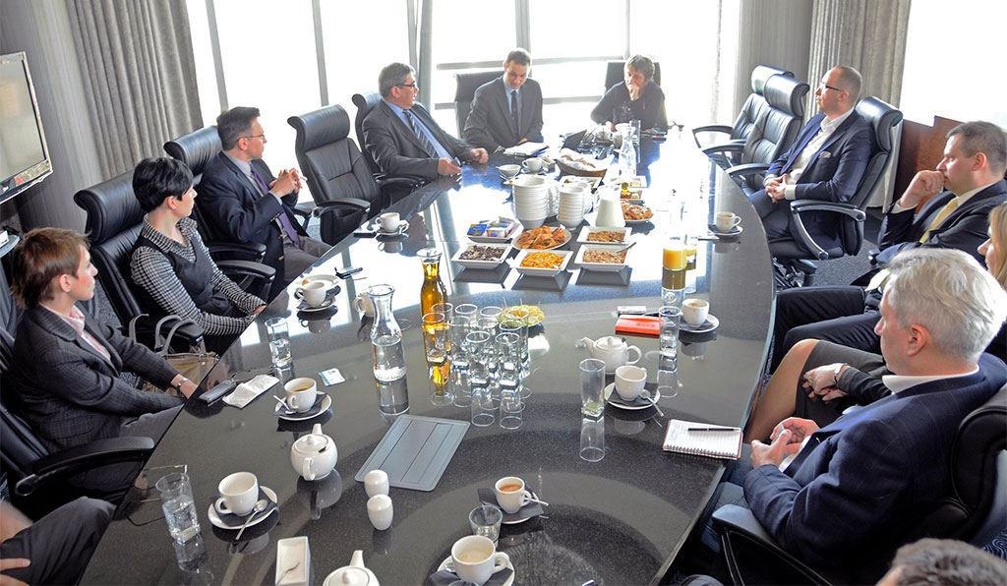
An effective ERM process affects the organization’s risk culture because it establishes an environment where people can raise their hands and express concerns about a deal, transaction, project or business plan without fear of retribution. This kind of open and positive environment is not possible without the CEO’s active and visible support. The CEO sets the tone by asking the tough questions about risk and risk management and by demonstrating a commitment to raise the focus of risk management to a strategic level.
The CEO “is ultimately responsible and should assume ownership” over the implementation of ERM. Because ERM is integral to running and managing a business, the CEO’s involvement is vital to its success.
Of course it is not just about the CEO. Senior executives, as illustrated above, need to be aware of their roles in the RM process and understand the types of risks that are present within the company. The board of directors collectively must approve the overall approach towards risk-taking and the lines of risk taking authority and accountability should also be clearly defined and approved.

The companies risk policies and procedures, once approved, need to reviewed at least annually and this is the time when the board of directors can express any changes towards its tolerance for and attitude toward risk management. This can be achieved in a number of ways such as;

- Be involved in reviewing and approving the risk parameters: These limits form the procedure for controlling risks.
- Monitor policy performance - The board must ensure that by regular monitoring the proactive elements of risk management are working and exceptions to risk policies are well defined, strictly audited, and closely monitored.
- The board should make sure that all new products are comprehensively reviewed by the risk management, legal, compliance and operations teams. This is an important aspect of risk management for any company with an eye on future risks.

VII. Briefly outline the main benefits of implementing ERM.

An effective enterprise risk management (ERM) program can help company’s manage their risks and maximize opportunities and therefore profits. Organizations in all types of industries (public and private) have observed a variety of benefits from enhancing their risk management programs. These benefits are as follows;

Creation of a more risk focused culture for the organization
Organizations that have implemented ERM have observed that by increasing the focus on risk at senior manager levels results in more discussion of risk at all levels. This allows risks to be considered more openly and breaks down silos with respect to how risk is managed.
Communication and discussion of risk is recognized as not only a process to provide information to senior management, but a way to sharing the same within and across operations of the company, which will also allow better insights and decision making concerning risk at all levels therefore promoting more focused values towards risk.


Standardized risk reporting
Standardized reports that track enterprise risks can improve the focus of company directors by providing data that enables better risk mitigation conclusions. The variety of data provided (status of key risk indicators, mitigation strategies, new and emerging risks, etc.) helps management understand the most important risk areas. These reports can also help department leaders develop a better understanding of risk appetite, risk thresholds, and risk tolerances and also gain an understanding of each other’s limitations.

Improved focus and perspective on risk
ERM develops leading pointers to help detect a potential risk event and provide an early warning. Key metrics (often known as KPI’s) and measurements of risk, further improve the value of reporting and analysis and provide the ability to track potential changes in risk vulnerabilities or likelihood, potentially alerting organizations to changes in their risk profile.

Efficient use of resources
Developing an ERM program does not replace the need for day to day risk management, but can improve the framework and tools used to perform the critical risk management functions in a consistent manner. Eliminating redundant processes improves efficiency by allocating the right amount of resources, and associated cost, to mitigating the risk.

Effective coordination of regulatory and compliance matters
Since ERM data involves identifying and monitoring controls and mitigation efforts across the organization, this information can help reduce the effort and cost of such audits and reviews. Bond rating agencies, financial statement auditors, and regulatory examiners, have now begun to inquire about, test, and use monitoring and reporting data from ERM programs as part of their checks on the wellbeing and compliance of companys.
Clearly through all of the benefits noted above, ERM can facilitate better cost management and risk visibility related to operational activities. It also enables better management of market, competitive, and economic conditions, and increases leverage and consolidation of disparate risk management functions.

2. “The fundamental goal of ERM is to avoid disruption or damage to the organisation as a result of unplanned or unmanaged risk events.” Discuss (7)

Each company involved in Risk Management must ask themselves a number of fundamental questions on what needs to be protected, how and why.
The first question is "What are our objectives for ERM? Companies typically have the same four general objectives for their ERM programs. The objectives, ranging from the reactive to the proactive, are as follows.
- Compliance—Reacting to externally imposed corporate governance guidelines that concern risk identification, disclosure, management, and monitoring.
- Defense—Anticipating problems before they threaten the company’s strategic objectives, largely a matter of avoiding the "land mines" which damage or disrupt operations

- Coordination/integration—Breaking down internal silos by coordinating various pockets of risk management activity for efficiency’s sake.
- Exploiting opportunities and creating value—Appreciating how risks interact across the enterprise and exploiting natural hedges among them.
Second question that company leaders need to answer is "What will be the scope of our ERM program?" Scope encompasses two dimensions such as both the types of risks that ERM will cover and the management processes that ERM is intended to influence i.e. Damage and disruption limitation. Risk types covered by a particular ERM program can include those in the following broad categories;
- Financial—e. g, interest rate, investment, credit, liquidity, asset market value
- Operational—e.g., technology, people/intellectual capital, political/regulatory
- Hazard—e.g., legal liability, property damage, natural catastrophe
- Strategic—e.g., poor planning and poor execution
- All encompassing—the theoretical ideal of ERM that is seldom actually achieved, and probably not necessary to achieve for most companies in the short term, however the overall desire is to avoid or limit damaging events
The third major question that guides the creation of a company-specific ERM operational framework is "What kind of organizational structure around ERM will work for us?" i.e. a made to measure structure.
Some firms institutionalize ERM through existing bodies with other duties, such as internal auditing or corporate strategy. Other firms see ERM as a specific entity. That entity can be a chief risk officer (CRO), or an ERM policy committee, or an ERM working group, or a combination of these entities/structures.
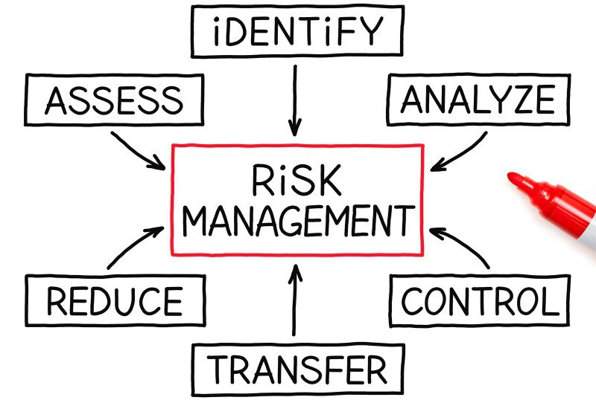
Most firms today tend to make ERM more a of coordinating, information collecting, and technical supportive function for the organization as a whole. Obviously the most common activities are risk identification and ranking. Less common are the more aggressive integrated risk management activities, such as measuring and exploiting natural hedges among the totality of the organization’s risks and evaluating risk management strategies in light of risk/return requirements.
The fourth and final key question in creating the operational framework is "What specific tools will we need to implement ERM?" The range of possible tools includes, but is certainly not limited some of the following;
- Risk audit guides—These guides can be used for risk mapping of individual risks, risk assessment workshops, and risk assessment interviews.
- Risk models—Mathematically rigorous approaches used to simulate the dynamics of a specific system by developing cause-effect relationships between all the variables of that system.
- Risk monitoring reports—These can include regular reports to managers, boards, and relevant external stakeholders such as regulators and investors. Where reporting is more formal, the reports are most likely to go to the executive committee and the board of directors. Other reports are likely to go to operational managers through "dashboards" that will enable them to adjust their actions to the reality of their risk environment.
Managers can choose and use tools they are acquainted with in order to manage risks they know, simply because they are familiar or easy to quantify. The danger here, of course, is that in so doing managers may end up not paying attention to risks that are potentially just as important simply because they are hard to quantify and managers don’t have, or know about, the tools to manage them.
In summary, companies that have invested the time and effort to get the above fundamentals right will have succeeded because they have laid a clear track to follow, established realistic expectations, assigned unambiguous roles and responsibilities, equipped themselves appropriately, and identified objective benchmarks to monitor their progress. There is no reason that all companies can’t achieve similar success in ERM and, as a result, in their respective businesses and in doing so have a systematic approach to limiting or avoiding disruption and/or damage to their operations due to unforeseen or un controlled events.

Case Study (9)

Nigel Rooney, 54, runs two small convenience stores in Norfolk and Norwich with his wife, Shaz, 52, admits that time is a very precious commodity for the couple.

"My great grandfather ran butchers in Somerset so we've been a retailing family for 130 years. But when it came to Health and Safety rules and regulations, working out our risk assessment used to be a real problem for us. We were frightened by the idea of it - the process seemed so complicated and daunting."

Nigel though is aware of the benefits of having proper Risk Management system in place for his business. He is thinking to hand over this side of his business to a qualified professional, who could handle all the tasks involved. Dylan, 35, is an energetic professional, who is basically an accountant but is qualified for Business Risk Management as well and offers his services to the clients in this field. Their meeting has been fixed for Monday. Dylan will make assessment of Nigel’s Business and will tell him the benefits of having risk management for his business.

Keeping the above situation in mind, answer the following question:

1. Outline the benefits of risk management which Dylan could share with Nigel.
A "risk analysis" questionnaire or survey, available from most insurance agents, can be helpful during the early stages of risk assessment. They will benefit significantly by analyzing their exposure to the following six kinds of risks associated with convenience store management;
- Property Losses
Physical Damage - A risk assessment typically finds that most family businesses carry coverage against the losses arising from property damage caused by many common exposures: fire, windstorm, lightning and vandalism. It also needs to assess;
Loss of Use - The business could also lose the use of property without suffering any physical damage.

Criminal Activity - Risk assessment also looks at risks from crimes committed by others. Burglary and robbery, white-collar crime, employee theft, embezzlement or forgery. Traders, in particular, may need protection against losses caused by acceptance of forged checks or unauthorized use of credit cards.
- Business Interruption Losses
A distinct kind of insurance will cover indirect losses that occur when a direct loss (that results from a covered peril, such as fire) forces a short-term interruption of business. During these forced interruptions, besides income being reduced or cut off completely, many business expenses will continue. Things like: taxes, loan payments, interest, salaries to key employees, and utilities. Without income to pay for these expenses, the business is forced to dip into reserves.
- Liability Losses
Public Liability - A family business that is found legally liable for harming a third party will have to pay damages to compensate the injured party. The court may also award a fine in hopes of discouraging future violations in cases involving violation of a statute that protects the community as a whole. Risk assessment evaluates a business and its operations and industry to anticipate potential exposures.
Liability to Employees - Should an employee be injured or die, as a result of a job-related accident or disease, the employee's family will collect a specified amount. So risk assessment will consider not only the types of injuries and death risks that might occur in the industry and business, but also what each business is doing to reduce risks.
- Key Person Losses
Dylan’s Risk assessment will assess the impact on Nigel’s business if a key person dies or is disabled, or if an accident or illness made it impossible for Nigel or Shaz to work. Clearly in this family oriented business the impact is even more critical.
- Family Brand and Reputation
With the rise of social media that provides fast access to news stories, "brand and reputation risk” also needs be considered as part of the total risk analysis. Although Nigel and Shaz seem a grounded couple and are only a small enterprise, dealing with and allowing for problems that could hurt the family's brand and reputation (divorce, alcohol, drug abuse and family feuds, etc.) is a smarter strategy then letting the problems fester and hoping the problems will resolve themselves meaning the family will not have to deal with these potential difficult situations.
2. What is the first step that Dylan will take for risk assessment of the business?
Risk assessment itself is the vital first step of risk management, even for a small holding enterprise such as that held by Nigel and Shaz. HSE however is the first step in the RA process to be reviewed and strategized for.

Initially Dylan will assess the health and safety risks faced by Nigel’s staff by systematically checking for possible physical, mental, chemical and biological hazards by considering;
- Physical risks: e.g. lifting, awkward postures, slips and trips, noise, dust, machinery, computer equipment, etc.
- Mental risks: e.g. excess workload, long hours, working with high-need clients, bullying, etc. These are also called 'psychosocial' hazards, affecting mental health and occurring within working relationships.
- Chemical risks: e.g. asbestos, cleaning fluids, aerosols, etc.
Following on from this first step Dylan will then;
- Decide who may be harmed, and how.
- Assess the risks and take action.
- Make a record of the findings.
- Review the risk assessment.

3. What will Dylan do at the risk control stage?

Risk control is the method by which Dylan will evaluate the potential losses of Nigel’s and Shaz’s two shops and take action to reduce or eliminate such threats. At this stage in the process this technique will utilize findings from his risk assessments, and involve identifying potential risk factors in the shops operations, such as technical and non-technical aspects of the business, financial policies etc., that may impact the well-being of the company. Risk control also implements changes to reduce risk in these areas.
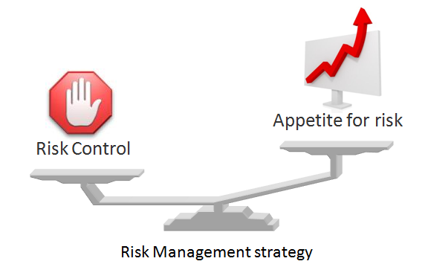
This is where the balance needs to be found between the findings and the controls needed to manage those identified risks. A standard format is normally used and this will identify all the identified risks/hazards, who or what might be harmed by them, what is already being done to limit and control these hazards, what further action is necessary and then there is the action side of the controls – who will take the action, when and ultimately the actual time it was completed.

Student Statement:

By submitting this assignment, I confirm that this is my own work.

Student Signature | Raymond Wilson | Date | 2nd Feb 2017

For Tutor / Assessor Use Only
Total Marks
Marks Obtained
Percentage / Grade

