
Assignment Cover Sheet

Student Name: | Saul Christopher Denby
Student Number: | 1498
Course: | Diploma in Fashion Design (Level 4)
Assignment NO: | 3

- I. How the income groups influence fashion?

New fashion trends to be initially expensive, so people with high incomes like celebrities
for example tend to buy items from new trends first. This celebrity endorsement will usually
influence their fans and admirers to also buy into the trend, and so it starts gaining popularity.
People on lower incomes can influence fashion through the clothing they would commonly wear.
The majority of people can’t afford expensive trends so they wear clothes of a casual and practical
nature, choosing function over fashion. Fashion designers can, and do, draw inspiration from
street styles and incorporate some of the themes into their designs to appeal to a wider market.

II. Why is awareness of fashion forecasting important for the designer and the buyer?

It is important for designers because it should help to steer their new ideas in the direction
of what society, or a chosen group will want or need in the coming seasons, or indeed years
ahead. Perhaps a certain colour will rise in popularity over the summer, or an anticipated
upcoming film will feature distinctive costume designs, or a new combination of fabrics is
predicted to retain heat over the winter. A fashion designer would not be able to create designs
that would meet the needs or interests of a coming year without an awareness of forecasting.
Regarding the buyers, I am not convinced that an awareness of fashion forecasting is important
to a buyer at all. After all, forecasting is a way of identifying future needs in the hope of maximising sales. So for buyers I don’t think an understanding of forecasting helps them with buying choices.

III. What is meant by fashion trend?

A fashion trend is a certain style or design which many designers incorporate because of
its growing appeal. A trend may well start small by just one designer, and then another becomes
inspired by it, and then another, and before you know it it can be seen everywhere.
Trends do tend to be relatively short lived, because of the internet we have an enormous wealth of
multi-national influences so its no surprise that new trends appear often.

IV. What are the different factors that affect fashion trends?

One of the most influential factors is the time of the year. Some trends are intended to be
worn during hot weather, like a particular style of shorts or t-shirts, so beyond summer they
could not be used anymore. And likewise a trendy winter coat could only be used during cold
weather.
People’s lifestyles can also affect trends, for example a certain trend might not be suitable to
be worn for many professions or leisure activities, so only a few people might buy it in which
case the trend would die out.
Another factor for a trend’s acceptance is it’s geographical location. Each nation has its own ideas
about what is considered acceptable and tasteful, because of multiculturalism and the wide reach
of the internet these national preferences are not as strong as they once were, but to some
extent they still influence. Some of the more revealing summer clothes seen in the US and Europe
would not be encouraged in the more conservative middle eastern countries, and the creative
styles of South Korea and Japan would most likely become fads in western countries.
And of course the cost of trends will very much affect the length of their popularity. If they have
high asking prices then they may well not last long, unless they are made famous by celebrities,
in which case cheaper copies will soon flood the market.

2. Define the following terms;

Classics - A design that started as a trend and goes on to enjoy a long period of popularity,
and more or less remains influential for years to come, a classic has the ability to be brought back
into fashion over time. They commonly have simple designs which is partly what makes them
so adaptable to any given time period.

Fads - Styles which quickly gain popularity and then loose it shortly after are called fads.
Fads are either intended for a specific interest or group, in which case they would only be used
by a very select group of people, or they are usually comparatively cheap to produce, so they
will suddenly appear everywhere and people will soon tire of them because there is no feeling
of exclusivity with owning them.

Interrupted cycles - If an unforeseen event or circumstance were to affect the expected
lifespan of a trend or line of clothing, it would be called an interrupted cycle. In the event of a
national emergency fashion designers would naturally delay their new creations until everything
was safe, which means the previous trend would remain for longer than was planned.
A cycle can also be interrupted short, possible a range of summer clothes arrives into stores
to late so there is then no use for them anymore.

Recurring cycles - Fairly self explanatory, styles popular decades ago can be brought
back into fashion with some changes to meet the tastes of the new age. Vintage inspirations
have been a part of fashion and style during almost every decade, and continues to be.

Fashion adaptation - A certain trend might be intended for a specific group of consumers,
but the trend might have potential to appeal to other or wider consumer groups, so the trend
is adapted to meet their expected interests.

Traditional fashion adoption - This means the process of acceptance to new styles by
consumers. Usually new trends are expensive and striking, so they need plenty of advertising
and media coverage in order for consumers to feel more comfortable about them, and to get ideas
about the contexts in which to wear them well.

Reverse adoption - Sometimes fashion designers draw their inspiration from consumers.
Consumers can create their own trends, this could be certain combinations of styles, or unusual
ways of wearing some item, or maybe something they have made themselves. Consumer’s
ideas can grow in popularity and begin to influence high end designers.

Dissemination - I believe this is when designs are made for a specific consumer group
based on observations of what that group most commonly wears and needs. The groups
could range from a specialist interest activity or an age group.

Compare fashion looks from 6 months ago with the present fashion, and make a
forecast for the directions of the future.

6 Months ago was summer time so bright colours were popular, as was loose fitting
long shirts for women, and tight fitting polo shirts for men. It could be said that women and
men dressed more and more alike, with very little gender difference in clothing. A good
example is the converse shoes, exactly the same style for women and men, as was the
summer trilbies.
Now in the winter colours are much darker shades, I think the clothing gender difference is
much clearer now because of layering, and the preferences of coat styles between genders is
much wider.
Something I noticed in womenswear is that there is a growing trend of pulling trousers up really
high over their stomach, I don’t know why this is, because it is not very flattering, but I didn’t
see very much of this trend 6 months ago.
Below are a few attempted forecasts for the coming season.

Colour: This is such a huge area that it makes predictions very difficult, boundaries are
being broken all the time, so every colour on the spectrum is now accepted by both women and
men, which wasn’t always the case. I imagine the eco-friendly attitude will continue its momentum
this coming year which in turn might inspire more nature colours to be worn, such as green, blue
and maybe yellow and white.

Fabric: At the time of writing, the coming season is summer, so I’m sure that linen will
return with a passion for both women and men’s wear. Cotton also is likely to become widespread
again, and to some extent probably silk too because of its light weight.

Silhouette: Last year there was quite a noticeable attraction to slim fitting clothing,
however at the start of this year several high profile brands are trying to start introducing loose
fitting clothing, and intentionally oversized items. If the advertising campaigns can successfully
make them look credible then I imagine the trend will become rather popular.

Line: Much associated with the silhouette above, I would think lines will become softer
and more draped. For example some brands have already left out shoulder pads and interfacing
in men’s summer suits, so it seams that the softer look with more rounded ‘corners’ could start
making an impact soon.

From current fashion magazines I have selected a few examples of various fashions.

High fashion

I have chosen these examples as high fashion because of the popularity and high
status of the brands, along with the high quality of the fabrics used and therefore the high
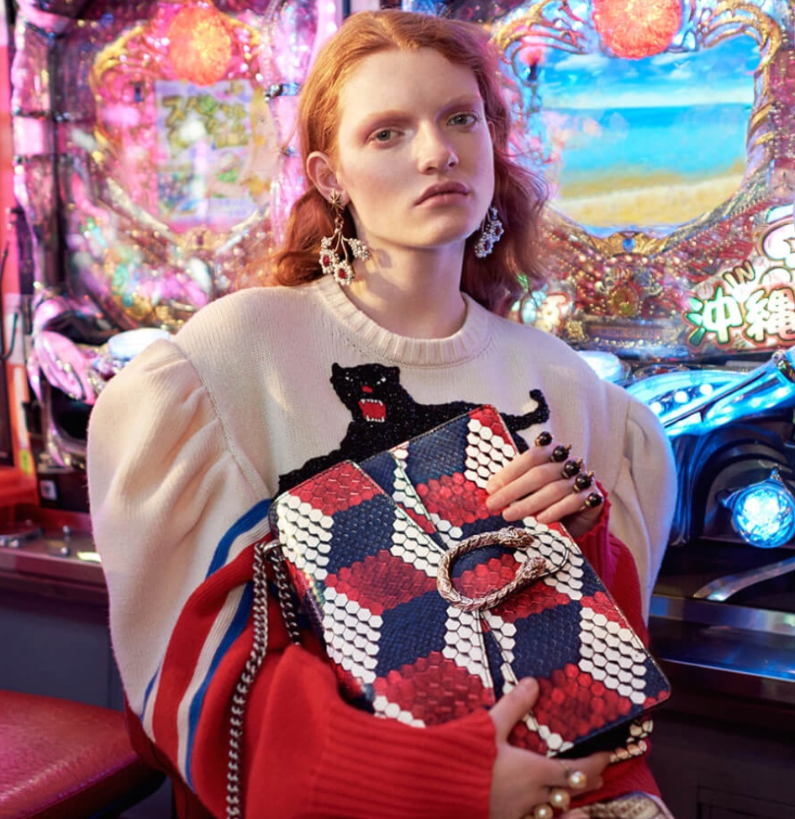
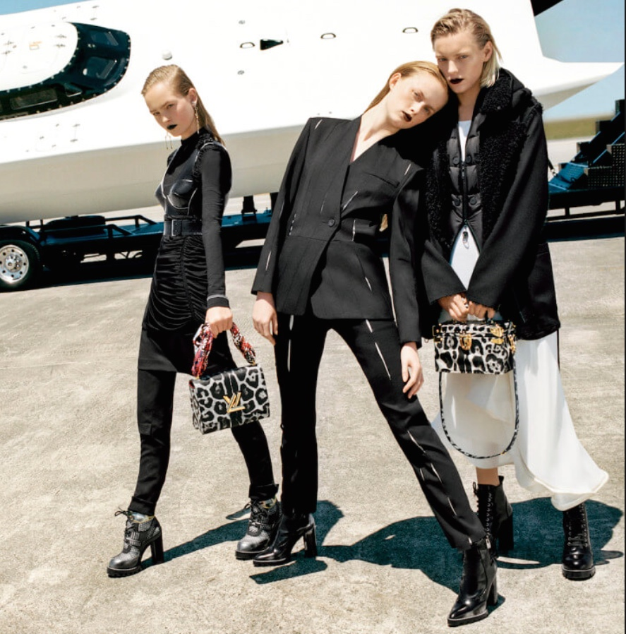
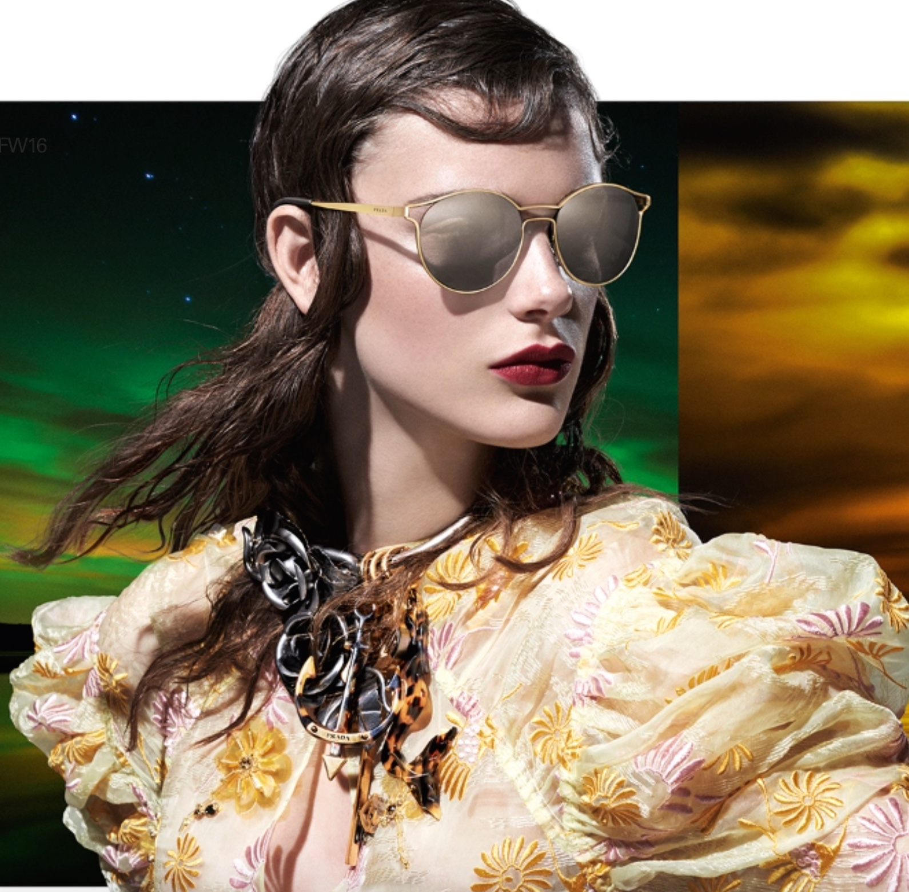
prices. Clockwise from top left: Prada, Gucci, Louis Vuitton, Hugo Boss and Giorgio Armani.

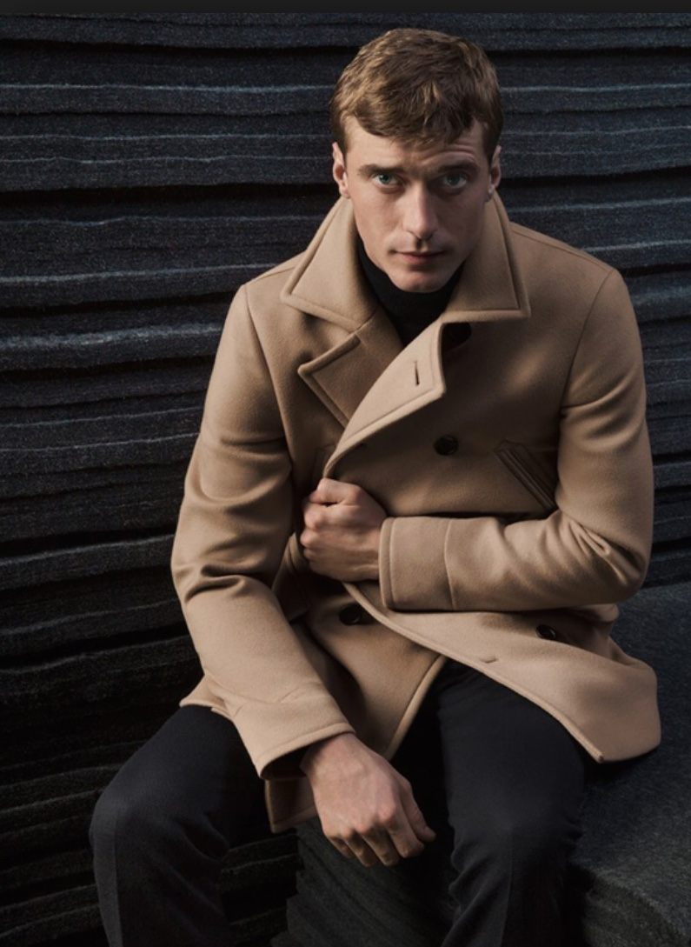
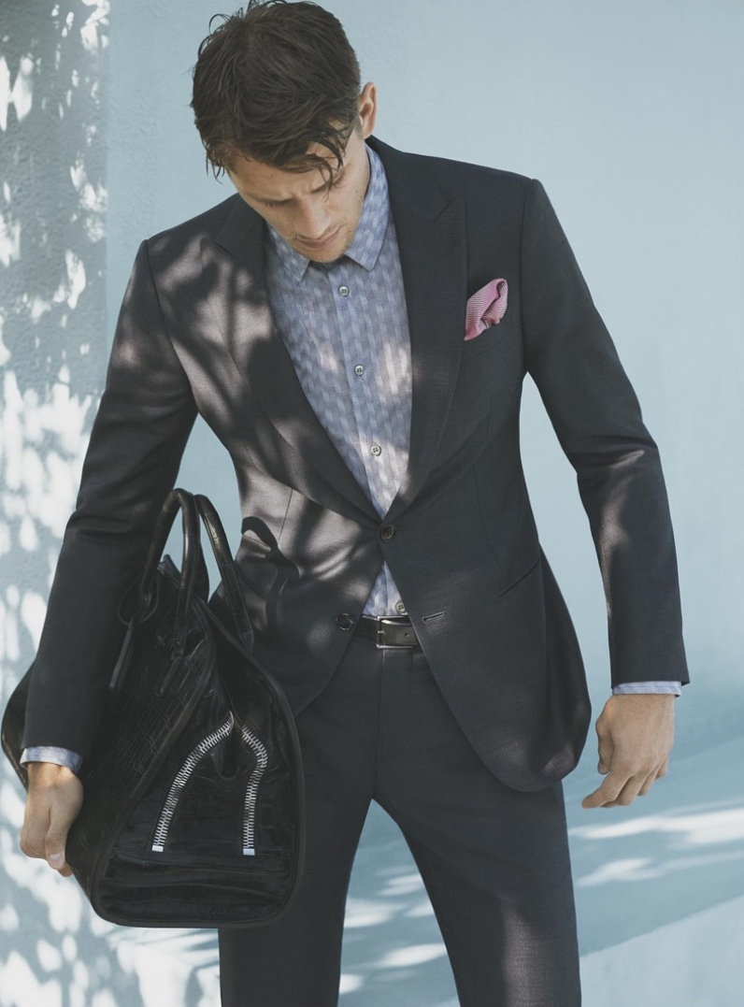

Mass Fashion

For mass fashion I have chosen brands whom have the widest range of consumers.
Clothing by these brands are some of the most common one can see on the street and in
many casual environments. Their clothing is designed to be more comfortable and practical
with lower prices. Top row: AG Jeans, Tommy Hilfiger. Middle row: Adidas, Topman.
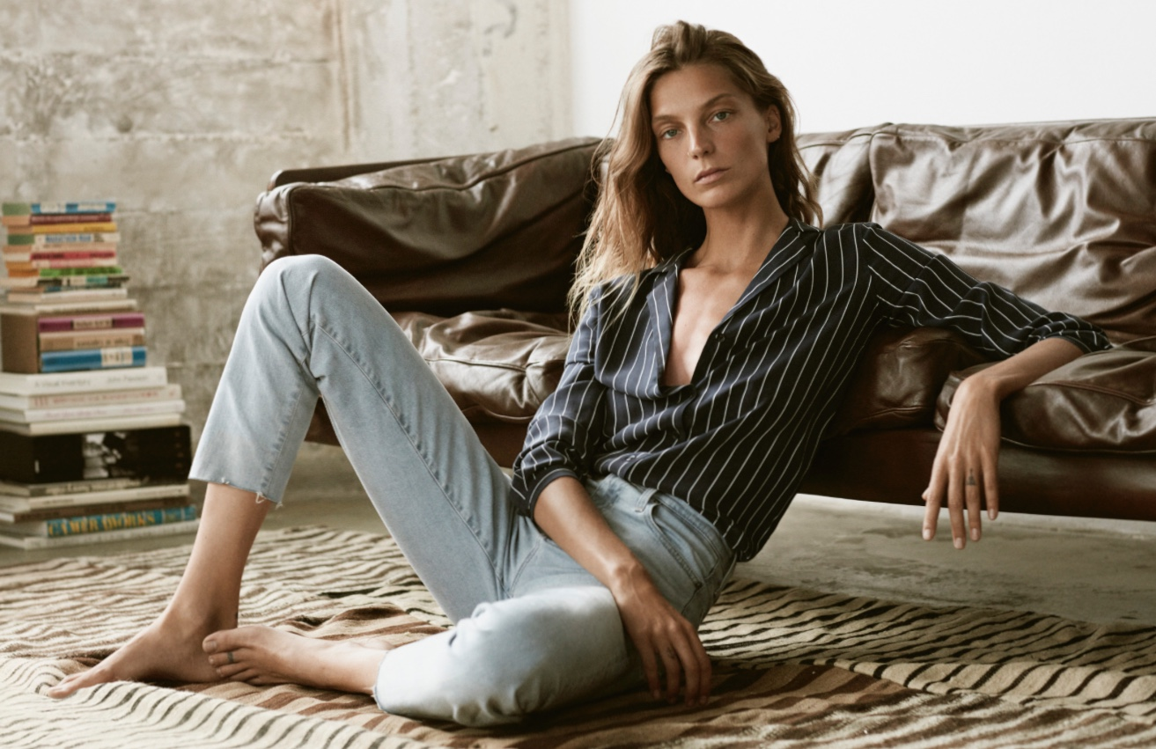
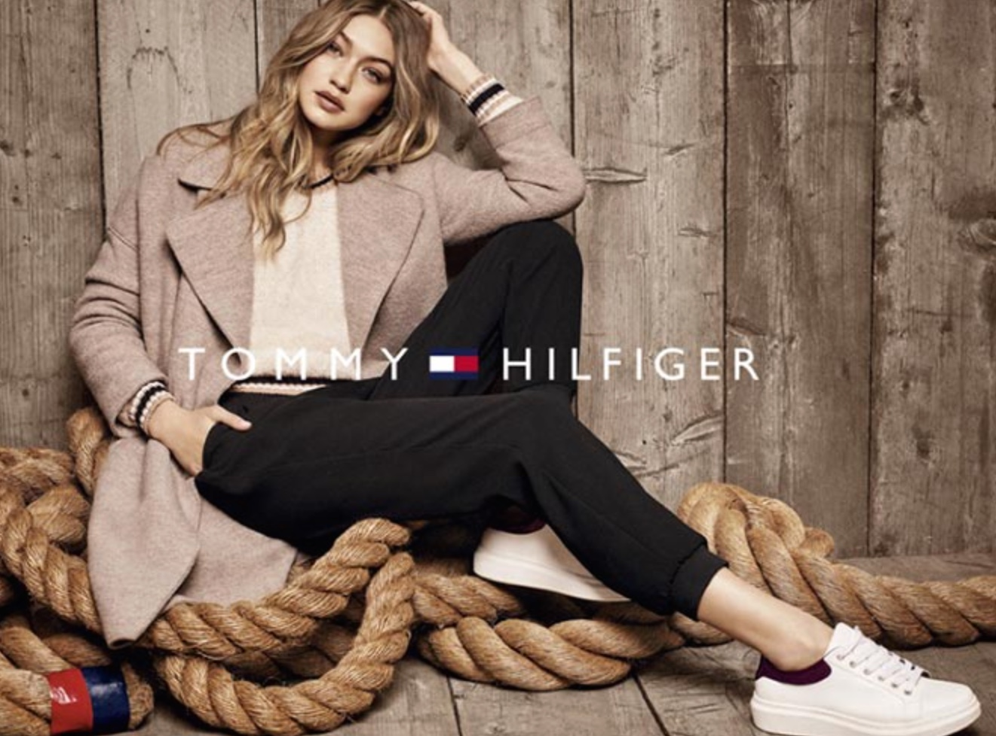
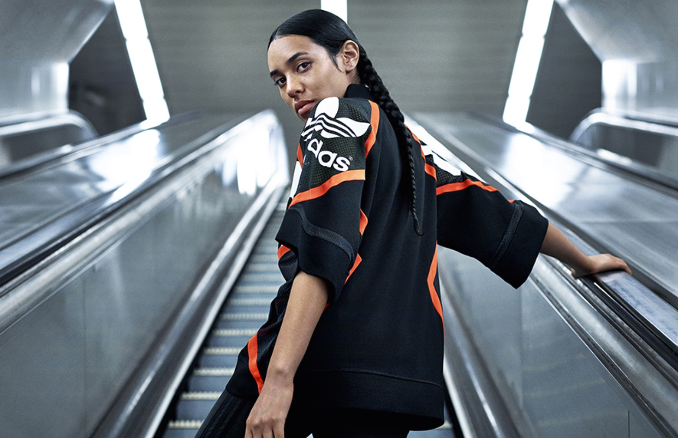
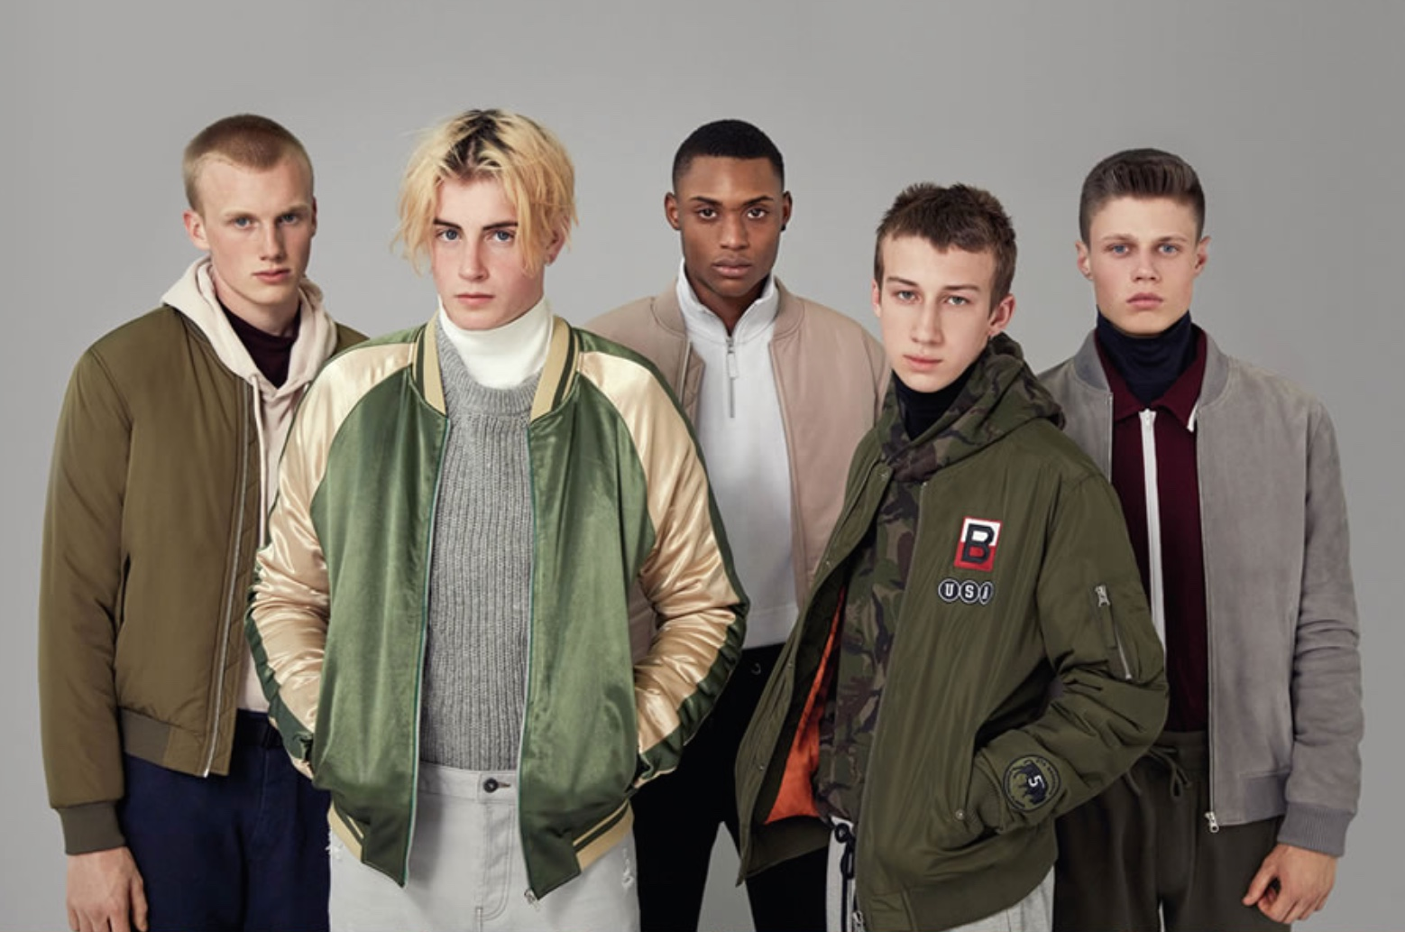
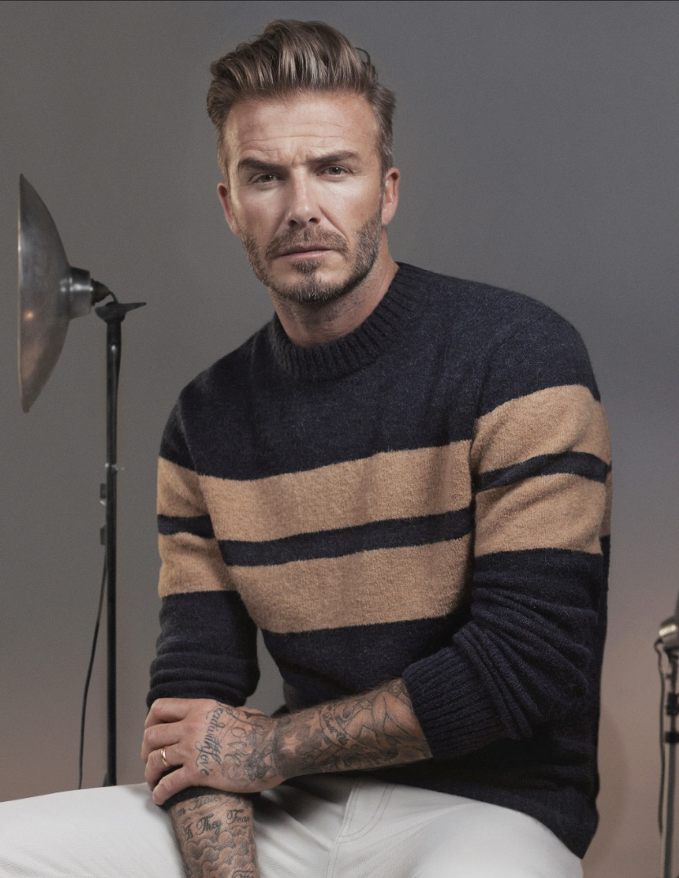
Bottom row: M&S.

Classics

Classics tend to be some of the simplest designs in the simplest of colour schemes,
which is what makes them so versatile and fashionable throughout decades. Classic’s styling
is most often incorporated into women and men’s formalwear, with the colours remaining
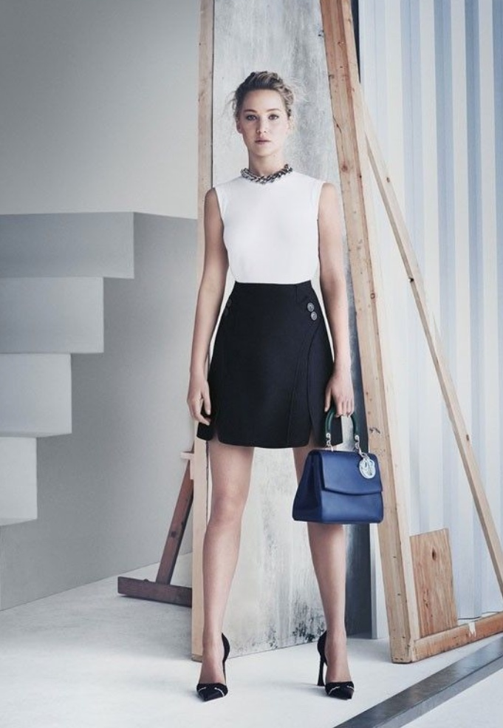
simple and timeless, such as black, white and red etc. Clockwise from top left: Dior, Dior,
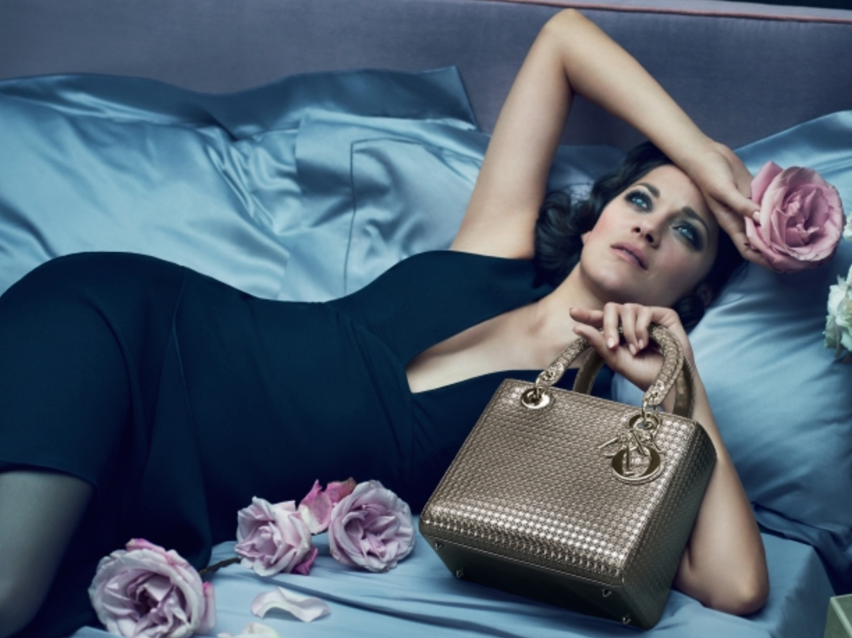
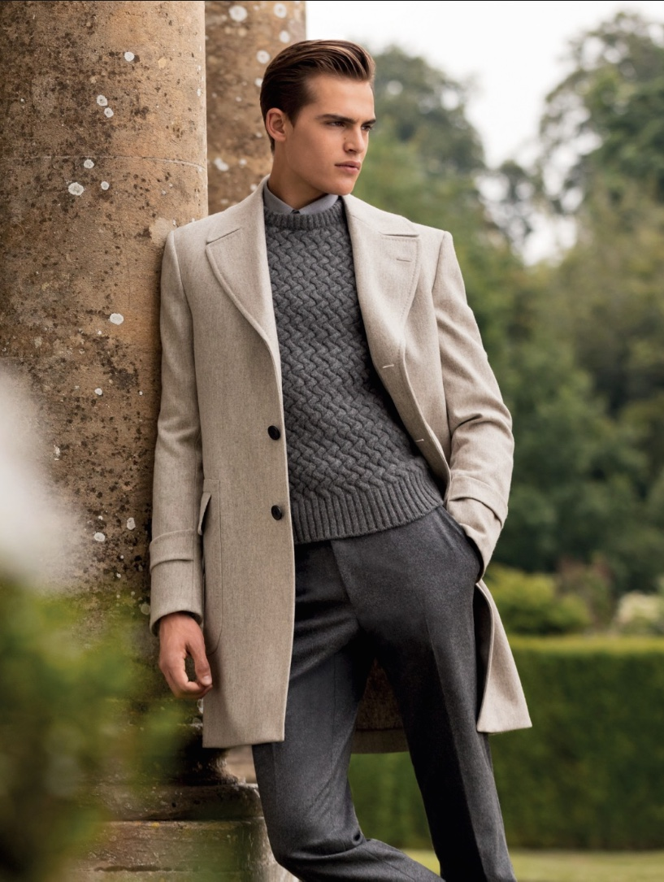
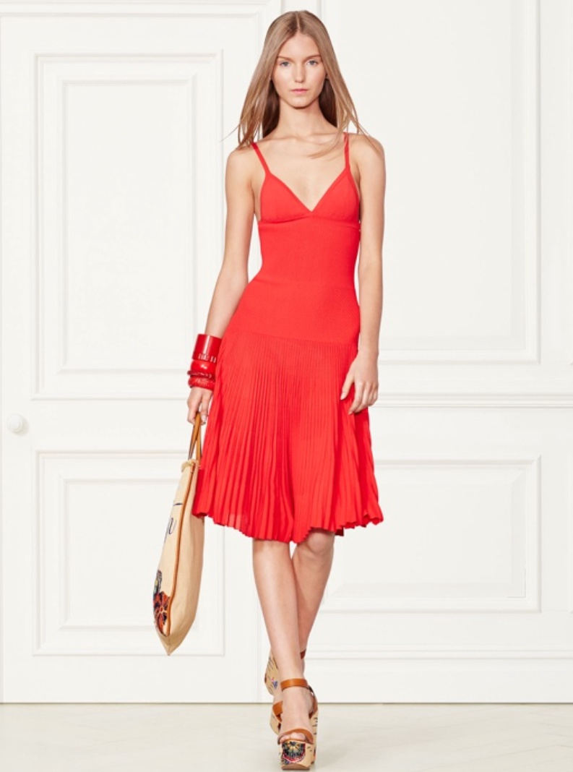
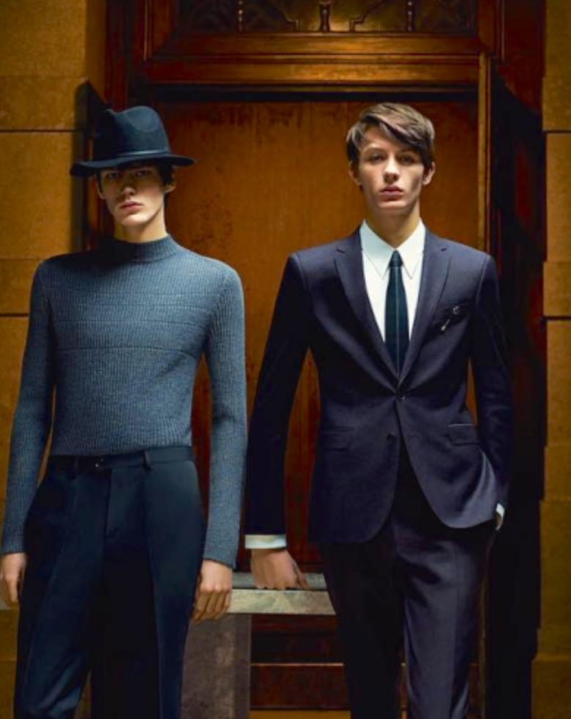
Hugo Boss, Ralph Lauren, Gieves & Hawkes.

Fads

It seams recently several high profile brands are using very colourful and intricate
patterned fabrics, or they are adding a lot of flourishes and patterns using needle work onto
already colourful clothes. I imagine these ideas will be too much for the majority of consumers
to take seriously, they are too overpowering to become mass fashion, and too visually chaotic to be considered classic. So their life span will probably be comparatively short.
Top row: Gucci, Gucci. Middle row: Philipp Plein, Burberry. Bottom row: Prada.

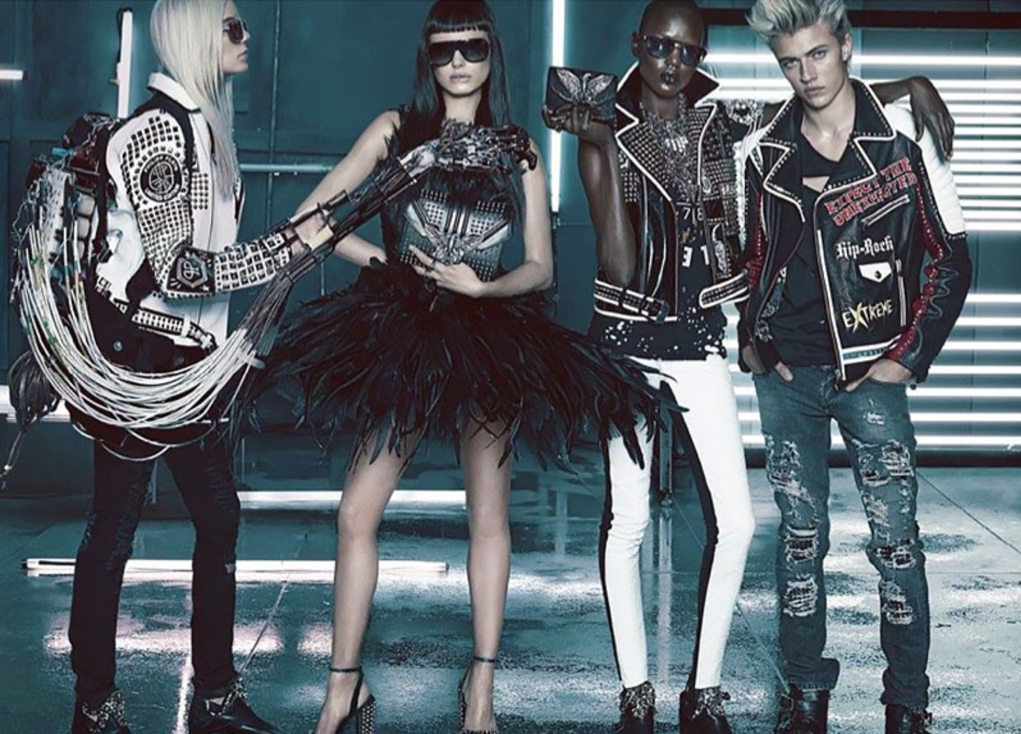
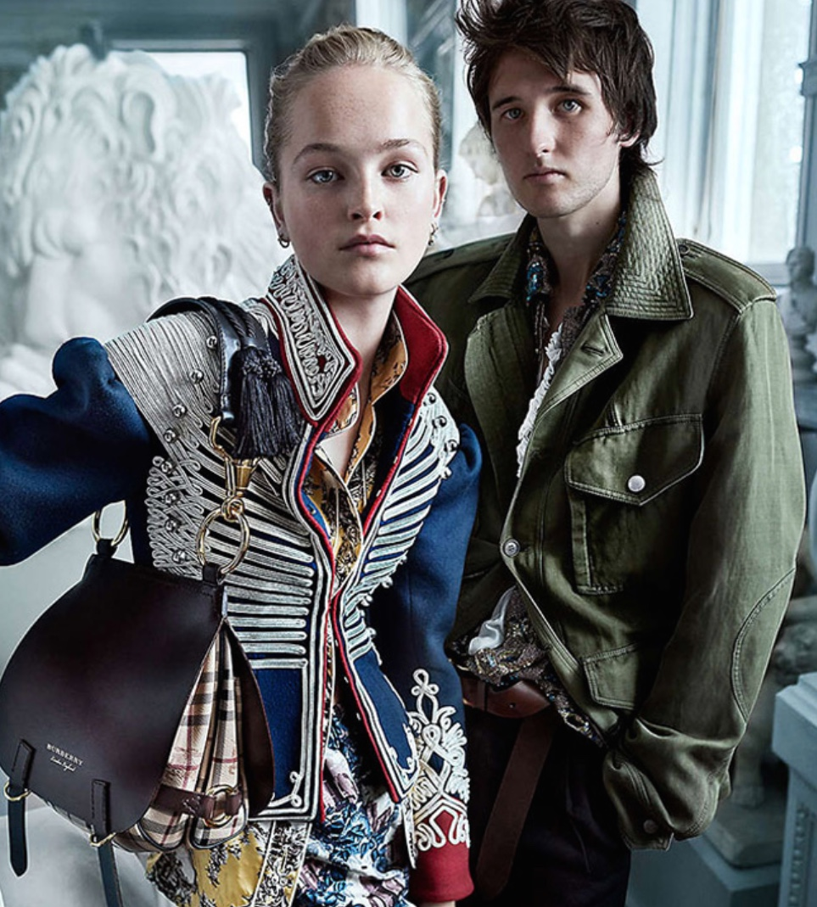
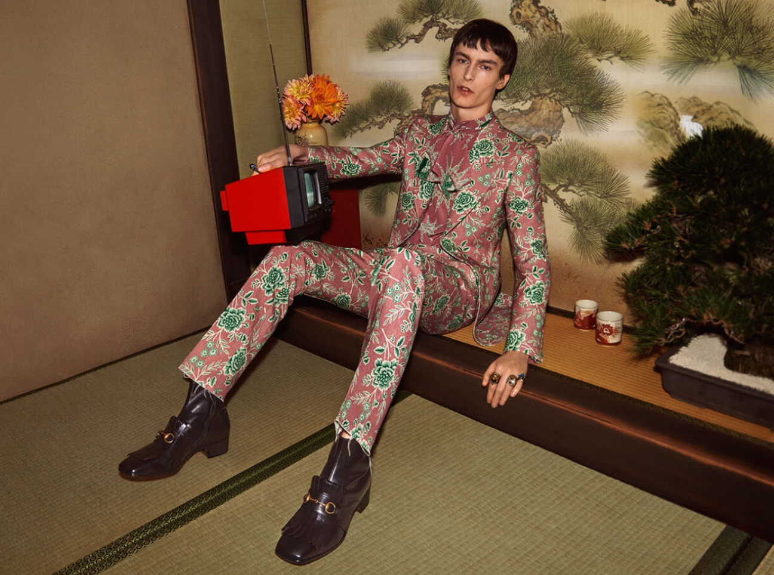
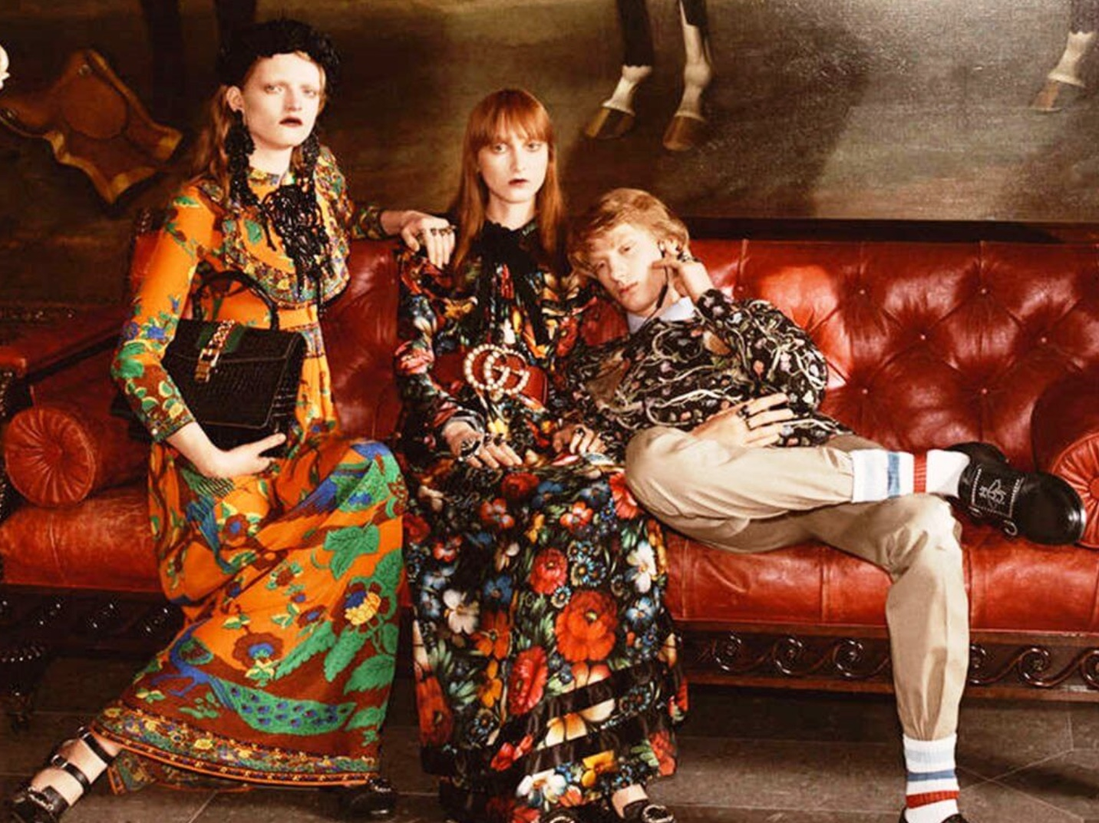

Student Statement:

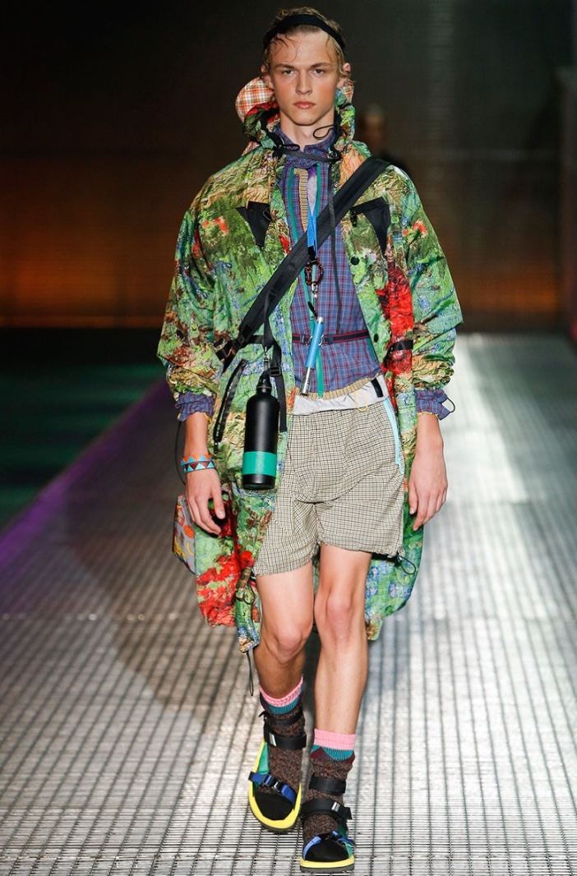
By submitting this assignment, I confirm that this is my own work.

Student Signature | Christopher Denby | Date | 15/01/2017

