
mf

Assignment Cover
^{Student Name:} | ^{Hiyam Daou}
^{Student Number:} | ²³²⁰
^{Course:} | ^{Diploma in Diet & Nutrition}
^{Assignment NO:} | ^{test 13 Weight Loss Management}

Multiple choice question:
- If we reduce our daily energy intake to around 500 calories below our energy requirement we can lose:

- 1kg a week
- 0.5 kg a week
- 0.2 kg a week

- the term basal metabolic rate refers to the energy calories we use during the day to;
- do physical activity
- keep our body function
- perform daily activities

- resting metabolic rate or RMR expands about:
- 70%of our total energy consumed
- 20% of our total energy consumed
- 10% of our total energy consumed

- stress and anxiety can cause:
- increase the energy expenditure
- decrease the energy expenditure
- energy expenditure is not affected by stress and anxiety

- sensible weight loss for a healthy adult should start with a:

- 500 reduced calories a day
- 1000 reduced calories a day
- 1500 reduced calories a day
O. 2. short Questions:

- motivation is one of the most important factors in weight loss. Discuss setting goals is very important in weight loss program why? once a person has lost weight how can he maintain it for long term?

Motivation is one of the most important factors which determined how successful we are at what we do, it is the driving force that gives us the will to accomplish tasks and eventually succeed at reaching our ultimate goal.
Motivation will be the most important part to work at, it will provide us with determination to get up and exercise even if we don’t feel up to it.
Motivation also drivers us to stick to low fat selections and recipes which are required to keep our progress moving.

ii. setting goals is very important in weight loss program. Why?

Goal setting required establishment of concrete objectives. Ones that are achievable. With goal setting you cement your plans.
Its easier to break a promise you make to yourself than those you make to other people. Goal setting should be test of your personal integrity. After al how can you keep your word to others if you cannot even keep a promise to yourself?
Goal setting is a powerful tool that makes you the master of your own future.
Your goals will determine your action today that will affect your situation tomorrow.
Specifying your goal will help you determine where you should focus your resources and effort. Goal setting is a blueprint of sorts one that will show you what to do and how to do it clarifying your goal will also weed out the distractions that can disrupt your progress. What exactly do you want to achieve? How long do you want to work to achieve it ? what would you do to achieve your goal?

Make sure your goals are measurable so that will not become discouraged.
You should list out all baby steps that make up the journey and place the goal and steps in a calendar
Goal setting requires that you consider all the baby steps that make up the journey from who you are today to who you want to become tomorrow.
The method of goal setting is that it has to be SMART.
.
meaning each letter in the word SMART stands for something:
S = Specific

The goal has to be specific. You cannot just wake up one day and declare that I have a goal of losing weight. That does not make any sense because that’s ultimately the destination it’s not specific. How much weight do you want to lose exactly? Bad weight water weight?
M= Measurable

Similarly, the goal has to be measurable. Let me give you example that her goal was to control 80-90% of their emotional eating and cravings. Emotional eating scale it assesses in response to emotions it includes subscales for anger/frustration anxiety and depression. The development of a measure to asses coping with negative affect by eating.

A = attainable

Instead of shooting for size that has not been seen in your closet for 10 years set more attainable goals. Even modest weight loss can improve your blood pressure and your chosterol blood sugar and triglyceride level. Losing as little as 10 pounds can put the zip back in your step and make you feel terrific about yourself.

R= relevant

The doesn’t need explanation whatever you decide to be your goal the means should as relevant to it as possible.

T=Time based
Unless you have specific time frame in your mind to attain that goal its just a dream.

Setting goals is very important in weight loss why cause:

- decide what you want
- specify your goal think about how to get what you want.
- Develop a step action plan including a plan to monitor your progress.
- Keep your goals realistic and constantly revisit them.

The more important aspect of goal setting is to keep your goal grounded. For instance, setting a goal to lose twenty pounds in 2 months may leave you disappointed. Setting goals to lose 2 pounds a week will allow you to achieve constant milestones.
Most people who fail at losing weight either give up half way because the set ridiculous goals or fail because they didn’t set any so keep in mind that you want to set realistic and achievable goals.
Once you have decided on your goals, stick to them and see them through to the very end. Cause once you get to where you want to be you’ll see that every step of the journey was totally worth it.
Remember the journey that matter not the destination you should always always have your mind set on the destination.
So enjoy the journey of the course but never ever lose sight of the ultimate destination your own fit body without the excess baggage.

The body fat step point is the mass of body fat your body attempts to defend against changes in either direction. It’s your body’s attempts to maintain homeostasis. This is why exercise more you eat more its also why if you restrict calories your metabolism slows down to compensate.

We care because this has some very important implications for human obesity. with such a powerful system in place to keep body fat mass in a narrow range a major departure from that range implies that the system isn’t functioning correctly. In other words, obesity has to result from a defect in the system that regulate body fat because a properly functioning system would not have allowed that degree of fatb gain in the first place.
We are gaining weight because we eat too many calories relative to energy expended.
But why are we eating many calories? Because the system that should be defending a low mass is now defending a high fat mass. Therefore, the solution in not simple to restrict calories or burn more calories through exercise. But try to reset the system that decides what fat mass to defend. Restricting calories isn’t necessarily a good solution because the body will attempt to defend its set point whether high or low by increasing hunger and decreasing its metabolic rate. That’s why low calories diets and most diets in general typically fail in the long term. Its miserable to fight hunger every day.

How do you reset the system how do you train your body to start burning stored body fat?
One word Ketosis

Is Ketosis dangers
Ketosis has earned a bad name though. For one thing your body enters a ketogenic state when it starts starving itself. But if you’re eating plenty of calories and sticking to nutrient dense diet you need not fear starvation Ketogensis doesn’t destroy muscle tissue, but rather the process by which stored fat is turned into Ketones a perfectly usable energy source for every major body system. Others object to Ketosis because it gets confused with Ketoacidosis a dangerous stat in which the body not only becomes Ketogenic but also cause the blood too acidic. If you’re still getting your limited carbohydrates from vegetables and fruits, you won’t fear Ketoacidosis.

When you cut carbohydrate intake to 50-80 gram per day and still include plenty of vegetables and fruits in your diet then your body can safety enter into Ketosis when it needs to.
When you’re at your desired weight and you don’t hope to lose anymore body fat, then stick between 100-150 gram of carbohydrates per day will help you maintain your new body fat set point.

Never have to count calories in fact also you don’t have to count carbohydrates just avoid grains sugars and sweet fruits. If you craving those foods eat more saturated fat from traditional source like ghee coconut oil.
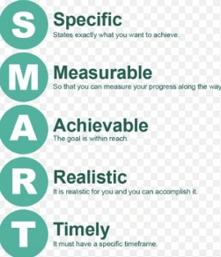
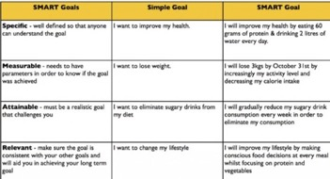

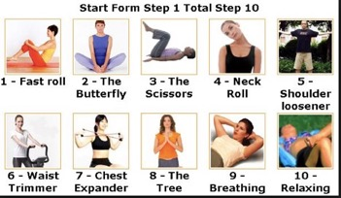
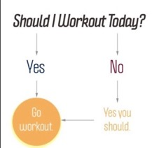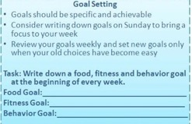

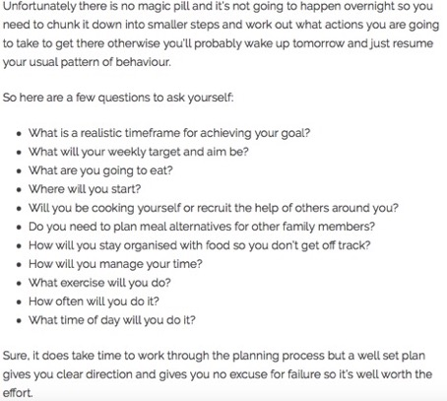

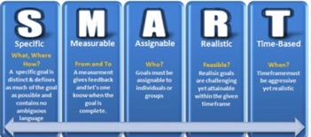

iii. once a person has lost weight, how can he maintain it for long term?

If you want to lose weight and keep it off for good. These five stragies will help you do just that.
- Set the right goals
Most people trying to lose weight only focus on their ultimate dropping pounds. But it’s important not to lose sight of the diet and exercise. Choose two or three diet and exercise goals at a time that you are willing to take on. And make sure they are specific and realistic.
For example exercise moore is a wonderful goal but it’s not specific. Walk 5 minutes every day is specific and measurable. But is it realistic if you’re just starting out?
Walk 30 minutes every day is better but what happens if work or weather interferes? Walk 30 minutes for 5 days each week is specific and realistic.
- Know your triggers
Are there situation that make you want eat more? Start noticing them for example you may learn that you’re more likely to overeat while you’re bored or stressed.
Then figure out way to get around those triggers. Do something else to sooth your stress for instance like meditation.
Also you might want to put treats away you’re more likely to eat them if they’re visible and easy to get to.

- Fill up on food

You should feel full. But how you do that might surprise you.
Its mostly about: 15 minutes to be specific. You need at least that much time to feel full. So eat slower giving your brain enough time to notice that you’ve eaten.
What you eat can also help. Think fiber like fruits and veggies to fill up.
Another trick is to use smaller plates so that small portions do not appear too small.

Also changing your eating schedule can help you reach your goal, especially if you tend to skip or delay meals and overeat later.

- Reward weight loss success but not with food

Reward is something that is desirable timely and depends on meeting your goal.
Rewards may include treating yourself to a movie or massage taking an afternoon off from work, or giving an hour of time to yourself.
Keep in mind that many small rewards given for meeting small goals can work better than bigger rewards for long difficult goals

- Keep track of your progress

Write down things like how much you exercise and what you eat there are many apps that can help to keep you on track.
Doing this can really open your eyes to what you are doing and what you need to do to meet your weight goals.
- Get enough sleep deprived people may crave the reward of unhealthy foods.
- Get 60 to 75 minutes of moderate exercise such as walking or 35 to 45 minutes of vigorous exercise such as running per day.
- Start working on increasing daily exercise while you’re on diet so that you are prepared for high amounts of activity by the time you need to maintain weight loss.
- Eat mindfully meaning that you savor each bite so that you feel satisfied without consuming too much.
- Don’t give up people who are successful at maintaining weight loss often go through several failed attempts first.
- Weight yourself regularly.
- Don’t skip meals people who skip meals may end up feeling hungrier later in the day and overeat.
- Don’t sit too long in front of the tv people who successfully keep weight off watch fewer hours of tv than the typical.
- Another habits are for maintaining weight loss is self-monitoring which means keeping calories tabs on your weight and eating habits like weight themselves daily also tack your daily food intake monitoring weight is important so that you know right away when pound is starting to creep back. It’s easier to catch it.
- One reason you exercise is important for keeping weight off is that it can prevent the metabolic slowdown that happen with weight loss so the body burns more calories even in resting state than it would if the person wasn’t exercising regularly.

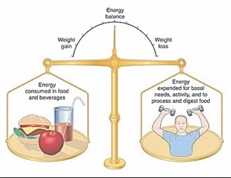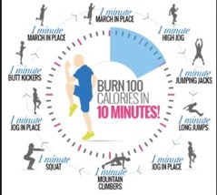

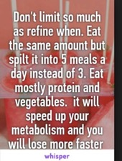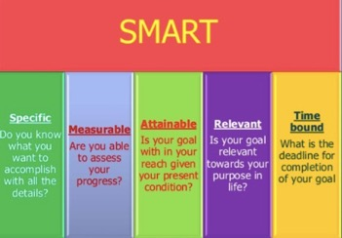

iv. how important it is knowing the total calories intake required for the person before devising any weight loss plan for him?

Its important cause weight loss and weight gain revolve around caloric consumption and
Expenditure because of this its important to understand the basics of calories.
In fact, your daily calorie intake is the only diet component that will truly differ or
change
Based on what your goal is.
Meaning once everything else protein fat carbs etc. is set to an optimal percentage of
Your calorie intake. It can all remain set that same way and you’ll still lose fat or build m
Muscle or do whatever else you are trying to do without any problem.
Calorie are the key and the reason why calorie are so important is actually pretty simple
once you understand some basic thing…
calorie in
everything we eat and drink contains calories. With the exception of obivious stuf like
water all foods and drinks contain some amount of calories and go on to make up our
daily calorie intake.
Since these are the calories being consumed and therefore taken in by your body they
Are commonly referred to as our calories?

Calories out
On the other hand, everything we do burns they are what our bodies use for energy
to do everything we need to do.

From intense exercise like weight training and crab to simple daily tasks like standing
Talking and brushing teeth in addition your body actually burns a significant number of
Calories each day on its own just keeping you alive and functioning properly. You know
Doing stuff like breathing pumping blood digesting food ect.

The calories that we are using and burring they are commonly referred to as our calories
Out.
Calories in VS calories out
The results you get depend most on your body’s battel between calories IN calories Out.
What I mean what your body will do lose weight maintain weight is decided by which
side most often wins this battle.

If calories out= calories Surplus
This means you consumed more calories than you burned and there was a surplus of left
Over that never got used.
You are eating calories more than your body knows to do with. It already burned all the
calories it needed to burn and used all of the calories it needed to use but you are still
continuing to give it even more calories.
Since your body has no immediate use for these excess calories that you are consuming
there is only 1 thing it can do store them on your body in some form.
If you than give it additional calories beyond that amount it stores them on your body
for later use. There are primarily 2 ways for these excess calories to be stored on your
body.

- As fat

People eat too much in a daily calorie intake meaning you systematically consuming more calories than your body needed so the extra will stored in the form of fat you consumed calories more than your body burned these extra left over calories that were never used for anything were stored on your body as fat.
- As muscle

Your muscle can’t be built out of nothing. To build a muscle you need energy and a lot of calories means to build a muscle you need additional calories these excess calories will be stored on your body in the form of muscle.
So a caloric surplus result in either muscle gain good or fat gain not good or some combination of both.
What cause excess calories to be stored as muscle instead of fat?
Means workout routine prove effectively to your body that muscle need to be built and send signal to your body to use the available excess to build new muscle rather than just store it all as fat.

If your primary goal is building muscle, there must be a caloric surplus.
Caloric deficit
Means you burned more calories than you consumed and there was a deficit of calories.
Since you are consuming lees calories than your body needs so your body find some alternative energy source on your body so it’s going to use the calories that it previously stored on your body.
So it obvious you always consume fewer calories than your body needs so automatically it uses your stored body fat for energy instead. You burn more calories than you consumed and this forced your body to dip into your fat storage and use burn your own body fat for energy.

So a caloric deficit it results either fat loss good or muscle loss not good or some combination of both.

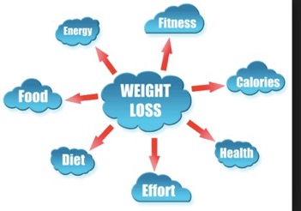

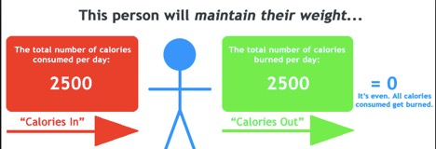

- How you burn stored body fat for energy instead of muscle.

Your body relies on three main nutrients for fuel. Because your body can breack down carbohydrates muscle and fat for energy understanding the order of nutrient breakdown can help you save or build muscle mass and increase fat loss.
The fuel that your body breaks down for energy is carbohydrates. After meal your body is in the fed sate and preferentially breaks down carbohydrates since they are easily accessible and turned into energy. after your body has used up the carbohydrates from a meal or snack your cells begin to break down glucose stored in your muscle and liver known as glycogen. Glycogen stores vary in each person but are typically depleted within 24 hours, meaning your body has to begin breaking down other compounds for energy.

Fat preferentially metabolized
When glucose and glycogen are not available your body preferentially breaks down fatty compound known as triacylcerols which are present in adipose or fat tissue. Because fat is high energy source with nine calories per gram, fat provides an efficient fuel source.
Your body metabolically prefers to preserve lean body mass and when possible break down fat store for fuel as much as possible only when your fat stores are extremely low or depleted does your body have to then break down protein.

Muscle breakdown
When glucose and fat are depleted your body will then turn to muscle to break down into individual amino acids. Which is carbohydrates and fat your body does not store amino acids which is why muscle breakdown is the only way to release amino acids for fuel.
When you are eating on a regular basis your body will not use muscle for energy. Protein is used for fuel only in a starvation state.
Because you need muscle tissue to survive and move, the natural tendency of metabolism is to spare muscle tissue and break down carbohydrate and fat first.

Other considerations
While your body avoids breaking down muscle tissue an inadequate diet prevents muscle gain. Although you may be working out and trying to gain muscle mass if you are not following a diet adequate in protein and calories your body will not build muscle cells and may even notice muscle losses. If you’re not eating enough protein the muscle damage during exercise cannot be fixed and muscle size or strength may decrease. Without adequate replenishment you may think body is breaking down muscle when instead your cells lack the nutrients needed to repair and rebuild. If you are trying to gain muscle mass or increase your overall strength.

Workout routine is the key factor in signals your body to use excess calories to build muscle rather than store them as fat. Routine workout is the key to maintain muscles and burn fat.

If your primary goal losing fat than there must be a caloric deficit.
Maintenance it’s when your daily calorie intake is equal to your daily calories output
When calories out you’ve reached your calories maintenance level.

Example 2500 calories per day from a combination of exercise weight training cardio etc. normal daily activities getting dressed showering driving etc. and your body doing the things it needs to do to sustain itself breathing pumping blood digesting food etc.
This means 2500 calories is your daily calorie maintenance level in this example if you consumed 2500 calories each day your body would remain the same your weight will not go up or down everything will just be maintained.
so the calories you eat you burn that means all the calories you take were used by your body there was no surplus or deficit it was even.
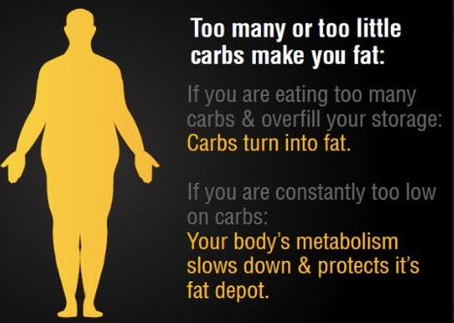

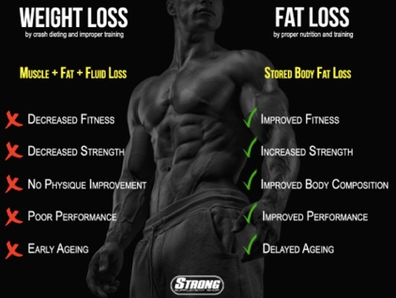

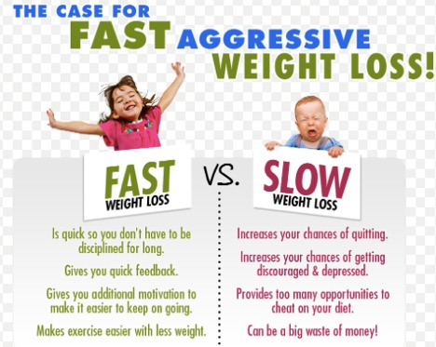

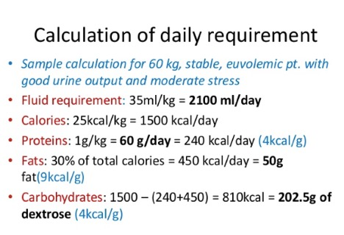
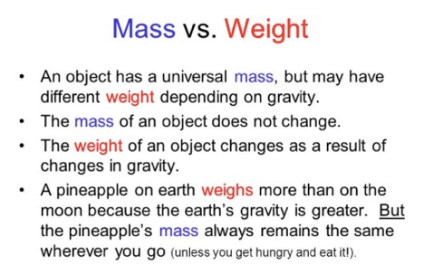
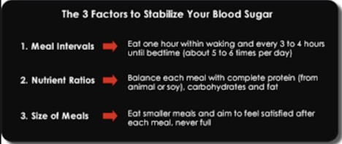
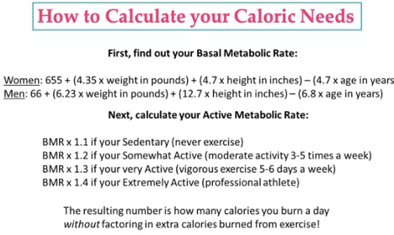
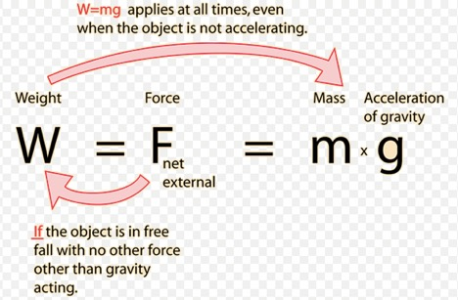
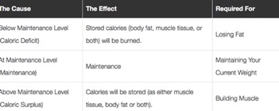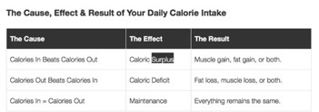

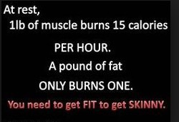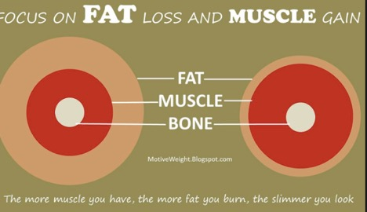
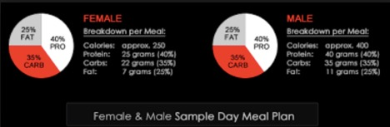
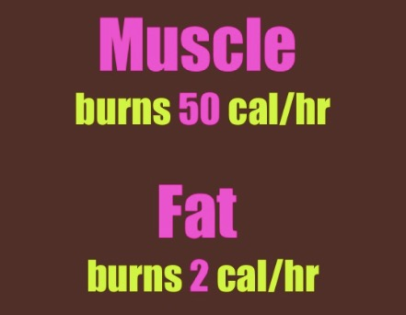

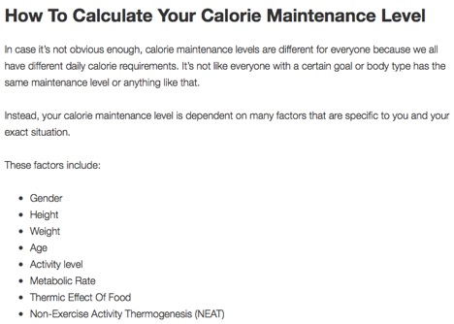

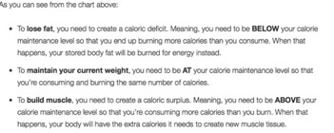

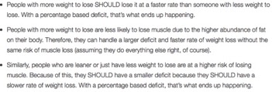
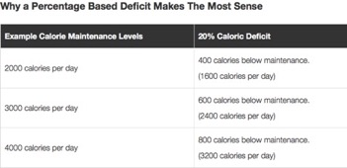
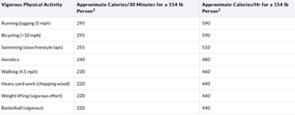

Its most important for every single weight loss diet is creating a caloric deficit.
This is when you consume fewer calories than your body burns or burn more calories than you consume it’s the same thing. Why it’s the deficit of calories that I and experts recommend and what makes it so ideal in the first place,
There are really 3 goals that need to kept in mind when planning how big or small a caloric deficit should be to optimally lose weight:
Maximizing fat loss
Minimizing muscle loss
Doing it all in way that is as doable and sustainable for you as possible

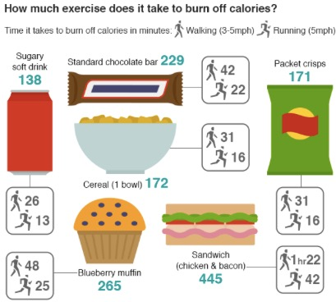

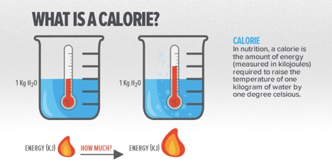
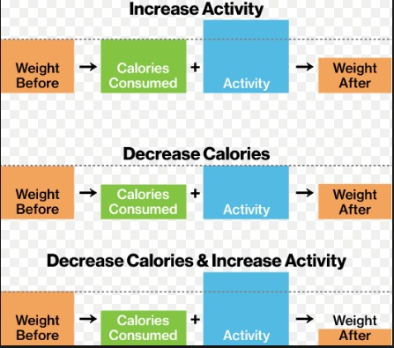

v. extra weight speeds up the metabolism discuss
fast metabolism has quit a bit to do with body size bunt not in the way many think. Skinny have slower resting metabolism less of them burn while they are resting. Larger body usually have a higher metabolism that is why they burn more calories at rest than their thinner people.
But not only additional weight that boosts metabolism muscle in particular has huge effect on the amount of overall calories someone burns throughout the day. this is just one of the reason its important to pair any weight loss program with a proper strength training plan.
Extra muscle can help accelerate weight loss much faster than a diet only plan.
Body size does factor in body composition has a far greater effect on metabolism.
Skipping a meal slows down your metabolism. Frequent meals eats has little to do with the speed of metabolism every four hours is popular because eating frequently helps to keep a cover or lid on both stomach hunger as well as craving in turn allows for better portion and choice control.

Metabolism how quickly someone burns calories. But while breaking things down is certainly an important part of metabolism, there are actually two main components. Catabolism or the braking down of chemical bonds to release energy is the most well-known part of the process as it releases energy in the form of calories. What’s just as essential is anabolism the storage of energy in the form of chemical bonds for later use including carbohydrates and fats. A properly functioning metabolism is a delicate balance of both functions.
Metabolism consist of both breaking things down and building things up both are vital to our health.
Body composition has a huge effect on how quickly someone body burns calories one easy way to ramp up your metabolism is to build muscle through lifting weight. Modifying your workout routine there are several other ways to be sure you’re burning calories at a higher rate.
Important factors to consider are the quantity and quality of the food we consume.
not only does muscle weigh more than fat but it uses more energy too. The average woman in her 30s who strength-trains 30 to 40 minutes twice a week for four months will increase her resting metabolism by 100 calories a day that means you’re resetting your thermostat to keep running at that rate even on the days when you don’t it to the gym.
Modification and exercise habits can make big different in how fast someone burns calories at rest.

Its important to find the right calorie level because eating an adequate number of calories helps keep your metabolism running near optimal levels even as you try to lose weight.
See how many calories you need a daily to maintain your weight. Use BMI your size age gender and activity level. From that number subtract 250 to 1000 calories to get the daily intake necessary for you to lose weight at rate of ½ to 2 pound per week.
If subtracting 1000 calorie puts you below the requisite 1200 for women or 1800 for men go with only 500 calories deficit. It means you’ll lose more slowly but you won’t negatively affect your metabolism. This gradual steady weight loss is more likely to be sustainable for the long term.
Exercise along with your diet to offset the possible slowdown of your metabolism from the calorie restriction. Working out helps you hold onto muscle mass, and since muscle tissue burns more calories than fat tissue having that muscle helps your metabolism stay rev up or accelerate sharply.
You also need to eat enough to feel energized for workouts if you feel tired slogging through your exercise time with barely enough energy you need to increase your calorie level.
Its good idea to eat small portions more often. You may tempted to skip meals but try not to do it. Not only does meal skipping create hunger that may lead you to eat more next sitting it also slows your metabolism.
Metabolic rate more than when they ate same number of calories at three to nine unpredictable intervals.

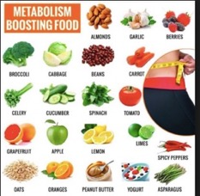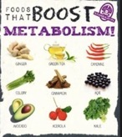

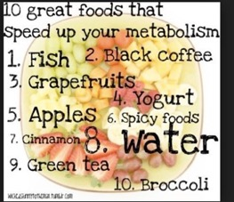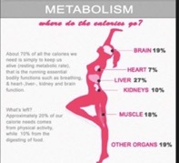

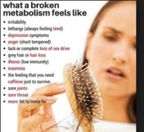
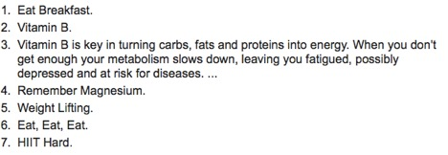
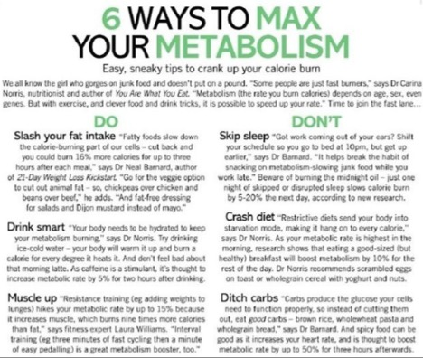

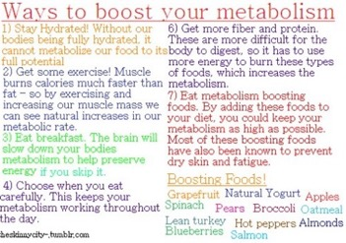

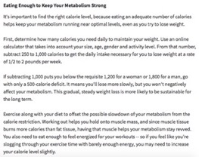

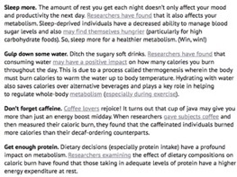

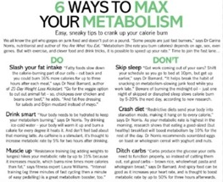
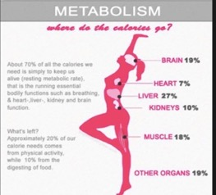
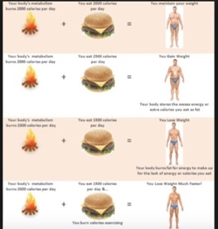

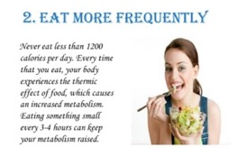
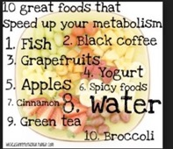
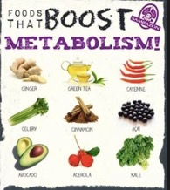

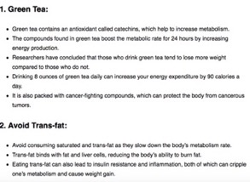

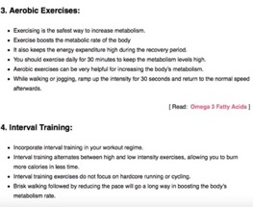

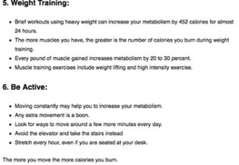
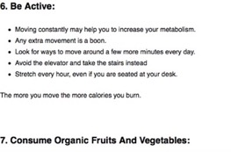
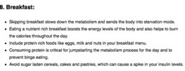

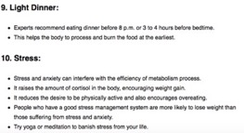

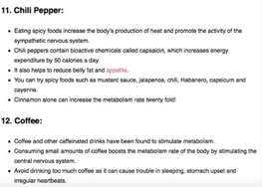
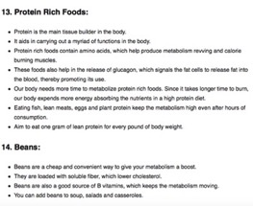
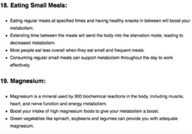

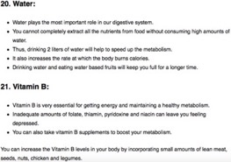

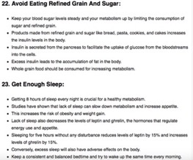

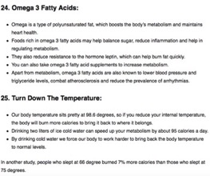

vi. design a weight loss

- Set your daily calorie limit
- Measure portions...
- Choose a higher protein or moderate protein diet…
- Go for either a low-carb or moderate –carb diet…
- Emphasize fruit and vegetables in your meals
- Drink hydrating fluids daily…
- Include regular activity….

Its three meals and two snakes daily plus each dish packs a filling balance of 45 percent carbohydrates 30 percent protein and 25 percent healthy fats. When it comes to drinks sticks on coffee tea and water to accelerate you weight loss you have to include exercise a daily so get motivated get started.

Salad: mixed lettuce ½ head lettuce 54 cal. 2 tomato 44 cal. 3 small cucumbers 57 calories 1 garlic 4 calories ½ lemon 8,5calories= total 167 calories per serving 83.5 calories

Mix green salad 1 lettuce head 108 calories 1 garlic 4 calories 1 lemon 17 calories 1tsp olive oil 40 calories total calories 169. This recipe for two each serving contain 84.5 calories

Cabbage 1 small head 176 calories 1 lemon 17 calories green leaf mint 1 garlic 4 calories. Total calories 179. Per serving 98 calories
Spinach 340 gram 79 calories ½ lemon 1tsp olive oil. Total calories 91 calories per 1 serving 45.5 calories.

Meal
4 ounces red snapper 113 calories 1 tsp olive oil 40 calories lemon juice ½ tsp seasoning 1 cup spaghetti squash 31 calories with 1 tsp olive oil and 2 tsp grated parmesan cheese 1 cup steamed green beans with tsp slivered almonds. Total calories 144

meal
turkey burger 180 calories
salad made 1 cup baby spinach7 calories ¼ cup halved cherry tomatoes 13 calories ½ cup cooked lentils 162 calories 2 tsp grated parmesan and tsp light Russian dressing 24 calories. Total calories 206

meal
4 ounces lean roast beef 192 calories ½ cup boiled wheat 56 calories with 1 backed potatoes 194 calories.

How to make it
2 cup of backed okra 162 calories 1 cup tomatoes 81 calories 1 onion cut small 44 calories 1 pinch cinnamon 1 pinch black peppers 2 garlic minced 9 calories 1 spoon salt with 2 cups of water.
Sizzle the onion and garlic with 1 spoon of olive oil for 4 minutes than add tomatoes peppers cinnamon and then 2 cups of backed okra.
2 cups of sweet beans 88 calories 2 cups of tomatoes pinch of cinnamon pinch of black peppers 3 carrots boiled 1 onion cut small 2 garlic minced, coriander 5 green leaves salt 1 spoon.

20 steamed shrimp= 140 calories 1 garlic 4 cal. 1 lemon 17 cal.
Sizzle the shrimp for 1tsp olive oil add garlic lemon and serve it. Total calories 161.

Soups:
1 cup tomato soup 74 calories
3 tomatoes 3 leaves basil 1 onion 44 cal. 1 garlic 1 pinch black pepper 1 pinch salt 2 cups water boil it for 40 minutes and serve it. total calories 118.

Soup
1 cup pumpkin soup 71 calories 1 cup pumpkin puree 2 cups water 1 onion 44 calories 1 tsp olive oil 2 garlic 1 pinch cinnamon 1 pinch black peppers boil it 40 minutes. Total calories 115.
soup:
1 chicken leg 81 calories 4 cups of water 1spoon of cinnamon 1 spoon black pepper 1 one onion 44 calories 1 garlic boil it to 50 minutes. Total calories 125.
Boil the chicken for 45 minutes add cinnamon pepper bay leaves onion and boil it for 50 minutes and serve it.

Soup
1 cup cabbage 65 calories pinch cinnamon pinch black pepper 1 spoon salt 1 onion 44 calories 1 garlic boil it 40 minutes and serve it total calories 109
boil the cabbage for 20 minutes than add onion garlic and peppers salt and serve it.

Monday | Breakfast | Sport | lunch | Sport | Dinner | Sport
Breakfast lunch  Dinner  Burned 1200calories /day | cups of water before  Porridge oats with milk 300 gram = 339 calories  Fruit mix 122 grams 50 calories  Banana=105  cal | cups of water before breakfast  Walk for 40 minutes before breakfast  Burn 300 calories | Lentil soup 100 gram= calorie 185  Stuffed vine leaves 2 pieces 44 calorie  salad  ½ breast chicken 115cal. | lunch walk 60 minutes burn 400  calories  Drink 3cups of water  Before lunch | 1/2 fillet=121 calories salad with 2 cups lettuce ½ sliced carrots 2 tsp of dressing Italian 100 cal.  Tomato soup 1cup= 100cal. | 2hours makes exercise for 60 minutes burn 500 calories drink 3 cups of water before & after
 | Calories  494 |  | Calories  344 |  | Calories  321 | Total calories  1159

Tuesday | Breakfast | Sport | lunch | Sport | Dinner | Sport
Breakfast lunch  Dinner  Burned 1200calories /day | 2 boiled eggs 156 cal.  1 cup milk low fat 107 26-gram slice of grain bread 69 cal. | cups of water before breakfast  Walk for 40 minutes before breakfast  Burn 300 calories | Lentil soup 100 gram= calorie 185  Stuffed vine leaves 2 pieces 44 calorie  salad  ½ breast chicken 115cal. | lunch walk 60 minutes burn 400  calories  Drink 3cups of water  Before lunch | 1/2 fillet=121 calories salad with 2 cups lettuce ½ sliced carrots 2 tsp of dressing Italian 100 cal.  Tomato soup 1cup= 100cal. | 2hours makes exercise for 60 minutes burn 500 calories drink 3 cups of water before & after
 | Calories  332 |  | Calories  344 |  | Calories  321 | Total calories intake  997

Wednesday | Breakfast | Sport | lunch | Sport | Dinner | Sport
Breakfast lunch  Dinner  Burned 1200calories /day | cups of water before  2 boiled eggs=156calories  Fruit mix 122 grams 50 calories  Banana=105  cal | cups of water before breakfast  Walk for 40 minutes before breakfast  Burn 300 calories | Lentil soup 100 gram= calorie 185  Stuffed vine leaves 2 pieces 44 calorie  salad  ½ breast chicken 115cal. | lunch walk 60 minutes’ burn 400  calories  Drink 3cups of water  Before lunch | 1/2 fillet=121 calories salad with 2 cups lettuce ½ sliced carrots 2 tsp of dressing Italian 100 cal.  Tomato soup 1cup= 100cal. | 2hours makes exercise for 60 minutes burn 500 calories drink 3 cups of water before & after
 | Calories  311 |  | Calories  344 |  | Calories  321 | Total calories intake  976

Thursday | Breakfast | Sport | lunch | Sport | Dinner | Sport
Breakfast lunch  Dinner  Burned 1200calories /day | cups of water before  Porridge oats with milk 300 gram = 339 calories  Fruit mix 122 grams 50 calories  Banana=105  cal | cups of water before breakfast  Walk for 40 minutes before breakfast  Burn 300 calories | Lentil soup 100 gram= calorie 185  Stuffed vine leaves 2 pieces 44 calorie  salad  ½ breast chicken 115cal. | lunch walk 60 minutes burn 400  calories  Drink 3cups of water  Before lunch | 1/2 fillet=121 calories salad with 2 cups lettuce ½ sliced carrots 2 tsp of dressing Italian 100 cal.  Tomato soup 1cup= 100cal. | 2hours makes exercise for 60 minutes burn 500 calories drink 3 cups of water before & after
 | Calories  494 |  | Calories  344 |  | Calories  321 | Total calories  1159

Friday | Breakfast | Sport | lunch | Sport | Dinner | Sport
Breakfast lunch  Dinner  Burned 1200calories /day | 2 cups of water before 1 hour  1 egg= 78 calories  1 glass lowfat milk  102 calories | cups of water before breakfast  Walk for 40 minutes before breakfast  Burn 300 calories | 1 cup Carrot soup=140 calories  ½ breast grilled chicken 115cal.  2 kiwi=84 calories | After walk 60 minutes burn 400  calories  Drink 3cups of water  Before lunch | 1 burgur meat= 200calories salad with 2 cups lettuce ½ sliced carrots 2 tsp of dressing Italian 100 cal.  Tomato soup 1cup= 100cal. | 2hours makes exercise for 60 minutes burn 500 calories drink 3 cups of water before & after
 | Calories  180 |  | Calories  424 |  | Calories  400 | Total calories  1004

Thursday | Breakfast | Sport | lunch | Sport | Dinner | Sport
Breakfast lunch  Dinner  Burned 1200calories /day | 2cups of water before 1 hour  4 white eggs calories= 69calories  1 cup mixed fruit=124calories  1glass low fat milk= 102 calories  Banana=105  cal | Walk for 40 minutes before breakfast  Burn 300 calories | Lentil soup 100 gram= calorie 185  4ounces of breast chicken 140cal.  1apple = 95calories | l walk 60 minutes burn 400  calories  Drink 3cups of water  Before lunch  After workout  Drink 3 cups water | 3 ounces 0f grilled salmon= 121calories  Tomato soup 1cup= 100cal.  Mixed salad 100 gram+1garlic+1tsp olive oil= 70 calories  Mongo 100 gram=60 calories | 2hours makes exercise for 60 minutes burn 500 calories drink 3 cups of water before & after
 | Calories  399 |  | Calories  420 |  | Calories  291 | Total calories  1170

Thursday | Breakfast | Sport | lunch | Sport | Dinner | Sport
Breakfast lunch  Dinner  Burned 1200calories /day | 1cups of water before  2 egg whites scrambled= 34 calories 1 class milk=103 calories  Fruit mix 1 cup = 124 calories  Banana=105  cal | cups of water before breakfast  Walk for 40 minutes before breakfast  Burn 300 calories | Lentil soup 100 gram= calorie 185  4 ounces Lean roast beef calorie=225calorie  salad mixed 100 gram with one tsp olive oil & ½ lemon 1 garlic =68 calories | lunch walk 60 minutes burn 400  calories  Drink 3cups of water  Before lunch | 1/2 fillet salmon= 184 calories salad with 2 cups lettuce ½ sliced carrots 2 tsp of dressing Italian 100 cal.  Tomato soup 1cup= 100cal. | 2hours makes exercise for 60 minutes burn 500 calories drink 3 cups of water before & after
 | Calories  366 |  | Calories  500 |  | Calories  284 | Total calories  1150

Lunch: soup lentils
1 ½ cups red lentils ½ tsp. salt 1 tsp. cumin 4 cloves garlic 2 carrots 1 onion 5 cups water 1tsp turmeric. Calories= 194
Dinner salad: 3 c watercress leaves 3c Tron arugula leaves 3c sliced strawberries ¼ c lemon juice ½ tsp olive oil ½ grated orange rind calories = 70

Soup chicken
1 breast chicken 8 cups of water ½ tsp ginger ½ tsp cinnamon ½ black peppers 2 bay leaves one onion. Boil the chicken with all spices for 45 minutes= calories 150.

Lunch : broiled tenderloin steak calories= 194
1 ½ tsp hoisin sauce, 1 ½ tsp grated peeled fresh ginger, 1 ½ tsp lower sodium soy sauce, ¼ tsp chill garlic sauce red pepper, 4-ounce beef tenderloin steak trimmed,1/8 tsp salt. One serving size Calories = 194.
Combine sauce ginger honey soy sauce and chill garlic in small bowl
Place the steaks on a foil lined broiler pan coated with olive oil sprinkle with salt. Broil steaks 5 inch from heat for 2 minutes and turn over, broil 2 minutes turn steak over. Brush steaks with half of hoisin with reaming hoisin mixture broil 2 minutes or until desired degree.
Lunch
Chicken with garlic basil and parsley. = calories 150
1 tsp dried parsley 1 tsp dried basil 4 skinless boneless breast halves 4 cloves garlic ½ tsp salt ½ tsp crushed red pepper 2 tomatoes.
Preheat oven 350 degrees sprinkle 1 tsp parsley and 1 tsp basil evenly over the bottom of backing dish. Arrange chicken breast halves in the dish and sprinkle evenly with garlic slices in small bowl mix the remaining 2 tsp parsley 2 tsp basil salt red pepper sprinkle over the chicken. Top with tomato slices.
Bake covered in the preheated oven 25 minutes remove cover and continue backing 15 minutes or until the chicken juice run clear.

Lunch:
Grilled chicken adobo = calories 255
1 ½ tsp minced garlic 3 bay leaves ½ tsp black pepper 3-pound skinless boneless chicken thighs 1 ½ cups soy sauce 1 ½ cups water ¾ cup vinegar 3 tsp honey.
Preheat grill high heat in large pot mix soy sauce water vinegar honey garlic bay and pepper bring the mixture to boil and place the chicken into the pot reduce heat and cook 35 to 40 minutes.
Remove chicken drain on paper towels and set aside until browned and crisp serve with remaining say sauce mixture.
Lunch slow cooker lemon garlic chicken= calories 192
1 tsp dried oregano ½ tsp salt ¼ ground black pepper 2-pound skinless boneless chicken breast halves 2 tsp butter ¼ cup water 3 tsp fresh lemon juice 2 cloves garlic minced 1 tsp chicken bouillon granules 1 tsp chopped fresh parsley.

In a bowl mix all spices rub all into chicken melt butter in a skillet over heat brown chicken in butter for 3 to 5 minutes on each side place chicken in slow cooker.
In the same skillet mix the water lemon juice garlic and bouillon bring the mixture to boil pour over the chicken in the slow cooker.
Cover and cook on high for 3 hours or low for 6 hours add the parsley to the slow cooker 15 to 30 minutes before the end of the cook time

Salad: green
Lettuce head= 75 calories onion 3 slice= 64 calories tomatoes 1 = 17 calories 4 cucumber= 4 calories garlic 2 = 33 calories ½ lemon juice= 1 calories. Total
= 196 calories.
Salad salmon:

This diet for losing weight
Calories in | 963 calories in
Calories out | 1200 burned
You burn more than you eat | So now you are losing every day -237 calories means in a week you lose 1659 calories

- Case study
Brrandon is 32 years old he thinks that he is overweight and he should reduce some weight he is very active does not take exercise at present he is 6 ft and 3in tall 191 cm and his weight is 140 kg 309 ib.

- Calculate Brandon’s BMI?
Height/weight= 140/190= 39

Design a weight loss program for Brandon so that Brandon could reduce 0.5 kg or 1 pound a week. According to this program he should be taking 300 less calories a day than his body requirement and he should further burn 200 calories through physical activity, the program should be based on a balanced diet.

To lose one pound a week you would have to put yourself in a 500 calories deficit every day eat less move more.

Brendon weight plan is:
Your Height 191 cm weight 140 kg age 32 yrs gender male your zero active.
So to lose 1 kilo per week you have to fellow this plan first your BMI= 39 is very high your health at risk the formula is height/weight.
Your BMI is classifying you as overweight obese which means you weight more than the normal amount for your height, BMI is an important risk factor to consider when managing your health. You may increase your risk of cardiovascular disease.
You should change your lifestyle through healthy eating and fitness to improve your health.
Your BMI classifies you overweight which means you weight more than the normal amount for your height. kg/m²

The plan calories per day to lose 1 kilo is 1661 calories.
Make small changes to your diet while slowly increasing your activity level. Substitute water for soda and you’ve lost about 200 calories. Walk 30 minutes a day to burn some more.
Eating no more than 1661 calories per day will help you lose 1killo per week. There’s no trick to losing weight. The best way to do it is by eating less eating healthier and adding aerobic exercise to your daily routine. Remember slow and steady wins the race. Losing a pound or two a week might not sound like much but it’s the best way to take weight off and keep it off for good. And over time you’ll develop healthy new habits that will keep you feeling great.
So burning 3500 calories equal 1 pound of weight loss to loss 1 kilogram of body weight you would need to creat a deficit of about 7700 calories.
As stated above 3500 calories equals about 1 pound (0.45 kilogram) of fat you need to burn 3500 calories more than you take in to lose 1 pound.
So in general if you cut 300 calories from your diet each day, you’d lose about 1 pound a week (500 calories *7 days = 3500 calories)
Calories burned during exercise is affected by body weight intensity of workout conditionally level and metabolism.

down vote

To lose one pound a week you need to have a good idea of how many calories you burn on a average day men burn 1900 to 2500 calories per day depending on their level of activity he should turn to an basal metabolic rate BMR calculators take into account his height weight age gender and level of activity to work out exactly how many calories he need to eat every day to keep his weight constant. Once you know your formula for losing one pound a week the idea is to create a 500 calories deficit each day by eating 500 fewer calories working off 500 more calories for example you might choose to eat 250 calories fewer than your daily caloric requirement and then do a workout that turn another 250 calories. You might burn off 500 calories with exercise alone. Other day you might cut your intake by 500 calories. But at the end of the day you achieve that 500 calories deficit you’ll lose one pound in seven days.
Keep in mind that one pounds a week is just one goal. If you want to speed up your weight loss, then make your caloric deficit lager. If you don’t feel like pushing yourself go for a smaller deficit. Simply cutting 100 extra calories from your diet every day can lead to up 10 pounds of weight loss in one year.

Losing a maximum of two pound per week or more than that you probably are not burning fat. Instead you’re cutting into your lean muscle mass and dropping water weight neither of which provide sustainable weight loss. You’ll gain all the weight back eventually, and feel tired and worn out in the meantime.

Weight loss goal losing one pound should ideally involve both diet and exercise.
Pursuing one without the other is setting yourself up to regain the weight later on. Exercise is not a free ticket to eat more. Work out on what you put in your mouth first physical activity is an essential component to a healthy lifestyle you also have to eat less to see the numbers on the scale drop.

One way to help keep yourself on target is to start keeping a dairy that notes every calorie you eat. The dairy also should include calories you are burning through exercise.

Cut down on fatty foods fat contains nine calories per gram compared with four calories per gram for carbohydrates or proteins, cutting a lot of fat out of your diet can cut hundreds of calories a day.

Eat whole grains they fill you up and take longer to digest than the simple carbohydrates contained in processed flour or white rice. Choose whole grain bread brown rice and oatmeal whole grains also contain lots of healthy fiber.

Think before you drink. Sodas and fruit juice contain tons of calories. Just sticking on water and diet drinks can decrease your caloric intake effortlessly.

Eat regular meal. Skipping meals can make you so hungry you’ll overeat later on and also can cause your metabolism to slow down, stick to three meals and snack per day.

Mix up your routine. Keep yourself from getting bored with exercise by pursuing different activities, combine outdoor sports with fitness classes. E.g. Ride bicycle once in a while do aerobic try yoga now and then.

Do regular strength training. Muscle at rest burns more calories than fat at rest. Increasing your muscle mass helps you lose weight more efficiently.
The more muscle you have the more fat you will burn.

Break it up. Do at least 30 minutes of exercise a day you don’t have to do it all at once to gain weight loss benefits.
Take a brisk 10 minutes’ walk around the block in the morning and a 20 minutes’ bike ride later in the day this way even the busiest of people can squeeze in calories burning activities.

Diet plan

Breakfast to keep hunger away limiting your calories intake to 500 calories include a
source of protein at each meal. Protein is more satiating than both carbs and fat. Also
try to eat about the same amount about 160 calories at each meal for a balance of
of energy throughout the day.

for breakfast ½ cup of fat free cottage cheese with a small banana makes a good option or hard-boiled egg with a slice of whole wheat dry toast. Or ¾ cup serving of whole grain unsweetened ready to eat cereal with 1 cup of nonfat milk also makes a good low cal breakfast.

Lunch meal
3 ounces of grilled chicken/turkey set on top of 3 cups of mixed greens with red vinegar added for flavor. 6-ounce container of nonfat Greek yogurt with 1 cup of fresh blueberries also makes a good high proteins lunch option with lettuce leaves with one spoon mustard and serve with whole grain fat free crackers.

Dinner
Fifteen large boiled shrimp garnished with tablespoon of olive oil plus 1 cup of steamed broccoli may help you tide up over until the morning. Or have breakfast for dinner with four egg white omelets filled with ½ cup of spinach ½ cup of mushrooms and ½ ounce of low fat cheddar cheese.

500 calories diet plan
breakfast ½ banana 6oz semi-skimmed milk 1tsp vanilla extract 1tsp cinnamon and 1/3 cup of crushed ice for a delicious banana milkshake.so 128 calories and top up your fruit fix with a tangerine 24 calories to keep you going until lunch. Calories so far =152.

Lunch half 0f Sainsbury creamy vegetables soup is super healthy option at only 53 calories. Add rice cake at 35 calories to the lunch menu to make it that more filling. Calories so far – 240.

Dinner easy beef stew its 240 calories per portion.

Total calories intake 500 calories per day

Soup recipe
SERVES 4
PREP 5 mins
READY IN 1 hour 30mins
450g stewing beef
1 red onion, cut into wedges
2 garlic cloves, sliced
A few sprigs of parsley or thyme
300g baby carrots
450ml beef stock
2tbsp sun-dried tomato paste 2tbsp balsamic vinegar 2tbsp gravy granules

What to do:

1 Heat the oven to 180C, Gas 4. Take a casserole and add all the ingredients; the beef, onion, garlic, a couple of sprigs of parsley or thyme, carrots, beef stock, sun-dried tomato paste, vinegar and gravy granules. Stir to combine.
2 Cook for 11/2 hours until the meat and vegetables are tender.
3 Serve sprinkled with the rest of the parsley or thyme. Great with garlic bread.
Per serving: 240 cals,

My menu
Salad: mixed lettuce ½ head lettuce 54 cal. 2 tomato 44 cal. 3 small cucumbers 57 calories 1 garlic 4 calories ½ lemon 8,5calories= total 167 calories per serving 83.5 calories

Mix green salad 1 lettuce head 108 calories 1 garlic 4 calories 1 lemon 17 calories 1tsp olive oil 40 calories total calories 169. This recipe for two each serving contain 84.5 calories

Cabbage 1 small head 176 calories 1 lemon 17 calories green leaf mint 1 garlic 4 calories. Total calories 179. Per serving 98 calories
Spinach 340 gram 79 calories ½ lemon 1tsp olive oil. Total calories 91 calories per 1 serving 45.5 calories.
Meal
4 ounces red snapper 113 calories 1 tsp olive oil 40 calories lemon juice ½ tsp seasoning 1 cup spaghetti squash 31 calories with 1 tsp olive oil and 2 tsp grated parmesan cheese 1 cup steamed green beans with tsp slivered almonds. Total calories 144

meal
turkey burger 180 calories
salad made 1 cup baby spinach7 calories ¼ cup halved cherry tomatoes 13 calories ½ cup cooked lentils 162 calories 2 tsp grated parmesan and tsp light Russian dressing 24 calories. Total calories 206

meal
4 ounces lean roast, beef 192 calories ½ cup boiled wheat 56 calories with 1 backed potatoes 194 calories.

How to make it
2 cup of backed okra 162 calories 1 cup tomatoes 81 calories 1 onion cut small 44 calories 1 pinch cinnamon 1 pinch black peppers 2 garlic minced 9 calories 1 spoon salt with 2 cups of water.
Sizzle the onion and garlic with 1 spoon of olive oil for 4 minutes than add tomatoes peppers cinnamon and then 2 cups of backed okra.
2 cups of sweet beans 88 calories 2 cups of tomatoes pinch of cinnamon pinch of black peppers 3 carrots boiled 1 onion cut small 2 garlic minced, coriander 5 green leaves salt 1 spoon.

20 steamed shrimp= 140 calories 1 garlic 4 cal. 1 lemon 17 cal.
Sizzle the shrimp for 1tsp olive oil add garlic lemon and serve it. Total calories 161.

Soups:
1 cup tomato soup 74 calories
3 tomatoes 3 leaves basil 1 onion 44 cal. 1 garlic 1 pinch black pepper 1 pinch salt 2 cups water boil it for 40 minutes and serve it. total calories 118.

Soup
1 cup pumpkin soup 71 calories 1 cup pumpkin puree 2 cups water 1 onion 44 calories 1 tsp olive oil 2 garlic 1 pinch cinnamon 1 pinch black peppers boil it 40 minutes. Total calories 115.
soup:
1 chicken leg 81 calories 4 cups of water 1spoon of cinnamon 1 spoon black pepper 1 one onion 44 calories 1 garlic boil it to 50 minutes. Total calories 125.
Boil the chicken for 45 minutes add cinnamon pepper bay leaves onion and boil it for 50 minutes and serve it.

Soup
1 cup cabbage 65 calories pinch cinnamon pinch black pepper 1 spoon salt 1 onion 44 calories 1 garlic boil it 40 minutes and serve it total calories 109
boil the cabbage for 20 minutes than add onion garlic and peppers salt and serve it.

