

Assignment Cover

^{Student Name:} | ^{Hiyam Daou}
^{Student Number:} | ²³²⁰
^{Course:} | ^{Diploma in Diet & Nutrition}
^{Assignment NO:} | test 11 Nutrition Requirement for Different People

Assessment 11
- Give short answers for the following questions:

- What are the recommended doses of folic acid before and after pregnancy?

Folic acid is a pregnancy superhero taking a prenatal vitamin with the recommended 400 micrograms (mcg) of folic acid before and during pregnancy can help prevent birth defects of your baby’s brain and spinal cord. Take it every day. birth defects occur within the first 3-4 weeks of pregnancy. So its important to have folate in your system during those early stages when your baby’s brain and spinal cord are developing.
Recommended that you start taking folic acid every for at least a month before a you become pregnant, and every day while you are pregnant. Also recommends that all women of childbearing age take folic acid every day. so its fine to start taking it even earlier.
The recommended dose for all women of childbearing age 400 mcg of folate each day.
Recommended for pregnancy each day: 400 mcg
For the first three months of pregnancy: 600 mcg
While breastfeeding: 500 mcg
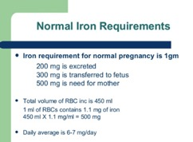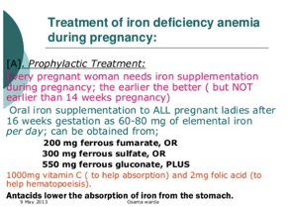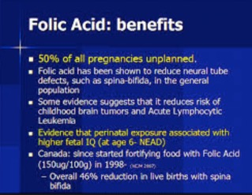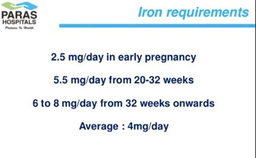

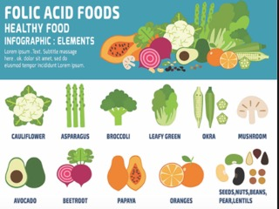

- What are the dietary sources of folate?
Foods that can help you get more folic acid in your diet include:
High amounts of folate Liver. Peas, beans, nuts, and eggs

400 mcg: Breakfast cereals fortified with 100% of the ¾ cup
215 mcg: Beef liver cooked braised 3 OZ
179 mcg: Lentils, mature seeds, cooked, boiled, ½ cup
115 mcg: Spinach, frozen, cooked, boiled, ½ cup
110 mcg: Egg noodles, enriched, cooked, ½ cup
100 mcg: Breakfast cereals, fortified with 25% of the ¾ cup
90 mcg: Great Northern beans, boiled, ½ cup

papaya one papaya= 115 mcg of folate (29%DV)
oranges one orange = 40 mcg of folate (10% DV)
grapefruit one grapefruit = 30 mcg of folate (8%DV)
strawberries 1 cup = 25 mcg of folate (6.5%DV)
raspberries 1 cup = 14 mcg of folate (4%DV)

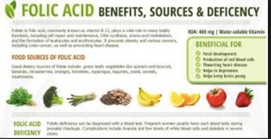

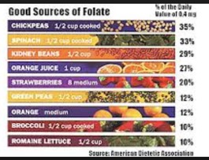
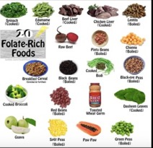

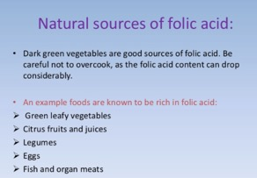

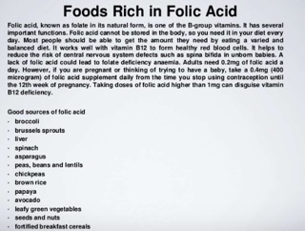

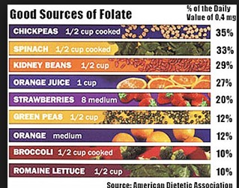

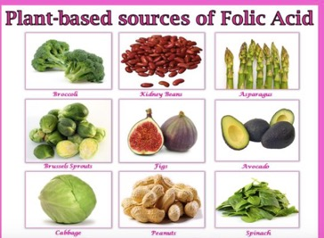

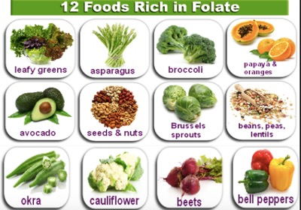

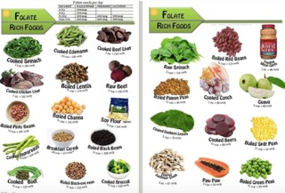

- How would you advise a woman for healthy diet who is planning for pregnancy?

Pregnancy nutrition needs more calcium, folic acid, iron and protein than a woman here is why four nutrients are important.
Folic acid also known as folate found in foods is B vitamin that is crucial in helping to prevent birth defects in baby’s brain and spine known as neural tube defects.
Calcium is mineral used to build a baby’s bones and teeth. If a pregnant woman does not consume enough calcium the mineral will be drawn from the mother’s stores in her bones and given to baby to meet the extra demands of pregnancy.
Iron pregnant woman need 27 milligrams of iron a day which is double the amount needed by woman who are not excepting. Additional amounts of minerals are needed to make more blood to supply the baby with oxygen. Getting too little iron during pregnancy can lead to anemia a condition resulting in fatigue and increased risk of infections.
Better absorption of the mineral has a glass of orange juice with an iron-fortified cereal.
Food source: meat poultry fish dried beans and peas.
Protein needed during pregnancy because it helps to build important organs in the baby such as the brain and heart.
Food sources: meat poultry fish dried beans and peas eggs nuts tofu.
Fruit and vegetables pregnant woman should focus on fruit and vegetables during the second and third trimesters. These colorful foods are low in calories and filled with fiber vitamin and minerals.
Lean protein: pregnant woman should include good protein source at every meal to support the baby’s growth such as meat poultry fish eggs beans totu cheese milk and nuts.
Whole grains are important source of energy in the diet, and they also provide fiber iron and B—vitamins. At least half of a pregnant woman’s carbohydrate choices each day should come from whole grain such as oatmeal whole wheat pasta or breads and brown rice.
Dairy aim to serve 3 to 4 serving of dairy foods a day such as milk yogurt and cheese which provide good dietary source of calcium protein and vitamin D.
Vitamin that hard to get it from food such as folic acid.
Food to limit
Caffeine, fish like albacore or white tuna has high levels of mercury.
Mercury is metal that can be harmful to a baby’s developing brain. Canned light tuna has less mercury and safer to eat during pregnancy.
A healthy diet and balanced good nutrition during pregnancy ensure that your baby gets the best start possible. The best diet is a balanced diet provides ample amounts of:
Protein, carbohydrates, healthy types of fat vitamins, and minerals.
Taking prenatal multivitamin will ensure that you get the basic requirements. But vitamin packed, fresh foods will help your baby get the best start in life.
Eating healthy balanced diet while you’re pregnant protects you and your growing baby. You should take a prenatal vitamin choosing the right foods will help you the complex mix of nutrient that pregnant women need aim for meal high in important nutrients like
calcium baby benefits build bone and teeth your baby takes the calcium she/he needs from your body so to keep your bones and teeth healthy you need to get enough to replace that amount.
From food like eggs milk
Choline baby benefits helps prevent problems in the spinal cord and brain called neural tube defects and enhances brain development.
Your benefits build strong bones and may help prevent high blood pressure.
From food like eggs
Docosahexaenoic Acid(DHA)
DHA is one of the Omega3 fatty acids.
Baby benefits help boost brain development and vision.
Your benefits may reduce your risk of heart disease in the future.
Folic acid
Baby benefits helps protect against spinal cord birth defects during the first 30 days of pregnancy helps prevent early miscarriage and premature delivery.
Your benefits prevent anemia.
Iodine
Baby benefits needed for brain and nervous system development important for preventing stunted growth server mental disability and deafness important in preventing miscarriage and stillbirth.
Your benefits important for a healthy thyroid.
Iron
Baby benefits helps prevent premature delivery.
Your benefits ward off anemia in pregnant women.
Potassium
Your benefits help keep blood pressure in check and proper fluid balance necessary for normal heart beat and angry.
Riboflavin
Your benefits needed to produce energy helps your body use the protein from food.
Vitamin B6
Your benefits help produce protein for new cells boosts the immune system and help form red blood cells.
B12
Your benefits help produce red blood cells and helps your body use fat and carbohydrates for energy.
Vitamin C
Your benefits make it easier for your body to absorb iron from plant foods builds strong bones and teeth boosts immunity keeps blood vessels strong and red blood cells healthy.
Vitamin D
Baby benefits helps your baby’s body use calcium to build bones and teeth.
Your benefits help your body absorb calcium from food and use it to build your bones and teeth.
Zinc
Baby benefits brain development.
Your benefits necessary to grow and repair cells and produce energy.

A healthy diet during pregnancy contains much of the same balance of vitamins, minerals, and nutrients as a healthy diet in general. The difference is that you need higher amounts. If you already have healthy eating habits, it will be easy to make slight adjustments to ensure a healthy pregnancy.

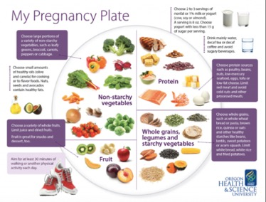
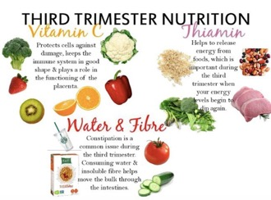
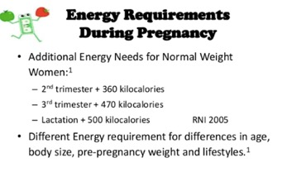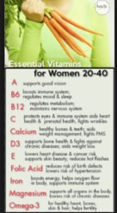

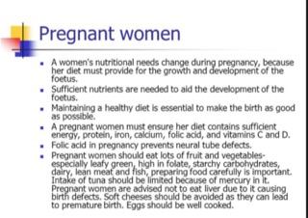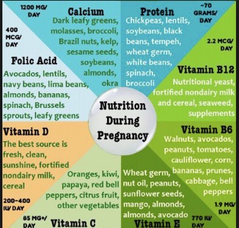
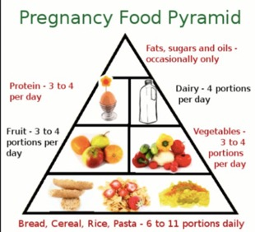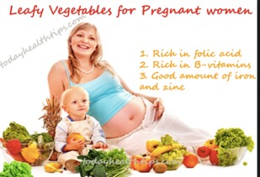
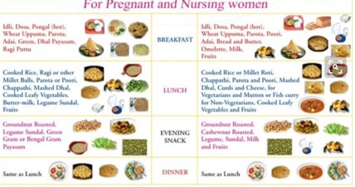

- What should healthy and balanced diet include to fulfill the needs of a pregnancy woman?

Healthy balanced diet and eating for two can be a never-wracking responsibility especially with so much conflicting information.
Its important to eat enough fish or does it contain too much mercury? Do you need meat for protein or is it too fatty? Are eggs okay or do they have too much cholesterol?
Eggs i
It’s amazing what you get in one egg for only about 90 calories, in addition to more than 12 vitamins and minerals eggs contain lots of quality protein which is essential for pregnancy.
Your baby’s cells are growing at an exponential rate and every cell is made of protein. Plus, as a pregnant woman you have your own protein needs.
Eggs also rich in choline which promotes your baby’s overall growth and brain health while helping prevent neural tube defects. Some eggs even contain omega 3 fats important for both brain and vision development.
Salmon
Salmon rich in high quality protein and good source of omega 3 fats which is good for your baby’s development and may help boost your mood.
Beans
Beans are good sources of iron folate calcium and zinc.
Navy beans lentils black beans pinto beans chickpeas beans contain most fiber and protein of all the vegetables.
You already know that it’s important to get enough protein during pregnancy but may not yet realize that fiber could become your new best friend when you are pregnant your gastrointestinal tract slows down putting you at risk for constipation and hemorrhoids. Fiber can help and prevent these problems.

Sweet potatoes
Sweet potatoes get their orange color from carotenoids plant pigment that are converted to vitamin to vitamin A in our bodies.
Sweet potatoes are great source of vitamin C, Folate and fiber.

Whole grains
Whole grains are important in pregnancy because they’re high in fiber and nutrients.
Including vitamin E, selenium, and phytonutrients plant compounds that protect cells.
Whole grain quinoa is easy to make and is very high in nutrients particularly protein.
Walnuts
Walnuts are one of the richest source of plant based omaga3.
Plant based omega 3 don’t provide much of the DHA that will benefit your baby they’re still good for both of you. Walnuts are also a good source of protein and fiber.
Greek yogurt
Greek yogurt has twice the protein of regular yogurt making it one of favorite pregnancy foods. And any kind of yogurt is a great source of calcium, which is vital in a pregnancy diet. If you don’t take enough calcium the limited amount you have will go to your baby depleting the calcium in your bones.
Dark green leafy vegetables
Spinach kale Swiss chard and other green leafy vegetables are loaded with vitamins and nutrients including vitamins A, C, and K as well as the all-important folate. They’ve also been found to promote eye health.
Lean meats
Meat is an excellent source of high quality protein lean meats with the fat trimmed off fat free. Don’t eat raw meat there’s a small risk of passing bacteria and parasites such as listeria toxoplasma or salmonella from meat to your baby.
Fruit and veggies
Eating plenty of green red orange yellow purple and white fruits and vegetables ensures you and your baby get a variety of nutrients. Each color group provides different vitamins and minerals.
During the later stages of pregnancy, the baby tastes the foods you eat through the amniotic fluid. If you expose your baby to a variety of healthy fruits and vegetables in the womb, you’ll increase the chance that your baby will recognize and accept those flavors later on.

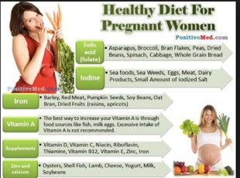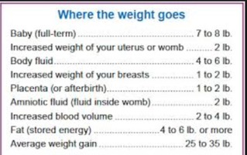

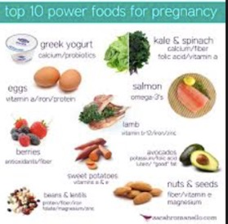

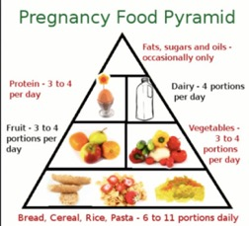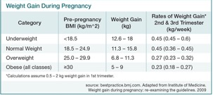
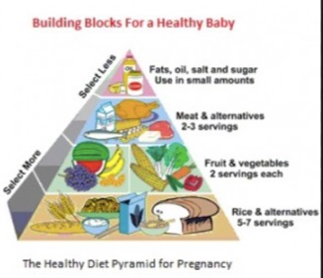

- What are the recommended foods to overcome problems like nausea and vomiting?

Eating small but frequent meals may help. Foods high in carbohydrate are best, such as bread crackers, etc. sickness is made worse by not eating at all. If you eat some food regularly, it may help to ease symptoms. Eating a plain or ginger biscuit about 20 minutes before getting up is said by some women to help. Cold meals may be better if nausea is associated with food smells.
Ginger tablets or syrup may be effective for relieving feelings of sickness nausea and vomiting in pregnancy.
Avoiding triggers some women find that a trigger can set off the sickness. For example, a smell or emotional stress.
Having lots to drink to avoid lack of fluid in the body dehydration may help. Drinking little and often rather than large amounts may help to preventing vomiting. Drink at least two liters a day. water is probably the best drink if you are feeling sick. Cold and sweet drinks can sometimes makes symptoms worse in some people.
Rest make sure you have plenty of rest and sleep in early pregnancy. Being tired is thought to make nausea and vomiting during pregnancy worse.
Acupressure may be effective for relieving nausea and vomiting in pregnancy.

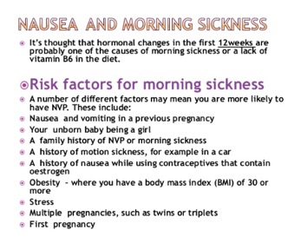
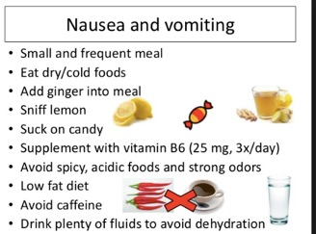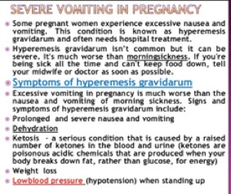
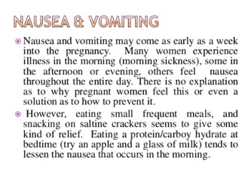
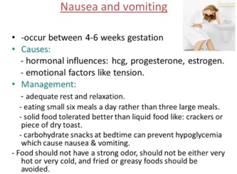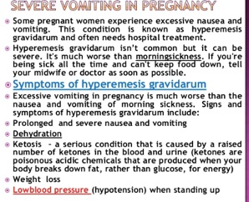

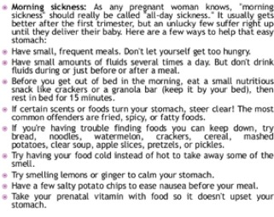
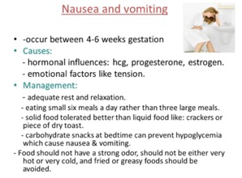

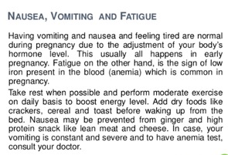

- What is weaning? And when it should be started?
Weaning is to accustoms an infant to food other than mother’s milk or formula.
Weaning considered when a baby nursing and gets all his nutrition from source other than the breast. Babies are also weaned from the bottle. The term usually refers to when a baby stops breastfeeding.
Weaning is transition from breast milk or formula milk to solid foods it is divided into the following stages: stage 1 babies are usually ready to start on solid foods between 4-6 months. Begin with smooth textures, mashed, minced, chopped, finger foods and finally family foods.
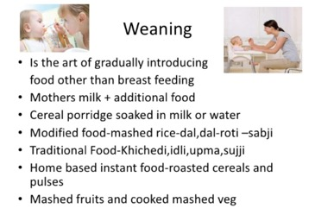

- What should be added to the diet of babies who are on vegetarian food?

Vegetarian babies diet makes sure that they give their babies two servings a day of pluses such as red lentils beans or chickpeas} or tofu to make sure that the baby gets all the energy and nutrients he/she needs. The vitamin C might help bodies absorb iron so they should be given fruit and vegetables at mealtimes. Its very important to give drops to babies who are on a vegetarian diet.

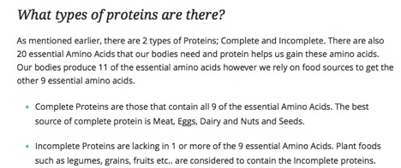
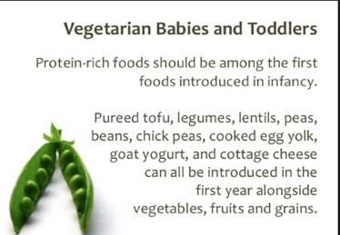

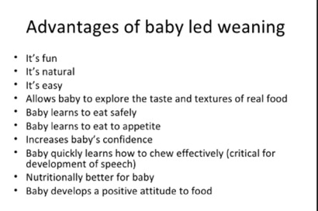

- Explain the stages of weaning in detail.

Stage 1 baby rice mixed to runny consistency with breast milk or formula.
Stage 2 after a few weeks of bay rice it is time to start introducing new tastes and flavors., such as pureed fruit or vegetables. Pureed carrots apple pear or mango are good ones to start with. You can combine different fruit and vegetables for example carrot and apple.
Stage 3 is now approaching the seven- month; you might consider introducing dairy products like unsweetened yogurts with strawberries.
In stage 3 as solid food becomes a bigger part of a baby’s diet, its important to offer a range of different foods. To provide the baby with all the vitamins and minerals he or she needs. The still be having breast or formula milk a day.
The baby should be given two to three servings a day of starchy foods such as potatoes yams rice or bread. Fruit and vegetables should be included at two or more meals reach day. The baby should be serving soft cooked meat fish tofu or pulses such as beans or lentils a day.
Red meat and lamp is an excellent source of iron.
Over six the baby can be given vitamin drops containing A,C and D. if the baby on infant formula there’s no need to vitamin cause the infant formula already contains added vitamin and minerals.
Stage 4
The start became increasingly used to eat solid foods. Three to four serving a day of starch foods and of fruit and vegetables should be given to the baby. Biscuits and cakes should be avoided because these foods will fiil the baby without providing nutrients.
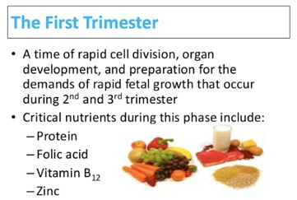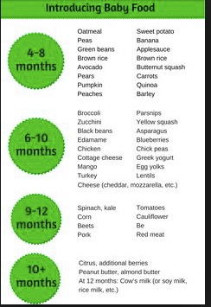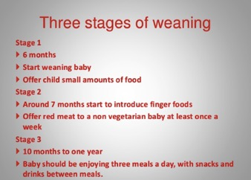
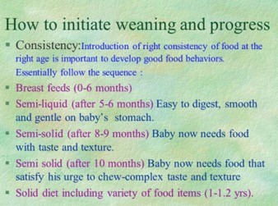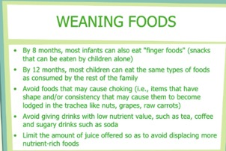

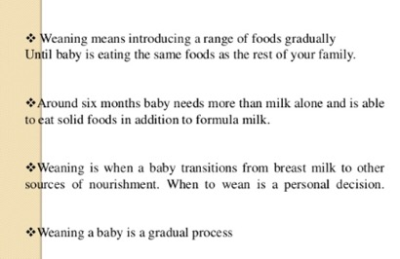
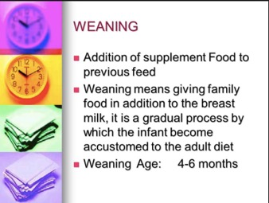
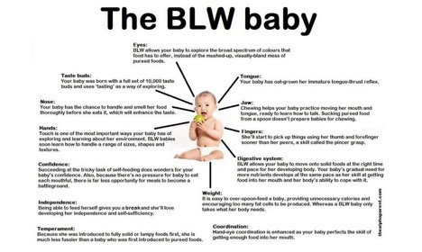
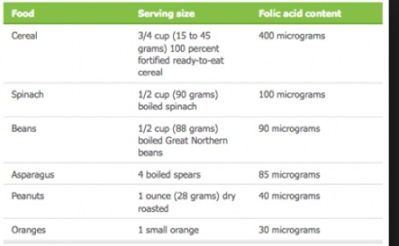

- Which diets are best for athletes? Discuss.

Athletes need a diet that provides enough energy in form of carbohydrates and fats as well as essential protein vitamins and minerals. This means a diet containing 55-60 percent of calories from carbohydrates 10 to 15 percent from sugars and the rest from starches, no more than 30 percent of calories from fat and the remaining about 10-15 percent from protein. That translates into eating a variety of foods every day grains vegetables fruit beans, lean meat and low fat dairy products. The base of the diet should come from carbohydrates in the form of starches and sugars. Fluids especially water are also important to the winning combination. Dehydration can stop even the finest athlete from playing his or her best game.
If an athlete eat right he will help to train longer and at a higher intensity
Delay the onset of fatigue
Promote recovery
Help body adapt to workouts
Improve body composition and strength
Enhance concentration
Help maintain healthy immune function
Reduce the chance of injury
Reduce the risk of heat cramps and stomach aches
Instead of protein supplements eat high protein such as lean meat, fish, poultry, nut, beans, eggs, or milk. Drink up milk is one of the best foods for recovery after an event, because it provides a good balance of protein and carbohydrates.

