
Assignment Cover Sheet

Student Name: | Chris Nicholls
Student Number:
Course: | Certificate in Risk Management Level 1
Assignment NO: | Unit 1

Marking Criteria:
We expect the learners to write minimum one well expressed point in three lines against each allocated mark. This means one needs to write 15 lines with 5 well expressed points to get high grades for a 5 marks question.
For high grades use examples and illustrations where appropriate.
Please insert your completed assignment ( in word format) here:

- Briefly describe the history of risk management.

The current form of risk management came in around 1956 in the Corporate Insurance sector where Insurance Managers bought insurance to cover business losses.

Two reports written in 1950’s strongly criticized American business college’s curricula as ineffective in making future decision makers. As a result, colleges began adopting new programs and focused on improving the business curricula by adding operations research, management science and moving away from over detailed courses.

Insurance managers began to realize a more cost effective solution was to prevent losses from happening in the first place by identifying and evaluating risks which in turn were managed to keep the cost of risk as low as possible.

A new approach to risk emerged which organizations quickly adopted and implemented within their own organizations. This new approach focused on three key areas; decision theory, risk financing, and risk control.

- How can the risk management process be developed?

A risk management process can be developed in the first instance by choosing which approach to take, either risk finance or risk control depending on the risks being monitored.

If cover for losses occurring from existing risk, then possibly risk financing is the best option, or the alternative is to use risk control to minimize loss by prevention and reduction methods.

The risk management cycle can be used to help develop the process, as below;

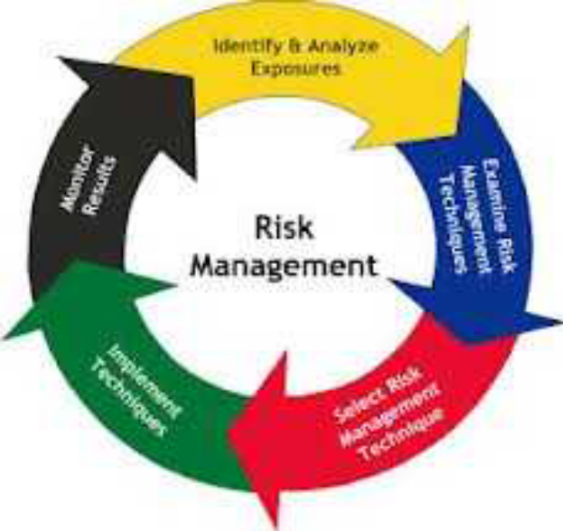

- What are the main benefits of business risk management?

Business risk management is there to ensure risks are properly evaluated and an associate cost value associated with the risk and a plan to remove or reduce identified risk.

Business objectives are more likely to succeed and realized risk is managed to reduce negative impact. Not only can risk management limit costs linked to losses, it can also increase income

Risk Management can contribute to business goals and objectives; this is achieved by guaranteeing that the organization won’t be held back from achieving other business goals and objectives.

- “Risk management can make a difference directly to profit”. Discuss.

Current research has shown that companies who put risk management at the top of their agenda are seeing better growth and increased profit.

With a dramatic increase in business risks, companies are spending more time preparing for risk at a strategic level than reacting to it. PwC quoted a 55% of risk management leader’s recorded increased annual profit.

Convention says that emphasizing risk management slows a business, but a business not planning or taking risk management seriously as part of the business core activity risks vulnerability to profit loss or perhaps even total collapse.

Ironically, not having a comprehensive risk management process could be a risk in itself. The final decision lies on the business management’s appetite for risk, or lack of.

- Briefly describe the three general risk management techniques.

Although no one technique is a guarantee, nor are all risks inevitable, the three general risk management techniques used today are;

Risk Avoidance;
Risk can be avoided simply by not making the risk viable, I.e Avoid sensitive documents being thrown in a bin by removing the bin and installing a shredder.

Risk Reduction;
Risk can be reduced by implementing a strategy, I.e. to reduce the risk of obtaining a virus on your PC, install antivirus software. Or to reduce the risk of theft, install CCTV and hire a security guard.

Risk Assumption;
Otherwise known as self-insurance, is a technique used by companies when certain circumstances are met. Assumption of risk states that by certain actions, a company assumes certain risks.

Student Statement:

By submitting this assignment, I confirm that this is my own work.

Student Signature | C. Nicholls | Date | 30.11.2016

For Tutor / Assessor Use Only
Total Marks
Marks Obtained
Percentage / Grade

