
Assignment Cover Sheet

Student Name: | Brendan Reilly
Student Number: | 5029
Course: | Preliminary Investigations, Location and Site Selection
Assignment NO: | 4

Preliminary Investigations, Location and Site Selection

ASSESSMENT 4
1.
i.
EIS or Environmental Impact Study is what developers have done to assess the environmental impact on the surrounding ecosystem for a potential project. If you can imagine project locations vary greatly form ocean to desert, hot and cold, urban to a class A nature reserve. Many factors influence if, how and when a construction project can take place.
The air, soil and waters can be contaminated by bringing in foreign objects and materials interacting with the native elements. This can have massive effects on insects, animals and humans. It could destroy an already natural untouched landscape. In a built up area it could endanger people with the hazardous materials. Block views and cause unrest to the locals.
ii.
The basic criterion for judging the suitability of the site for construction is taken very seriously, it can effect accessibility, structural techniques used to design and build, site preparation needed, cost and value. Elements that will be integral to find a suitable location are
- Climate and weather,
- Physical aspects like lie of the land, type of strata under the ground, condition of soil and features trees rivers etc.
- Energy, utilities materials and resources are also crucial to finding an ideal location.
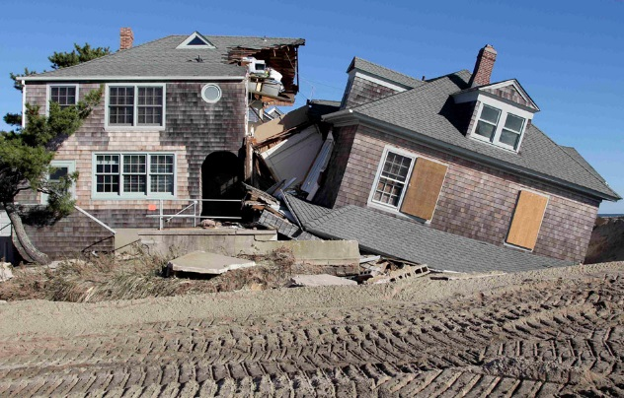
Climate & weather conditions severely affect all types of construction operations. You need to consider weather conditions while planning and executing the tasks on the project. Hot and dry conditions can pose major problems for the construction industry. Building codes & regulations also have to be followed for building in hot and dry weather. Dry weather means lack of moisture, which may cause formation of dry dust. Large amounts of dust clouds hovering around the construction site can be dangerous. Dust in people’s eyes is a major hazard and such PPE must be warn at all times. Dust can be a problem for machinery and equipment as well. Jobs carried out in cold weather is ensuring that mortar and grout get adequate heat for normal cement hydration. Water pipes can freeze up and bust causing expenses. The cold can also bring on hyperthermia which can cause health problems and even death to workers. Severe climates that can bring natural disasters such as typhoons cyclones hurricanes tornados monsoons tsunamis earthquakes etc. They can all make location and building structure critical.

iii.
Topographic data is information on the physical presence in the area to which we want to build. It has all the information on the level of the earth & sea level. Geologists & Surveyors are brought in to collect such information. Before the designs can be drawn up, this information has to be collected. (Topo) maps are created and made into digital maps for engineers and surveyors to use and guide them in decision making. The elevation with be portrayed as contour lines but slopes, shape of the land, rocks, surroundings and features of the land will all be recorded. Soil type moisture in the ground and the natural water level under the surface must all be known. Contractors, the government and other industry’s use them to assist with urban planning, mining, emergency management and the establishment of legal boundaries and land ownership.
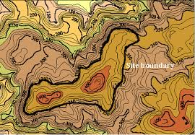

iv.
Constructing buildings on rocks has many advantages, after all a building is only as strong as it foundations and rock, stone and mortar have been used for thousands of years. However the earth is constantly moving and that includes the rock under our feet they may not more for long periods but they have and will move again. So knowing the type and structure of the rock is important.

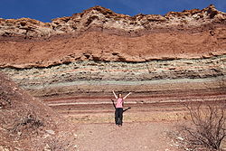sedimentary rock:
Permeability rock can let water pass through the rocks. Sandstone more so than granite. Fractured rock which is mostly sedimentary or metamorphic rocks can seepage and let the water pass along there bedding. Igneous rocks are large and allow water to dissolve in the cracks causing chemical changes.

Not built on sufficient ground:
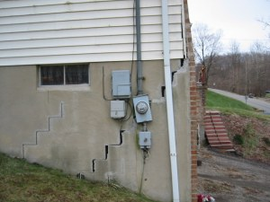
Building on rocky ground that’s flat, with a water level that is much lower is ideal and the most stable, but may be more costly if you need to bring in machinery to cut and drill the rock and to attach underground service etc.

2.
- D1
- C2
- C1
- D1
- A1

Student Statement:

By submitting this assignment, I confirm that this is my own work. Why cost and time estimates are important to every project: o Cost estimates are more than just how much money the owner needs to commit and when is it required; o The ability to accurately forecast completion cost and completion time of projects allows owners, builders, investors, users, and the general community to plan their investments and operations with more certainty and without the adverse impacts that sudden and unexpected surprises give; o Even positive impacts, when unexpected, can have a reduced positive flow on effect.

Student Signature |  | Date

For Tutor / Assessor Use Only
Total Marks
Marks Obtained
Percentage / Grade

