
Assignment Cover Sheet

Student Name: | Ray Wilson
Student Number: | 1390
Course: | Environmental Management
Assignment No: | 9

Assignment 9 Total Marks 30

1. What is energy management? How it can be useful to humans? Give its short term and long-term effects. 7

“Energy management" is a term that has a number of meanings, but generally it relates to saving energy in businesses, public-sector/government organizations, and homes. When it comes to energy saving, energy management is the process of monitoring, controlling, and conserving energy in a building, power station, transport or organization. Typically this involves the following steps;
- Metering the energy consumption used and collecting the data.
- Finding opportunities to save energy, and estimating how much energy each of these opportunities could save. As an example in a typical home you would analyze the meter data for gas and electricity to find and quantify routine energy waste, and you might also investigate the energy savings that you could make by replacing equipment (e.g. energy saving light bulbs as shown below), regular servicing of boilers etc. or by installing or upgrading loft/cavity wall insulation.



- Taking action to target the opportunities to save energy (i.e. tackling the routine waste and replacing or upgrading the inefficient equipment). Typically you'd start with the best opportunities first.
- Tracking the progress of any changes by analyzing the meters to see how well your energy-saving efforts have worked.
So, if you're a homeowner looking to save energy most of the principles that apply to businesses and other organizations are also applicable to homes. Certainly the four-step process approach indicated above and bullet points detailed below is entirely applicable to home energy management
To confuse matters, many people use "energy management" to refer specifically to those energy-saving efforts that focus on making better use of existing buildings and equipment. Strictly speaking, this limits things to the behavioral aspects of energy saving (i.e. encouraging people to use less energy by raising energy awareness), although the use of cheap control equipment such as timer switches is often included in the definition as well.
The above four-step process applies either way - it's entirely up to the individual whether you consider energy-saving measures that involve buying new equipment or upgrading building fabric.
As indicated above it's not just about saving energy in buildings - the term "energy management" is also used in other fields:
- It's something that energy suppliers or utility companies do to ensure that their power stations and renewable energy sources generate enough energy to meet demand (the amount of energy that their customers need).
- It's used to refer to techniques for managing and controlling one's own levels of personal energy.
- It also has relevance in aviation – it's a skill that aircraft pilots learn in some shape or form. We know nothing about aircraft energy management, but we can at least manage a picture of a man on a plane...
- Transport of goods on the sea and road needs careful management as the ever increasing costs of the fuel needed to power this transportation can be the difference between profit and loss, therefore not only is it vital to manage the energy (fuels) required it can make the difference of staying in business.

Whilst energy management has been popular in larger buildings for a long time, it has only recently started catching on in homes. Most homeowners aren't even aware of the term, and take more of a haphazard, flying-blind approach to reducing their energy consumption instead of finding a happy medium.
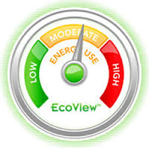But the monitoring- and results-driven approach used by professional energy managers is just as effective in the home as it is in larger buildings and the following should be included in a home related EMS;
Keep it simple - A simple and effective device is thermostat software to automate heating and cooling. This lowers the bills while maintaining the desired level of comfort. Other simple measures like adding insulation, tinting of window glass, using skylight for illumination, CFL bulbs, solar heaters will conserve huge amounts of energy and stop unnecessary wastage.
Utility-free - There are numerous devices available on the market, which can be used without being attached to any meter. These devices optimize voltage and current demands thus reducing active power demands and thereby saving electricity sometimes by as much as a third.
Rule setting - There are web-based interfaces, which enable control of home energy use. A consumer can allocate and declare a certain amount of money he wants to pay for electricity. These types of EMS’s control the power flow between various appliances and directs power to the appliance, which is doing important functions at that time.
Remote control - Controlling home appliances remotely is the latest theme in home energy management. It is now possible to leave an appliance on and the energy management system will switch it off at the appropriate time. Mobile applications, which allow one to switch on and off the appliances from the phone, are also being designed and are becoming more commonly used.

Energy management is vitally important to the human race. Much of the importance of energy saving stems from the global need to save energy - this global need affects energy prices, emissions targets, and legislation, all of which lead to several compelling reasons why you should save energy at your organization specifically.
If it wasn't for the global need to save energy, the term "energy management" might never have even been coined... Globally we humans need to save energy in order to;
- Reduce the damage that we're doing to our planet, Earth. As a human race we would probably find things rather difficult without the Earth, so it makes good sense to try to make it last.
- Reduce our dependence on the fossil fuels that are becoming increasingly limited in supply.

One advantage of energy efficiency actions, compared to other measures is the speed with which results are often produced. For this reason, energy efficiency is often quoted as one of the best near term options to reduce energy demand and greenhouse gas emissions.

An improvement in technical efficiency can have immediate effect on energy consumption and especially in the case of smaller projects cab be relatively quick to be put in place.
This is an important feature of energy efficiency improvements as society considers which measures are likely to deliver the benefits needed at different moments in time.

The short‐term outcomes, possible through energy efficiency improvements, are crucial in helping solve problems facing policy makers such as sudden changes in unemployment patterns, energy supply and energy affordability to name a few.
Energy efficiency in other areas can provide longer term outcomes such as national competitiveness, reduced public health costs and energy security that ensure economic sustainability for future generations.

2. How can energy management concept be applied to the businesses or how can Energy Management be useful for businesses? 8

Energy management, in the business sense, is the use of technology to improve the energy performance of an organization. To be fully effective it needs to be an integral part of an organization’s wider management processes - and any corporate social responsibility (CSR) policy.
The management of energy is often neglected, even though there is considerable potential to save energy and reduce costs, something all companies are keen on. Rising energy prices, climate change legislation and the need to be environmentally responsible all require effective energy management. Companies need to find the correct formula and need to have in place;
- Senior management commitment - Without the support of senior managers, energy management will falter and be marginalized. Senior managers need to be convinced of the business case for investing funds and staff time in managing energy.
- An energy policy - An energy policy is a written statement of senior management's commitment to managing energy and its environmental impacts. Often it forms part of a wider corporate social responsibility (CSR) policy. For large organizations an energy policy should be no more than two pages long; a few paragraphs may be sufficient for smaller organizations.
- An energy strategy - An energy strategy is a working document setting out how energy will be managed in an organization. It should contain an action plan of tasks, which will initially involve understanding the organization’s current position and establishing the management framework. As the processes are established, the tasks should address the identification and implementation of specific energy saving projects.

A complete and effective energy strategy will also need to address the following features;
- Organizing roles and responsibilities and ensuring there are sufficient resources available.
- Compliance with energy and climate change regulations is required of businesses and the public sector.
- Investment in projects will be needed to take full advantage of cost-effective energy efficiency opportunities.
- Procurement of buildings, equipment and services should take due account of the implications for energy efficiency and energy related costs.
This day and age there are numerous types of computer software that facilitates energy management from a business prospective and as illustrated below these packages will cover procurement, use and reporting that aims to significantly reduce energy costs.
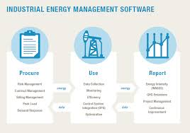

All the aforementioned are the means of controlling and reducing your organization’s energy consumption. This is of crucial importance and useful since it enables organizations to achieve the following;

Reduce costs - This is becoming more and more important this day and age as energy costs are continuously on the rise.

Reduce carbon emissions - Governments and companies worldwide, some to a greater extent to others it must be said, are finding it necessary to reduce carbon emissions owing to the environmental damage that they are causing. Organizations need to be proactive and look forward to maintaining a minimal carbon footprint in order to promote a green, sustainable image, which would help the organization achieve better social acceptance and avoid the costs imposed by carbon taxes due to unlimited emissions.

Reduce risk – Companies now know the energy consumption is directly proportional to risk or rising prices and contrariwise proportional to supply. Furthermore, if there is a risk of increase of energy price or shortage of supply, it could have a negative impact on the company’s cost-effectiveness. It may even put the future of the business/organization in jeopardy therefore with effective energy management, this risk can be reduced in order to make it more predictable.
'Energy Management Systems' are becoming a widely accepted concept with a rise in energy costs, non-availability of quality power and increased awareness about energy management among consumers. By creating awareness regarding the need for energy management, incentives for best energy managed companies and power tariff structure suited to encourage energy saving can improve the existing power situation and will help formulate a better planned power supply system. This can be of enormous benefit for most companies, however the investment required is a major consideration.

The investment needed is dependent upon the type of building, range of parameters to be monitored, utilities to be connected to the system and level of sophistication. Hence, in opting for an energy management system, care should be taken to arrive at an appropriate system with the desired level and range of operation. The monitored parameters should be recorded and studied carefully, in order to evolve necessary steps and maintenance schedules for optimum use of energy.

3. Differentiate between the terms Reduce, Reuse and Recycle. Give examples for each. 7

The most effective way to reduce waste is to not create it in the first place. Making a new product requires a lot of materials and energy: raw materials must be extracted from the earth, and the product must be fabricated and then transported to wherever it will be sold. As a result, reduction, reuse and recycling are the most effective ways you can save natural resources, protect the environment, and save money.
By keeping purchases to a minimum we can all contribute to an important way of reducing the toll on the Earth's resources. Lowering consumption is the key to the concept of reducing, which can apply to physical objects as well as natural resources, such as gas, electricity and water. Not to be confused with reusing or recycling, reducing means lowering or eliminating use from the start. Cutting back on unnecessary purchases and consumption lowers the rate at which materials are used, but also effectively lowers the energy, gas and transportation costs that are accrued when an item is made and sold. The term "reduce" clearly relates to lifestyle. Reducing driving would mean combining trips, carpooling, and walking, biking, and taking public transportation whenever possible. Taking shorter showers, landscaping appropriately to the local climate and replacing older, less efficient appliances with Energy Star appliances all fit under the reducing concept.
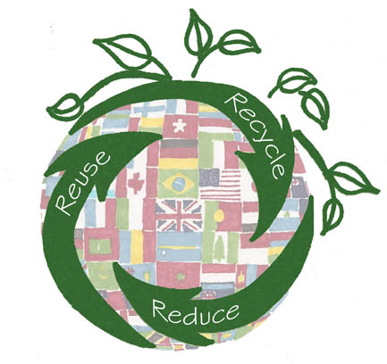
"Reuse" is a broad term that combines reusing materials and using items that have reusable qualities. Cutlery, for instance, that can be reused prevents waste at the landfill, but it also lowers the amount of energy needed to manufacture new products. Less pollution results, and more natural resources are left intact. Consider the possibilities of an item before discarding it, as it might be reused toward a different purpose than originally intended. An old shirt can be used as a car rag. Though reuse is obviously different from reducing use, when an item is reused, consumption is reduced as a by-product.
The term "recycle" refers to the process in which an element or its components are used to create something new. Plastic bottles can be recycled and made into carpets, pathways and benches. Glass and aluminum are other commonly recycled materials. Recycling is technically a form of reusing, but it refers more specifically to items that are discarded and broken down into their raw materials. Recycling companies convert the original item and then sell the now-usable material. Some companies purchase secondhand material and use it to manufacture a new product, which is another form of recycling.

There are numerous benefits of Reducing and Reusing and some of these are as follows;
- Prevents pollution caused by reducing the need to harvest new raw materials;
- Saves valuable energy;
- Reduces greenhouse gas emissions that contribute to global climate change;
- Helps sustain the environment for future generations;
- Saves money;
- Reduces the amount of waste that will need to be recycled or sent to landfills and incinerators;
- Allows products to be used to their optimum extent.

Some conventional Ideas on how to Reduce and reuse
- Buy used. You can find everything from clothes, car parts to building materials at specialized reuse centers and consignment shops. Often, used items are less expensive and just as good as new.
- Look for products that use less packaging. When manufacturers make their products with less packaging, they use less raw material. This reduces waste and costs. These extra savings can be passed along to the consumer. Buying in bulk food stuffs, for example, can reduce packaging and save money.
- Buy reusable over disposable items. Look for items that can be reused; the little things can add up. For example, you can take your own cutlery, crockery and cup to work, rather than using disposable items.
- Maintain and repair products, like clothing, tires, and appliances, so that they won't have to be thrown out and replaced as frequently.
- Borrow, rent, or share items that are used infrequently, like party decorations, tools, or furniture.

Donation
One person's trash is another person's treasure. Instead of discarding unwanted appliances, tools, or clothes, try selling or better still donating them. Not only will you be reducing waste, you'll be helping others. Local churches, community centers, thrift stores, schools, and nonprofit organizations may accept a variety of donated items, including used clothes, books, working electronics, and unneeded furniture.

Benefits of Donation
- Prevents usable goods from going into landfills
- Helps your community and those in need
- Tax benefits may be available.
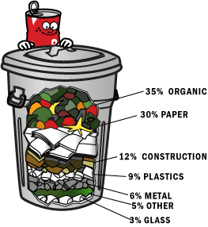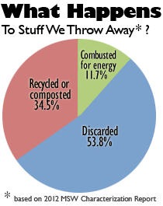

Recycling is the process of collecting and processing materials that would otherwise be thrown away as trash and turning them into new products. Recycling can benefit your community and the environment and, as illustrated above, there is statistical data that shows what we normally throw away as “rubbish” can clearly be recycled and put to environmentally friendly use.

Benefits of Recycling
- Reduces the amount of waste sent to landfills and incinerators;
- Conserves natural resources such as timber, water, and minerals;
- Prevents pollution by reducing the need to collect new raw materials;
- Saves energy;
- Reduces greenhouse gas emissions that contribute to global climate change;
- Helps sustain the environment for future generations;
- Helps create new well-paying jobs in the recycling and manufacturing industries.

Steps to Recycling Materials
Recycling includes the three steps below, which create a continuous loop, represented by the familiar international recycling symbol.
- Step 1 - Collection and Processing

- Step 2 - Manufacturing

- Step 3 - Purchasing New Products Made from Recycled Materials



4. How can we use fossil fuel? Share its advantages and disadvantages. 8
Fossil fuels as the name suggests are derivatives of plant and animal fossils that are million years old. These are primarily formed from the remains of the decayed plants and animals of the carboniferous era. The three fuel sources coal, natural gas and oil/petroleum helps to meet the energy and electricity demands of today’s world. The demand for energy will never be in the declining graph. Industrial revolution has shown the way forward and upwards with regards to usage and it’s still going on. It’s been estimated that in the USA fossil fuels are used for more than 85 percent of all energy consumption in ways such as;
- Electricity - Coal primarily is used in power plants for electricity production.
- Transportation - The vast majority of vehicles require fossil fuels, diesel, compressed gases & petrol to operate.
- Heating - Most of the countries heating requirements are met through fossil fuel-based heating oils, natural gas or indirectly through fossil fuel-generated electricity.
- Cooling - Like heating, most cooling systems (such as air conditioning) rely directly or indirectly on fossil fuel provided energy.
Across the globe, as with the USA detailed above, fossil fuels are still the major energy source and the sustained high level consumption is leading to disastrous effects such as air pollution due to releases carbon dioxide, nitrogen monoxide, nitrogen dioxide, carbon monoxide and sulphur dioxide etc. This is having severe consequences on habitats and also human health.
These are of course non-renewable sources of energy as they are derived from pre-historic fossils and are no longer available if once used. Their source is limited and they are depleting at a faster rate but they have positives as well as the obvious negatives.

Some of the advantages of Fossil Fuels are as follow;
- Easily Available: Since these fossil fuels have been of such a great utility, more and more extractions are going on every day. Geologists all around the world are trying to find out mines of coals. The pressure is even more as the population is increasing day by day, especially in developing countries. With the advancement in science and technology, the refineries and the extraction procedures have also improved a lot. This makes the availability even smoother and potentially cheaper.
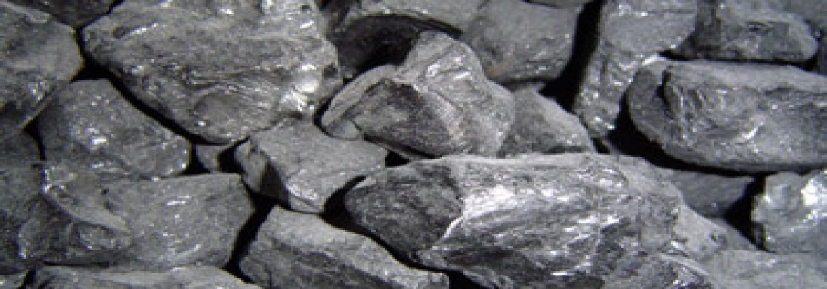
- Produce Large Amount of Energy: Fossil fuels are easily combustible. Most combustion engines need to be powered with little amount of fuel to and they can produce large amount of energy. Fossil fuels have been serving us for centuries. It is considered as a portable form of energy and the industrial revolution popularized the usage of fossil fuel across the globe. All machines, devices, vehicles depend on the fossil fuels, may it be coal (illustrated above), petroleum or natural gas. Sustainable fuel sources such as solar, wind or geothermal are in their infancy in relative terms and have complex processes to harness energy from them.
- High energy Value: All energy produced has some calorific value. The more the value, the more effective it is. Fossil fuels are the highest producers of calorific value in terms of energy. This is also one of the reasons why they are still preferred over the renewable sources of energy or the alternative sources of energy being developed.
- Stability: The fossil fuels are composed of the molecules of carbon, and hydrogen. This makes them very stable. The nuclear energy, for instance is produced from radioactive elements and the energy is produced due to their instability. Fossil fuels, due to their constancy in the constitution of the molecules are easy to store as well. They do not form any other compound if stored in the cans for a long time. For the same reason, carrying fossil fuels is also easy than any other form of fuels.
- Transportation: Currently industries need regular supply of fossil fuel like oil, gas and coal. The biggest advantage of using fossil fuels is that they can be easily stored and transported from one place to another and this needs the fuels to be robust enough to be carried from one part of the land to another. Large reserves of coal are taken from the coal mines to the industries which are miles away from the mines. Petroleum is being transported in large volumes too, to storage and power stations to produce energy. Even natural gas is nowadays being transferred to different continents due to bulk LNG tankers. Transportation is possible as these fuels are portable.
- Abundantly Available: Though every effort is made to make the usage of alternative fuels popular, still fossil fuels are the most common ones in use. This is because, these are very easily available. They have a vast presence over the globe. Though it is known to everyone that fossil fuels are going to expire one day but they should still last for another 40 -50 years at current consumption rates.
- Low Cost: Fossil fuels are available all over the world and the methods to extract energy from them are also not that expensive. To obtain the fossil fuels in their refined form, they need to be properly treated. This does not need a wide set up and is economical. Unlike other alternative sources like solar power or wind turbines whose initial investment cost are too high, fossil fuels have pretty low cost as compared to them. The high cost prevents many people from installing wind turbines or solar panels at their home.
- Easy Set Up: Since they are widely available, the construction of fossil fuel power plant can take anywhere in the world as long as your get large quantities of fossil fuels to feed them.

Of course there are disadvantages of using Fossil Fuels such as;
- Environmental Hazards: Pollution is the major disadvantage that is formed due to fossil fuels. When burnt they give out carbon dioxide, a greenhouse gas which is the main aspect of global warming. Rise in temperature of earth have resulted in melting of polar ice caps, flooding of low lying areas, rise in sea levels. If such conditions (as illustrated below) continue to prevail, the face of earth will face radical changes.
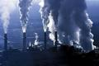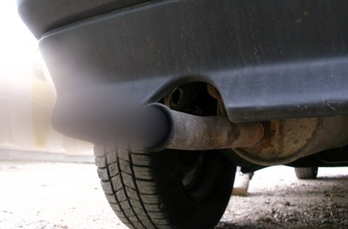
- Rising Prices: Middle-east countries have huge reserves of oil and natural gas and many other countries are dependent on them for constant supply of these fuels. Organization of the Petroleum Exporting Countries (OPEC) are responsible for 40 percent of the world’s oil production and hold the majority of the world’s oil reserves, according to the Energy Information Administration (EIA). OPEC constantly monitor the volume of oil consumed and then adjusts its own production to maintain its desired barrel price. This obviously results in worldwide price fluctuations which are currently at the lower end of the scale.
- Acid Rain: When burnt, fossil fuels produce Sulphur dioxide gas which is the factor for acid rain. Acid rain leads to destruction of monuments made up of brickwork or marbles, even crops are affected due to acidification of loams. Coal mining results in destruction of abundant lands and also endangers the lives of mineworkers. The natural gas causes nasty smells and also a lot of problems with transportation. Transportation of crude oil causes oil spills over seas reasoning to hazards to the aquatic life by lessening the oxygen content of water.
- Human Health Getting Affected: The ozone layer is reportedly being worn-out due to the release of greenhouse gases from the fuels. Hence, ozone holes are being created from which harmful UV rays enter the earth surface that affect human life causing diseases like cancer. Skin cancer is the major form of disease that is caused due to the reaction of infra-red rays and the pigment present in the skin.
- Non-Renewable: As the fossil fuels are extracted to an unlimited level it is for sure that they will deplete some day or the other. Since they are non-renewable it is likely that fuels expenses will face a hike in near future. It would take millions of years to replace coal, and oil, and we are using them quickly. There is a limited amount of these fuels available and we are not actually sure where that limit is.
- Impact on Aquatic/bird Life by Oil Spill: Fossil fuels are needed in huge reserves wherever power plants are set up. This requires them to be transported to the desired location via truck, train, or ship. Too often we hear of oil tankers or ships releasing oil through an assortment of reasons whilst carrying crude oil to get refined. The impact of this is that crude oil contains some toxic substances which when mixed up with water pose serious hazards to aquatic and bird life.
- Coal Mining: Extraction of coal from areas that have huge reserves is not only a difficult and dangerous task but it also poses health hazards to the lives of the workers who are employed there. Coal mining destroys wide areas of land that results in an ecological imbalance.
- Need Huge Amount of Reserves: Coal and Oil fed power plants needs huge and regular supply of feedstock to produce large amount of electricity on a constant basis. This means they need constant reserves of coal/oil, almost train-loads of fuel, to carry out the process of generating electricity.
Technologies to get more out of the earth are progressing, but they don’t seem to be doing it as quickly as our demand is growing. In addition, while coal is much more abundant than oil, extraction of coal can be very unsafe, and is damaging to the environment on a large scale, causing erosion, acidification of the environment, and destruction of wild lands as illustrated below.

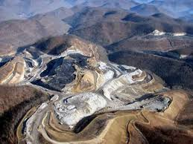
Though the fossil fuels meet our energy and fuel needs today, still it’s a high time to look forward for the alternative renewable sources of energy such as wind turbines, solar panels, tidal generators and compost.

Student Statement:

By submitting this assignment, I confirm that this is my own work.

Student Signature | Raymond Wilson | Date | 3rd June 2015

For Tutor / Assessor Use Only
Total Marks
Marks Obtained
Percentage / Grade

