
Assignment Cover Sheet

Student Name: | Raymond Wilson
Student Number: | 2362
Course: | Diploma in Logistics and Supply Chain Management
Assignment No: | 13
Marking Criteria:
We expect the learners to write minimum one well expressed point in three lines against each allocated mark. This means one needs to write 15 lines with 5 well expressed points to get high grades for a 5 marks question.
For high grades use examples and illustrations where appropriate.
Assessment #13 Supply Chain Performance Measurement Total Marks: 30

1. Give short answers to the following questions: (20)

i. What is the framework for supply chain performance measurement?

Supply Chain Performance (SCP) refers to the lengthy supply chain’s activities in meeting end-customer requirements, including product availability, on-time delivery, and all the necessary inventory and capability in the supply chain to deliver that performance in a responsive manner.

Supply Chain Performance measurement, crosses company boundaries since it includes basic materials, components, subassemblies and finished products, and distribution through various channels to the end customer. SCP also crosses traditional functional organization lines such as procurement, manufacturing, distribution, marketing & sales, and research & development. Supply chains need to continuously improve to be successful in today’s markets and to achieve this they need performance measures, or “metrics,” which support global SCP improvements rather than narrow company-specific or function-specific (silo) metrics which inhibit chain-wide improvements.

Raw tonnage is an inappropriate measure of supply chain performance for a diverse product line where gross margin per ton varies considerably. The use of “bad” metrics can be a major impediment to the implementation of effective integrated supply chain management in today’s highly competitive business environment.

An example of bad performance metrics is as follows;
Johan had just slammed the door on the way out of his boss’s office. As operations manager for a major structural steel component producing facility, he was proud of the fact that he had in past months achieved significantly high production figures for high margin specialty milled orders. But his Line Manager had just criticized him for producing fewer tons of low margin items than had been budgeted for. Johan has just been a victim of a “bad” performance measure or metric situation.



It’s vitally important for companies to understand and react to customer performance expectations. Ultimately this will lead to significantly better returns for the suppliers who provide the best services. Certain key performance indicators (KPI’s) or metrics, as identified and bulleted below, are therefore used to measure and monitor certain parameters so as to ascertain the performance obligations to the customers.

- Customer Service
- Internal Efficiency
- Demand Flexibility
- Product Development

Although the information required from these four categories is needed to provide the necessary feedback it is sometimes difficult to come by due to confidentiality issues or the hesitancy to share such information from companies fearful of releasing information which can be used against them.

ii. What is meant by internal efficiency of a supply chain?

Organizational efficiency is normally defined as an internal standard of performance. Supply chain efficiency however is related to whether a company’s processes are harnessing resources in the best way possible, whether those resources are financial, human, physical or technological. Bottom line; profitability.

It is worth noting here that the definition of efficiency says nothing about improving customer service. Although a supplier might have a very efficient supply chain that minimizes costs for materials and packaging he can have very unhappy customers when the product they receive is not up to the specifications agreed.
When considering the efficiency or effectiveness of a supply chain, the evaluation comes from a number of different perspectives. The supply chain is efficient when we are able to get products at the lowest cost but companies should also be looking at how well they are coordinating with others in the supply chain for extended manufacturing processes.
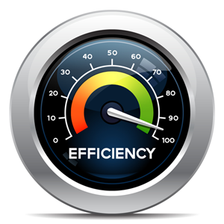When a supply chain is effective customers are satisfied that they got the right product in the right timeframe to meet their needs. Other stakeholders might be looking at how much revenue was generated relative to the cost and vendors and other business partners might also be looking at how well the SC was able to solve problems along the way.

While many believe supply chain efficiency and SC effectiveness to be one and the same, over the last decade or so researchers have established that, “the most efficient supply chain is not always effective.” Although statistically improvements in supply chain technology have resulted in many process efficiencies for companies, they have not resulted in an overall reduction in costs to customers or improvements in margins for companies themselves.

Why, you may ask, is this happening? Reasons include increased commodity costs and increased reliance on outsourcing whereupon companies have pushed costs to their supply chain partners, but this has not resulted in better results for customers on the measures they care about, such as on-time delivery and lower prices.

The following well-publicized recent case highlights the point precisely; The Boeing Company, recently forayed into large-scale outsourcing of its manufacturing processes to its supply chain partners for its 787 Dreamliner program which resulted in nearly three years of delays in delivering product to customers, and billions of dollars in cost overruns. Boeing’s 787 supply chain strategy was envisioned not just as a necessity but as a way to be more competitive against its major rival, Airbus, by keeping manufacturing and assembly costs low while sharing risk with Boeing’s suppliers. Based on definitions of supply chain efficiency vs supply chain effectiveness, this strategy was efficient in that it met internal company needs for a lean supply chain, yet not effective due to its negative impacts on customers and other stakeholders.

Clearly supply chain systems are extremely complex and in general, it is very difficult to improve efficiency in meaningful ways, unless we look at both efficiency and effectiveness. Companies must look beyond their internal company efficiency requirements on how to improve processes as they can impact external partners and customers as well.

iii. What are the customer service metrics? And what do they measure?

Customer service is a highly measurable activity. In today’s environment call volume, chat times, resolution rates, interaction counts, and a myriad of other numbers/figures are captured, recorded and measured to analyze performance. Measurements can easily be taken at an individual ticket level and then aggregated to report on overall team performance and individual customer service agents.

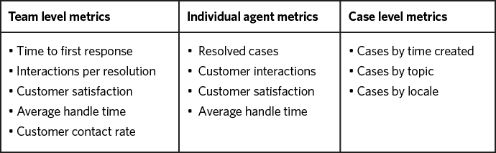
As a customer service provider, companies have access to most of these numbers and probably a “ton more”. The challenge is deciding which to report on, who to report it to, and how it should be presented. A simple matrix is illustrated above.
The main point of customer service is not to generate nice-looking graphs and reports and they need to understand their audience (critical to communication in all forms). It’s important to get the correct outcome and what gets measured needs to get managed (even if that’s to the detriment of the company).
The metrics chosen to report on should always be the following;
- Meaningful. They should tie back to something your company wants to achieve. For example, when your goal is highly responsive support, time to first response is an ideal metric. Resolution time may not matter.
- Moveable. You should measure things on which your team can have impact.
- Authentic. Your reports must tell a true story. It’s possible to use real numbers to send a misleading message. Be honest even when it hurts.
- Contextualized. Numbers in isolation can be stripped of meaning, so provide them in context.
- Consistent. The trends over time are usually more important than specific data, and looking back over a quarter or a year can give you some fantastic insights and encouragement.

Focus on trends, because the direction of change usually matters most. Eighty percent customer satisfaction may not sound great, but a month-on-month increase from 70% to 80% is excellent news. As illustrated in the caption below by taking a complaint you can develop a strategy can give a constant improvement output therefore dealing with customer complaints, improving service etc. which will enhance reputation and attract new customers

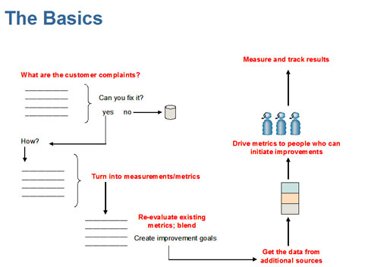
Direct limited attention to anomalies and changes. Managers are busy people, and they have a limited amount of attention give. Make sure it’s easy for them to know what to spend their time on.
Look for correlations that tell a bigger story. Looking at individual metrics is useful, but understanding the connections between them is where the real insight can come.

iv. What is the difference between build to order and build to stock products?

Build-to-order manufacturing is used by companies to create products to the exact specifications requested by a customer.
There are many benefits and disadvantages to this strategy of manufacturing. On the positive side, the products are custom-made to a client's needs which ensures customer satisfaction and companies do not have to panic about having inventory that does not sell (or the need to carry endless stock). On the negative side, businesses have a low supply of ready-to-sell products and customers have to wait longer to obtain their customized products.
The main advantage to a build-to-order strategy is the specialty of each product to meet the customer's expectations. A customer will order a product with certain specifications, and will expect the manufacture to provide this product to meet their criteria. (the humble sandwich, illustrated below, being a prime example).

As briefed above, the build-to-order strategy eliminates needless inventory from a suppliers stores or shelves. Instead of sitting on numerous products that don't sell, the build-to-order strategy only sells inventory specifically ordered by a customer. The provider therefore does not have to worry about losing money due to unsold items and it also gives them the ability to offer new customizations and products without having to worry about selling old inventory.
The build-to-order strategy clearly takes longer for customer orders to be filled. A long wait time could potentially send individuals away to purchase from other stores/locations with full inventories. The downside here means a delay in time could cause the company to lose potential sales and slow cash flow.
Build to stock (or make to stock) is a plan in which goods are manufactured and stored in form of inventory to meet future demand. In case, present-day demand is low, future demand is estimated and production planning is done in such a way that inventory cost as well as opportunity loss due to stock out are minimum risk.
This permits companies to reduce their overtime cost, utilize present idle capacity, better prepares producer to meet future demand , and saves on maintenance cost due to efficient use of machines in future to name but a few benefits. The downside however is it may also result in greater inventory cost or opportunity loss due to stock-out due to incorrect forecasting. Therefore a major key item is to ensure product forecasting is done accurately.
Manufacturing companies should always employ make-to-stock production if they produce stock independently of orders because they want to provide clientele straight away with goods from that stock later on. Obviously there is an element of guess work here and a company may need to anticipate that there might be client future demand, so as to produce supplies without having sales orders.
This does not imply that irrationally high stock levels need to be kept as this can be avoided by;
- Creating a production plan in advance in order to plan your stock.
- Receiving sales orders comparatively early on.
v. Explain the term ‘Data warehouse’.
There are basically two approaches to data warehousing, defined as top down and bottom up. The top down approach spins off data marts for specific groups of users after the complete data warehouse has been created. The bottom up approach builds the data marts first and then combines them into a single, all-encompassing data warehouse.
In a very general sense, the two may appear to be similar, but there are very important make up differences, in architecture, technology and usage patterns.
The term itself (data warehouse) was coined by William H. Inmon, who is known as the Father of Data Warehousing. Data warehousing highlights the results of data from these diverse sources for useful analysis and access, but does not generally start from the point-of-view of the end user (who may need access to specialized, sometimes local databases).
Typically, a data warehouse is stored on an initiative mainframe server or more and more nowadays, in the “cloud”. Data from various online transaction processing applications and other sources is selectively extracted for use by analytical applications and user queries.
A data warehouse is a specific type of database, which focuses on a very specific application; the storing, filtering, retrieving and analysing huge volumes of information. This application, a typical model scenario is illustrated below, imposes a different set of constraints and leads to a completely different architecture and usage pattern.
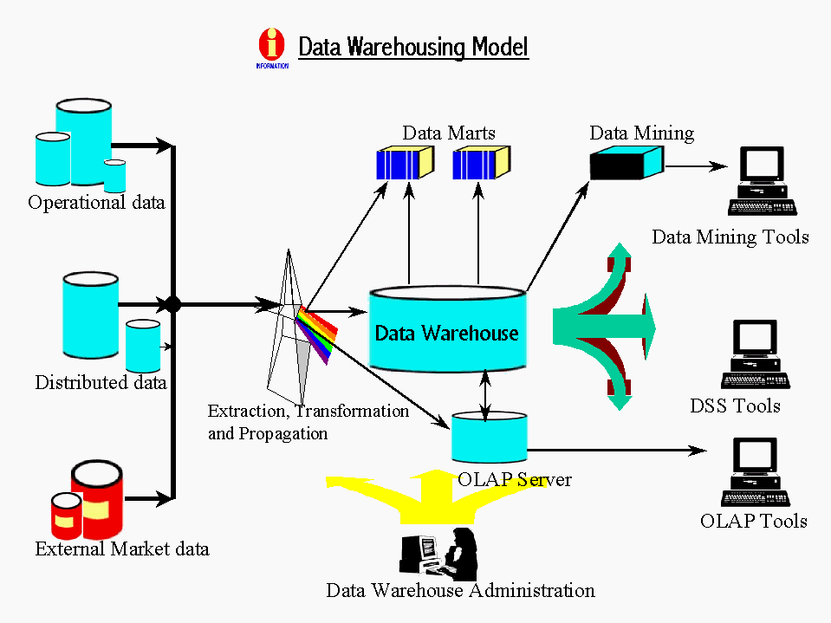
- Of course databases themselves need to be managed as databases usually store only the data that is currently in active use; older records can be purged and moved to backups, mainly for performance reasons. Data warehouses are therefore used to store much older historical records; it's also common to use data warehouses to store additional information that is bought in or captured from elsewhere to complement the information that is generated and stored by the internal database system.

- It is important to understand how and why Databases and Data warehouses differ in other ways so as to understand their interfaces. Brief as follows;
- Access designs are different whereupon Database records are often accessed, retrieved and updated one by one; data warehouses are nearly always accessed by reporting engines that work on entire datasets at a time to generate aggregates and other analytical information. Databases are frequently updated, normally only a field or record at a time; data warehouses however aren't updated very frequently (and for all practical purposes, never at the field or record level) instead data is attached in large consignments.

- The data storage structures also differ as Databases are usually standardized, which means that a lot of work is done to guarantee that there's a unique copy of any given bit of information (which is important for performance and consistency reasons). It's common practice however to store different versions of the same information on a data warehouse system, using different arrangements to compose and access the information.

2. Discuss in details the operations that suggest supply chain performance. (10)

As a minimum, the following categories of supply chain operations should be measured and improved upon, were findings indicate improvement is required, with the objective of meeting the performance requirements of the relevant Supply Chain markets the process caters too;

SCM Plan operations

Overall Supply Chain measurements (or metrics) such as Inventory Turns, Cycle Time, DPMO and Fill Rate are used to track Supply Chain performance. Commonly used by Supply Chain Management, these metrics can help companies to understand how efficiently they are operating over a given period of time. Measurements can cover many areas including Procurement, Production, Distribution, Warehousing, Inventory, Transportation, Customer Service – basically any area of the plan used for the supply chain. However, a good performance in one part of the Supply Chain is not sufficient. Any Supply Chain is only as strong as its weakest link. The solution is to focus on the key metrics in each area by;

  - By tracking the Metrics this allows companies to ensure performance over time and guides them on how to optimize their Supply Chain. It allows management to identify problem areas. It also allows for comparison to other companies through like industry benchmarking.
  - Certain metrics, such as Inventory Turns, have a universally accepted definition. Other metrics, such as Backorders, may need to be customized for a company’s particular industry or logistics business model.
  - Measurements alone are not the solution! The solution lies in the corrective actions that you take to improve the process or system. The measurements should be used to track the results of your improvement efforts.
  - Supply Chain Performance Measurements should have an owner. A person/department that is answerable for achieving a target on the metric.
  - SCM therefore needs to encourage and support the process changes to achieve the desired targets.

Using the correct set of metrics can lead any company to recognize if they have the proper balance between service and cost.

Sourcing operations

Source operations (or Development) is the next stage of the supply chain management process. It basically involves building a strong relationship with the suppliers of raw materials needed in making the product the company delivers. This phase involves not only identifying reliable suppliers but also the planning methods of shipping, delivery and payment.

Companies (and there SC managers) must develop a set of pricing, delivery and payment processes with their suppliers and create appropriate metrics for monitoring and improving the relationship on an ongoing basis. This then allows for the processes to be developed that will allow the management of the goods and inventory (inclusive of lead times, receiving, verifying, transferring and ultimately payment of the services provided)

Making operations

At this third stage the product is manufactured, tested as appropriate, packed and scheduled for delivery to the customer. It is clearly one of the most metric intensive sections of the supply chain process which ultimately provides companies with SKU (Stock Keeping Units) metric information that measures product quality, production output and worker/equipment productivity to name but a few.



Deliver operation

The fourth phase, Delivery, is the logistical stage when the customers’ requirements are “matched and despatched”. Companies must coordinate all the customer orders through their network of facilities, set up delivery methods and most importantly ensure there is an invoicing system in place to receive the due payments
All of the afore mentioned, form part of the Supply-chain operations reference (SCOR) model which is a process developed and widely used (and endorsed by the Supply Chain Council) as the cross-industry, standard diagnostic tool for supply chain management.
The SCOR model, as illustrated below, describes the business activities associated with satisfying a customer's demand, which include plan, source, make, deliver, and return processes. Use of the model includes analyzing the current state of a company's processes and goals, quantifying operational performance, and comparing company performance to benchmark data. SCOR developed a set of metrics for supply chain performance, and Supply Chain council members subsequently formed industry groups to collect best practices information that companies can use to promote and advance their supply chain models.
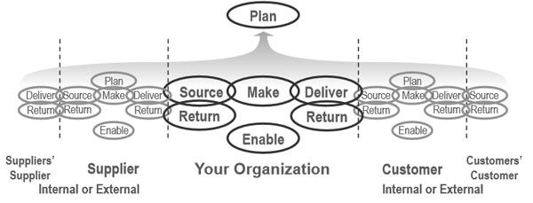

This reference model enables users to address, improve, and communicate supply chain management practices within and between all interested or involved parties along the supply chain.

Footnote:
SCOR was developed in 1996 by the management consulting firm PRTM (which is now part of PricewaterhouseCoopers) and AMR Research (now part of Gartner) and was endorsed by the Supply Chain Council (now part of APICS) as the cross-industry standard strategy, performance management, and process improvement diagnostic tool for Supply Chain Management.

Student Statement:

By submitting this assignment, I confirm that this is my own work.

Student Signature | Raymond Wilson | Date | 2nd Jan 2017

For Tutor / Assessor Use Only
Total Marks
Marks Obtained
Percentage / Grade

