
Assignment Cover Sheet

Student Name: | Deborah del Pozo Gómez
Student Number: | 2628
Course: | Level 4 Travel & Tourism
Assignment NO: | 1

Marking Criteria:
We expect the learners to write minimum one well expressed point in three lines against each allocated mark. This means one needs to write 15 lines with 5 well expressed points to get high grades for a 5 marks question.
For high grades use examples and illustrations where appropriate.
Please insert your completed assignment ( in word format) here:

- Give brief answers for the following questions:

- Sport Tourism is a kind of holiday which refers to the holidays or short break which involves either watching or playing a particular sport. This concept also includes travelling away from home for these purposes and staying away for at least one night.

- The main difference between inbound and outbound tourism is that inbound tourism refers to non-resident or foreign tourists entering a country, and outbound tourism refers to residents leaving their own country to visit another one.

- Motivating factors are the things that make people want to travel, for instance, discovering a different city and culture, visiting relatives and family, studying abroad, learning a new language or going to relax to a sunny beach.

- Tourism refers to people travelling from their places of origin to their places of interest and staying outside their usual environment for at least 24 hours and no more than one year for leisure, business, visiting relatives and family, and other purposes.

Travel is generally related to someone moving from one place to another for any reason and involves any location while tourism refers to someone moving for leisure and it is mainly focus on mass market destinations.

- The main difference between packaged and self-packaged holidays is that packaged holidays are sold for a single price by a travel agent and includes travel, accommodation and transfer services and self-packaged holidays are organized by a tourist making their own arrangements.

- Over the past few years our lifestyle have suffered several changes that have affected tourism in some way. Things like environmental awareness, the changes in family structures or technology have modified the way we live, our priorities and also the way we travel.

- The main types of leisure tourism are holidays, short breaks and city breaks.
- Holidays are leisure trips taken to relax, rest and enjoy and which normally last less than two weeks.
- Short breaks last no more than one week and are taken as second holidays, normally during weekends or bank holidays.
- A City break is a short holiday of around three days taken to a popular city which has a number of tourist attractions and facilities, and are also easy to get to, for instance, Barcelona or Berlin.

- Business tourism is when people have to travel for business purposes, such as meetings, conferences or trade fairs. It is important to the travel industry and it takes place thorough out the year. Its main types are:

- Business meetings: People travel every day to business meetings that may or may not involve a stay away from home. Hotels close to motorways and railway stations are used for this purpose.
- Trade fairs: Companies pay to have a stand at the trade fair to show their products to customers and these fairs attract thousands of visitors every year. It is a good opportunity to know new products and meet business contacts.
- Conferences and Conventions: Many organizations hold an annual conference which may be attended by hundreds of people, some of them will need to travel and stay in this place for at least one or two nights.
- Corporate hospitality: Companies often entertain their guest whilst are visiting on business, for instance, by providing tickets for a tourist attraction or a sporting event.

- Summarise the advantages and disadvantages of package holiday.

The advantages of package holidays are:

- Package holidays are often cheaper than paying for each item individually.
- Those who buy the package as a single ´product´ know exactly how much the holidays are going to cost.
- Travel agents and tours operators are responsible for booking and organize the holidays.
- All the details about the resort and hotel they are visiting are available in the brochures and website.
- Some people feel more confident travelling to places where most people staying in the hotel are from the UK.
- Often tour operators provides a ´rep´ in the resort to give advice and help with problems that may arise.
- Entertainment and children’s activities are provided by many hotels, as part of the package.
- Package holidays are associated with mass tourism and this concept involves large volumes of tourist all travelling to the same destination, generally located on coast because most tourist are looking for sun and sand.

The disadvantages of package holidays are:

- Mass market destinations are associated with some of the negative impacts of tourism such as poor behaviour, contamination or crime.
- People do not want to spend the holidays just sunbathing as there is an increasing awareness of the dangers of skin cancer.
- Tour operators need to fill their aircraft and offer limited choice of flights and departure times.
- Some people want to escape from the crowds and mass market destinations.
- People became less satisfied with the standard of the accommodation and food provided.
- Sometimes there are some hidden costs and extra charges not specified in brochures and people feel confused about the price.
- Confident travellers do not like being organised by tour operators to suit their schedules. Tourists prefer to construct a trip based around what they want to visit and do.

- Differentiate between different forms of tourism and link them to the impact on the environment and culture.

Taking into consideration the purpose of the travel we can differentiate between Leisure Tourism, Business Tourism and Visiting Friends and Relatives.

Leisure tourism refers to trips taken to relax, rest and enjoy. We can also call them ´Pleasure trips´ or ´Holidays´ and normally last less than two weeks. We can identify several forms of tourism in this category, such as short breaks, city breaks and other forms of tourist for many different purposes, for instance, health tourism –if the main purpose is having an operation or receiving a special treatment that is not available in your country-, sports tourism –these tours can be taken as spectator or as a competitor- or educational tourism –if the main purpose is learning a new language or studying in a good university. Short breaks are holidays of no more than one week and are becoming popular as second holiday. City breaks are short holidays of around two or three nights taken to a city which has a number of tourist attractions and facilities, for example, Barcelona or Praga.

This form of tourism probably has the highest impact on the environment. Tourists for leisure are looking for sand, relax and enjoy and they often overlook the importance of environmental awareness or having a good behaviour. Regarding the environmental awareness, transports by air produce an important share of air emissions and car or trail journeys produce emissions from energy production and are directly linked to global warming, air pollution and acid rain. All these transports are also producing noise pollution that is becoming a problem of modern life.

It is also noteworthy that construction of hotels, parking and other facilities for leisure (such as shopping centre or cinemas) cause an important impact on environment, deforestation and lead to sewage pollution. Seas and lakes close to these constructions are damaged and this fact is directly affecting the flora and fauna. For instance, in Yucatán (México) sewage has stimulate the growth of algae and is causing damage to coral reefs.
Furthermore, these new constructions are modifying the original structure of towns and natural parks and standardizing all the places to the American or European model. Tourists want to live the experience of a new culture, but they also look for familiar restaurants, hotels and supermarkets where they can feel comfortable spending money but which never have been in that place before.

Another serious consequence of leisure tourism is waste disposal, especially in places with high volumes of tourism. Tourists produce waste in cities and landscapes leaving behind their rubbish but also transportation and hotels produce waste every day. For instance, a cruise ship can produce more than 60.000 tons of waste every year and some trails in the Andes (Peru) and in Nepal have been renamed ´Coca Cola trail´ and ´Toilet paper trail´ due to the levels of contamination produces by tourist.

Leisure holidays also have an important impact on culture. The growing market of tourism is shaping in some way the way we live and our needs. During the last few years, transportation have improved a lot and people is allow to travel further and cheaper. There are new travel agents and flight companies and this competence have led to better prices, better entertainment and more choices.

The increase of cancer awareness have changed the way people used to spend their holidays in the past. Nowadays people do not want to lay on the sand all day because skin cancer risk is increasing every year.

In addition, Tourism market is turning local cultures into tourist attractions, traditional rites and festivals are being reduced to something that must reach tourist expectations. For instance, although the long necks of Kareni women are considered a practice against Human Right for many people, places like Chiang Mai (Thailand) have become a tourist attraction that has based its revenues in these women so they offer tours and activities around these villages showing `their real lives´. Adapting the culture to the tastes of tourist led to a loss of authenticity.

There is a second form of tourism called Business Tourism. Many people have to travel for business purposes and this includes driving to a meeting or flying to another country or city for a conference, a fair trade and so on. It takes place thorough out the year and is very important for the industry because some business like budget hotel chains rely on the income generated by these travels. In this group we can differentiate business meetings, trade fairs, conferences, conventions or corporate hospitality.

Although the impact of this tourism on the environment is not as high as the leisure tourism, it is also relevant. As I previously said, transportation generate emissions, the construction of hotel and facilities changes the landscape and people produce waste disposal.

There is another group of tourist who are travelling only for visiting their families and relatives. Although in most of the cases they return in the same day, sometimes they stay overnight. This group do not spend too much money because they normally stay in relatives houses but they spend money on presents, souvenirs, products and services, because they tend to visit restaurants or use the local transport.

They have an impact on environment because they use transportation. They also have an impact on the culture because they normally meet for parties (birthdays and weddings) or cultural festivals so they are helping to keep the traditions alive.

Activity
Choose one country in Asia and research some of the natural and cultural attractions which might appeal to visitors from the UK.

THAILAND

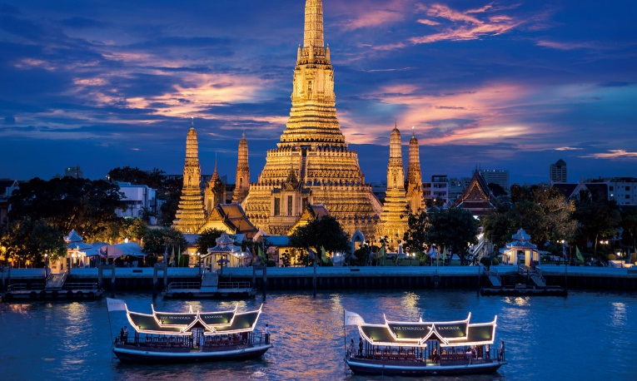
Thailand is situated in Southeast Asia and is one of the top destinations for holidays, so we can say that tourism makes up about 6% of the economy. Thailand offers good food (Pad Thai, papaya salad, smoothies, curries and seafood), traditional rites, amazing festivals (Loi (Krathong or Songkran), amazing landscapes, street night markets, some of the best beaches in the world and the famous Thai massages (with or without ´happy end´). But what are the best places to visit in Thailand?
Bangkok

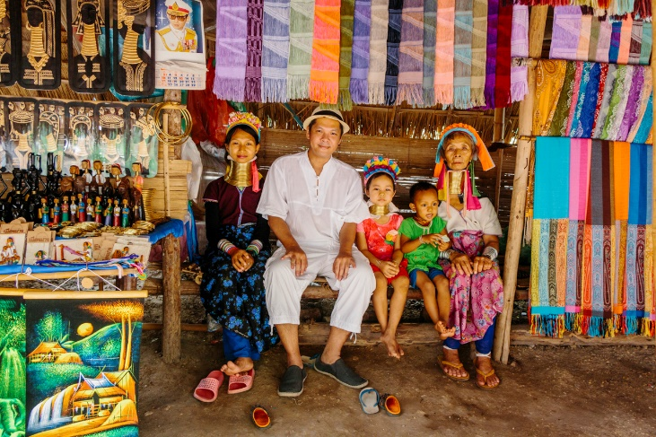
Chiang Mai
This city was one of two tourist destinations in Thailand on Trip Advisor’s 2014 list of ´25 Best Destinations in the World´. Chiang Mai offers amazing temples (Wat Chedi Luang or Wat Phra That Doi Suthep), natural parks (Doi Suthep-Piu and Elephant Nature Park), waterfalls and cultural attractions. One of the main attractions are the hill tribe villages where Kareni people (Long-Necked women) live. Tourists also visit these villages looking for elephant farms where they can help working as volunteers or visit the farm as part of a tour. This tour also includes a ride but many people do not agree this practice. Close to this village, there is an orchid farm where tourist can see some of the most exotic flowers in the world. Orchids are a symbol in the country and people often use them to decorate their clothes as well as restaurants and hotels.
Kareni People, Chiang Mai

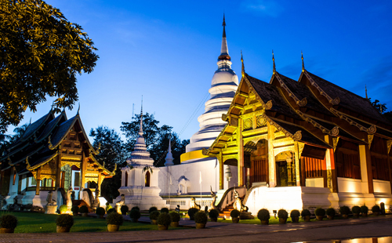
In addition, Chiang Mai is the best city in Thailand to celebrate Songkran Festival (Thai New Year’s Festival) that takes place in April and receive millions of tourist every year that want to participate in the water festival and splash water on their relatives.
Wat Phra Singh, Chiang Mai

Krabi
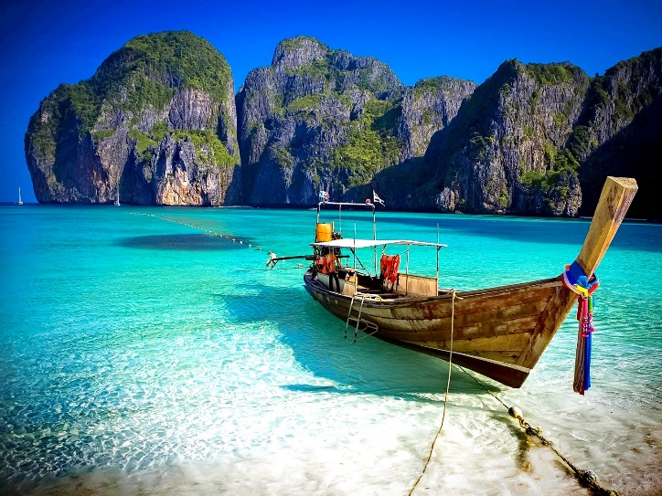
This province has become popular thanks to the film ´The Beach´ (Danny Boyle, 2000) where Leonardo di Caprio tried to escape from a paradise called Ko Phi Phi. Indeed, the islands that we can find in Krabi are the perfect definition of paradise. The main ones are Ao nang, Railay and Ko Phi Phi but there are over eighty smaller islands where tourist can enjoy the sand, the sun and the warm water. Krabi is the best place to eat seafood and fish in Thailand, but is also one of the most expensive places in the country. Tourists can also feel disappointed in the main islands because are always swamped by too many tourist. Koh Lanta is the great unknown and a good alternative which offers all the beauty of the other islands but has the advantage of being quiet.
Ko Phi Phi, Krabi
It is also a popular destination for adrenaline junkies that are looking for bamboo tattoos, rock-climbing, snorkelling and kayaking.

Bangkok
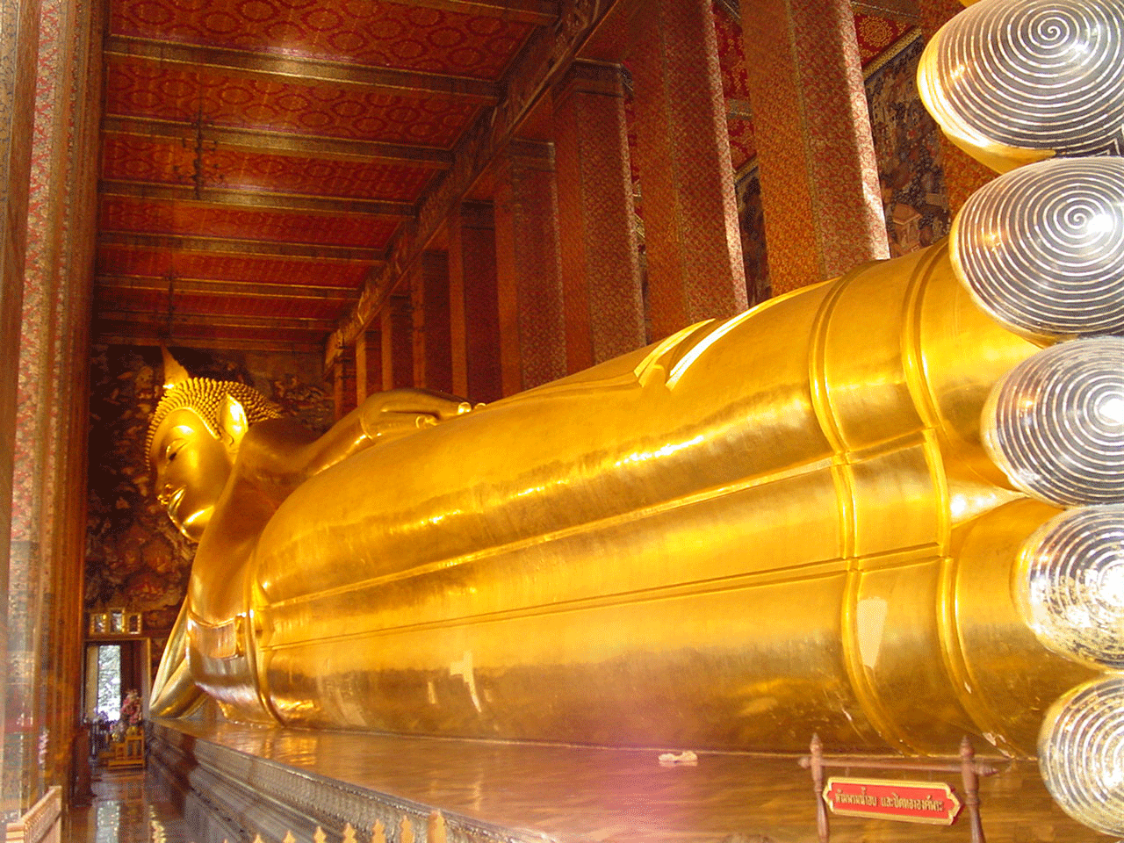
The capital is a big industrialized city where tourists can visit some amazing temples such as Wat Arun, Wat Pho or Golden Buddha, walk around the Grand Palace or enjoy a cruise through the Chao Phraya river. Wat Pho is also known as the temple of the reclining Buddha because there is a huge golden statue of 46 metres inside. This temple is also the birthplace of the traditional Thai massage.
But Bangkok is also a place of contrasts where the poverty and the richness of the country are living together so it is easy to see skyscrapers and shacks in the same street. Night street markets are one of the main attractions for tourists looking for cheap clothes, souvenirs, technology, local fruits, seafood and meat. There are also a good number of museums where tourist will be allow to discover the culture (Gem and Jewelry Museum, Thai Bank Museum, King Rama VI Museum, Rare Stone Museum, Bangkok Doll Museum and so on). Jim Thomson house is also one of the attractiveness of the city, a place rich in culture and art. Thomson was an American entrepreneur who collected old structures from Thailand, Cambodia, Laos and Burna, becoming the major art collector of Southeast Asian art.
Reclining Buddha in Wat Pho Temple, Bangkok
Bangkok
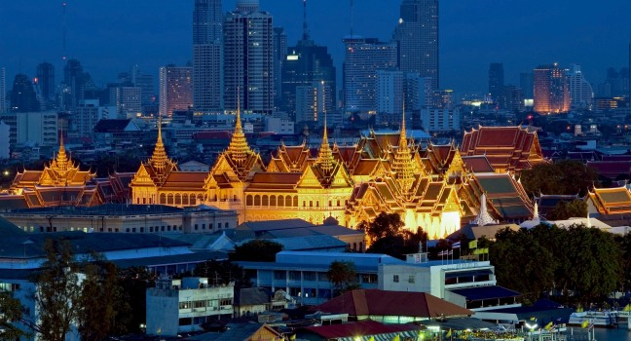
Ayutthaya
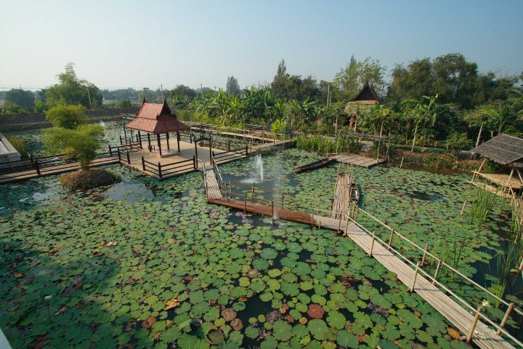
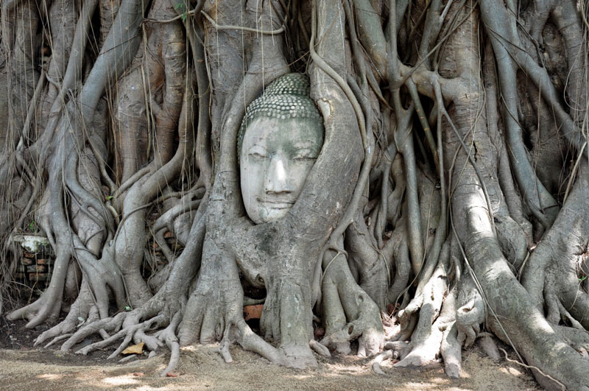
Ayutthaya (also called Ayutthaya Kingdom or Siam) was destroyed by the Burmese army in 1767 but the ruins of the city are preserved in Ayutthaya historical park where there are a good number of temples that worth to visit, for instance, Wat Yai Cha Mongkhon, Wat MahaThat or Wat Phra Sri Sanphet. In Wat Phra Maha tourists can spot the famous tree that has grown around Buddha’s head. It is forbidden to take any pictures above Buddha’s head so tourist must lay or sit down when visiting the tree. Wat That Sri Sanphet is the largest temple in the city and is famous for its distinctive Thai-style stupas. Wat Yai Cha Mongkhon is easily recognized for its reclining Buddha covered with an orange tunic. Wat Lokaya Sutha is not the best temple to visit as is completely destroyed but has a huge reclining Buddha (42x8m) that deserves a visit.
Ayutthaya Garden River
Buddha head, Wat Phra Maha, Ayutthaya
The best way to visit the city is hiring a tuk-tuk or riding a bike. Crossing the river is also a great experience that any tourist should not miss due to the colours of the water and water lilies.

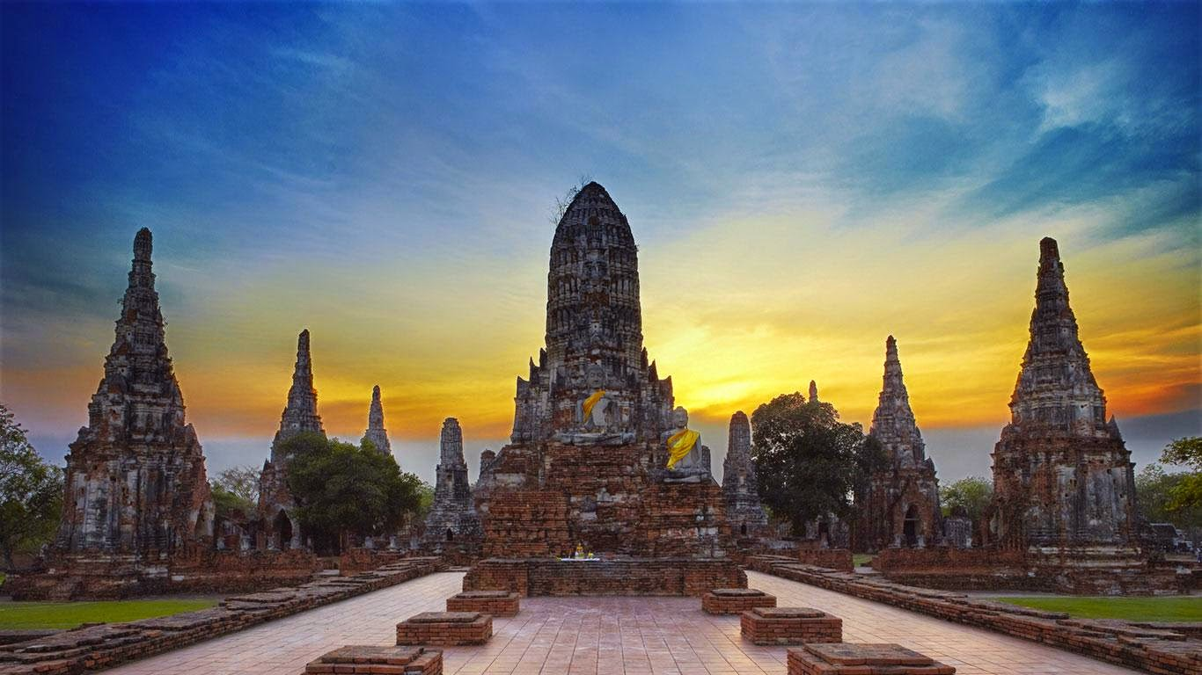
Wat Chaiwatthanaram, Ayutthaya

Student Statement:

By submitting this assignment, I confirm that this is my own work.

Student Signature | Deborah del Pozo Gómez | Date | 25/10/2016

For Tutor / Assessor Use Only
Total Marks
Marks Obtained
Percentage / Grade

