
Assignment Cover Sheet

Student Name: | Shweta Jewlikar
Student Number: | 1610
Course: | Diploma in Fashion Design Level 4
Assignment NO: | 2

Marking Criteria:
We expect the learners to write minimum one well expressed point in three lines against each allocated mark. This means one needs to write 15 lines with 5 well expressed points to get high grades for a 5 marks question.
For high grades use examples and illustrations where appropriate.

- Give short answers for the following questions:

- What is meant by the term, ‘weight and hand’ in the textile industry?

  - Weight term describes texture of cloths such as lightweight, medium weight or heavy weight.
  - Weight is a physical property of texture which helps Illusions ,can be created by texture which can make apparent body size look very different, making a person look thinner or heavier.

- Name the warm colours? How are these best used in dress designing?

- Red, yellow and Orange are considered as main warm colours.
- Reds:
    - Red colour indicates hot, angry, passionate, sentimental and powerful and can be used to make dress to express those emotions.
    - Also used a lot in valentines, romance and love and are considered exciting and fiery.
    - As said passionate used frequently in sporting clothes and evening wear.

- Yellow:
    - Represent cheerfulness, brightness, sunny and friendly feelings. Mostly can be used in combination with other colours as these colours not suit many skin colours.

- Orange:
    - Orange colour indicates cheerful, joyful, warm, lively, hope and hence can be used in designing active wears.

- Why it is important for a designer to consider the scale of a pattern, when using patterned fabrics in dress designing?

  - The scale of a pattern should complement the design and not overpower or underplay it.
  - For example, a large print would overshadow the actual design. In order to display a larger print to its best advantage, it should be the most important element of a garment and not be broken up with details or seams.
  - The structure should remain simple. When a design begins to form with dominating lines or details, it is best to keep the fabric plain and of secondary importance.
  - The pattern may be an important part of how a design looks. It is important for the scale of the pattern to match the person’s scale.

- What is the difference between conventional design and geometric design?

- Conventional Design is choosing something from nature and adopting it to suit the purpose of the object. Then it becomes decorative and the motif is no longer naturalistic.

- Geometric Designs are not taken from nature but rather are derived from shapes, i.e., circles, rectangles, triangles, parallel lines, and so on.

- Define the term ‘colour dimension.’ Explain the following terms: Hue, value, and intensity
‘colour dimension’

Colour Dimension can be defined as way to identify different colours cloths. It helps us to choose particular colour which suits particular group of individuals. Colour dimension helps us to decide which colour can be used for different occasion and in what amount. Hence plays major role in designing a pattern and selection of fabric.

There are different Colour Dimensions as follows: Hue, Value and Intensity
Hue:
- It is the property of colour which helps to decide which colour it is. This can we more descried with the help of fig 1 below.
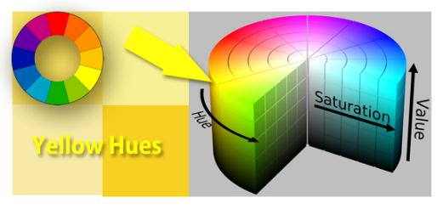
Fig1. Yellow Hues

- As Per fig 1 yellow hues belongs to the yellow colour group.

Value:

- Value denotes the use of lights and darks. It is the variation of strength in colours.
- The scale of colour value moves from white to black, white being pure light and black being the absence of it.
- It is obvious that white will lighten colours and black will darken them when it is added.
- Lighter values are called tints and darker values are referred to as shades as shown in Fig 2.
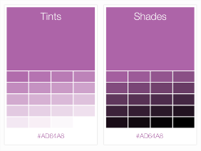
Fig2. Tints and Shades
- Garments always have value contrasts, whether they are the colours created by the designer or those made by normal gathers and folds.
- One of the strongest value contrasts, example, is black against white.

Intensity:

- Intensity refers to the brightness or strength of a colour of the weakness (paleness) of a colour. Fig 3 shows example of bright colour tops and fig 4 shows pale colour dresses.
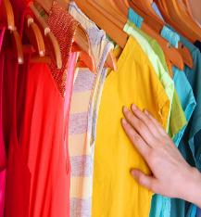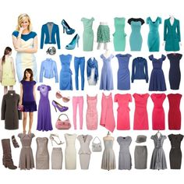
Fig3 . Bright Colour Tops Fig4 Pale Colour Dresses
- High-intensity colours would be the bright ones and low-intensity colours would be the paler ones.
- When water is added to paint in order to make it paler, its intensity is lessened.
- Within a green hue, for example, a dark, rich green is high-intensity whereas a soft pastel green is low intensity.fig 5 shows brightness.

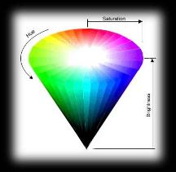
Fig 5.Brightness
- Balance is usually achieved when colours of the same intensity are used together, but a balance can also be reached by using a touch of bright colour in stitching or other embroidery when there are large amounts of dark colours around them.Fig6 shows dress having different colours with same intensity.

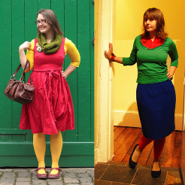
Fig6. Different colour with same intensity of colour

- Write a short note on the following; Basic Shapes in dress designing

Basic Shapes
There are seven basic shapes in dress designing. Every season’s adaptations are of one or more of these. Figure 7 shows which shape dress suits which body type.

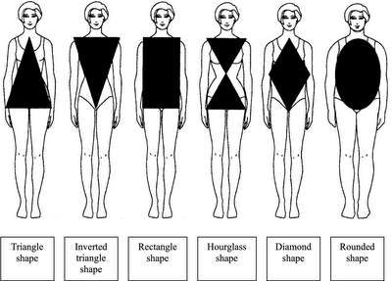
Figure 7. Different shape with body type.

Rectangular:
- Figure 7.1 shows an example of a garment which is long, straight, and hanging in loose, graceful folds, such as in Greek and Roman styles.

- It will have straight line sheaths and could be for tailored suits. This type of style with these particular lines is slenderising and suitable for women who are either well proportioned or heavier women.

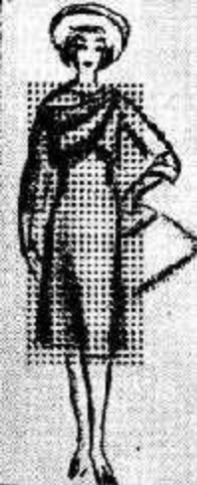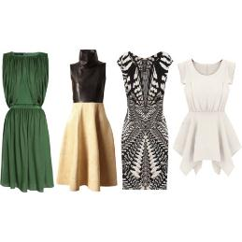
Figure 7.1 Rectangular Shaped dresses

Triangle
- Figure 7.2 shows an example of a Spanish style which includes a fitted bodice and a bell shaped, gently widening skirt.

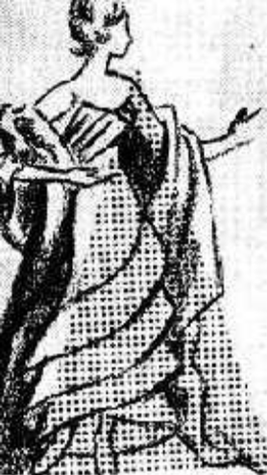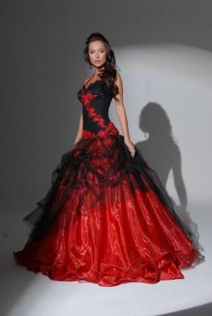
Figure 7.2 Bell Shaped Dress

Inverted Triangle

- Figure 7.3 has wide shoulders and a narrow skirt with dolman or raglan sleeves. This is a particularly good design for women with a large bust.

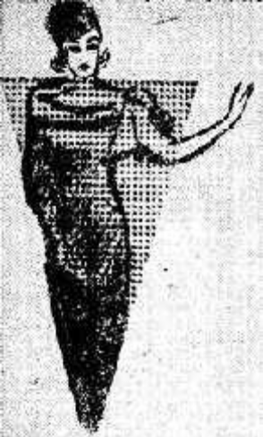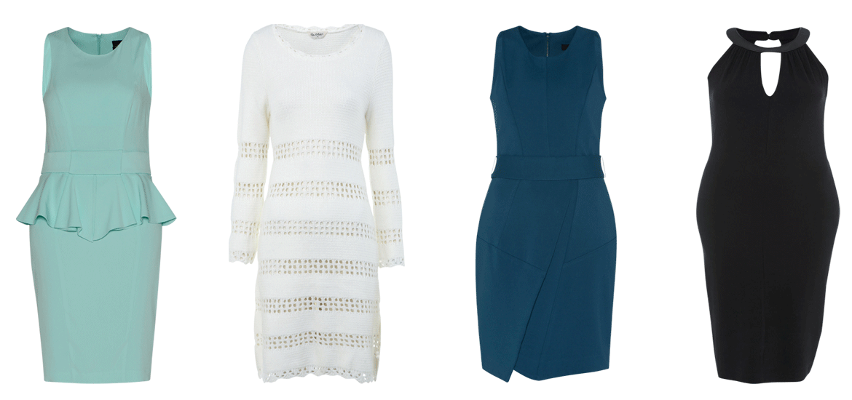
Figure 7.3 Inverted Triangle Shaped Dresses

Oval

- Figure 7.4 shows the oval shape is draped over a figure and softly shaped.
- It is a very feminine and decorative form. It is suitable for women who are well-proportioned and have the ‘ideal’ figure.
- This style is suitable for afternoon and evening wear in particular.

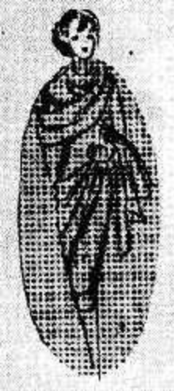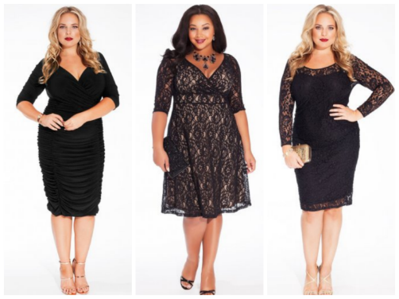
Figure 7.4 Oval Shaped Dresses

Square
- The square design has straight or boat shaped necklines, or boxy jackets, or capes.
- This style is good for women with very thin figures and can camouflage certain figure irregularities when the proportions are well planned and have a good design.

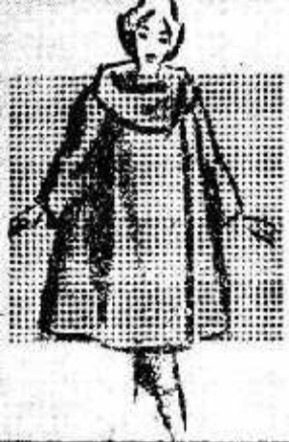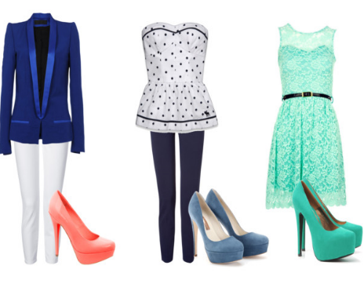
Figure 7.5 Square Shaped Dresses

Round
  - Round shaped designs include wide skirts, petal shapes and puffy sleeves.
  - This style is suitable for formal wear or afternoon frocks.
  - This particular fashion design best suits the very young and/or the very thin figured.
  - Waist line not prominent so focus should be made on waist line to enhance the look.
  - This will help to present body in upper and lower parts effectively.
  - Figure 7.7 shows some sample of round shaped dresses.

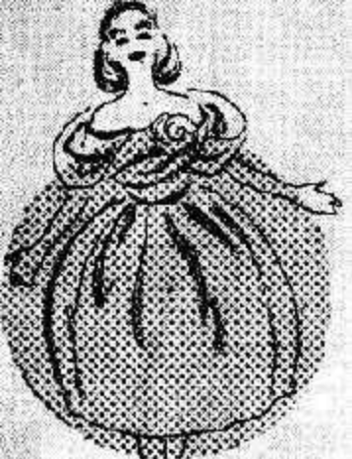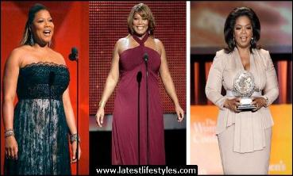
Figure 7.7 Round Shaped Dresses

Hourglass
- The hourglass style includes wide shoulders and either a natural or ‘wasp’ waist which comes in.
- It fits smoothly over the hips and usually has a full skirt.
- This is a good design for the tall, thin figure.
- Perfect waist curve and looks prominent.

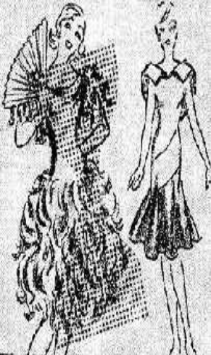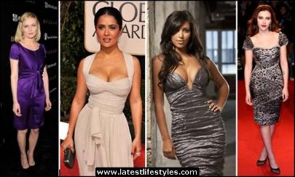
Figure. 7.7 Hourglass Shaped Dresses

Project

Look through costume books for pictures of an historic dress. Using these inspirations, design a garment
using the line, shapes, colours, and details from the historic garment in a new combination for our lifestyle.

- Figure 8 shows design of garment , used line shapes and colours along with combination of some historic lifestyle.
- Keeping in mind Rectangular shape to suit body type of heavier women.
- Used Light Orange colour to indicate cheerful, joyful, warm and lively.
- Used silver patch around waist line. This makes waist line prominent.
- Added belt of brown color to give fancy look.
- Slightly puffed sleeves with cut.

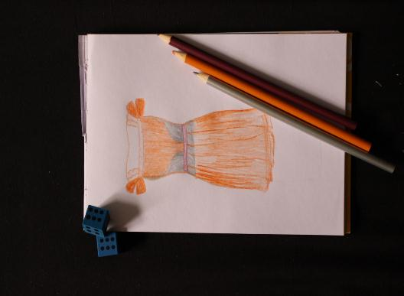
Figure 8. Rectangular Shaped Dress.

Total Marks
Marks Obtained
Percentage / Grade

