
Brent
Assignment Cover Sheet

Student Name: | Mery Ann Alaba
Student Number: | 1406
Course: | Fashion Design
Assignment NO: | Assessment 2

Marking Criteria:
We expect the learners to write minimum one well expressed point in three lines against each allocated mark. This means one needs to write 15 lines with 5 well expressed points to get high grades for a 5 marks question.
For high grades use examples and illustrations where appropriate.
Assessment 2

- Question

- Fad is something more interesting or tenser in life, can be defined as short lived fashion and lasting for a very little time or period.

It is acceptable by only particular group like metallic or hippies –their
clothing, accessories, hairstyle etc.

- Fashion forecasting is a global career and focuses on upcoming trends, can predicts the colours, fabrics and style that can be presented on runway and into the stores for the upcoming seasons.

Fashion forecasting is a new upcoming design, style in a different level of fashion.

- The difference of Fashion forecasting and Trend forecasting are;

Fashion forecasting is done through communication by media, cinema,
fashion show magazines, and newspaper, includes the market research,
consumer focus groups, In-store informat interviews, shopping, sales
records, evaluating the collections, fashion trends, and Trend for Target
Markets.

In short advertising and all concepts applies in a all levels of the fashion
industry.

While Trend forecasting are the styling ideas that a major collections that
have in common. They indicate the direction in which fashion is moving.

Several designers use a similar fashion idea and I think this is a viral as the
press notices similarities between collections and highlights them, the
media exposure helps to establish the trends.

And there is a life span of trend is about five months instead of a year as
well in a junior market span is only 3 months.

- Fashion Trend is the styling ideas that became viral in a global trends and it will not last longer, there is a certain period of time only.

- a.) Price
b.) Fit
c.) Appropriateness
d.) Brand

- Different between Fashion & Style

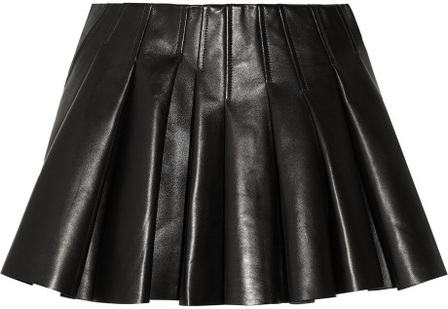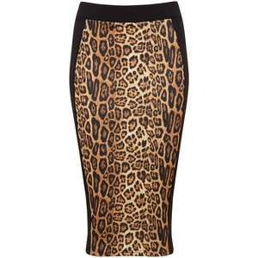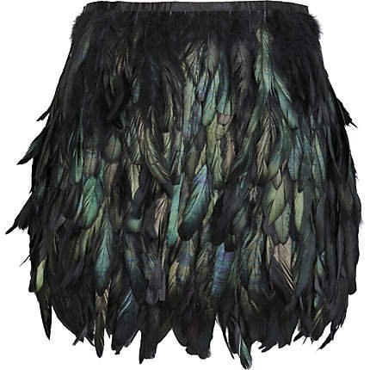

Fashion is most mysterious aspect of clothing and it is a narrow sense of the world means the changing form of clothing, which differentiate humans from others animals, leather or nature fabricated.

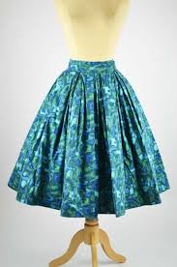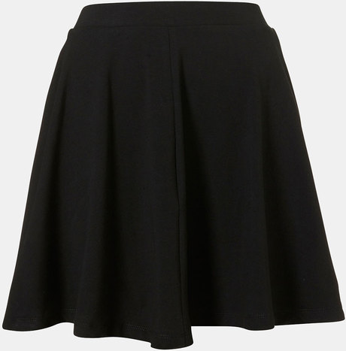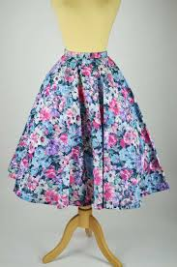

Style is always constant it is popular word in a fashion and refers to a sub-division within fashion. Also it is repetitious but important to stress that fashion is synonymous with acceptance.

Student Statement:

By submitting this assignment, I confirm that this is my own work.

Student Signature | Mery Ann P. Alaba | Date | 6 April 2015

For Tutor / Assessor Use Only
Total Marks
Marks Obtained
Percentage / Grade

