
Assignment Cover Sheet

Student Name: | Raymond Wilson
Student Number: | 5297
Course: | Diploma in Risk Management
Assignment No: | 2
Marking Criteria:
We expect the learners to write minimum one well expressed point in three lines against each allocated mark. This means one needs to write 15 lines with 5 well expressed points to get high grades for a 5 marks question.
For high grades use examples and illustrations where appropriate.
Assessment 2 The Types of Risk Total Marks: 30

1. Short Questions:
I. Define the following terms: (18)

- Equity
In simplistic terms Equity is the value of an asset less the value of all liabilities on that asset and can be best summed up as an accounting equation; Equity = Assets - Liabilities
This simple definition however can have somewhat different meanings when referring to different kinds of assets. The following are summaries of some of the more specific definitions for the various forms of equity;
- A stock or any other security representing an ownership interest (private equity).
- The amount of the funds contributed by the owners plus the retained earnings or losses (shareholders' equity).
- In the context of margin trading, the value of securities in a margin account minus what has been borrowed from the brokerage.
- In the context of real estate, the difference between the current value of the property and the amount the owner still owes on the mortgage. (“real property value.”)
- When a business goes bankrupt and has to be liquidated, the amount of money remaining (if any) after the business repays its creditors (most often called “ownership equity” or “liable capital.”)

b) Commodity Risk
Commodity risk is the threat that a change to the price of a manufacturing input will adversely impact a producer who uses that input. These “inputs” include raw materials such as, but not limited to, cotton, corn, wheat, oil, sugar, soybeans, copper, aluminum and steel. Many factors can affect commodity prices including political/regulatory changes, seasonal variations, weather patterns, technology and even market conditions. Commodity price risks are often “hedged” by major consumers.
Unanticipated changes in commodity prices can significantly cut a producer's profit margin, and make accurate budgeting forecasting extremely difficult. Producers can however protect themselves from such fluctuations by implementing financial strategies that will guarantee a commodity's price or lock in a worst-case-scenario price (to minimize potential losses).

II. What is the difference between ‘micro political risk’ and ‘macro political risk’?

Businesses that expand their operations into foreign countries face many political risks that would not come into the equation for domestic operations. Risk management describes the methods businesses use to control and adapt these political risks as "macro" and "micro".
When a company decides to do business in another nation, it opens itself up to a host of risks as its operations are subject to that country's laws and political climate. If, for example, a U.K. corporation opens a factory in South Africa and SA goes to war or changes its government or laws, it could have a significant impact on the business' operations and profitability.

 Micro risk defines political risk that does not affect all types of businesses. An example being, if a country enacts new strict environmental emission regulations on factories, it would affect most industrial operations in the country, but it might not affect certain industries like the services or leisure sectors. Businesses or investors can manage micro risk by shifting their investments into projects or industries that are not affected by such unfavorable changes.
Macro risk however refers to risks that affect all businesses that operate in a particular foreign country. Examples of macro risks include the possibilities that a nation could fall into civil war, devalue its currency or significantly increase its taxes. Industry managers therefore must be well-informed about a country's laws and political situation to manage related macro risks. A couple of methods of how to manage this risk could be;
- Managers might avoid investing in a certain country if they think it is likely the country will pass hostile legislation.
- Branch out the business operation by expanding into several foreign countries is a way to mitigate individual country risk.

III. What is credit risk? Outline main categories of credit risk.

Credit risk refers to the risk of loss of principal or loss of a financial reward stemming from a borrower’s failure in repaying a loan or meet a contractual debt. Credit risk comes about every time a debtor is looking ahead to use future cash flows through the payment of a current obligation. Investors are rewarded, sometimes significantly, for presuming credit risk through the way of interest payments from the issuer or borrower on the monies borrowed via a debt contract.

Credit risk is also related closely to an investment’s potential return, the most noteworthy being that the yields on bonds correlate strongly to their supposed credit risk. A higher credit risk therefore mirrors a higher interest rate demanded by the investors for lending their money.

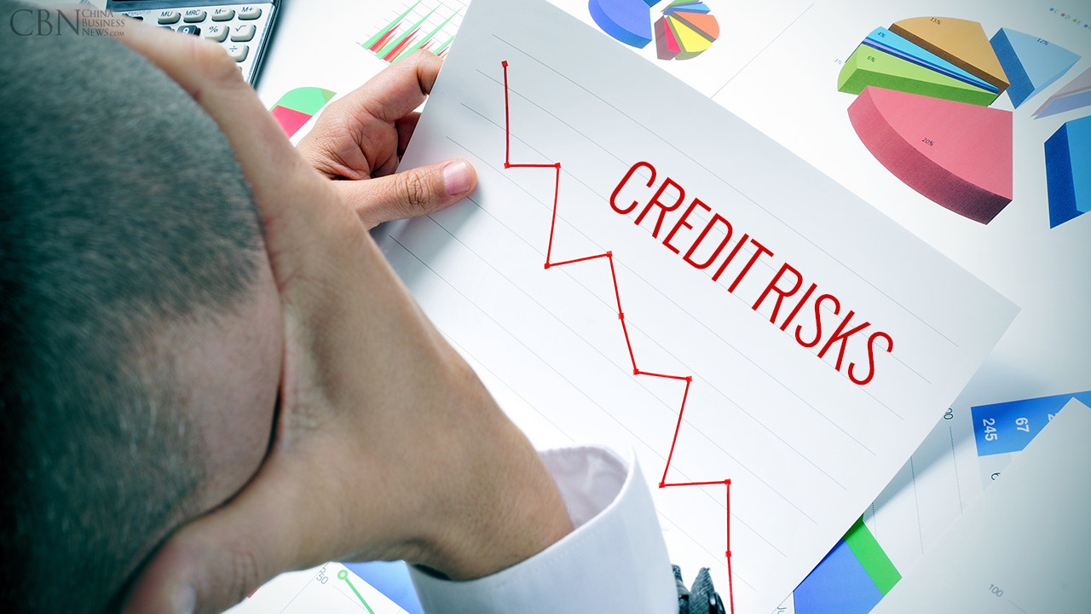

There are, generally, three types of credit risk:
- Credit spread risk occurring due to volatility in the difference between investments’ interest rates and the risk free return rate.
- Default risk arising when the borrower is not able to make contractual payments.
- Downgrade risk resulting from the downgrades in the risk rating of an issuer.

There are of course numerous sub divisions of the three main types of risk identified above such as Bonds, Retail lending, Corporate lending, Insurance default and so on.
IV. Outline the main categories of social risk.

Social risks are ever-present and numerous. Environmental degradation, labor and human rights violations, corruption or the implications of undue social and economic stratification or marginalization are all types of social risk that can not only cause serious harm to the local people involved, but can make business unsustainable in the long run.

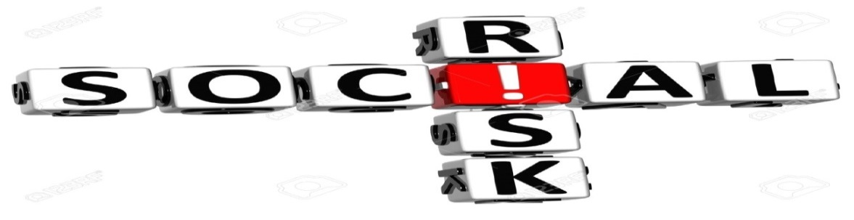

The following are some of the main risks faced by companies;
- Human Rights - Businesses are increasingly recognizing that they have the responsibility of protecting and respecting the rights of individuals, and that by doing so business flourishes.
- Rule of Law - In order to develop and implement a realistic plan for social risk mitigation, it is essential to understand the context of the local government’s level of social control, and commitment to social and human rights.
- Corruption – Which includes bribery, preferential government procurement, or other inappropriate relationships, can damage reputation and legal standing, and the ability to maintain a license to operate.
- Security - Whether the National, contractors or in-house security forces provide security, there is a risk that security personnel will fail to adhere to the firm’s human rights codes and policies.
- Land – The use of land and its ownership are often contentious. From corruption, environmental concerns, or matters relating to political, legal, financial, or even indigenous rights, Corporations must ensure the right to purchase and/or use land is achieved free and clear prior to any investment.
- Environment - Proactive management of environmental impact is vital to manage the reputational, regulatory and financial risks relating to the natural environment.
- Public health - Health problems can pose a range of business risks including absenteeism and low morale, obesity, costs of health care and other community expectations with regard to health and safety services.
- Working Conditions - Unsafe working conditions lead to decreased productivity, lowered morale and employee retention, reputational risk and can be in conflict with local or international labour standards. Retirement age, unemployment and life expectancy have influences in this category.

Some of the above elements of society can affect business performance over which businesses have token control or sway. Existing and developing trends in lifestyle, social attitudes and the varieties these pose need to be reviewed by companies in terms of the risks and opportunities resulting from the evolving characteristics of the labour force.

V. Outline the benefits of technology risk management.

Technology risk is any potential for technology failures to disrupt a business such as information security incidents or service outages. For many organizations today, protecting valuable information from risk will be a growing priority especially with regards to security related issues and to remain competitive, profitable and trusted by your customers it’s a concern that needs to be taken seriously.

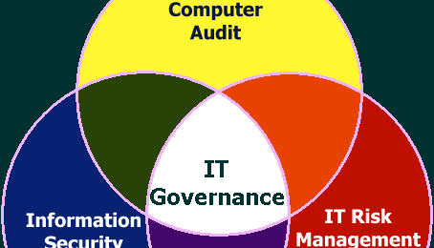

Information and Technology Risk Management, through auditing, screening, governance etc. is the solution to managing an organization’s information risks. It’s basically the procedure of identifying, understanding and managing the risks to your information within the context of your business and customer needs.

Below are some of the good reasons why a robust Information and Technology Risk Management approach makes sound business sense;

- Vigorous IT Risk Management brings competitive advantage through an increase in trust that will improve the company’s reputation for better sales results.
- Effective IT Risk Management lowers the odds of a harmful information security incident.
- Mastering IT Risk Management gives visibility and confidence to make better business decisions which can be based on real risks, not rumor or scaremongering.
- IT Risk Management can save money through more efficient controls, designs and appropriate levels of protection.
- IT Risk Management will include business continuity, keeping the business going in unforeseen circumstances or emergencies.
- IT Risk Management gives full visibility and accessibility which allows personnel to Know where information is that will enable you to put your hands on the right details fast, faced with any request for information (e.g. HR/legal)
- Understanding and managing these types of risks brings peace of mind to all involved and they can be confident that due care and diligently exercised risk management has been carried out in accordance with the business objectives and requirements.

VI. The following table contains risk types and categories. Match the appropriate risk type and risk category in each case.

Risk Type Risk Category
Operational Risk Theft and fraud
Bribery
Health and safety issues
Money laundering
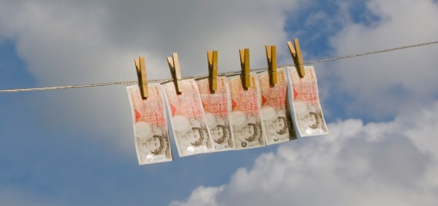
Credit Risk | Indemnity commission  Business related loans  
Market Risk | Change in foreign exchange rates


2. “Financial risk is one of the high priority types for every business”. Discuss (3)
There are many ways to categorize a company's financial risks. One possible perspective is provided by separating financial risk into three broader categories: market risk, credit risk, and liquidity risk
Risk is integral to any business enterprise, Therefore it is an essential feature of running a successful business to have Financial Risk Management plan in place. A company's management team has varying levels of control in regard to risk, as some risks can be directly managed, whilst other risks are largely beyond the control of the company. The best a company can do, in most instances, is try to anticipate possible financial risks, assess the potential impact on the business and be prepared with a plan to react to adverse events based on the following three categories;
Market risk involves the risk of varying conditions in the specific open market in which a company competes for its business. One example of market risk nowadays is the increasing tendency of consumers to shop online instead of shops/stores etc. This side of market risk has presented significant challenges to old-fashioned retail businesses to a point that companies that have been able to adapt to serve the online shopping public have thrived and seen substantial revenue growth, while companies that have not embrace the evolution, been slow to adapt or even made bad choices in their reaction to the changing marketplace have fallen by the wayside or gone out of business.
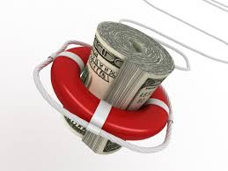
Credit risk is the hazard businesses may face by extending credit to customers. This risk is due to the possibility that a customer may default on payment. It can also refer to the company's own credit risk with suppliers Each company must control its own credit obligations by ensuring that it always has sufficient cash flow to pay its bills in a timely manner. If not, suppliers may either stop extending credit to the company, or even stop doing business with the company altogether.
Liquidity risk includes asset liquidity and operating funding risk. Asset liquidity is related to the comparative ease with which a company can convert its assets into cash should there be a sudden, substantial need for additional cash flow. Operating funding liquidity is a reference to daily cash flow needed to keep the business going. Overall, global or seasonal downturns in revenue can present a substantial risk if the company suddenly finds itself without enough cash on hand to pay the basic expenses necessary to continue functioning as a business.

3. “Introduction of genuine environmental policies may enable a business to attract more customer, investors and employees”. Discuss (3)

Corporate social responsibility (CSR) is not going to solve all the world’s problems. That said, CSR, of which environmental issues form a major part, is a way for companies to benefit themselves while also benefiting society and the world at large.

Environmentally friendly or environment-friendly (also referred to as eco-friendly, nature-friendly, and green) are promoting and sustainability terms referring to goods and services, laws, guidelines and policies that cause reduced/minimal impact, or no harm upon ecosystems, people or the environment.

Running an environmentally friendly business nowadays helps you reduce your impact on the environment and preserves natural resources. Your business can help the environment in many ways,
For example, companies can;
- use products that reduce the reliance on natural resources (e.g. rainwater tanks, solar hot water systems)
- use products that are made from recycled material (e.g. paper supplies made from recycled paper/cardboard etc., furniture made from recycled rubber)
- look at all their business activities to see if anything can be done differently (e.g. reducing travel by holding video conference calls, invest in and utilize clean power supply’s i.e. solar power instead of fossil fuel boilers for hot water usage).

Making businesses environmentally friendly (by adopting and implementing sustainable policies) not only benefits the environment but can also save the companies money as well as attracting new investment, new customers and the new employees.



Promoting environmentally friendly methods of operating can set a business apart from its competitors and attract new customers who want to invest or buy products and services from an environmentally friendly business. Some examples are as follows;

- Customer engagement – For a number of years now, US company Walmart or better known as ASDA in the UK, has established itself as a leader on environmental efforts (yes, you read that correctly, Walmart is a leader in environmentalism). In 2008, Walmart ran a televised ad campaign designed to raise awareness about the environment and the product choices consumers could make to improve. Using CSR in this way can help companies engage with their customers in new ways and since the message is about something “good,” it can often be an easier way to talk to your customers. Media and the internet is often an underestimated and underused tool for business/company communication.
- Employee engagement – Along similar lines, if a company’s own employees don’t know what’s going on within their own organization, an opportunity is being missed. Sara Lee, a major US baking company – Logo illustrated above, created a cross-functional, global Sustainability Working Team to help create a strategy for sustainability. Many others, at more of a grass root level, promote awareness by having “green” days with employees, or have a campaign for tree planting.
Case Study
Hairdressing has always been an important part of David’s life. Back in the mid-nineties his parents opened a small hairdressing business in Derby. Today, the salon remains very much a family concern.
Running a busy unisex salon with ten employees, however, involves much more than cutting, styling or colouring hair.

There are key safety issues to consider too. Hairdressing products can carry risks of eye or skin irritation for both staff and customers. Water, through the wash basins, is a major area of risk - people might slip on wet floors.

With wet work -- when staff are constantly shampooing 20-30 times a day - there's a risk of occupational dermatitis, a major issue in the industry." These are the issues pointed out by one of David’s friends who suggested that apart from usual insurance they should have proper risk management procedures in place. And a risk assessment should be carries out for the business by a professional. David approached a risk management professional who carried out risk assessment for the business.

Keeping the above case in mind please answer the following questions: (6)

1. Which type of risk is the business faced with?

Consumers spend a lot of money on hair and beauty services. In the U.S. alone, it is estimated annual revenues from beauty salons is in excess of $20 billion. But these services can be inherently risky not just for the companies involved but for clients and employees as well. From hair care products and chemicals to cutting tools, dryers and the hands-on nature of the business, salon and barber shop owners need to comply with the constantly changing state and federal regulations designed to promote safety and protect their clients and staff from accidents and injuries. These business risks include;

Personal Injury Risks - The vast assortment of chemicals, products, trimmers, dryers and other electrical equipment used on a daily basis creates a setting where accidents and injuries can happen.

Hiring and Retaining the Best Employees - As with any consumer personal service business, the success of hairdressing businesses depends on the skills and expertise its employees. The competition for talent is fierce, so besides making sure employees have all the necessary credentials and qualifications, companies need to consider offering incentives, benefits and pleasant working conditions to keep the best talent on board.

Competition and Customer Retention Issues - The hairdressing business is a highly fragmented one but also very competitive. Marketing and promotional efforts need to be continuously aimed at generating new customers from walk-ins and then turning those customers into regulars who will frequently return and provide the financial backbone for the business. Often, this means being aware of customer attitudes and identifying and solving minor issues to ensure a positive experience during the visits.

Property and Personal Risks – By nature the substantial investment in equipment and product inventory, along with the physical structure of the place of business and the health and welfare of the employees requires comprehensive insurance protection.

Licensing and Regulatory Concerns - The salon and barber shop industry has many regulations and licensing requirements designed to ensure the safety of employees and clients. Rules and regulations for the business as well as individual professionals change frequently so it’s critical that you stay up-to-date on local or government requirements and relevant safety standards.

2. Is there any environmental issue involved?
All hairdressers use gels, texturizers, straighteners, relaxers, shampoos, conditioners, dyes and other substances that contain hazardous chemicals. Clearly these can cause environmental issues if not managed correctly.


Hair dressing professionals are accustomed to making others feel good-looking, but with rising environmental concerns about the depletion of our Earth’s natural resources, attention to the beauty of the world they live in has come to the fore in recent times and the following are some of the actions that can be taken so that any hairdresser can provide an eco-friendly hair salon;
- Only sell and use recyclable products
- Offer products with no animal testing, or animal-derived ingredients
- Offer truly formaldehyde-free keratin treatments
- Use eco-friendly décor throughout salon
- Use eco-friendly salon equipment
- Use organic hair color products
- Choose to offer products with a negative carbon footprint
- Use products with available refills
- Wash salon towels efficiently
- Implement fun environment saving adventures with fellow stylists and clients.
3. Is business faced with any operational risk? If so which type of risk it is?

The use of use gels, texturizers, shampoos, etc. that contain hazardous chemicals is not only an environmental issue (as detailed in question 1. above) it is also an operational risk. These products can carry risks of eye or skin irritation for both staff and customers. Water is used with most of the aforementioned and is an area of risk where people might slip on wet floors. Chemical exposure can also occur if a hairdresser does not wear gloves when handling such hazardous substances. The consequences of exposure depend on the type of chemical used and how the exposure occurred. Spray products and excess hair also make the floors slippery. Untidy areas and poorly lit hallways also increase the risk for this type of injury. Hairdressers should wear shoes with nonslip soles and sweep the floor immediately after cutting hair to minimize the effects of these hazards.

Hairdressers also spend a lot of time their time on their feet. They also make repetitive movements with their hands and upper arms. These physical demands put them at risk of repetitive stress injuries such as carpal tunnel syndrome and bursitis. Elevating the arms repeatedly also puts hairdressers at risk for musculoskeletal disorders of the shoulders and neck.

Hairdressers regularly work with scissors and other sharp objects, putting them at risk for
cuts and puncture wounds.
 Hair dressers should carry sharp objects with the sharp end pointed toward the floor to reduce the risk of cuts and punctures if a person carrying a sharp object falls or bumps into another person.
Another risk is being exposed to electrical equipment such as blow dryers and other electrical tools can cause shocks and electrocution if not used properly. They can also cause injuries if they are damaged and not repaired in a timely manner. All appliances should be tested regularly and tagged if the inspector notes any malfunctions. Hairdressers should also avoid getting electrical appliances wet, as this increases the risk of electrocution.

4. What could be the benefits for the implementation of risk management for this business?

Applying a risk-management program may seem like an extravagant policy for a small business to consider, which most hairdressing outlets are, yet such a strategy has a place from business planning through insurance to operations planning. Risk-management programs do however provide both the strategic basis and the operational framework for handling a crisis within a company, as well as providing a robust policy for overall crisis management.
The easiest risks to manage in hairdressing are those linked to its own actions, as a company and shop floor employees will have complete control over daily performance. That being said, they can also be considered the hardest, because sometimes it can be difficult to assess self-performance, and to honestly accept change in order to progress.
The biggest risks to manage, and where companies will benefit most from if the risks are managed, are generally those which are outside of the company’s direct control. These can have a huge impact on the success of your business including staff, customers, suppliers, landlords and premises as summarized below;
Staff
No matter how experienced or qualified the team are, “a chain is only as strong as its weakest link” therefore it is important to continue to invest in further knowledge and education for the staff to create a stronger team working for the buisness, and therefore minimising the potential for things to go wrong. To start with, when hiring, ensure the best possible candidate is offered the position. This does not necessarily mean the most experienced staff member but the one that is keen to learn, can interact with customers and loves what they do.
 After this, a career plan for each staff member, incorporating education and career progression, is vital. Employees will feel valued and as a result, bring a positive attitude with them to work.
Customers
There are many precautions you should take when dealing with customers, and qualified beauty therapists should look at including risk management controls such as;
- Full customer consultation
- Transparency
- Client or suggestion cards
- Signed consent forms (wherever necessary)
- Disclaimer notes
- Before and after photos
- Broad insurance protection, and knowledge on what you have to do in the event of a claim
- Be prepared to say no if you are not wanting to treat a customer for any reason
Landlord/Premises
In many cases, the location of the business premises is one of the most important factors in the success of the business itself. Certainly, in real estate terms, it is all about location, location, location however there are other features that need to be considered prior to signing the lease agreement.
One of the main concerns is that most business owners are so keen to occupy their ‘ideal’ location that they readily forget that the lease is a legal document that can transfer exceptional liability to the business owner. It is now common for lease agreements to pass landlord legal responsibilities onto the tenant. Before signing a lease therefore, it is worth remembering that as a legal document the contents can have a substantial impact on your business so seek legal advice and recommendations prior to signing.
Suppliers
The quality of your customer satisfaction is strongly dependant on the products you use. Whilst the beauty therapy market is flooded with concepts and products, it is essential that research is carried out to ensure the products used provide the best possible results for the clients.

Only reputable companies or ones that come highly recommended should be used.

Student Statement:

By submitting this assignment, I confirm that this is my own work.

Student Signature | Raymond Wilson | Date | 25th Jan 2017

For Tutor / Assessor Use Only
Total Marks
Marks Obtained
Percentage / Grade

