
Assignment Cover Sheet

Student Name: | Rebekka Annika Schendel
Student Number: | 1391
Course: | Principles of Design
Assignment NO: | Unit 6

Marking Criteria:
We expect the learners to write minimum one well expressed point in three lines against each allocated mark. This means one needs to write 15 lines with 5 well expressed points to get high grades for a 5 marks question.
For high grades use examples and illustrations where appropriate.
Q: 1. Give short answers for the following questions:
I. How is the formal balance achieved in dress designing?
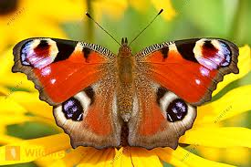
The formal balance in dress designing is achieved if the design has on both sides the same objects. It is like a mirror image. Here is an example of formal balance in dress designing and in nature:

Here are examples which show the difference between formal balance and informal balance. Formal balance: on both sides the same, informal balance: on both sides not the same but always still in balance.

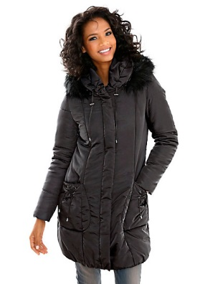
II. How can harmony be created in a design?
Harmony in a design is the result of good designing. Harmony can be created in a design if the principles and elements are used effectively and accordingly to each other. To achieve harmony in design means that all aspects for a good design, for example size, gender, climate, age, personality of the wearer etc. are well considered, and the result is that the garment will fit well to the wearer, the wearer feels comfortable in it – to make it short; the garment is perfectly for the wearer and the wearer will be happy with it so long how possible. The important aspects are
Function, decoration and structure which must be in accordance with each other to achieve harmony in a design.

III. What is the relationship between the principles and elements in a design?
The guidelines for the elements of design (line, shape, form, color and texture) are the principles of design (emphasis, rhythm, balance, harmony and proportion). The principles of design say how the elements of design are to be used. That is the relationship between the principles and elements of design. Let as make an example; the principles of design are like the scissor and the needle, and the elements of design are like the yarn and fabric. The scissor make the decision which form the fabric becomes and the needle make the decision where the yarn holts the fabric together.

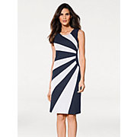
IV. Describe at least three ways for creating rhythm in dress designing.
There are some ways to create rhythm in dress designing. One way to create rhythm in dress designing is through radiation. This is created by lines, folds, tucks, darts, gathers and pleats which originate from a central point as an organized movement, like on the picture.

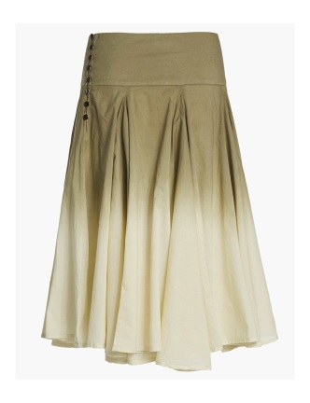
Another way to create rhythm in dress designing is through progression (gradation). This is created by degrease or increase of design elements. There is an example from a skirt with rhythm created by progression.

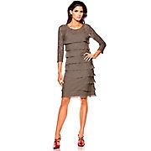
Rhythm is also created by repetition or regular repeats of design elements.
Here is an example from a garment with rhythm through repetition.

2. What are the principles of design? How do they help a designer analyze the effectiveness of a design?
The principles of design are balance, rhythm, harmony, emphasis and proportion. The guidelines for the elements of design are the principles of design.
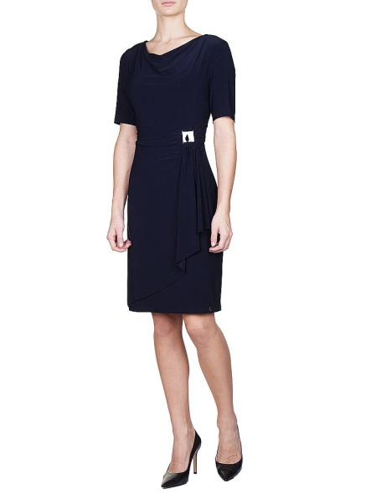
Principles of design are helping tools in the design process to create an attractive design for a successful garment. When the elements of design are well arranged -guided by the principles of design - the designed garment will be beautiful and pleasing to the eye. Other ways, if a design is not so successful and not pleasing to the eye and gives a feeling of disorder, the principles of design can help to analyze the design and to discover the mistake in the design and bring it in to the right order. On this way the design principles can make a design successful, or an unsuccessful design to a successful design.

Activity
This beautiful dress as this kinds of lines: straight lines – vertical and diagonal but also horizontal lines, full curve and
restrained curve.
The Silhouette from the dress is also good.
It has the shape H or also named as rectangle but it has also a slight X shape or also named as hourglass-shape.
Color : Oxford blue
Texture- fabric patterns and trims: a soft falling fabric without trims.
Balance: informal balance
Proportion: good
Rhythm: through transition
Emphasis: the point of emphasis – the center of interest is on the left side of the waist.

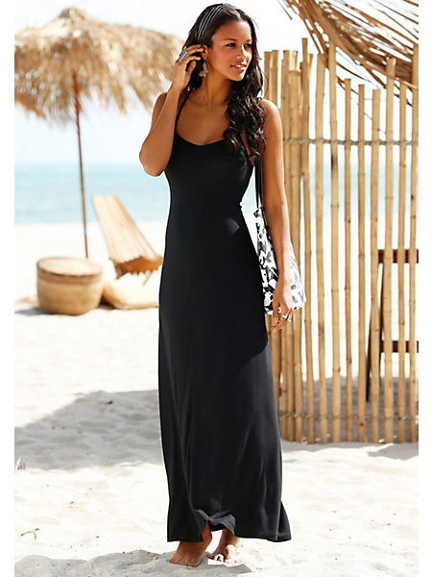
Somehow this dress is very beautiful. It is so pleasant to the eye and the point of emphasis – the center of interest, is the face! It has also a slight rhythm in it through transition. The proportion is also well. It is well in balance – in the type of formal balance. A very simply dress without any trims, the texture is fine and the fabric is soft falling. Midnight blue or Oxford blue might be the color which makes the dress noble. Rectangle or also called as H shape is the shape of the dress there might be also a slight X or hour glass shape in it.
The lines are restrained curves.

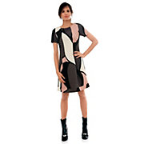
Here is a dress which is somehow not so pleasant to the eye and gives a feeling of disorder and disharmony. It has this kind of lines: straight lines and restrained curves.
The shape of this dress is rectangle/H.
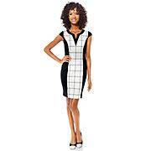
The colors are black, white, grew and pink which are a well composition. Somehow I cannot really say if there is a balance but it might be an informal balance. Emphasis: the center of interest is the white form in the middle of the dress and also the pink one near the shoulder. That is irritating! The patterns of the dress are too big and there is no order! The viewer has difficulties to look into the face because the patterns are so irritating. The fabric is stiff.

On this dress the point of emphasis is on the neckline. It is well in balance, in formal balance. The colors are black and white. The shape of the dress is oval. The fabric is not very soft but also not so stiff. Lines are: straight lines - horizontal, vertical and also diagonal; restrained curves.
The problem on this design is that trims are to big which gives a feeling of lost unit and it is very difficult for the viewer to look into the face of the wearer, maybe the contrast is to strong.

Picture references:
Question number: 1.; I. www.heine.at , www.wildlife-media.at , IV. www.heine.at , www.bevonboch.com , www.heine.at
Activity: 1. Picture www.kastner-oehler.at, 2.,3.,4. Picture www.heine.at

Student Statement:

By submitting this assignment, I confirm that this is my own work.

Student Signature | Rebekka Annika Schendel | Date | 09.09.2016

For Tutor / Assessor Use Only
Total Marks
Marks Obtained
Percentage / Grade

