
Assignment Cover Sheet

Student Name: | Sharron Fox
Student Number: | 3789
Course: | Logistics in Supply Chain Management
Assignment NO: | Two

Marking Criteria:
We expect the learners to write minimum one well expressed point in three lines against each allocated mark. This means one needs to write 15 lines with 5 well expressed points to get high grades for a 5 marks question.
For high grades use examples and illustrations where appropriate.
Assignment #2
- Activities involved in logistics :
1)Customer order
2)Demand Forecasting / Planning
3)Inventory Production
4)Warehousing and storage
5)Order Processed
6)Packing and shipping
7)Carrier – Despatch
ii) Cross Docking :
Stock is delivered and warehoused at a large separate location, which may or may not be part of the same company it may be a sub contractor warehouse.. The warehouse is then used to accept multiple large deliveries from various suppliers, received and unloaded then broken down into relevant SKU’s of smaller required quantities. The stock is then packed and onward shipped to locations in smaller required quantities.
- Main aim of logistics:
The goal of logistics is to get things from point A to B in a timely, efficient, cost effective manner. Taking into account the requirements of the manufacturer / supplier and the end user

- Activities included in Stock control Procedures :

Stock control is managing all product in stock and requirements at a given time. This can be effected by Seasonal stock requirements, Safety stock and Cycle stock, always remembering that all stock on the shelves has a cost effect to the company. Decisions need to be made to understand what stock is to be held, how much stock, which stock control method is required per SKU, having a stock control system (Manual and computerized) to understand the stock being held / requirements, quality of the stock.
- Importance of communication in a supply chain :
It is important for accurate supply chain communication, if the correct information is not relayed this could result in having the wrong SKU’s in stock, tying up cash flow, ultimately effecting the delivery to the customer and potentially future business.
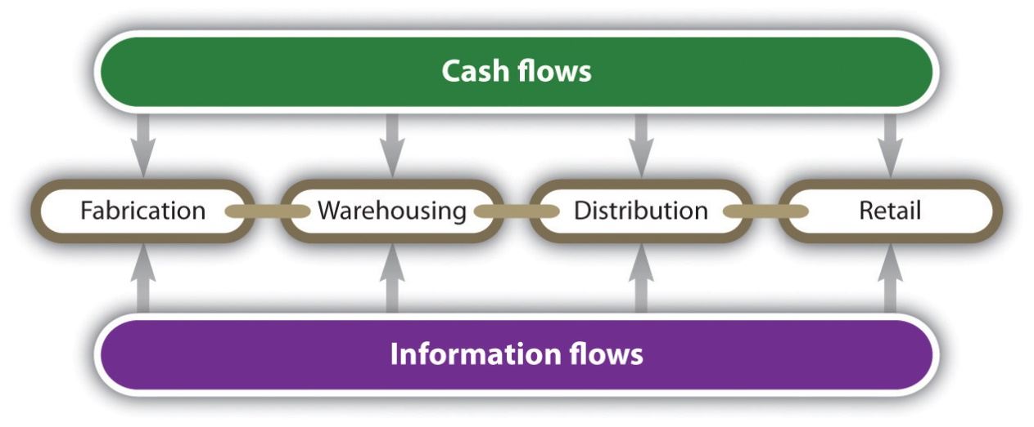

- Logistic activities organised in different size organisations :
Logistics in a small size company ie a farm could be as simple as harvesting the produce and placing in their own farm store, medium size company may have many more steps through the production to logistic and a large size company may have more in depth supply chain for production and more ways to market through retailers and distribution. The steps in the supply chain tend to be dictated by the product being produced rather than size of the organization.

- Logistics effect the price of the product :
The more steps involved in the logistics process, all have a cost associated that will impact the ultimate production cost of the product, whether these steps are internal or external sourced. The volume being produced will also have an impact on the initial production costs, generally being produced in larger quantities makes the product more economical as the production set ups are the bulk of the cost, then it is just run costs in addition making the unit cost per unit less than a smaller production. Purchasing raw materials in bulk can reduce the produce production cost for example. Logistics is about obtaining economic costs by knowledge and communication.

2) Logistics are essential for every organization :

Regardless of the business size, logistics can help the efficiency of the supply chain in reducing costs where appropriate, avoiding waste of time and materials. Logistics is very important within a company and works closely with supply chain, working together they make the business seamless

3) Logistics improve on issues related to environmental protection :
Carbon footprint :- Transit logistics, considering the best method of stock movement, alternatives to cars are available such as rail or water. Planning shipment release may be an option to ship in one shipment rather than multiple shipments. For example, if your business is making and receiving deliveries to and from a warehouse, it might make sense to have one central distribution centre. This could be cost-effective and has less environmental impact than a dispersed distribution system.
Packaging :- Considering alternatives to boxing items to reduce environmental waste, use biodegradable shrink wrap or equivalent for example, May also be a more cost effective option to a standard box.
Production and warehouse recycling.

Case Study :
- The departments are endeavoring to save ultimate base / production costs on buying in bulk quantities that will be used within a period of time, unfortunately due to low order bulk this is then tying up funds needed to pay bills.
- It does not sound like they have a Sales & Order Procedure, sales / marketing staff are not reporting back their order expectations, which would then allow production / purchasing to plan / purchase accordingly. Purchase appear to be being arranged against previous annual demand rather than real up to date information and possibly seasonal orders.
- I would recommend Chris puts procedures in place which captures real life next three months requirements whilst funds are tight, put restraints in place for a second authorization before purchases can be made. Regular meetings with his sales and marketing team to understand the latest market requirements.

Student Statement:

By submitting this assignment, I confirm that this is my own work.

Student Signature |  | Date
For Tutor / Assessor Use Only
Total Marks
Marks Obtained
Percentage / Grade

