
Assignment Cover Sheet

Student Name: | Rebekka Annika Schendel
Student Number: | 1391
Course: | Elements of Design
Assignment NO: | Unit 5

Marking Criteria:
We expect the learners to write minimum one well expressed point in three lines against each allocated mark. This means one needs to write 15 lines with 5 well expressed points to get high grades for a 5 marks question.
For high grades use examples and illustrations where appropriate.
1. Give short answers for the following questions:

I. What is meant by ‘weight and hand’ in textile industry ?

Weight and hand means in the textile industry the characteristics of texture. Texture is the appearance of fabric. Light weight, medium weight and heavy weight are three dimensions which can be used to describe the Texture.
With hand is meant how the texture feels, for example: soft or stiff, rough or smooth etc.
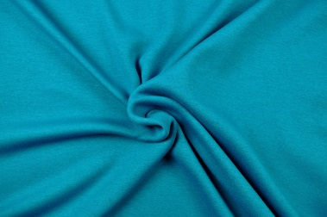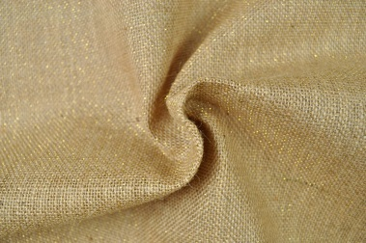

The aspect of ‘weight and hand’ is in textile industry very important. Because it has an effect on the color of the fabric and the physical proportion.

II. Name the warm colors. How best these can used in dress designing?

The warm colors are red, orange and yellow. Warm colors are lively, friendly, romantic, stimulating and optimistic but also aggressive, dangerous and fiery.


The warm colors are best used in dress designing for evening wear, sportswear and clothes for security.
Some winter clothes are often in red in combination with white or black. But it can be used for more, if the intensity is not so strong. Warm colors draw always attention particularly with high intensity.

III. Why it is important for a designer to consider the scale of a pattern, when using patterned fabric in dress designing?

When using patterned fabric in dress designing, it is very important for a designer to consider the scale of a pattern. The design must be complemented from the scale of a pattern.

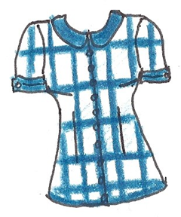
The print these blouse is too
large and strong, it dominate
the design.

The print of these blouse
complement the design.

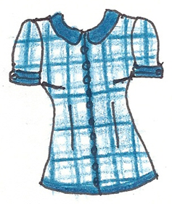
It is also very important that the print will not cut up by dominating lines, seams and details. Otherwise the fabric has to be plain and unimportant if the design idea has dominating lines, seams and details.

VI. What is the difference between conventional design and geometric design?

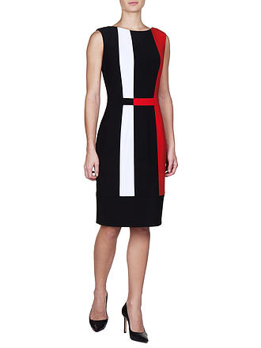
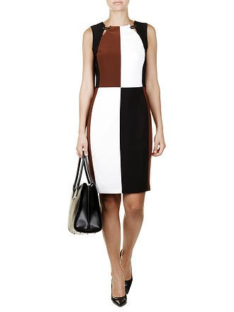
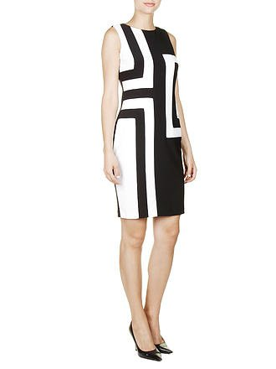
The difference between conventional design and geometrical design are those: conventional design takes the inspiration from nature and geometric design takes the inspiration from geometric objects like circles, triangles, rectangles etc.

Here are
three examples from dresses
in geometric
design:

Here are three examples from clothes in conventional design:
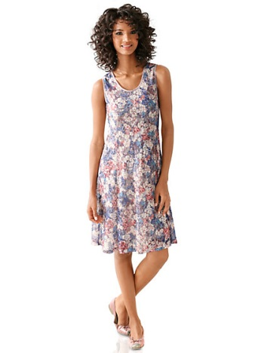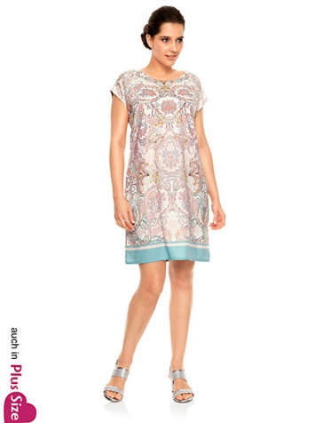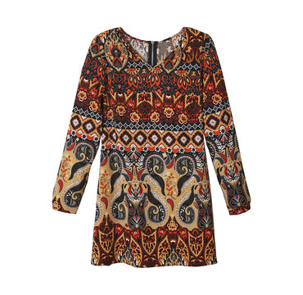

Conventional designs take the inspiration from nature and arrange it to decorate the design.

2. Define the term color dimension. Explain the following terms; Hue, value, intensity.

Hue, value and intensity are three dimensions of color.
Hue means that we can distinguish one color from the other, for example yellow from green etc.

With value is meant the lightness or darkness from a color.

Darkness = black darker values = shades value scale lighter values = tints lightness = white

Black and white are not really colors, they are only pure light or the total absence of light. Pure white against pure black is the strongest value contrast.
Every garment has values - every object which is three dimensional.

Intensity is the strength or weakness of a color. Strong colors (colors with high -intensity) are also called as bright colors and weak colors (colors with low-intensity)
are also called as pale colors.

3. Write short note on the following; basic shapes in dress designing

There are seven basic shapes in dress designing: Hourglass, triangle, oval, round, inverted triangle, square and rectangle.
There are also combinations. The basic shapes can be also categorized in X, A, O, V, H, I, 0.
Here are some examples of shapes in clothes:
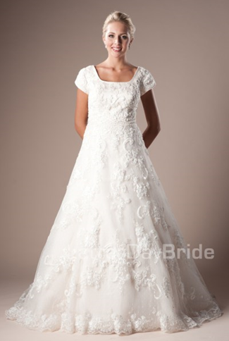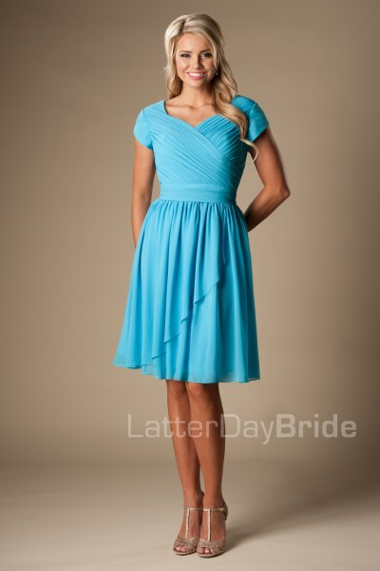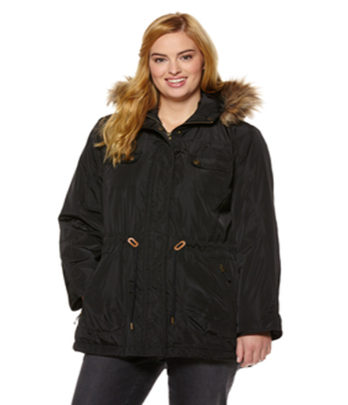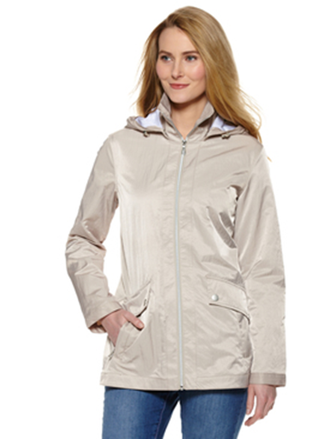

Project:
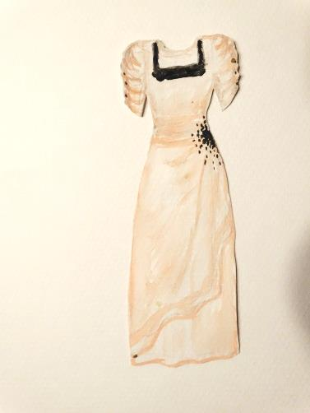
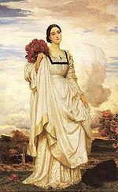
Dress in 1879

becomes a

bridesmaid dress

of

2016 !?

Picture reference:
Question 1: I.: www.stoffmeile.at; II.: www.berufsbekleidung-stuttgart.de ; VI.: www.kastner-oehler.at, www.nkd.com; www.heine.at;
Question 3: www.latterdaybride.com; www.charles-voegele.at;
Project: www.wikipedia.org , 1870s in Western fashion

Student Statement:

By submitting this assignment, I confirm that this is my own work.

Student Signature | Rebekka Annika Schendel | Date | 28.08.2016

For Tutor / Assessor Use Only
Total Marks
Marks Obtained
Percentage / Grade

