
Assignment Cover Sheet

Student Name: | Raymond Wilson
Student Number: | 2362
Course: | Diploma in Logistics and Supply Chain Management
Assignment No: | 8
Marking Criteria:
We expect the learners to write minimum one well expressed point in three lines against each allocated mark. This means one needs to write 15 lines with 5 well expressed points to get high grades for a 5 marks question.
For high grades use examples and illustrations where appropriate.
Assessment #8 Inventory Management Total Marks: 30

1. Give short answers for the following questions: (15)

- What is Inventory Management?
Inventory management is the practice of efficiently controlling the constant flow of units in and out of an existing inventory. This process typically involves controlling the transfer in of units in order to avoid the inventory from becoming too high, or the reduction to levels that could put the operation of the company into difficulty. Competent inventory management also seeks to regulate the costs associated with the inventory, both from the viewpoint of the total value of the goods included and the tax burden generated by the amassed value of the inventory.
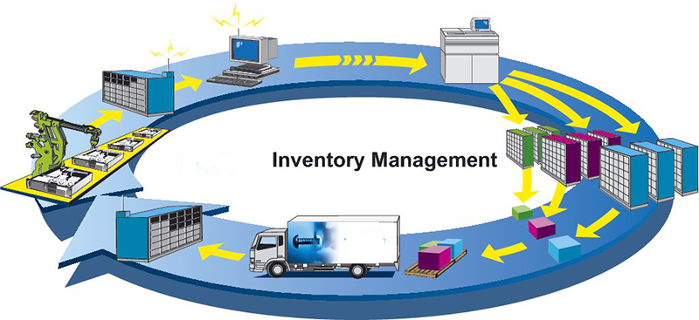
Balancing the various responsibilities of inventory management means paying attention to four key aspects of any inventory;
- The first phase has to do with time. In terms of materials acquired for inclusion in the overall inventory, this means understanding how long it takes for a supplier to process an order and execute a delivery.
- Inventory management also demands that a firm understanding of how long it will take for those materials to transfer out of the inventory be established.
- Knowing these two important lead times (as detailed in 1 & 2 above) makes it possible to know when to place an order and how many units must be ordered to keep production running smoothly.
- Calculating buffer stock needs is also key to effective inventory management. Essentially, buffer stock is additional units above and beyond the minimum number required to maintain production levels.
Inventory management is not just limited to documenting the delivery of raw materials and the movement of those materials into operational process. The movement of those materials as they go through the various stages of the operation is also important.
Finally, inventory management also includes keeping accurate records of finished goods that are ready for shipment. This often means adding the production of newly completed goods to the inventory totals as well as subtracting the most recent shipments of finished goods to buyers.

- What is the purpose of keeping stocks in a supply chain?

The purpose of stock control is to make certain that a business always has sufficient stocks to meet its own needs and those of its consumers. It also needs, however, to ensure the minimum amount of stock is held so as to avoid damage and waste, and to minimize the cost of holding stock.

Having too high or too low a stock is detrimental. High stocks represent money lying idle when it could be put to better use, whereas low stocks could result in not being able to take on new and meet existing orders. The illustration below highlights some of the reasons for carrying stock;

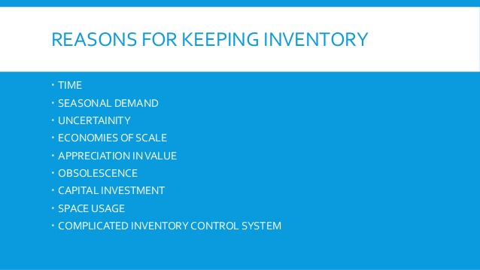
Buffer stocks can be built up as a preventative measure against running out of stocks due to unexpected variations in demand. A minimum level will normally be set, below which it will be expected that stocks will not fall though this may depend upon the lead-time between placing an order and its receipt, therefore making the company vulnerable to outside sources beyond their control.

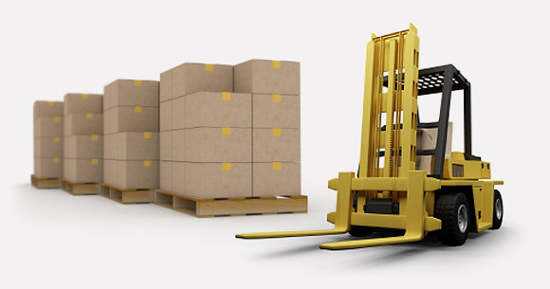
It is important that companies maintain stock based on the following criteria;

- Maximum stock: The most stock that the firm is willing or able to hold.
- Minimum stock: This is the stock below which it is felt to be unsafe for the firm to operate.
- Re-order level: The point at which the firm will re-order stock.
- Re-order quantity: This is the number of new items that will be bought in when stocks fall to the re-order level.

iii. What is a reorder cost?

Around the world reorder cost can be defined as the overall expense involved in repeating an external supply order.

It may also include order the following related costs;

- Preparation
- Communications
- Transportation
- Receiving
- Inspection/quality control
- administration
- overheads
- and other miscellaneous costs.
In reality, the best guesstimate for a reorder cost usually comes from dividing the annual cost of the purchasing department by the number of orders sent out.
The reorder cost is clearly linked to the reorder point and that time period can be a week, a month, or a year and an all-inclusive cost needs to be determined;.
Here’s the formula for that reorder point;
- Reorder point = number of units sold per unit of time x order lead time



An example of this is as follows;
A large hardware store needs to replenish one of its products, a standard size wood chisel. The unit of time is determined as one week. The weekly turnover level is 70 chisels and the purchase order lead time is three weeks. Here is the required reorder point for the chisels:
- Reorder point = 70 units x 3 weeks
- Reorder point = 210 units

When the inventory level falls to 210 units, an order is made for more chisels which is directly associated with the replacement or reorder costs.

iv. Define the holding cost.

In business management the term “holding cost” is money spent to keep and maintain a stock of goods in storage. Of these costs the most obvious will include;
- rent for the required space (and labor to operate the space)
- equipment
- supplies
- insurances, security
- interest on money invested in the inventory and space, and other direct expenses.
Holding costs (part of a suite of operating costs as illustrated below) are the additional costs involved in storing and maintaining a piece of inventory over the course of a year. Holding costs are computed in the economic order quantity calculation that businesses use in order to decide the optimal time to order new inventory.
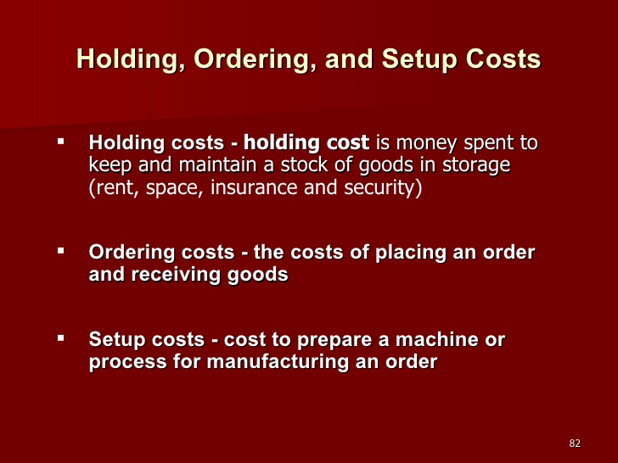
The holding costs concept is pretty simple. Businesses have to stock inventory that isn't in use or on the showroom floor. So if a firm orders too much of a product, the extra inventory has to be put in the back warehouse until it can be put out on the shelves/floor space for customers to buy. This means not only do companies have to pay for the warehouse storage space, but they also have to pay for security, insurance, maintenance and protection of the inventory. For instance, the warehouse could be broken into or, even worse, employees could steal inventory from a unsystematic storage room. All of these costs are considered holding costs.
It is worth noting however that some stored goods have a “shelf life” and become obsolete before they are sold, reducing their contribution to revenue while having no effect on their holding cost. Inevitably some goods will be damaged by handling, weather, or other mechanisms and some goods are lost through mishandling, poor record keeping, theft and even shrinkage of product.
- What does the procurement department do in a supply chain?

In today’s environment the procurement function is currently receiving increased attention as an important contributor to the overall strategic success of an enterprise.
Procurement’s contributions to corporate strategic planning in the supply chain process include, but are not limited to, the following;
- Monitoring supply market trends
- Interpreting the impact of these trends on the firm
- Identifying the materials and services required to support company and strategic business unit strategies
- Developing supply options
- Disaster recovery planning
- Supplier monitoring and measurement

- 
- Procurement also plays a key role in supply chain management through its integration with production, scheduling, logistics, sales, and accounting/ finance.
Of course procurement does not only play a key role with other departments it is vital for them to operate. Clearly the right type of material needs to be specified and ordered on time so that the production line can make and through logistics the goods are then distributed, sold and make the necessary profit for the entity to function and although the caption above is amusing in reality procurement relies on the other departments for information to ensure they can service the whole SCM process effectively

2. Discuss the main reasons for keeping the stocks. (7)

Too much inventory or not enough inventory causes both financial and operational impacts to any business as well as effecting future business opportunities. Inventory holding is used by organizations as hedge against various external and internal factors, as precaution, as opportunity, as a need and for speculative purposes.
Most companies will have material inventory warehouses attached to the production facilities where raw materials, consumables and packing materials are stored and issued for production. The reasons for holding inventories can obviously vary from a case to case basis but are summarized as follow;

Meet variation in Production Demand
Production plans need to evolve in response to the sales, estimates, orders and stocking patterns. Accordingly the demand for raw material supply for production varies with the product plan in terms of specific stock keeping units (SKU) as well as batch quantities.
Holding the necessary stocks at a nearby warehouse helps issue the required quantity and item to the production line just in time.

Cater to Cyclical and Seasonal Demand
Market demand and associated supplies are often recurring and depend upon various factors like seasons; festivals etc. and past sales data will help companies to anticipate any surges of demand in the market well in advance. Clearly they will need to stock up with the required materials and hold inventories to be able to increase production and rush supplies to the market to meet these increased demand periods.

Economies of Scale in Procurement
Buying raw or production materials in larger lots and holding inventory is normally found to be cheaper for the company than buying frequent small lots. In such cases the company buys in bulk and holds inventories at nearby warehouse facilities.

Take advantage of Price Increase and Quantity Discounts
Price increase and decreases can be expected during the course of the year due to changes in demand and supply in the national or international market, impact of taxes and budgets etc., company’s therefore tend to buy raw materials in advance of these foreseeable evets and hold stocks as a hedge against increased costs.
Companies will also buy in bulk at appropriate times when quantity discounts are offered by the supplier. In such cases the savings on account of the discount enjoyed would be substantially higher that of inventory carrying cost.
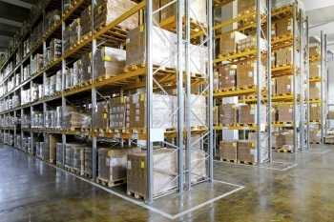

Reduce Transit Cost and Transit Times
Raw materials are often imported from overseas or from a remote location supplier within the country, and a company can save a lot in terms of transportation cost buy buying in bulk and transporting as a container load or a full truck load as obviously part shipments will be normally costlier.
In terms of transit time too, shipping a full container or a full truck load is direct and faster unlike part shipment load where the freight forwarder waits for other loads to fill the container and he may drop them off to others prior to your needs and this can take several days or weeks.
There could be a lot of factors resulting in shipping delays and transportation too, which can hamper the supply chain forcing companies to hold safety stock of raw material inventories.

Long Lead and High demand items need to be held in Inventory
Depending on the company’s business sphere of operations some raw material supplies from vendors have long lead times often running into several months. Coupled with this if the particular item is in high demand and short supply one can expect disruption of supplies. In such cases it is safer to hold inventories and have more control of your needs.
The bottom line is that by holding managed stock/inventories companies remain independent and free from vendor and other outside dependencies.

3. Discuss, in detail, the costs involved in keeping the stocks. (8)

Inventory stock procurement, storage and management are normally associated with huge costs for each the following functions;

Ordering Cost
Th The cost of procurement and inbound logistics form a major part of ordering costs. Ordering cost are therefore dependent and suspect to fluctuations based on two factors - The cost of ordering excess and the cost of ordering too less.
Both These factors are directly opposite of each other whereas ordering excess quantity will result in carrying cost of inventory. Whereas ordering less will result in increase of replenishment cost and ordering costs.
Co Collectively these costs are called Total Stocking Cost. If a plan is developed to determine the order quantity vs the TSC, a graph can be made which shows the quantities gradually declining until a certain point after which with every increase in quantity the TSC will proportionately show an increase. This practical analysis and the associated cost implications form the basis of defining the Inventory Procurement decision by answering the two basic fundamental questions - How Much to be Ordered and When.

Carrying Cost
Carrying cost is the expense associated with holding inventory over a period of time. In other words, it’s the cost of possessing, storing, and keeping inventory to be later sold on to customers.
For the purposes of managerial accounting, there are many different costs associated with inventory beyond its actual cost and this is one of the biggest reasons why stores normally want to sell their inventory within 90 days of buying it. It costs money to stock and maintain goods before they are sold to customers.
The various carrying costs of inventory are as follows:
- Interest cost of the foregone funds invested in inventory
- Losses due to obsolete inventory
- Losses due to damaged inventory
- Losses due to stolen inventory
- Insurance on the warehouse area
- Depreciation on the warehouse and the storage systems within it
- Compensation and benefits for those employees charged with operating the warehouse area
- Cost of the pallets and other containers used to store inventory
- Cost of warehouse fire suppression systems
- Cost of utilities for the warehouse
- Taxes on the value of the inventory
The carrying cost of inventory can easily add up to 25% of the value of the inventory.
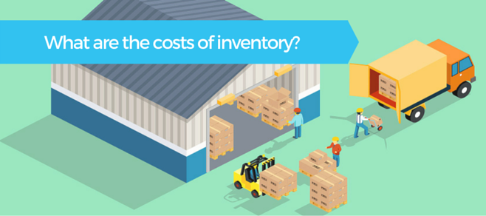

Shortage or stock out Cost & Cost of Replenishment
Stock-out costs is the price associated with the depletion of the inventory to such a state that additional costs are incurred. The exhaustion of inventory could be a result of various factors, the most notable amongst them being defective shelf replenishment practices.

Stock-outs can prove to be very costly for companies. The potential fallout for stockholders could be postponement of a purchase or even worse whereas the consumers may get frustrated and switch stores or even purchase substitute items (brands). Stock-outs could occur at any time with the supply chain process. Numerous retailers will therefore follow the concept of “Safety Stock” in order to avoid the situation of stock-outs
Regular audits of the inventory therefore need to be carried out to check for the potential frequency of stock-outs of different items. Advanced modelling tools and frameworks are nowadays used to determine the economic order quantities that will minimize the stock out and also the inventory carrying cost.
Replenishment (or top up) is the movement of inventory from reserve product storage locations to the main storage, picking and shipment locations. The purpose of replenishment is to keep inventory flowing through the supply chain by maintaining efficient order and line item fill rates. The process helps prevent costly inventory overstocking.

Cost of Loss, pilferage, shrinkage and obsolescence etc.
Inventory shrinkage is the main term used to describe the loss of stored stock. Simply, if a company’s inventory records report that 1,000 units of breakfast cereal are on hand, but a physical count indicates that there are only 990 units on hand, there is an inventory shrinkage of 10 units. The retailer's inventory shrinkage might be due to shoplifting, employee theft, damage, uselessness, etc.
The shrinkage term is also used by manufacturers when referring to the loss of raw materials during a production process. A prime example is a producer of baked food items as they will experience shrinkage throughout its processes due to ingredients adhering to the mixing apparatus, due to evaporation and clearly the baking process itself. This shrinkage is also known as spoilage or waste and it can be either normal or abnormal.

This cost is dependent on the percentage of shrinkage and can vary significantly between operating entities.

Cost of Logistics
Some companies manufacture products that rely on the use of raw goods from other countries, while others choose to locate their entire product manufacturing plants overseas. Prime driver for keeping production costs low by producing or sourcing raw goods in other countries allows companies to make more profit, but the logistical costs of transporting and storing products can eat into those profits quite quickly and is dependent on many variables. Business owners can benefit from understanding logistics, and the detailed costs involved, to maximize their margins and minimize costs.

Sales Discounts, Volume discounts and other related costs.
Discounts, loyalty offers and bulk buy pricing is common business practice and can help a company to move stock, attract new customers, or reach sales targets during slow sales period.
Before a company considers cutting its retail sales price in half (as illustrated below) in the hope of drumming up sales, it's good to develop a plan to make sure you're still making a profit for the extra orders coming in. It is important to know and consider the following;

- your current profit margin, markup and breakeven point
- calculate the best discount price that can be offered whilst still making a suitable profit
- decide how long the sales price will be offered
- prepare a marketing plan to encourage new customers and bring inactive customers back
- do research and find out what deals your competitors are offering and their current pricing range for similar products
- review other choices for promoting sales offers without the need to reduce prices
- regularly review your accounts weekly, monthly and annually if the business has a sales dip and adjust prices accordingly.

All of the above are important aspects of keeping, moving and selling of stock and all have a cost impact that needs to be managed and allowed for.

Student Statement:

By submitting this assignment, I confirm that this is my own work.

Student Signature | Raymond Wilson | Date | 31st Oct 2016

For Tutor / Assessor Use Only
Total Marks
Marks Obtained
Percentage / Grade

