
Assignment Cover Sheet

Student Name: | Hissourou Aboubakar
Student Number:
Course: | Creating The Sales Plan
Assignment NO: | Unit -4

Marking Criteria:
We expect the learners to write minimum one well expressed point in three lines against each allocated mark. This means one needs to write 15 lines with 5 well expressed points to get high grades for a 5 marks question.
For high grades use examples and illustrations where appropriate.
Answer the following questions?

1. How to build your sales force? Discuss with detail? (10)

2. How to work sales cycle? Discuss. (10)

- How to build your sales force? Discuss with detail?

Answer,

Building Your Sales Force
When it comes to your sales force, you have the same things to consider as with each other area of your
Business. Do you hire specialists (people with a proven track record in sales), or people who have
Product knowledge, but less sales experience? Are you currently the manager and sales leader, or do you
need someone in that role?.

2. How to work sales cycle? Discuss.

Answer,

The Sales Cycle
We speak about sales in terms of cycles to help us organize our activities and keep focused. Here is a
look at the basic sales cycle:

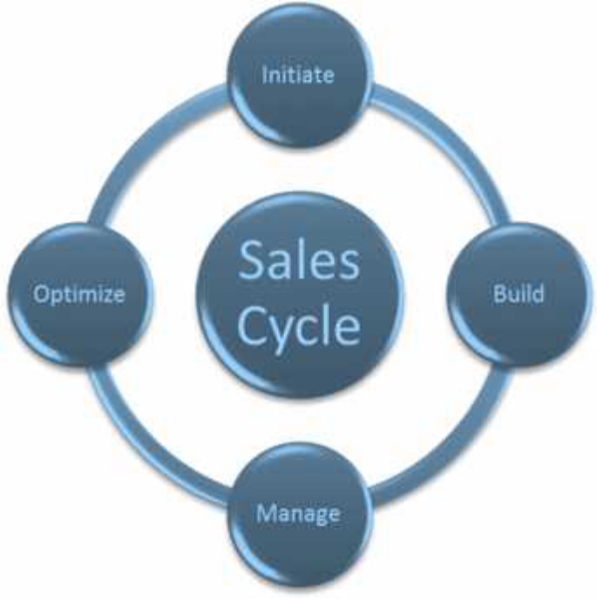
Initiate
The first stage of the cycling is finding new opportunities and establishing relationships that focus on
Identifying and solving client needs. These relationships can evolve in many ways.
The easiest sales are with customers that you already know or have already bought from you. In order to
keep your pipeline full, however, it’s important to attract a variety of customers from different industries
Or types of businesses. That way, if there is an economic slowdown, a business shutdown, or a natural
Disaster, your potential to sell is not so strongly affected.
These days, it is common for salespeople to get involved in a range of networking activities that may not
seem directly related to one particular sale, but they are a help in getting established within a network or
Community.
Many top salespeople learned a tremendous amount about sales by cold calling, and there are lots of
Salespeople who make all of their sales strictly over the phone. Phone sales often mean that the
Salesperson is taking incoming calls from inquiring clients. This means that they do not have to find
Clients, but they do have to qualify those clients within a phone call.

Build
This is where you convert opportunities into clients by building trust and credibility.
Once you meet your client, you begin building your relationship with them. These relationships are
Based on trust. As you build the relationship, you will investigate your potential client’s problems, get a
solid understanding of their situation, pre-qualify them as a buyer, and consider how you will make your
Presentation to them in a dynamic way. Remember that your presentation has to appeal to them from
Their point of view, and that customer focused selling is a consultative process.

Manage
The next stage is managing the relationship and focusing on serving your customers by offering
Solutions, resolving problems, meeting their needs, and getting their agreement to buy.
In this part of the sales cycle, you will make your presentation, considering all aspect of your client’s
Needs and the benefits of your solution. You will also ask them to make a buying decision and work
Through any objections that they have.
Another thing that a sales professional must work with is what makes their company, product, and/or
Service unique. This is called your Unique Selling Point (or Position) – the USP for short. Make sure that
You can answer your prospects when they ask why you are in the best position to provide this solution.
Our customers are experiencing information overload much of the time, so the amount of attention that
They will give you is limited. If you send them a written proposal, expect that they will scan it very
Quickly. This means that your headings and text need to be short and to the point. During an in person or
telephone presentation, watch and listen for cues that you have their attention and are answering their
Questions. Adjust your approach as necessary to keep them engaged.

Optimize
In the last phase of the cycle, we grow the relationship with consistent results and problem solving. This
is the time to set up long term relationships through additional problem solving, business building, and
Referrals.
This is also the aspect of the sales cycle that you will use to help top up your pipeline. Even if your
prospect says “no,” that does not mean that they will never do business with you, or that they don’t
Trust you. Sometimes it means that they need more time to consider your offer, or that there is some
Very real barrier they have to deal with. Instead of thinking that “no” is the end of your relationship, you
Can continue to build the relationship. For example, you can ask the client for referrals.
The other aspect to consider at this stage of the sales cycle is whether there are other opportunities to
Work with the same organization. Can you build on the relationship that you have developed and help
Other departments, locations, and people within the same company? If you have not been introduced to
Those opportunities through the sales cycle, ask.
The final phase of optimizing is to evaluate what you have done throughout this sale. What have you
Learned? What can you do better or differently next time in order to reach a more successful result?

Student Statement:

By submitting this assignment, I confirm that this is my own work.

Student Signature | Hissourou Aboubakar | Date | 06/01/2017

For Tutor / Assessor Use Only
Total Marks
Marks Obtained
Percentage / Grade

