
Assignment Cover Sheet

Student Name: | Saleema Choudrey
Student Number: | 1240
Course: | Fashion Designing
Assignment NO: | Unit 14

surface decorations

unit 14

Question 1.
Multiple choice.
- Shaping
- To finish and decorate the garment
- Braided trims are made by interfacing three or more yarns to form a flat narrow fabric.
- A layer of garment is placed between the garment fabric and its facing.
- The interfacing should be neither heavier nor lighter than the actual garment.
- Three broad classes

2. Write short notes on the followings.
Pockets
A small bag sewn to garment for personal use. Like putting coins, cards, money etc. which should not come in the way of a garment pattern or be too big. The procedure of inserting a pocket is divided in three broad classes.
- The patch principle
- The inset principle
- The through principle
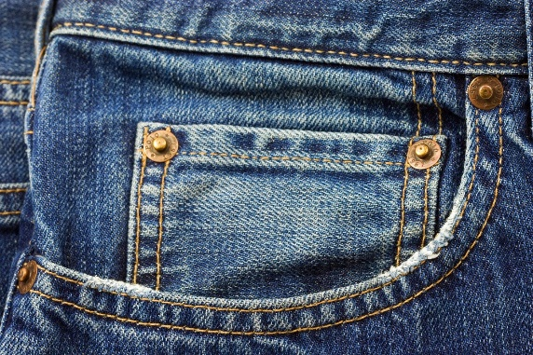
(Adapted from: http://www.politicalmetaphors.com/)
Belts
A belt is a flexible band/strap make of vinyl, leather or any other fabric to wear on jeans or dresses. Or it can be used to hold on things on the waist. There are two kind of belts.
- Track trade ,which is sold to retailers
- Cut-up trade, which are cheaper belts sold to manufacturers.
Garment belts are made of cheaper materials. Such as vinyl, bonded leather or ribbon. They easily can be stitched or glued to the garment. Stitched stays stronger for a longer time. Novelty belt can be made of any type of fabric just to create the look the person wants.
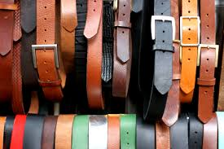
(Adapted from:https://onlineshoppingclothesnsw.wordpress.com/2015/08/31/menaes-leather-belts-can-be-purchased-online/)
Care labels
Care labels give information about washing and taking care of the garment. It’s a white square label attached to the garment. The label can also tell a lot about the designer or company from which the garment belongs to. Because of the label customers buy clothes of that company/designer. The manufacturer must give the following information on the label.
- Showing fiber content
- Care instructions
- Country of origin
This information should be included next to the designer’s/ manufacturers label. Labels are made of satin and are usually attached to the neck or the side of the garment.

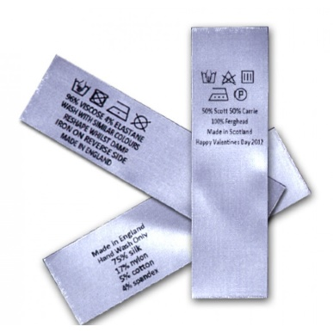
(Adapted from: http://www.wovenlabelsuk.com/garment-labels/wl-05a.html)

3. Explain the following terms as discussed in the module

Applique
Applique is a design which can be applied on top of fabric for decoration. The edges can be sewn by hand or by machine.
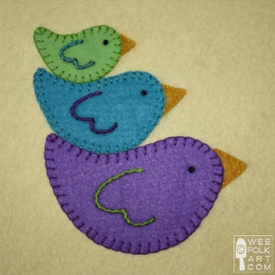

Banding
Banding is a small decorative fabric that gives edges a finishing touch. Or used for decorative designing.
Beading
Beading is an openwork trimming. Embroidery or lace used for evening wear to trim the edges. The lace itself could be decorated with beads to give it a sparkly look.
Galloon
Galloon is a emroided lace used to trim edges, and decorate at the same time. It can be used as a see-through design as well.
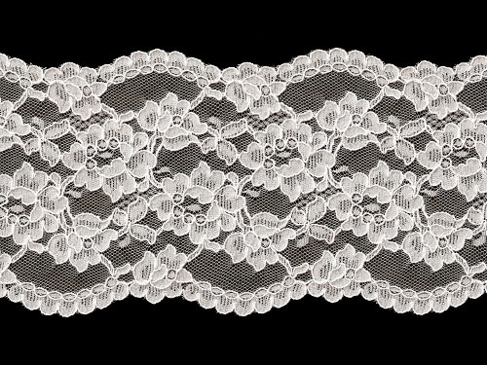
Medallions
Motif designs sewn together in one chain. Used as a lace at the edge of a garment or on top. Individual Motifs can be used as a single design to decorate a garment.

Reference:
www.burdastyle.com
www.pinterest.com
www.pinkvilla.com

Student Statement:

By submitting this assignment, I confirm that this is my own work.

Student Signature | ss.choudrey | Date | 15/04/2016

For Tutor / Assessor Use Only
Total Marks
Marks Obtained
Percentage / Grade

