

Assignment Cover Sheet

Student Name: | Hiyam Daou
Student Number: | 2320
Course: | Diploma in Diet & Nutrition
Assignment NO: | 1

Question 1
Multiple Choice Question: please note the correct answers are in red.

- Nutrition is the process of consuming absorbing and;
- Strong nutrient
- using nutrients
- losing nutrients

- proteins are involved in;
- a range of biochemical reactions
- maintaining ionic balance in the body
- growth repair and general maintaining of the body

- vitamin is important for;
- a range of biochemical reactions
- providing energy to the body
- growth and repair of the body

vi. an) an excess of only 200 calories per day for 10 days is likely to result in weight gain
of nearly;
- 0.5 pounds
- 1 pound
- 2 pounds
- one Kale is approximately

- 5.2 KJ
- 4.2 KJ
- 6.2 KJ

VI. people maintain a stable weight when their total energy intake balances their;

- total energy expenditure (TEE)
- basal metabolic rate (BMR)
- reference energy intake (REI)

vii. which of the following BMI is considered health?

- 30-35
- 35-40
- 18.5-25

viii. when we are in energy balance we

- put on weight
- lose weight
- retain the same weight

xi. BMI between 30-35 is considered;

- normal
- overweight
- obese

x. the formula for calculating BMI is:

- BMI=weight * height
- BMI=weight/KG
- Height/m
- Height/M2
- BMI= Weight/kg height/m2

Q: 2: short Question

- The energy requirement is different for different people. Why?

The amount of energy we need varies this due to the following age, activity, level pregnancy.
People who are active tend to need more energy than sedentary. Example an adult office worker might need 2388 calories per day. But manual worker might need 3585 calories per day. Pregnancy in general the greater a person’s mass the more energy they need. Men tend to need more energy than woman and a woman’s energy needs increase when she’s pregnant. This mainly because she carrying extra mass.
Example of lifestyles with different level of energy demands.
Sedentary or light activity lifestyles these people have occupations that do not demand much physical effort, are not required to walk long distances, generally use motor vehicles for transportation do not exercise or participate in sports regular, and spend most of their leisure time sitting or standing with little body displacement (e.g. talking reading watching to listening to the radio using computers)

Active or moderately active lifestyles. These people have occupations that are not strenuous in terms of energy demands but involve more energy expenditure than that describes for sedentary lifestyle.

Vigorous or vigorously active lifestyle these people engage regularly in strenuous work or in strenuous leisure activities for several hours.
Extremes of low and high physical activity level (PAL). Extremely low level of energy expenditure allows for survival but they are not compatible with long-term heath moving around freely or earning a living.
The diversity in body size body compositions and habitual physical activity among adult population with different geographic culture and economic backgrounds does not allow a universal application of energy requirements based on TEE.

- what is BMI? And how can it be calculated?
BMI body mass index is used to determine whether you are in a healthy weight range for your height it is useful consider BMI alongside waist circumference as increases or decreases in weight outside the healthy range may increase your health risks.
BMI compares your weight to your height and calculate by dividing your weight in kilograms by your height in meters square. It gives you an idea of whether you’re underweight a healthy weight overweight or obese for your height. BMI is on type of tool to help health professionals to ass’s risk for chronic disease. Another important circumference it is also important to understand your other risks factors. The formula is BMI= weight/kg height/m2.
Iii.
Define whole food and also describe their important in our diet.

Whole food is unprocessed and unrefined as little as possible before being consumed example: whole food include unpolished grains beans fruits vegetables and animal products include meats and non-homogenized dairy products.
Food that has been processed or refined as little as possible and is free from additives or other artificial substances.
Why are important to our diet because whole food don’t contain additives like salt, fats or other preservatives that you’d find in processed and refine food eating while food ensures that you gain the maximum amount of nutrient from your meal.

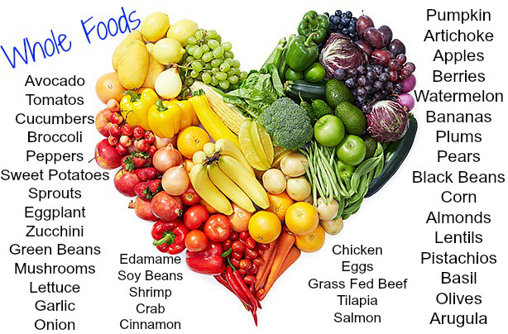

- What are refined foods? Are they nutritious? If not, why?

Refined foods are foods altered from their original state. In exchange for altering the texture of the original grain or sugar, nutrient is lost and shelf-life is generally increased.
A good rule of thumb when trying to contrast whole versus refined food is that whole foods do not have a long shelf-life. Boxed and packaged foods generally contain refined grains and sugars additionally foods made with white sugar and flour that have been refined are no longer whole foods. The human body does not process refined foods in the same way as whole foods partially due to the decreased fifer content in refined foods. Refined foods are also generally higher in calories than whole foods. Food that have been processed in some way or changed are considered refine since one or more of their edible components is removed in the processing these foods are technically no longer consider natural. One reason this is troublesome is because nutrient is lost in the processing. For example, when an orange is processed into orange juice the membrane and pulp are removed. Vitamins, minerals, and fiber are also removed when you do not eat a whole orange, orange juice is also higher in calories since one cup of orange juice is equivalent to about four oranges. Most people cannot eat four oranges in one sitting, in addition to eating the rest of their breakfast when orange juice is typically enjoyed! Another problem with refined foods is that additional ingredients can be added, which aren’t food and aren’t healthy. Take whole wheat for example, which is often altered into enriched wheat flour. All of the intrinsic vitamins and minerals in the wheat are stripped out and then about half that number of vitamins and minerals are added back in the form of chemical nutrients this is what is called enriching the flour. The chemical nutrients are not as well-absorbed in our bodies as the inherent nutrients are. Additionally, unless the flour says whole wheat. bleach has been used to whiten the flour. Yes, chlorine bleach like what you use on your white clothes. I can’t imagine that it can be washed out of flour can you? An additional issue with refining foods is that the food might be altered in such a way that causes health problems. For example, since refined grains are quickly broken down into simple sugars during digestion they are promptly absorbed into your bloodstream. As a result, if you are eating this food without protein or fat such as eating a plain bagel your blood sugar level will usually spike and then crash, draining your energy and leaving you moody and tired. And your risk of becoming diabetic is increased when we eat a food that is refined we crave to eat more and more which lead us to overeating of refined food. Cause whole food gives us satisfaction. Example one-pound bag of potato chip a large bag can have 10 to 12 medium potatoes how easy to eat it in one sitting but can you eat a five potatoes in one sitting.? If you eat morning low fat milk highly sweetened than after half an hour you eat one chocolate bar why this happened to replace the fat your body is craving from the sweetened low fat milk.

The solution is eating whole foods that modified as little as possible the benefit of whole foods it will provided you with good enzymes vitamins and mineral and protecting you from stressful live and any change in our environment.

Example of refined foods.

v. What is basal metabolic rate? What is the different between total energy?
expenditure (TEE) and Basal Metabolic Rate (BMR)?

Basal metabolic rate the rate at which body uses energy while at rest to keep vital
functions going
Such as breathing and keeping warm. Basal metabolic rate is the amount of energy
Expended while resting in neutrally temperate environment when your digestive
System s inactive so your energy will be used only to maintains your vital organs
Which Include your heart lungs decrease with age and increase with muscle mass.

Basal metabolic rate or BMR is the amount of the energy required. To sustain a one’s
Daily involuntary bodily function such as circulation respiration temperature
maintenance hormone secretion nerve activity and new tissue synthesis. BMR
consumes the majority of calories per day for functioning.
To determine the daily calories needs (DCN).
DCN=BMR=DAILLY ACTIVITY CALORIES

there is numerous equation to determine BMR an easy one is
Men: kg. weight * 24 = call/day
women: kg. body weight*22= call/day

The BMR is estimated with equations summarized from statistical data. The most
Commonly used one is MIFFIN- ST JEOR EQUATION:
BMR=10*weight) +6.25*height(cm) - 5 * age(y) + 5 (man)
BMR= 10*weight) +6.25*height(cm) - 5 * age(y) -161 (woman)

Basal metabolic rate is the amount of energy we expended while we ae resting and
while
The digestive system is inactive. Which requires twelve hours fasting.

The total energy expenditure (TEE) is the amount of calories burned by the amount of
Activity sedentary moderate or strenuous) it is calculating by adding 30% of basal energy
Expenditure (BEE) calories to the BEE for sedentary activity.

Total energy expenditure this’s very precise metabolic rate calculates your resting
Metabolic rate and total energy consumption in calories or kilojoules. This can be helpful
Tool for weight loss as it allows you to estimate the amount of calories that represent
Your energy balance.

vi. What are micro-nutrients? And why our body needs them?

micronutrients are vitamins and minerals are two types of micronutrients we need it in small amounts. Micronutrient play crucial roles in human nutrient plus prevention of many diseases and make physical and mental function.
Micronutrient are important in human and mental function.
Micronutrient are regulation of metabolism heartbeat and cellular ph.
Micronutrient are essential for bone density.
Lack of micronutrient can lead and increased risk for various disease in adulthood.

Types of micronutrient are two:
Water soluble and fat soluble.
Water soluble vitamins are easily lost through bodily fluids must be replaced each day.
Water soluble are B12, B complex, B6, and vitamin C.

Fat soluble are:
A, D, E, and K, are stored in body for long periods of time.
If you consume large amount of fat-soluble it leads to toxicity in the body.

Minerals are also available in two form micro minerals and macro minerals:
Marco minerals are tow needed in large amounts.
Calcium, magnesium, phosphorus, sodium, potassium.

Micro minerals are only needed in small amounts:
Iron, Copper, Iodine, Zinc, Fluoride.

Micronutrients in food are:
Calcium: milk yogurt spinach and sardines.
Vitamin B12: beef fish cheese and eggs
Zinc beef cashews beans and turkey
Vitamin C: orange, peppers, broccoli. And bananas
Potassium: bananas spinach potatoes, and apricots
Low calories food contains more micronutrients like vegetables.

micronutrients

macronutrients provide energy to support growth metabolism and other body functions.
Carbohydrate provide 4 calories per gram.
Protein provide 4 calories per gram.
Fat provide 9 calories per gram.
Carbohydrate are the body’s main source of fuel.
Carbohydrate are easily used by body for energy.
All of the tissues and cells in our body can use glucose for energy.
Carbohydrate is needed for central nervous system, kidney, brain, muscles to function properly.
Carbohydrate can be stored in the muscles and liver and later used for energy.
Carbohydrate are important in intestinal health and waste elimination.
Carbohydrate found in starchy foods like grain and potatoes cheese nuts seeds vegetables fruits milk and yogurt.

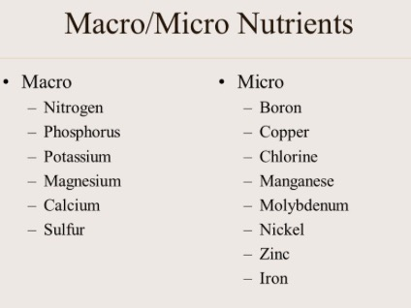

3 case study
lucy 32 is a fairly active young woman who works out in the gym several days a week. She has a stressful job. Her. Her diet intake record also shows that the diet she is taking is healthy and balanced. Her BMI falls within the range but her skin is very dry and most of the time she feels tired and fatigued. She has been taking good care of herself and her diet and takes appropriate rest also but is greatly worried about these problems. Most of the time she does not feel fresh and is not enjoying her life well.

Question:
- The reason for Lucy’s dry skin seems that:
- She is not taking proper amount of vegetables in her diet
- She is not taking proper exercise
- She is not drinking enough water

- The reason for Lucy’s tiredness could be

- Her stressful job
- Her physical activity
- dehydration

- what could be the best dietary advice for Lucy?

- she should take multivitamin supplement
- she should take more rest
- she should take 6-8 glasses of water daily

