
Brent
Assignment Cover Sheet

Student Name: | Mery Ann Alaba
Student Number: | 1406
Course: | Fashion Design
Assignment NO: | Assessment 5

Marking Criteria:
We expect the learners to write minimum one well expressed point in three lines against each allocated mark. This means one needs to write 15 lines with 5 well expressed points to get high grades for a 5 marks question.
For high grades use examples and illustrations where appropriate.
Assessment 6

Question

- Formal Balance achieved in dress designing if the dress design have feeling of dignity or formality.

The upper and lower portion of the dress design are so arrange it gives an effect balance, there should not be the effect to much of weight at the bottom or a heavy appearance.

It is shows as well both side of the dress are exactly alike, plaiting on either side is of the same width and amount and it place the same distance from the head to feet.

Formal balance as well in dress can improved upon moving the monogram to the centre of the dress.

- Harmony created when all parts of the design are related, in regular and orderly manner.

When the design has unity, it gives an overall impression that attracts and holds the attention of the observer and gives a feeling of belongingness of the composition.

This effects is created when the elements of design are used effectively according to the design principles.

- The relationship between the principles and design those two are the guidelines for the design.

They are used for creating, discussing & evaluating garment ON and OFF the individual. IN order to arrange the elements of the design well, application of the principles like balance, proportion, emphasis and unit/harmony are essential.

Those to are not abstract art terms but specific guides that help to create
attractive garment.

IV. 3 Ways for creating Rhythm in dress designing

Rhythm by Continuous line movement

This type of rhythm is obtained by flowing lines of trim, bands of color,
fabric design, which make the eye move in continuous line. Rhythm is
broken when lines, trimmings, or fabric design are not matched at the
seams or at other construction points. Fabric design with widely placed
motifs may lack rhythm. Often the garment design will interrupt this type of
fabric designs produce strange effects when worn on the body. So care
needs to be exercised while using such fabric design in a dress.

Rhythm through Repetition

Rhythm is achieved by repetition or regular repeats of motifs of design,
shapes, buttons, tucks, pleats, laces, edgings, color, textures, fabric
design etc. This can be done with all parts having the same shaped edges.
They might be squared, rounded, or scalloped. Repetition of colors can
create good effect, especially if the colors are distributed in an interesting
way.

The rhythm created by smooth undulating lines reminds us of gentle wave
which imparts a peaceful and calming effect. Lines which have sharp
points and jagged when repeated gives an exciting rhythm which is more
suitable for a dramatic evening wear.

Rhythm through Progression

Rhythm is also created by Progression or by gradation. Gradation implies
a gradual increase or decrease of similar design elements. Colours can go
from light to dark or textures from fine to coarse or vice versa. Shapes may
range from small to large, and lines may range from thin to thick. The
gradual changes provide continuity while giving a feeling of movement. An
system consequence of gradually increasing or decreasing changes in
sizes of motifs buttons, trim, flowers, ruffles, intensity, fabric design also
create rhythm.

Q:2 The following principles of design are;

- Balance – It is Implies pose, equilibrium, stability and security. They analyze the average of human body in visually symmetric, meaning body seems to be same on each side of a central line. For a design of the dress, they should be grouped in such a way that there seems to be equal interest or weight on each side of an imaginary centre. If the dress design is balance it can produce by structural parts and added some decoration on it.

- Emphasis – It is a concentration of interest in one area of a design that acts as the centre of attention. Contribute to create eye arresting area that any other part. All areas may interest, but all area should not have equal strength of interest. Part of the dress requires subordination in order to emphasize some area.

- Harmony – Is a unity of the design or visual unity. It is a relationship among all parts within a whole. This is created when all parts of the design are related, in a regular and orderly manner. If the design has unity it gives an overall impression that attracts and holds the attention of the observer and gives a feeling of belongingness to the composition. Functional aspect of harmony imply that a garment is comfortable, moves easily and breathes with body, performs any specialized effectively and fits well.

- Proportion – Simply the pleasing interrelationship of the size of all parts of the garments. Generally, unequal proportion is more interesting than equal. Comparing with a mirror and patter catalogue our eye automatically compares the smaller part on the outfit with the larger one. Comparison could proportion.

- Rhythm – It is a organized movement, has a result from organized or a gradual change, giving the feeling of continuity throughout the design. Also have become stronger when a pattern is repeated, but repetition is not very essential always. Rhythm is used most effectively with line, shape and space and also by changing the hue, value and intensity of the colourse.

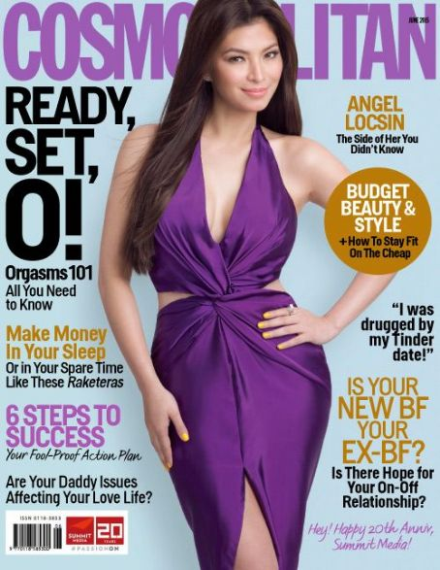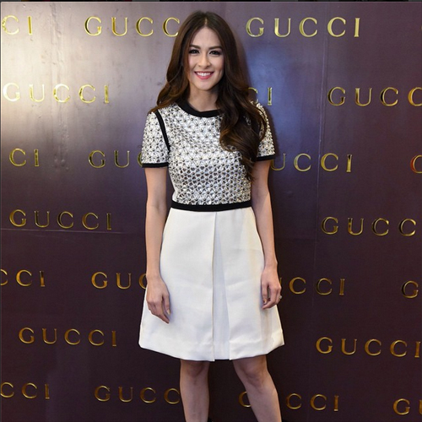

This are the sample in Fashion magazine that I found, more likely Formal Balance, the line, silhouette, shapes and space, color texture (fabric, pattern and trim) are balance.

The upper and lower portions of the design are so arrange, it gives an effect of balance, it shows not to much of weight at the bottom or heavy appearance.

The distance from head to toe is exactly alike; either side is of the same width and amount. The dresses are equally well balance in the waistline.

All dresses give interesting things to look, style with proportions the model look taller and slimmer.

The rhythm are organized it has pleasing arrangement of the design elements so that it gives to the eye move easily over the apparel. It shown as well the stronger effect even the pattern is repeated from the bottom and top.

Both dresses emphasis the concentration of the interest especially of the area of the design, color and fabric.

Yes, all Elements works harmoniously all parts of the design, related in a regular and orderly manner, it gives a visual unity, the tree aspects of design are there the design function, structure and decoration are accordance with each other.

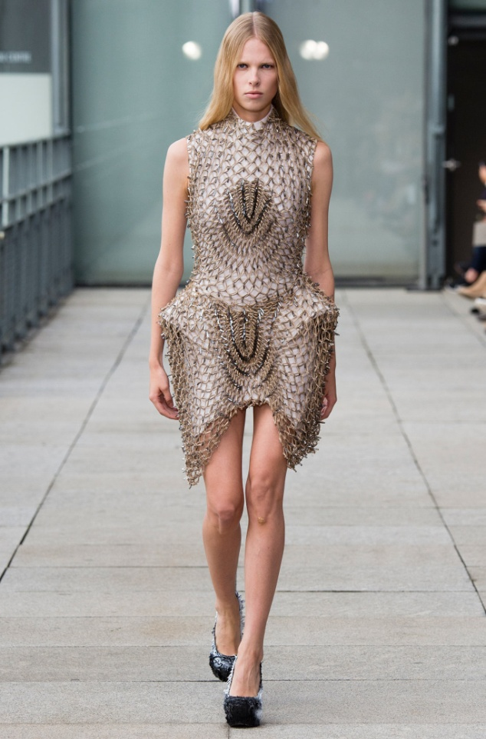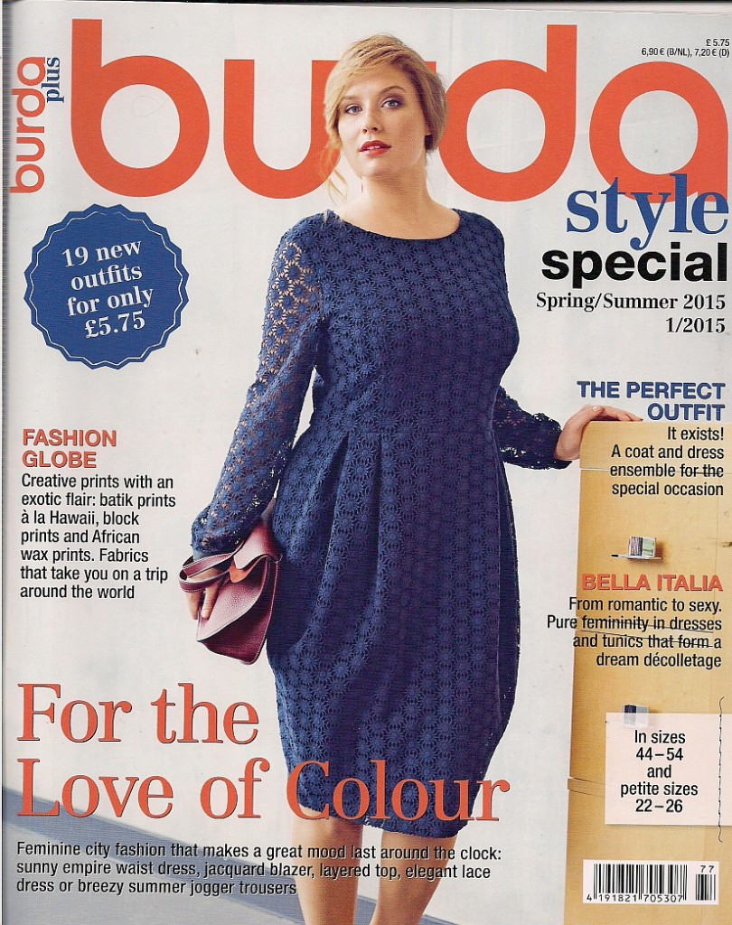

- b.)

- This sample of garments that unsuccessful for me the line, silhouette, shapes and space, color, texture (fabric, pattern and trim is not balance, Yes I agree it gives Emphasis to get a centre of attention, but the harmony, overall impression unity of the design is not much attractive because this type of dress is not usually using in an events that we commonly used. Proportion is ok there is unequal proportion, for the rhythm it is not giving a feeling of
Continuity throughout the design.

- This sample of garments is little bit unsuccessful the line, silhouette, shapes and space, color, texture (fabric, pattern and trim are not balance, It’s more emphasize the body not the design of the clothes, overall impression quite nice, unity of the design is not much attractive because its more bulky look in the waistline the design also for the silhouette that they used is not giving more attention. Proportion is not ok I cannot see the unequal proportion on it, Rhythm or feeling for continuity throughout the design is there, but in a case to case basis.

Student Statement:

By submitting this assignment, I confirm that this is my own work.

Student Signature | Mery Ann P. Alaba | Date | 4 Aug 2015

For Tutor / Assessor Use Only
Total Marks
Marks Obtained
Percentage / Grade

