
Assignment Cover Sheet

Student Name: | Shweta Jewlikar
Student Number: | 1610
Course: | Diploma in Fashion Design Level 4
Assignment NO: | 4

Marking Criteria:
We expect the learners to write minimum one well expressed point in three lines against each allocated mark. This means one needs to write 15 lines with 5 well expressed points to get high grades for a 5 marks question.
For high grades use examples and illustrations where appropriate.

1. Which type of materials should be chosen to dress a thin person? And when choosing a striped print, which type of stripes would you recommend for dressing a thin person?

- For thin figured person it is best to choose materials which do not cling to the body.
- Also as shiny materials increase the appearance of size and can be selected as dress material.
- Clingy fabrics are best for designing dress for thin person.
- Fabrics such as Satin and Jersey can be consider while creating dress for thin person.
- Jersey fabric can be of any type as mention below
  - Cotton
  - Rayon
  - Viscose fabric
  - Synthetic
- Wool can also be used to design the dress for thin figure person.
- Figure (1) below are few samples of fabrics.

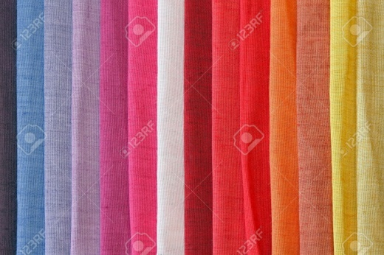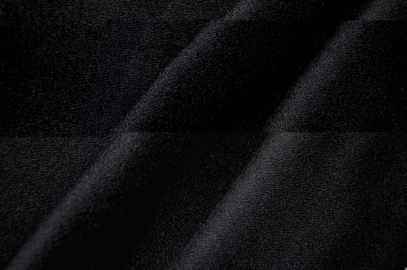
Figure (1) a. Cotton Figure (1) b. Rayon

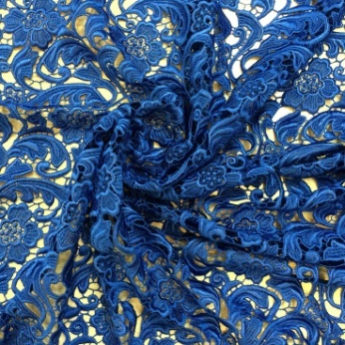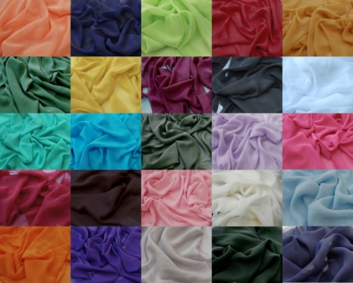
Figure (1) c. Viscose Figure (1) d. Synthetic

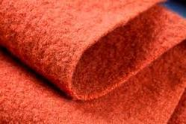
Figure (1) e. Woollen

- It is best if the lines of the silhouette are not continuous.
- Vertical lines in the dress gives it slim look, So using horizontal stripes in dress will give more wider look to the model. As shown in figure (2).
- Also combination of stripes can also be used to give thin person wider look. As shown in figure (3).

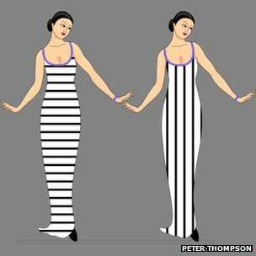

Figure (2) Horizontal stripes and Vertical stripes

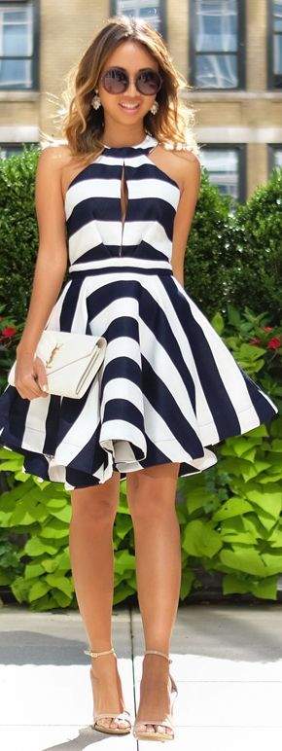

Figure (3) Mixed stripes dress.

2. How would you design a dress for a person with large waist and hips? Which design techniques would you apply?

- When a person has a large waist and/or hips that are out of proportion to the rest of the figure then he/she should dress in a way that moves the interest away from that area.
- Also we can emphasise few parts so that focus will be away from the waist line. Figure (4) below is one of those type.
- In figure (4) neck line is emphasizes so the viewer eye get attracted towards neck line.

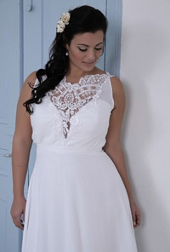
Figure (4) Neck line is highlighted

- The Upper body should be made a centre of interest and therefore the dress/garment should be designed so it moves the eyes towards the head.
- Below dress is one of the example how we can move eye of viewer away from waist line. Figure (4) a.
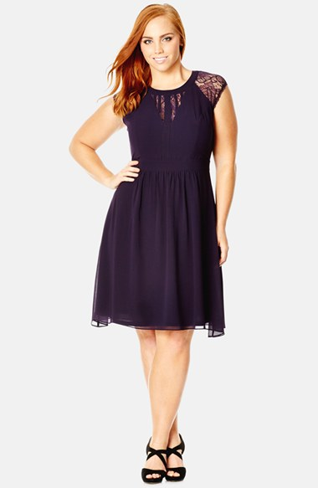
Figure (4) a. large waist line

Below design techniques can be considered to design dress for person with large waist and/or hips.

- More weight can be added on upper part of body so that eye will move towards neck line/head.
- Vertical line can be used near waist line to give it slimmer look. As shown in figure (5).

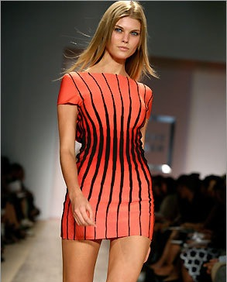
Figure (5) Vertical lines at Waist line

- Faint colour dress with dark colour weight on upper body part can move eyes of views towards head area and not towards waist. As shown in figure (6).
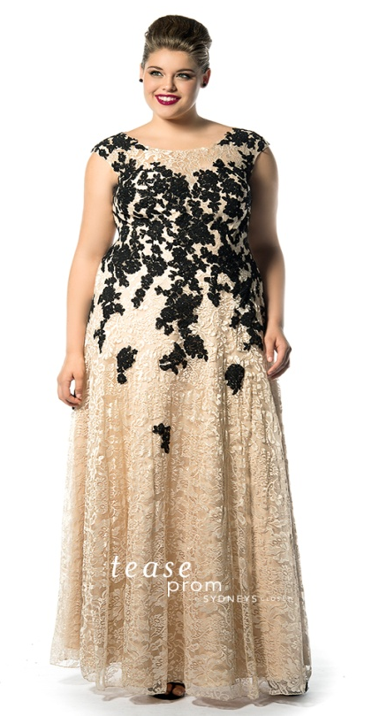

Figure (6) Weight on upper body part

3. A person with stout figure must never try wearing a dress which is too tight for him/her.
Discuss this here.

- A person with stout figure must never try wearing a dress which is too tight because it emphasise on the figure of person.
- It focuses on imperfect proportion of body parts.
- It highlights the curve parts of the body which does not look good and looks out of rhythm.
- As show in figure (7) this person has stout body type and wearing too tight dress.
- All the focus and emphasise is on curve areas of person rather than face or person all together.
- And hence people with stout figure avoid wearing dress which is too tight.
- The overall look of person will not look balanced.

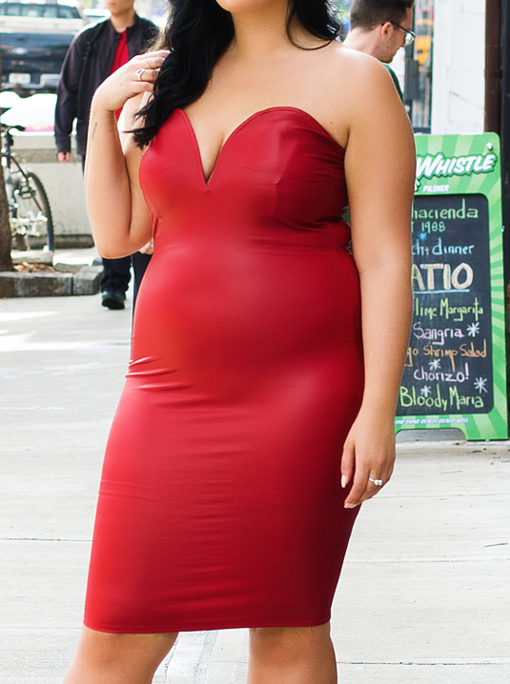

Figure (7) Too Tight dress

4. How would you design a dress for a person with round shoulders so this problem is least noticeable?

- Set-in sleeves pattern can be used to design dress.
- These types of shoulder patterns reduce the effect of round shoulders and hence least noticeable.
- Figure (8) show one of such pattern.

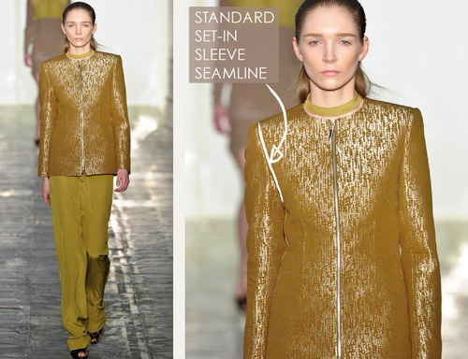
Figure (8) Set-in Sleeves

- One of others ways to reduce round shoulders effect is to use bolero jackets. Figure (9) is an example of such jackets.

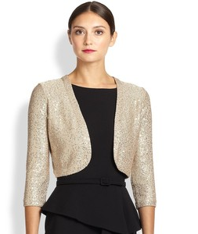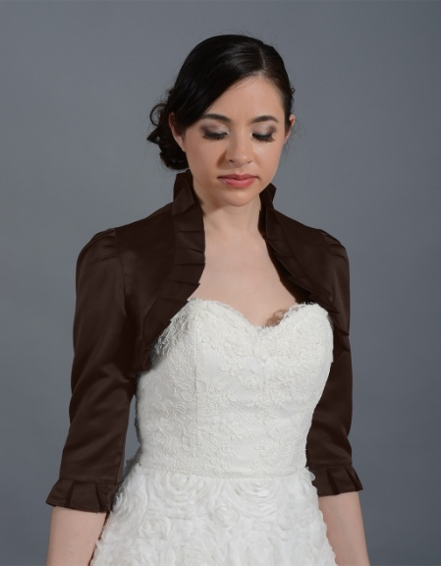
Figure (9) Bolero Jacket

- Place shoulder seams one-half back of the normal shoulder line. One of such example is as shown below in figure (10).

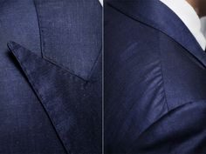
Figure (10) Shoulder seam line

Activity
Make a collage of the pictures from a magazine with people wearing dresses unsuitable for their figures. For each picture, explain how this could have been designed correctly for that person’s figure.

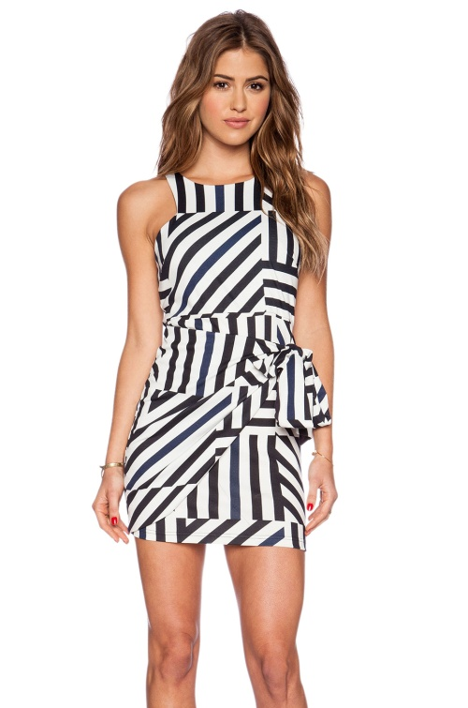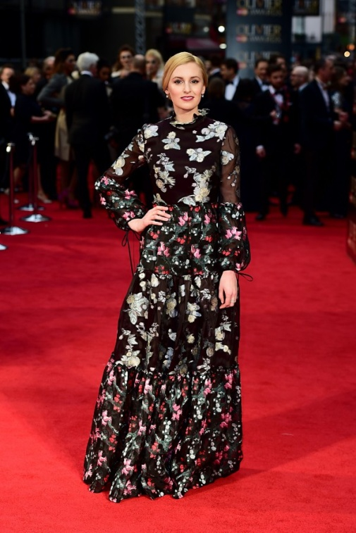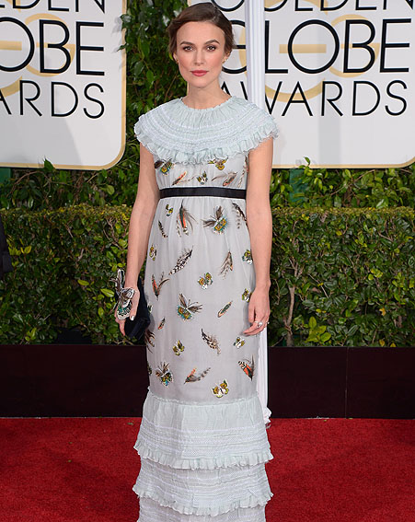
Figure (11) .a Figure (11) .b Figure (11) .c

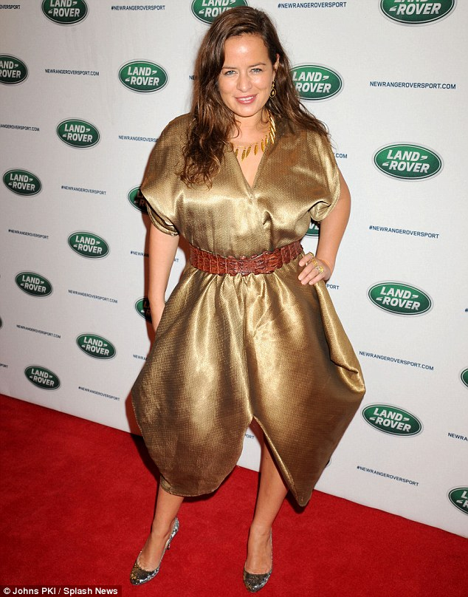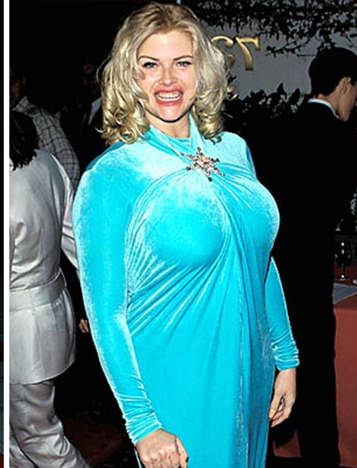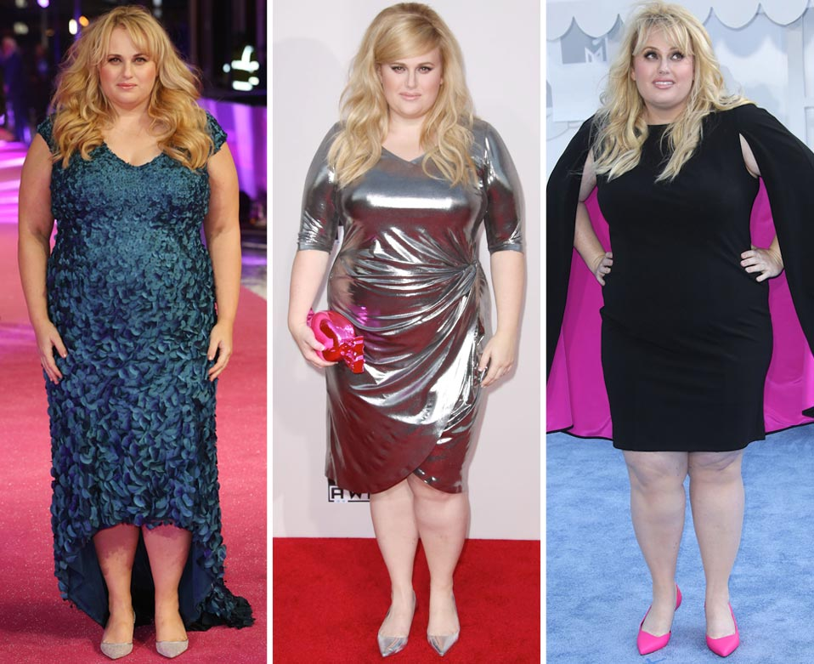
Figure (11) .d Figure (11) .e Figure (11) .f

- Figure (11) a.

- Figure (11) a. the person has thin figure and the outfit is unsuitable for this kind of figure.
- The combination of strips is not used on proper scale. Due to improper scale of lines the person is looking more thin and shorter.
- This could be improved by increasing the size of scale and minimizing the combination. More use of horizontal lines.
- The dress can be redesign in one of the way as given below. Figure (11) a.1

Figure (11) a.1

- Figure (11) b.

- Figure (11) b. Is not properly design and looking too much heavy on this person? Selection of fabric and combination of fabric is not proper both are giving very heavy look to person.
- One fabric is suppressing the effect of other and hence in total all looks like a single fabric used.
- This can be improved by selecting one fabric with large print and other fabric with small prints.
- Also fabric of different colours can be used which will create cool combination
- Combining such type of fabric will emphasise both fabric without suppressing effect of each other.
- Figure (11) b.1 show one of such cool combination of printed fabric.

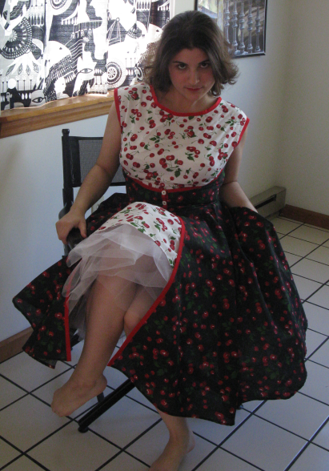
Figure (11) b.1

- Figure (11) c.

- Figure (11) c. The person has round shoulders and the pattern used around the neck and shoulder line making it more noticeable.
- This could be improved by just creating simple round neck or by using bolero jacket.
- Figure (11) c.1 show one of such type.

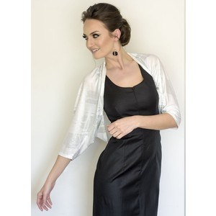
Figure (11) c.1

- Figure (11) d.

- Figure (11) d. This person has large waist and can be seen easily in this outfit.
- Using belt at waist line gives focus on that part and emphasise large waist.
- Selection of fabric is not good. Silk fabric gives heavier look to this person.
- This could be improved by removing the belt and creating some weight on neck line.
- Fabric can be used which has less shine so it will not give heavy look to the person.
- Figure (11) d.1 is one of such type.

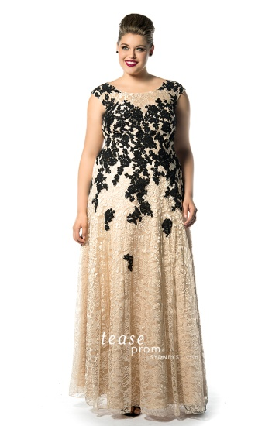
Figure (11) d.1

- Figure (11) e and Figure (11) f.

- Figure (11) .e and figure (11) .f shows that person is wearing too much tight dress. Due to tight dress more emphasise is given to body part.
- Few body parts are highlighted so much creating unpleasant looks to both of them.
- Also the fabric used is shiny which give broader look to the person.
- This could be improved by proper selection of fabric which does not stick to body.
- Dress should be design so that it is not too tight and thus avoid body curves.
- Figure (11) e.1 is one of the design which can be used.

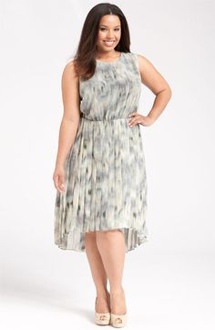
Figure (11) e.1

