
Assignment Cover Sheet

Student Name: | Frank Cook
Student Number: | 1734
Course: | International Diploma in Project Management
Assignment NO: | 02

1.Short Questions: (15)

i. You are a project manager working on gathering requirements and establishing estimates for the project. Which process group are you in?

b. Initiation Planning



ii. What does the term ‘project deliverables’ mean?

Deliverables are products of projects that can be delivered. Deliverables are verifiable and measurable, they describe a tangible or intangible object to produce an unique outcome/result or specific tasks, It could be a report, a document, a plan, a policy, a process, a milestone or any other interrelated outcome to the overall project.

Specific deliverables are known as Milestones measured by a fixed point in time, during the course of the project. These deliverables are significant to achieve project success, meeting each deliverables is significant accomplishments over the project life span.

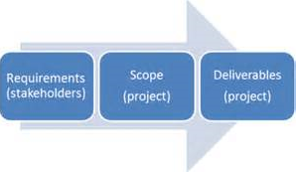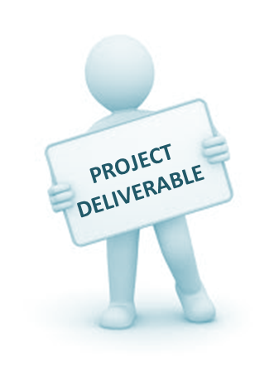

iii. What is the purpose of determining a project’s goals and objectives?

The purpose of developing the Overall Goal and Specific Objectives is to paint a clear picture of what the project is aiming to realize. By setting realistic goals and targets project execution success can be measured and evaluated. To track success of completion of tasks they must have been identified by senior stake holders and inputted project Charter and a project management plan deployment with the cascade of scopes, to measure and monitor completion/success using Work Breakdown Schedule (WBS) and Gantt charts
When setting Goals using S.M.A.R.T GOALS and CLEAR GOALS methods are best practices as follows.

S.M.A.R.T.
Specific – To set specific goals, answer the following questions: who, what, where, when, which, and why.
Measurable – Create criteria that you can use to measure the success of a goal.
Attainable – Identify the most important goals and what it will take to achieve them.
Realistic – You should be willing and able to work toward a particular goal.
Timely – Create a timeframe to achieve the goal.

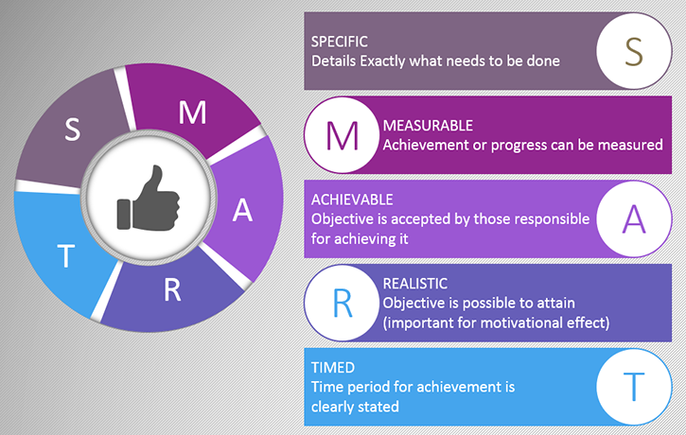

C.L.E.A.R.
Collaborative – The goal should encourage employees to work together.
Limited – They should be limited in scope and time to keep it manageable.
Emotional – Goals should tap into the passion of employees and be something they can form an emotional connection to. This can optimize the quality of work.
Appreciable – Break larger goals into smaller tasks that can be quickly achieved.
Refinable – As new situations arise, be flexible and refine goals as needed.
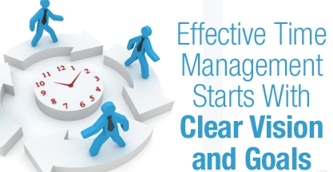
By using these tools to defined success criteria, the overall goal of project success may be known and documented.

iv. At which stage of the project is the project’s constrains identified?

In the initiation phase is where triple constraints are primarily recognized, But It is in the Planning stage where the project’s constrains are identified/defined/refined as required. The scope statement provides details of project constraints along with Product description, acceptance criteria, Key deliverables, project boundaries and assumptions information.

Project Planning! Outlines the plan as to how the project is to be fulfilled. This is where project management triangle or Dempster’s triangle is crucial. Its used to gauge whether a project’s objectives are being met against defined project scope, time, cost and quality. The objective is to keep the triangle equilateral or balanced.

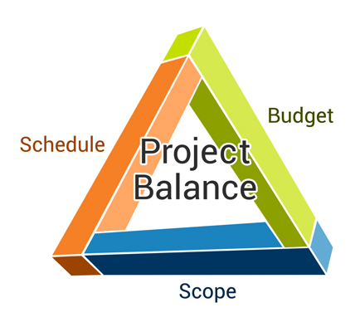

Planning is the art of arranging resources such as scope, time and cost to bring about a preferred result. Triple Constraint is the balance of the project’s scope, schedule (time) and cost. During the planning process of a project, the project management team define the project scope, time, cost and quality of a project. As the process continues, it may be discover that there may be some changes or adjustments to be made in one of the project’s scope, time and cost. When this happens, the other factors of the triple constraint is likely to be affected.

Planning gives clarity to all stakeholders about the objectives, scope, cost and timescales. sets the baseline for scope, cost and schedule, Identifies the right people to deployed Defines what is included in scope, Identifies items not included in scope Breaks project into manageable pieces, Defines major project deliverables and the projects critical path, and Defines key project risks

v. Explain the term ‘project charter.’ Which type of information does it contain?

The starting point, Back bone and cornerstone of a project is the project charter or also know as Terms of Reference ToR .
A project charter depicts the purpose of the project and how you will undertake it. It's a vital component of the project initiation and planning phases, it will be refer to throughout the duration of the project.

Creation of a project charter is a question of incorporating all required information to make the project such as an overview of the project, the stakeholders, the project deliverables, Goals and Objectives, resource and cost estimates, Road map, the business case or need for the project, a feasibility study if required, Roles and responsibilities, resources, Project duration, Project Constraints and communication processes/systems.

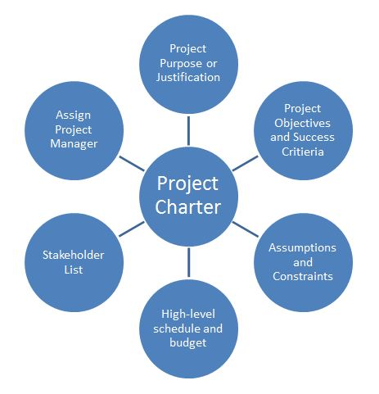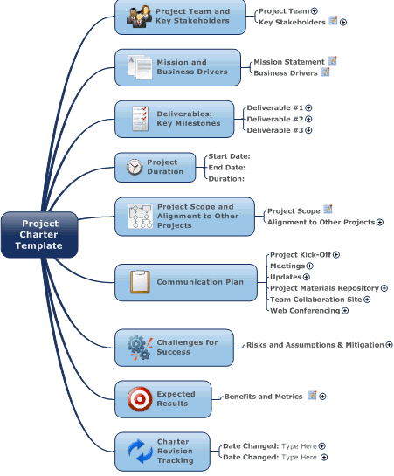

The Project charter cannot be implemented until approvals and sign-off from the project sponsor, senior management, and the key stakeholders. The project charter is an official, written acknowledgment and recognition that the project exists! Thus ending the Initiation phase, Now Charter may be issued or release by senior management.
 The project has now been granted with the project boundaries set, The Project manager now as the authority to assign organizational responsibility the work of the project.

2. “Properly planning your project up - front dramatically increases the project’s chance for Success.” Discuss this. (5)

Failure to plan is planning to fail! Knowing all is the key know the pass, present and foreseeable future! Without concise informative information and/or expert opinion, it is very difficult to plan for.

Use long and short term planning and spend more effort on planning, Planning for the expected (Things in my control) and planning for the unexpected contingency planning (I cannot control the weather! But can move the project from the weather).
Plan to Plan, without planning nothing can be achieved! goals and objects, milestones, and meetings etc. are impossible without some form of planning. Planning from the start is imperative to project success, it effects all the the project life cycle phases.

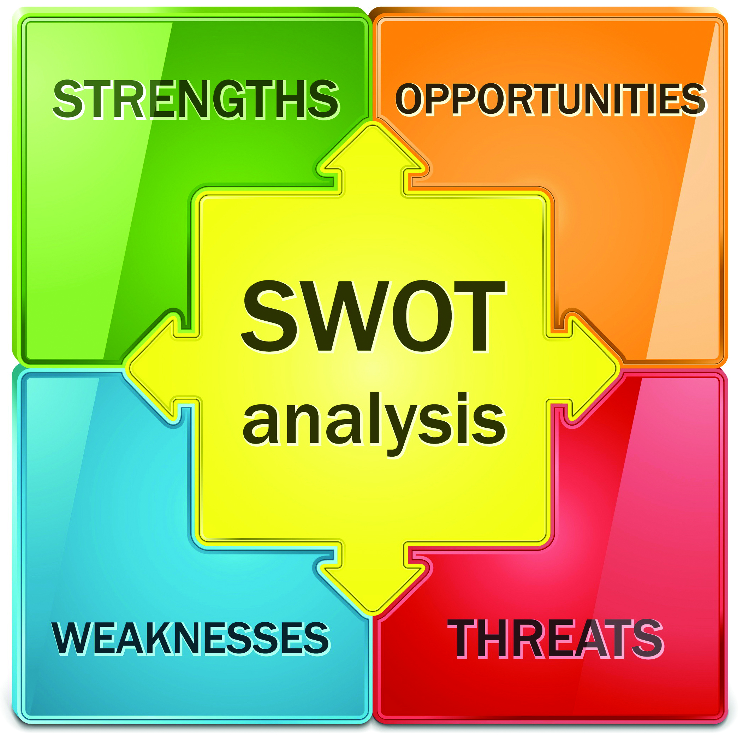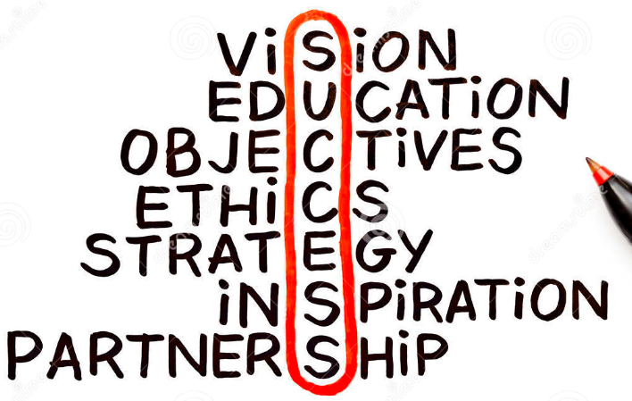

Predominantly all problem stem or root from poor or lack of planning, which simply increases stress and work load, as you known a quick fix is not always the right one and can be costly indeed. I keep in mind for every action there is a reaction, good and bad positive or negative.
Risk assessment or risk management is a fundamentally part of planning, using SWOT Analysis is a good way of evaluating project risks. . if we do it! what are the consequences of our actions? can it cause a chain reaction? or escalade further.
I believe that identifying the negatives is being positive! Prevention is often far less expensive than the cost and time to rectify, that’s why pre planning is critical for project successes.
A project plan as two options is of sound quality and the outcome is project success or due to lack of effort, the plan does not go to plan and the project is a failure.

I have and always put up the poster in my office of “the 6 P’s’ as a reminder of the importance of planning .

3. What is the Project Planning Phase about? Which plans are made during this stage? (5)

The Project Planning Phase is the second phase of the project life cycle and begins after the approval of the Project Charter and ends with the approval of the Project Plan, along with the Business Case is the primary document for this phase of the project, the Project Plan provides the Project Manager with an roadmap for how the Project will progress and how it will be executed. Planning is an iterative process It involves creating of a set of plans to guide the team through the execution and closure phases.
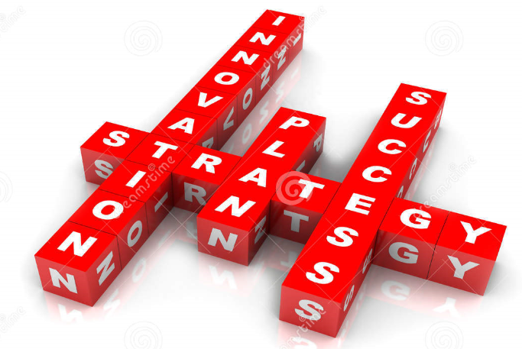
The project management plan outlines the who, what, when of a project. The plan is what is executed to ensure the project deliverables are achieved. The project plan is the master tool for controlling the project. A plan will normally contain a list of tasks/activities, resource, milestones, timeframes, WBS, Scope statement, Budget, schedule and key deliverable items.

Good planning is essential and the key factor to successful project management with emphases on developing a plan for everyone to abide by. Subsidiary plans to be develop are:-
Project Management plan includes other management plans:-
- Scope Management Plan
- Schedule Management Plan
- Cost Management Plan
- Quality Management Plan
- Human resources/staffing Management Plan
- Communications Management Plan
- Risk Management Plan
- Procurement Management Plan
- Change Management Plan
- Release Management Plan

These plans created during this phase will assist the PM to manage time, cost, quality, change, risk and issues. These PLANS will aid you manage staff and external suppliers, to ensure that the delivering the project is on time and within budget.

Time and effort invested in Project Planning activities will provide the solid foundations to inaugurate and run a successful project. Time and effort will be used on the SWOT technique at early stages of the project and throughout the project ensures sound educated evaluations are made .
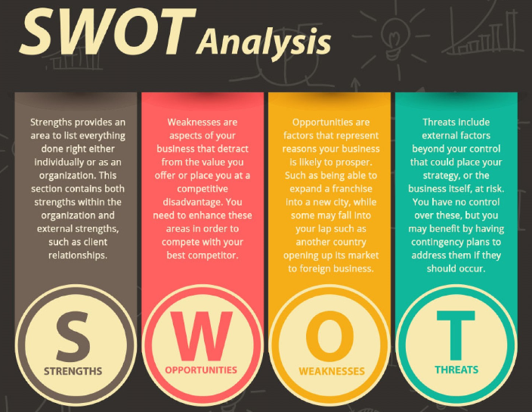

4.Outline the activities performed during the Project Closure Phase. (5)

Closure of a project is just as important as initiating the project, It is no good putting all the hard work in to the required standards and then failing to finish with the same quality and work ethics. It isn’t over, till it’s over.

Like baking a cake all ingredients/components coming together to produce the perfect cake ,
Now the cake is not complete until the final stage which is the ornate icing and decorations!


Before handing over the cake, if the icing is not aesthetically pleasing to the eye and to customer specification, Then PROJECT CAKE is a failure! thus leaving all project stakeholders disappointed and follow up projects unlikely.

In order to competently complete a project it is necessary to deliver the remaining activities or deliverables by way of producing an handover plan therefore transferring the deliverables to an operational environment may be performed.
The PM must Identify any/all outstanding activities, risk or issues that have not been complete during the project, creating a punch list and close out items systematically. PM must Gather of all required project documentation to hand over to the client/end user.
All stake holders and interested parties must be notified of the project, cancelling of contracts and releasing of project resources as required (Demobilization of personnel)
A post mortem meeting is required to share and discuss lessons learnt, an evaluation of accomplishments. What we did well, Where we failed at and what we can improve on in the future.
A final budget must be performed and final project report produced.

Student Statement:

By submitting this assignment, I confirm that this is my own work.

Student Signature | Frank Cook | Date | 13 Jun 2016

For Tutor / Assessor Use Only
Total Marks
Marks Obtained
Percentage / Grade

